Update to the Coordinated Human Service Transportation Plan for the National Capital Region - Draft
JULY 2018
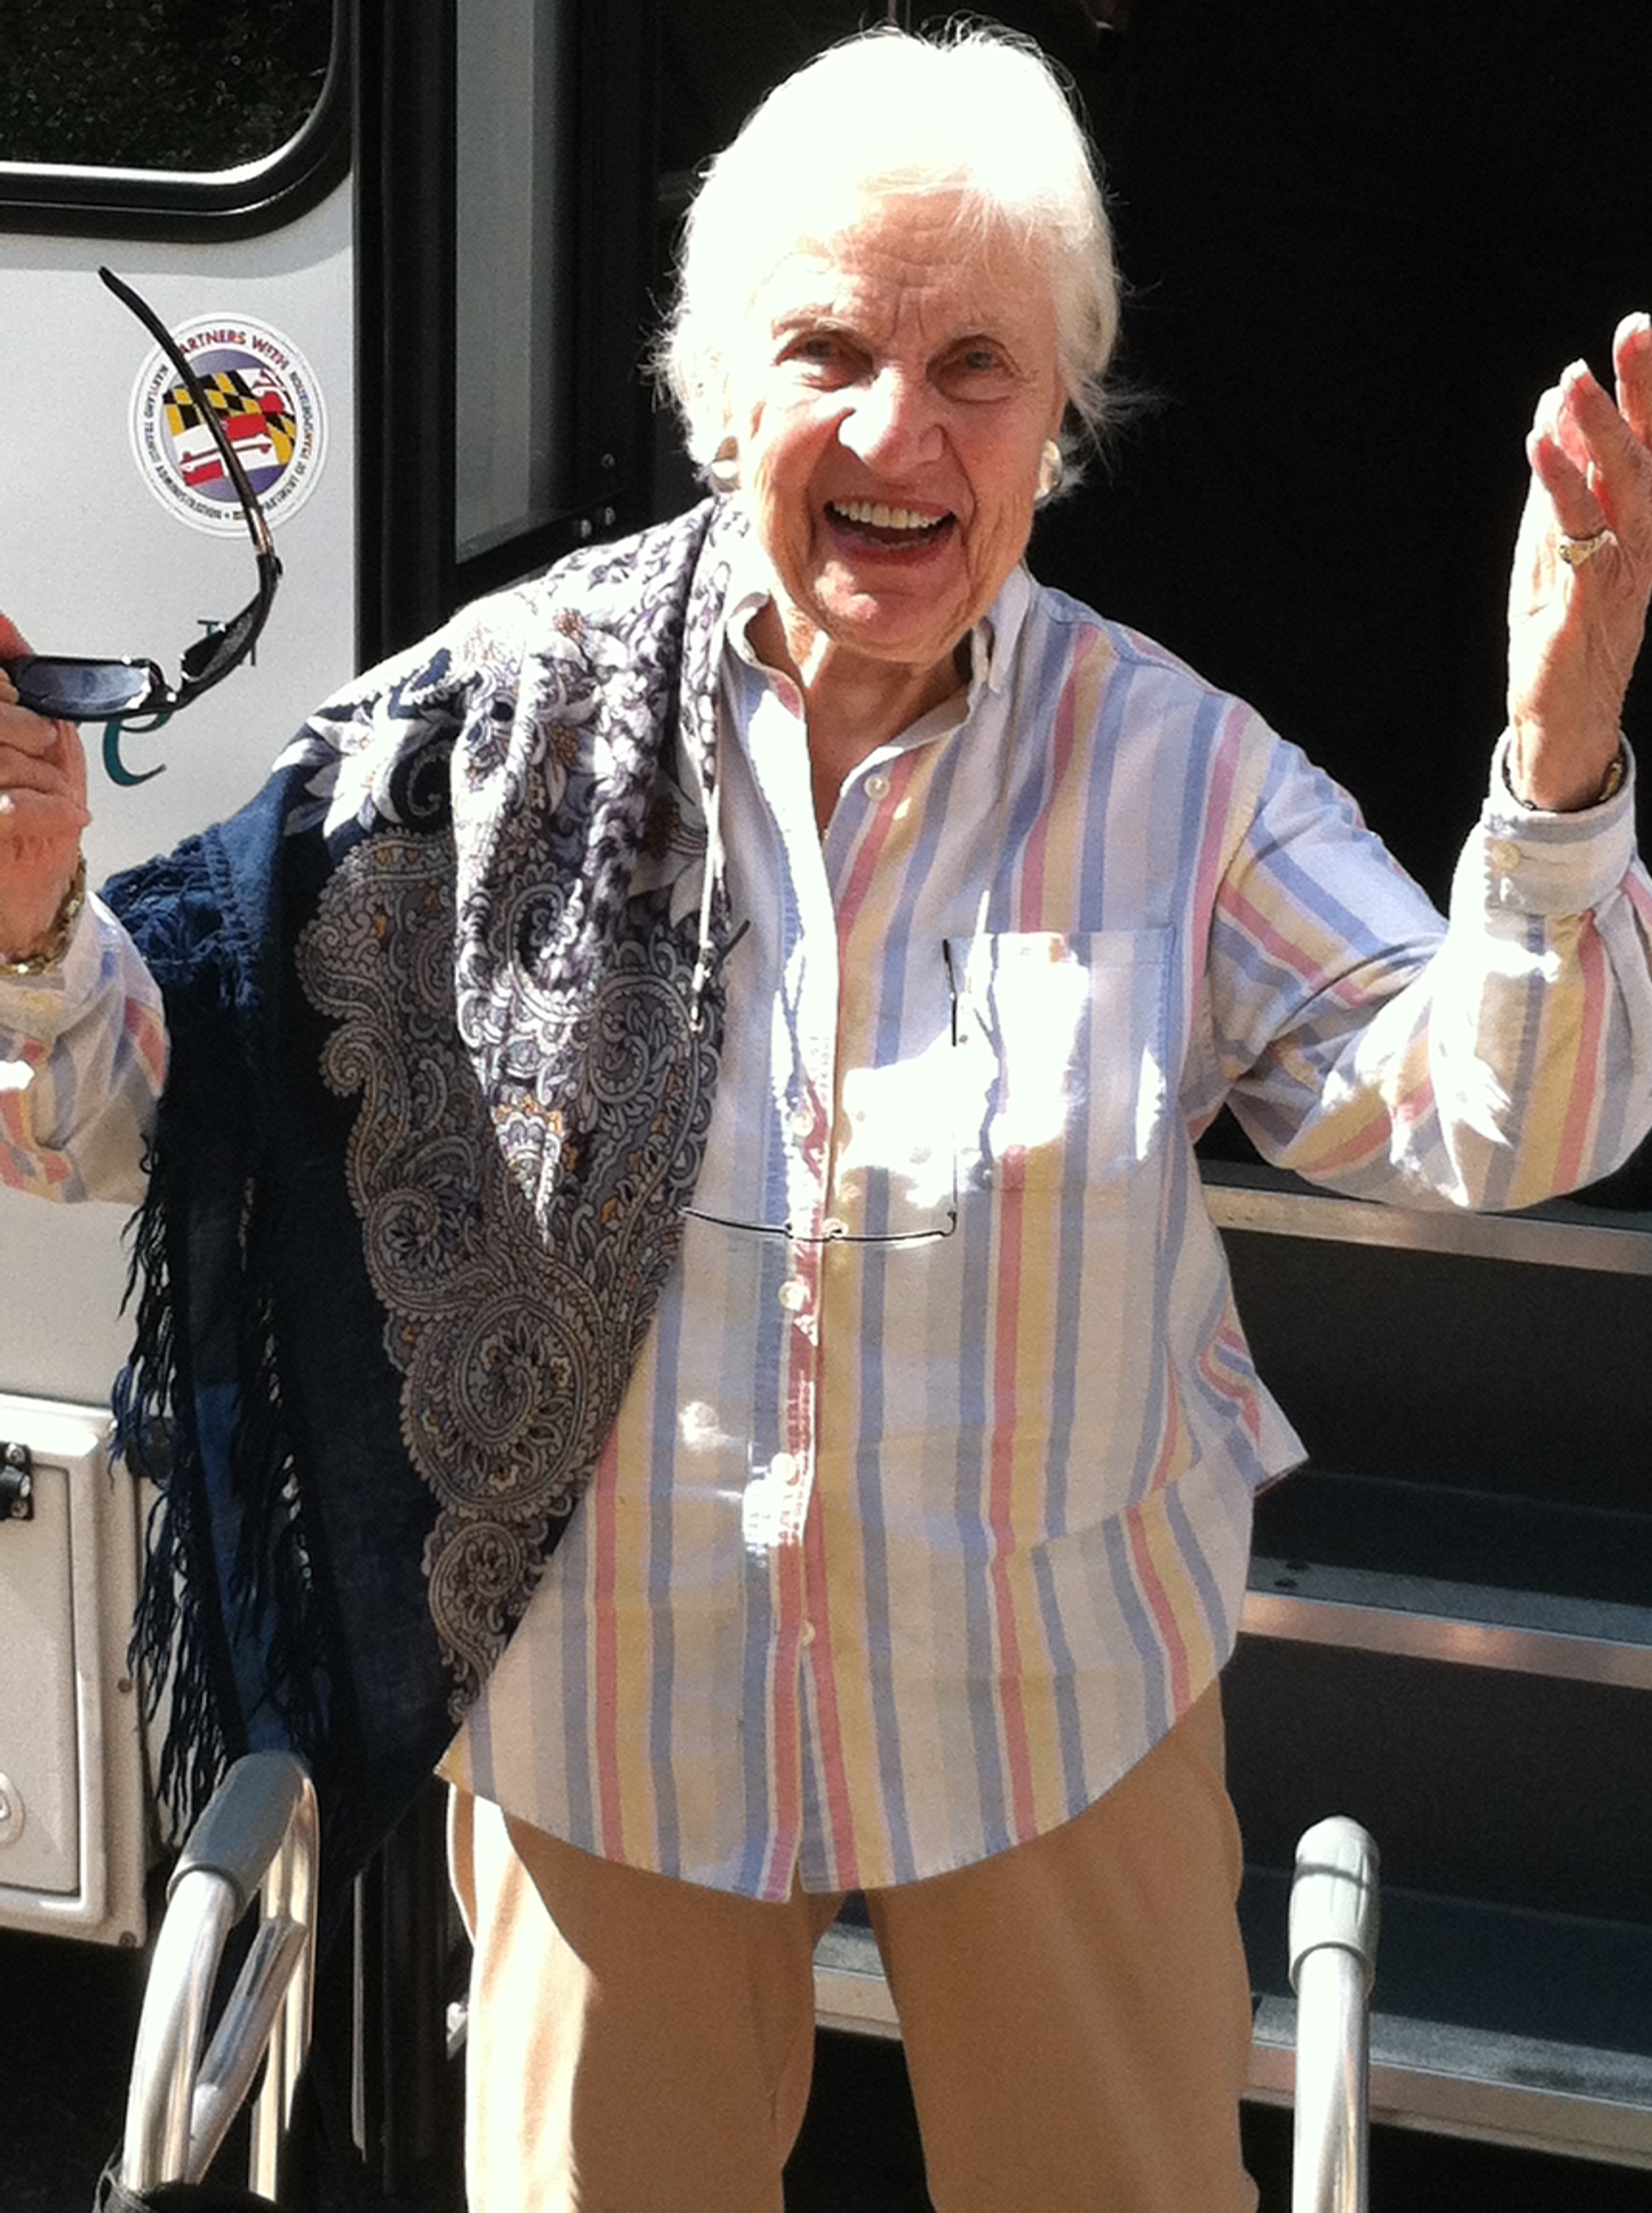
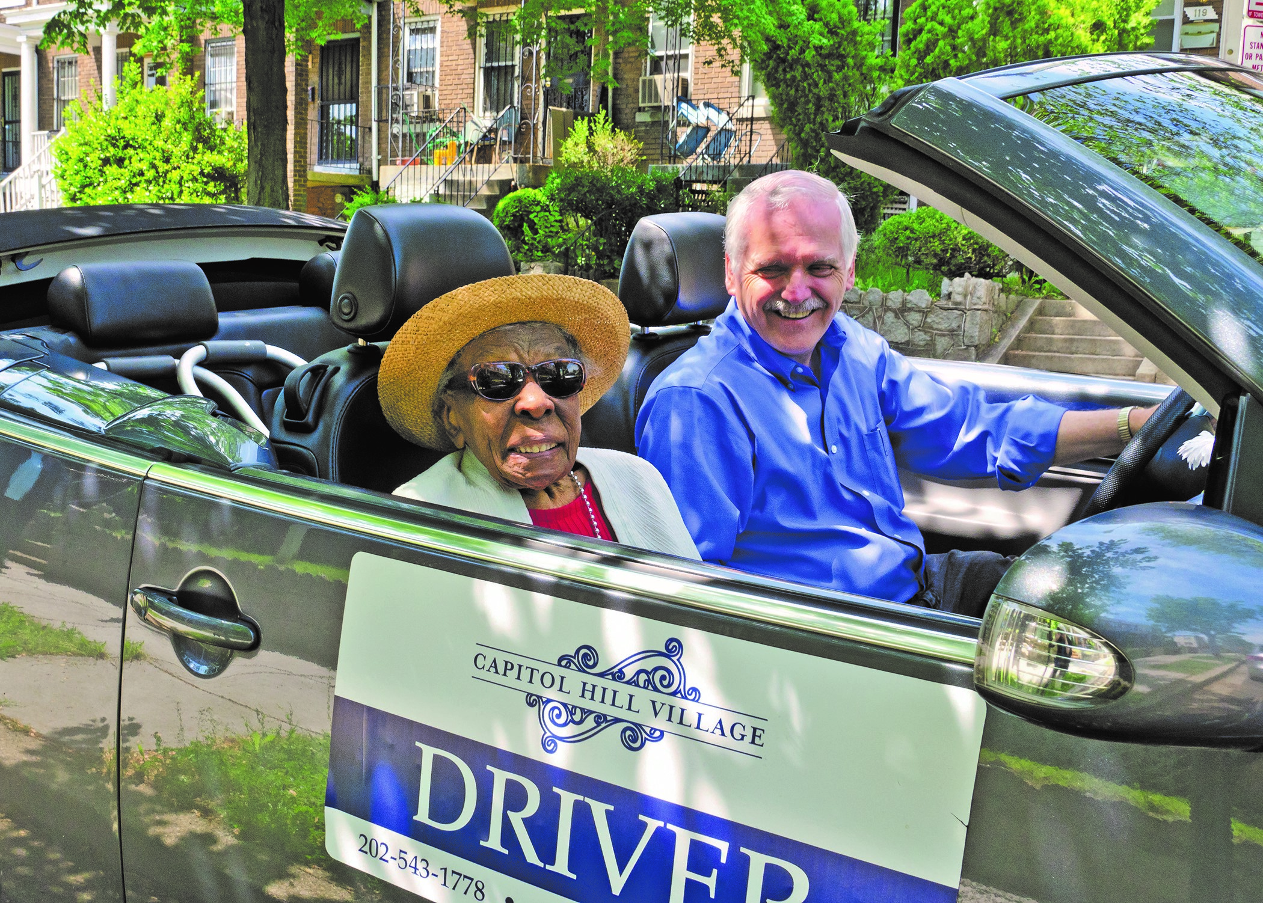
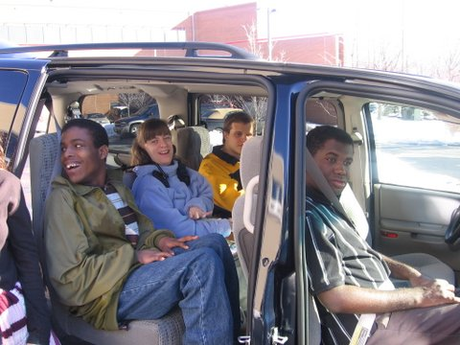
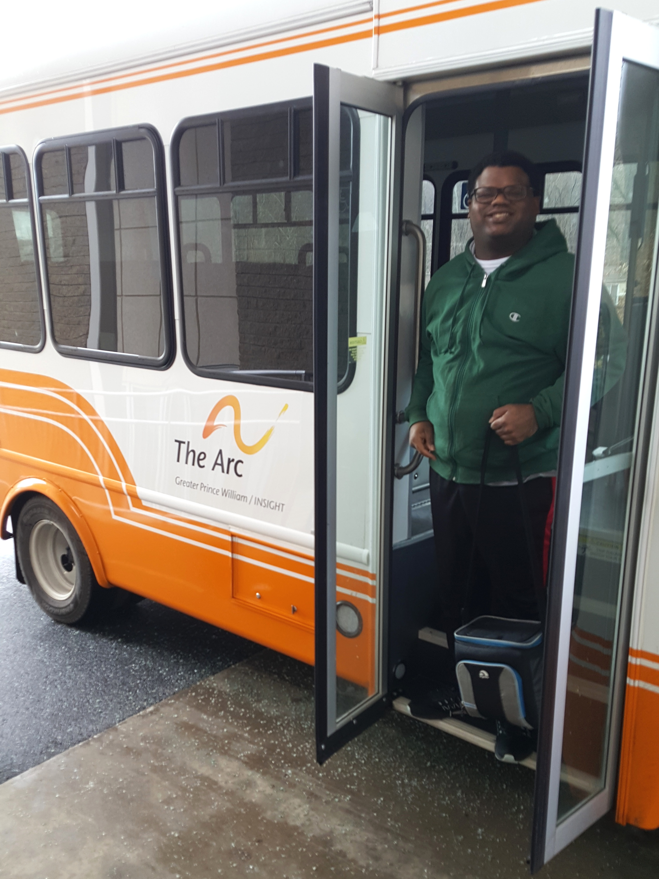
Update to the Coordinated Human Service Transportation Plan for
the National Capital Region - draft
Prepared by the National Capital Region Transportation Planning Board
Adopted on (INSERT DATE)

About the TPB
The National Capital Region Transportation Planning Board (TPB) is the federally designated metropolitan planning organization (MPO) for metropolitan Washington. It is responsible for developing and carrying out a continuing, cooperative, and comprehensive transportation planning process in the metropolitan area. Members of the TPB include representatives of the transportation agencies of the states of Maryland and Virginia and the District of Columbia, 24 local governments, the Washington Metropolitan Area Transit Authority, the Maryland and Virginia General Assemblies, and nonvoting members from the Metropolitan Washington Airports Authority and federal agencies. The TPB is staffed by the Department of Transportation Planning at the Metropolitan Washington Council of Governments (COG).

Credits
Editors: Wendy Klancher, Lynn Winchell-Mendy, and Sergio Ritacco
Design: Sergio Ritacco
Photo Credits (clockwise from top left): The Arc of Greater Prince William County, Capitol Hill Village, Community Support Services, Jewish Council for the Aging.

Acknowledgements
Special thanks to the Kacy Kostiuk, Chair, and members of the Access for All Advisory Committee for their contributions.

Accommodations Policy
Alternative formats of this document are available upon request. Visit www.mwcog.org/accommodations or call (202) 962-3300 or (202) 962-3213 (TDD).

TITLE VI NONDISCRIMINATION POLICY
The Metropolitan Washington Council of Governments (COG) fully complies with Title VI of the Civil Rights Act of 1964 and related statutes and regulations prohibiting discrimination in all programs and activities. For more information, to file a Title VI related complaint, or to obtain information in another language, visit www.mwcog.org/nondiscrimination or call (202) 962-3300.

El Consejo de Gobiernos del Área Metropolitana de Washington (COG) cumple con el Título VI de la Ley sobre los Derechos Civiles de 1964 y otras leyes y reglamentos en todos sus programas y actividades. Para obtener más información, someter un pleito relacionado al Título VI, u obtener información en otro idioma, visite www.mwcog.org/nondiscrimination o llame al (202) 962-3300.

Copyright © 2017 by the Metropolitan Washington Council of Governments
TABLE OF CONTENTS
Section 1: Introduction 7
THE ENHANCED MOBILITY PROGRAM 7
TPB Role in Enhanced Mobility 8
What Is Coordination? 8
Mobility Management 9
Purpose of the Coordinated Plan 9
Key Elements of the Update to the Coordinated Plan 10
PREVIOUS EXPERIENCE WITH JARC, NEW FREEDOM AND ENHANCED MOBILITY GRANTS 10
Section 2: Plan Development 13
Additional Public Input and Comments 13
TPB Policy Framework and Guiding Principles 14
TPB VISION GOALS 14
TPB’s REGIONAL TRANSPORTATION PRIORITIES PLAN 14
COG’s Region Forward Goals 14
TPB’s Seven Endorsed Initiatives 15
GUIDING PRINCIPLES 16
Section 3: Assessment of Needs 17
Regional Demographic Profile 17
Unmet Transportation Needs 19
Section 4: Summary of Existing Services 21
Section 5: Strategies for Improved Service and Coordination 23
Barriers to Coordination 23
Opportunities for Coordination and Mobility Management 23
Strategies for Improved Service and Coordination 24
I. Expand availability and coordination of transportation options 24
II. Increase awareness of existing transportation services 25
III. Improve accessibility of transportation options 25
IV. Make transportation options more affordable and sustainable 25
Section 6: Priority Projects 27
A. Mobility Management 27
B. Coordinated Planning Efforts 27
C. Travel Training 28
D. Door-through-Door or Escorted Transportation Service 28
E. Increase Access to Transit Stations (and First Mile/Last Mile Connections) 28
F. Increase Wheelchair-Accessible Options in Taxi and Ride-Hailing Services 29
G. Volunteer Driver Programs 30
H. Tailored Transportation Service for Clients of Human Service Agencies
(e.g. Vehicle Acquisition) 30

Funding Types and Match Amounts 30
Section 7: Framework for Competitive Selection 33
Geographic Eligibility: The Washington DC-VA-MD Urbanized Area 36
Appendix A: Members of the TPB ACCESS For ALL Advisory Committee 37
Appendix B: competitive selection criteria 39
Appendix C: Inventory of Specialized Services 41
Appendix D: Regional Demographic Profile of
Transportation-Disadvantaged Groups 45
Appendix E: TPB Resolution RXX-2019 Approving Update to
the Coordinated Plan November 16, 2018 55

Figures and Tables
Figure 1: Key Elements of the Coordinated Human Service Transportation Plan 10
Figure 2: TPB Planning Area and Washington DC-VA-MD Urbanized Area,
As Defined by the 2010 Census 12
Table 1: Transportation-Disadvantaged Populations in the Washington Region 17
Figure 3: Regional Demographic Profile of Transportation-Disadvantaged Populations
in the Washington Region 18
Table 2: The Four A’s of Significant Unmet Transportation Needs 19
Figure 4: Specialized Transportation Services 22
Table 3: Eligible Activities, Funding Types and Possible Sources of Match 31
Figure 5: Equity Emphasis Areas and the Washington DC-MD-VA Urbanized Area 35
Figure 6: Flow of Funds for the Enhanced Mobility Program 36

Section 1: Introduction
Almost six million people choose to live, work, learn and play in the Washington, DC region. Efficient transportation plays a major role in supporting travel to and from the many activities that make the region the vibrant and dynamic area that it is. Facilitating the movement of residents and visitors requires a complex transportation infrastructure of various modes supported by a substantial network of public and private providers. This transportation system must serve equally the needs of all who rely on it. Some transportation-disadvantaged groups such as persons with disabilities and older adults with limited incomes or mobility impairments have specialized needs that necessitate focused planning and coordination efforts.

Federal regulations require that projects selected for funding under the Enhanced Mobility for Individuals and Individuals with Disabilities (Section 5310) Program be "included in a locally developed, coordinated public transit-human services transportation plan," and that the plan be "developed and approved through a process that included participation by seniors, individuals with disabilities, representatives of public, private, and nonprofit transportation and human services providers and other members of the public" utilizing transportation services. These coordinated plans identify the transportation needs of individuals with disabilities, older adults, and people with low incomes, provide strategies for meeting these needs, and prioritize transportation services for funding and implementation.

THE ENHANCED MOBILITY PROGRAM

The Federal Transit Administration’s (FTA’s) Enhanced Mobility of Seniors and Individuals with Disabilities Program (Section 5310) provides funding for transportation for people with disabilities and older adults who have difficulty using public transit or need improved access to it.

FTA states that the goal of the Enhanced Mobility program is to “improve mobility for seniors and individuals with disabilities…by removing barriers to transportation services and expanding the transportation mobility options available”. The annual apportionment for the Washington, DC-VA-MD Urbanized Area of approximately $2.8 million can be spent throughout the Urbanized Area (see Figure 2) but not outside of this area officially defined by the U.S. Census Bureau. In consultation with The Maryland Transit Administration (MTA), the Virginia Department of Rail and Public Transportation (DRPT), the District Department of Transportation (DDOT) and Washington Metropolitan Area Transit Authority (WMATA), COG agreed to serve as the Designated Recipient for this new program. In June of 2013 the Governor of Maryland, the Governor of Virginia and the Mayor of the District of Columbia designated COG, as the TPB’s administrative agent, the recipient of the Enhanced Mobility Program for the Washington, DC-VA-MD Urbanized Area.

Eligible recipients of the funds include non-profit organizations, local governments, transit agencies and private for-profit providers who must provide the required matching grant funds for capital (20 percent of total project cost) and operating expenses (50 percent), for:

- Public transportation projects planned, designed, and carried out to meet the special needs of older adults and individuals with disabilities when public transportation is insufficient, inappropriate, or unavailable;
- Public transportation projects that exceed the requirements of the ADA;
- Public transportation projects that improve access to fixed-route service and decrease reliance on paratransit; and
- Alternatives to public transit that assist seniors and individuals with disabilities with transportation.
The Enhanced Mobility program includes a mobility management category that enables those projects that improve access to multiple transportation options to take advantage of the 80/20 capital match.

TPB Role in Enhanced Mobility

The Metropolitan Washington Council of Governments, (COG) as the administrative agent for the National Capital Region Transportation Planning Board (TPB), is the designated recipient for this program for the Washington DC-VA-MD Urbanized Area. The TPB is responsible for the competitive selection of Enhanced Mobility projects and for certifying that all projects selected for funding are included in a “locally-developed, coordinated public transit human service transportation plan that includes participation by seniors, individuals with disabilities; representatives of public, private and nonprofit transportation and human service providers, and other members of the public.” The Coordinated Plan was developed under the guidance of the Access for All Advisory Committee which includes the participation described in the requirement.

What Is Coordination?

The National Council of State Legislatures (NCSL) defines coordination approaches for human service transportation as “the harmonization of program standards, shared use of resources, synchronized planning and dispatch, multi-agency program discussion and various other techniques”.

Coordination is a difficult term to define and means different things to different people. Within the context of human service transportation, the term refers to agencies, jurisdictions and non-profit organizations working together to maximize transportation services for people with disabilities, low-income populations and older adults and to eliminate service gaps. Various state and federal funding streams have different administrative and eligibility requirements, which complicate the coordination of public and human service transportation.

Mobility Management

In recent years, “coordination” of human services has focused on mobility management, which has been a preferred approach to coordination. FTA states that “Mobility management is an innovative approach for managing and delivering coordinated transportation services to customers, including older adults, people with disabilities, and individuals with lower incomes. Changes in demographics, shifts in land use patterns, and the creation of new and different job markets require new approaches for providing transportation services, particularly for customers with special needs. Mobility management focuses on meeting individual customer needs through a wide range of transportation options and service providers. It also focuses on coordinating these services and providers in order to achieve a more efficient transportation service delivery system for public policy makers and taxpayers who underwrite the cost of service delivery.”

For the purposes of the Enhanced Mobility program, FTA defines mobility management as “short-range planning and management activities and projects for improving coordination among transportation service providers” and includes travel training, trip planning and one-stop travel information centers.

Under the Enhanced Mobility Program, the Federal Transit Administration (FTA) allows qualifying “Mobility Management” activities to be a capital expense which means that the applicant only needs to provide 20 percent of the cost (and the federal portion is 80%) as opposed to the 50/50 operating match;

Purpose of the Coordinated Plan

The Coordinated Human Service Transportation Plan (“Coordinated Plan”) guides funding decisions for the Federal Transit Administration’s (FTA’s) Section 5310 Enhanced Mobility of Seniors and Individuals with Disabilities program (“Enhanced Mobility Program”). The TPB’ adopted its first Coordinated Plan in 2007 and was subsequently updated in 2009 and 2014. The Coordinated Plan under FTA rules must be updated every four years -- each time the TPB updates its long-range transportation plan.

The purpose of this Coordinated Human Service Transportation Plan is to identify strategies and projects that help meet the transportation needs of people with disabilities, older adults and those with low-incomes to guide funding decisions for the FTA’s Section 5310 Enhanced Mobility Program.
In addition, the Coordinated Plan is also intended to broaden the dialogue and support further collaboration between human service agencies and transportation providers to better serve persons with disabilities and older adults.

The Coordinated Plan covers the jurisdictions of the multi-state region that is the National Capital Region Transportation Planning Board’s (TPB’s) planning area. Figure 2 shows a map of the TPB planning area and the Washington DC-VA-MD Urbanized Area. The Metropolitan Washington Council of Governments, as the TPB’s administrative agent, serves as the designated recipient for Enhanced Mobility program for the Washington DC-VA-MD Urbanized Area.

Key Elements of the Update to the Coordinated Plan

The TPB adopted the first Coordinated Plan in 2007 and two subsequent updates in 2009 and 2014. There are five key elements of the Coordinated Plan. As Figure 1 illustrates, the key elements include 1) an identification of unmet transportation needs of people with disabilities, older adults and those with limited incomes, 2) an inventory of existing transportation services for these population groups, 3) strategies for improved service and coordination, 4) priority projects for implementation and 5) project selection criteria.
Figure 1: Key Elements of the Coordinated Human Service Transportation Plan

PREVIOUS EXPERIENCE WITH FTA Specialized Transportation GRANTS

The TPB’s prior experience grant solicitation, selection and implementation of over 100 JARC, New Freedom and Enhanced mobility project were used to update the federally required Coordinated Human Service Transportation Plan (“Coordinated Plan”) and enhance the Enhanced Mobility program application and selection process.

Job Access and Reverse Commute (JARC) and New Freedom

COG served as the designated recipient for the former Job Access and Reverse Commute (JARC) and New Freedom programs between 2007 and 2013. Note that FTA;s Job Access and Reverse Commute program was specifically targeted to low-income workers. Between 2007 and 20123, the TPB conducted seven solicitations and awarded 66 JARC and new Freedom grants totaling over $25 million in federal and matching funds under the guidance of the Coordinated Plan. In 2011, the TPB’s JARC and New Freedom programs were assessed by a consultant and this assessment recommended the TPB move to a bi-annual solicitation process (every other year) and confirmed that the solicitation and selection process were objective and effective. These grants included travel training, wheelchair-accessible taxis, low-interest car loan programs, reverse commute bus services and door-through-door transportation services; listings of previously funded projects can be found here: mwcog.org/tpbcoordination .

Enhanced Mobility of Individuals with Disabilities and Older Adults

MAP-21 (Moving Ahead for Progress in the 21st Century) created the Section 5310 Enhanced Mobility of Seniors and Individuals with Disabilities program; an entirely new program that combines the old Section 5310 and New Freedom programs and eliminated the JARC program. In 2013, COG became the designated recipient for the new Section 5310 Enhanced mobility program. The TPB has conducted two solicitations for Enhanced Mobility grants (in 2015 and 2017) which resulted in over 35 projects funded totaling over $16 million (in federal and matching funds). These grants included travel training, volunteer driver programs, vehicle acquisition, mobility management (at the personal and systems level), wheelchair-accessible taxis, and improved information on specialized transportation; listings of previously funded projects can be found here: mwcog.org/tpbcoordination.

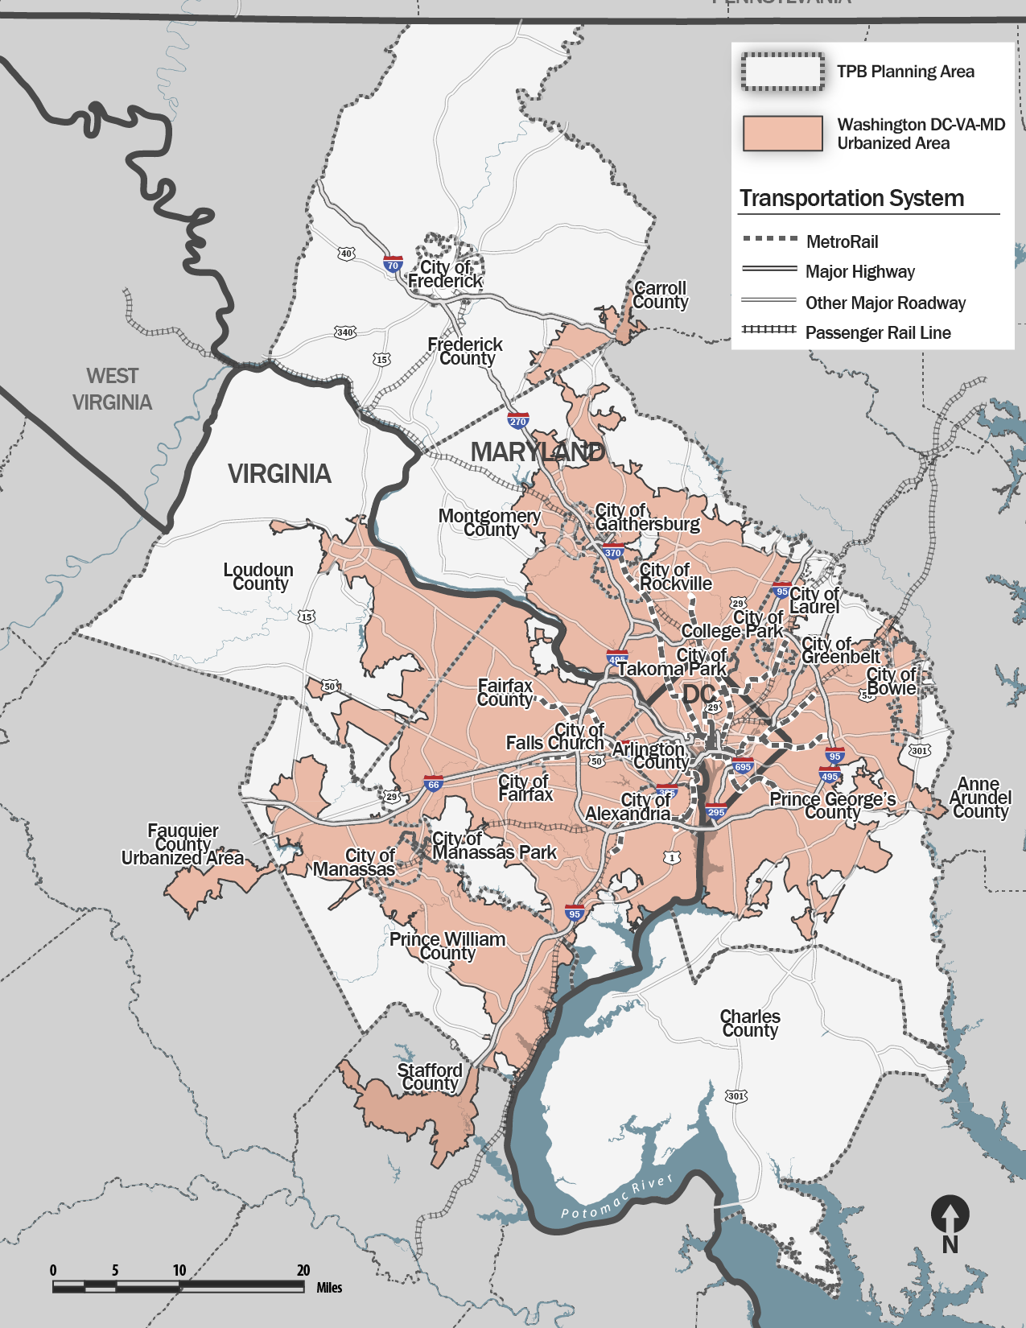
Figure 2: TPB Planning Area and Washington DC-VA-MD Urbanized Area, As Defined by the 2010 Census
Section 2: Plan Development

The Coordinated Human Service Transportation Plan (“Coordinated Plan”) must be updated to guide funding decisions for the Federal Transit Administration’s (FTA’s) Section 5310 Enhanced Mobility of Seniors and Individuals with Disabilities program.

This Coordinated Plan builds upon the 2014 update to the Plan. The TPB’s Access for All (AFA) Advisory Committee is charged with overseeing updates to the Coordinated Plan. The AFA advises the TPB on transportation issues, programs, policies, and services important to traditionally underserved communities, including low-income communities, minority communities, people with limited English proficiency, people with disabilities, and older adults. AFA members include community leaders and other individuals representing the various AFA constituencies, and also human service and transportation or transit agencies and private providers. A list of AFA members is included in Appendix 1.

As stated in the previous section, there are five key elements of the Coordinated Plan: 1) an identification of unmet transportation needs of people with disabilities, older adults and those with low-incomes, 2) an inventory of existing transportation services for these population groups, 3) strategies for improved service and coordination, 4) priority projects for implementation and 5) competitive selection criteria. AFA members guided the development of the key elements of the update the Coordinated Plan and the competitive selection criteria.

The kick-off for the update to the Coordinated Plan in 2018 began on February 8 at the AFA meeting, where participants received a presentation on the Coordinated Plan and the unmet transportation needs identified previously by the AFA. The unmet transportation needs are the building block for Coordinated Plan, as the other key elements are based on these needs. The inventory of existing services (in Appendix 5) was distributed for revisions in February and March. Meeting participants broke out into small groups to discuss the needs by theme. The revised unmet needs were distributed to the AFA for comment and presented at the May 10 AFA meeting. On June 7, the AFA reviewed the strategies to meet the needs and priority projects. The final elements reflected in this Coordinated Plan were presented to the AFA at a July 12 webinar. A draft of the Coordinated Plan was presented to the TPB on (INSERT DATE) and adopted on (INSERT DATE).

Additional Public Input and Comments

In addition to the AFA guiding the update process, a presentation on the update to the Coordination Plan was given at the Annual Public Transit Forum for Private Providers on June 5, 2018, and the
Citizen Advisory Committee (CAC) received a presentation on the draft plan and was asked to comment on July 12, 2018.

This Coordinated Plan was released for a 30-day public comment period from (INSERT DATE) to (INSERT DATE), (DESCRIBE how comment period was advertised and any COMMENTS RECEIVED)

TPB Policy Framework and Guiding Principles

As the metropolitan planning organization and the designated recipient of Enhanced Mobility funds, TPB and COG have the unique opportunity to develop a plan that addresses the unmet needs of people with disabilities, older adults and those with limited incomes to support their independence and mobility. The TPB and COG has adopted several goals or initiatives related to equity and access for all -- including transportation-disadvantaged populations which are provided here as a context for the Coordinated Plan. Also below are the “Guiding Principles” for the Coordinated Plan.

TPB VISION GOALS

The TPB Vision, adopted in 1998, provides a comprehensive set of policy goals, objectives, and strategies to help guide transportation planning and investment decisions in the Washington region. Goal 1 states:

The Metropolitan Washington region's transportation system will provide reasonable access at reasonable cost to everyone in the region.

TPB’s REGIONAL TRANSPORTATION PRIORITIES PLAN

The TPB adopted Regional Transportation Priorities Plan (RTPP) in January 2014. It focuses the region’s attention on a handful of transportation priorities and strategies with the greatest potential to advance regional goals rooted in the TPB Vision. Priority 2 states:

Strengthen Public Confidence and Ensure Fairness: Efforts to increase accountability and address the needs of historically transportation-disadvantaged populations should be considered in all stages of project planning, design, and implementation.

COG’s Region Forward Goals

The Metropolitan Washington Council of Governments developed Region Forward to guide local and regional decision making. Nine broad goal areas are identified, one of which is transportation, and numerous objectives and targets for assessing progress toward achieving each of the goals.

The applicable goals to the Coordinated Plan from Region Forward include the following:

- We seek a broad range of public and private transportation choices for our region which maximizes accessibility and affordability to everyone and minimizes reliance upon single occupancy use of the automobile.
- We seek a transportation system that maximizes community connectivity and walkability, and minimizes ecological harm to the region and world beyond.
- We seek to minimize economic disparities and enhance the prosperity of each jurisdiction and the region as a whole through balanced growth and access to high-quality jobs for everyone.
TPB’s Seven Endorsed Initiatives

The TPB identified seven initiatives in 2017 and 2018 for a better transportation future. The TPB endorsed these seven ideas after working through a year-long process with its Long-Range Plan Task Force. Together these seven ideas will be included in the aspirational or unfunded element of Visualize 2045, the TPB’s long-range transportation plan. The initiatives are listed below; note that the initiatives are not ranked, numbers are used for identification purposes only.

The seventh initiative, increase pedestrian and bicycle access to high-capacity transit, was incorporated into this Coordinated Plan as one of the priority projects in Section 6– slightly augmented to include access to bus stops as well as Metro or BRT stations.

- Optimized Regional Land-use Balance – Increase jobs and housing around underused rail stations and Activity Centers with high-capacity transit. Build additional housing in the region to match employment projections.
- Regionwide Bus Rapid Transit and Transitways – Add bus rapid transit and transitways, and streetcar routes at various locations throughout the region.
- Metrorail Capacity Improvements – Replace six-car trains with eight-car trains on all Metrorail lines. Add a second Rosslyn station, and a new rail line across the Potomac River connecting the District of Columbia and Virginia.
- Employer-Based Travel Demand Management Policies – Develop policies to increase teleworking and the number of employees receiving transit and carpool subsidies. Increase the price for most of the parking for work trips.
- Regional Express Travel Network – Extend network of express toll lanes on existing highways and add new express bus service.
- Completion of the National Capital Trail – Complete a proposed loop of circumferential trail connections circling the core of the Washington region.
- Pedestrian and Bicycle Access to High-Capacity Transit – Improve walking and biking capacity to increase access to regional transit systems, including Metrorail, commuter rail, light rail, and bus rapid transit (BRT).

GUIDING PRINCIPLES

The TPB has established Guiding Principles for its Coordinated Human Service Transportation Plan. These principles build upon each other and are reflected throughout this Coordinated Plan in the strategies and priorities.

The Right to Mobility

People with specialized transportation needs have a right to mobility. Individuals with limited incomes and people with disabilities rely heavily, sometimes exclusively, on public and specialized transportation services to live independent and fulfilling lives. These services are essential for travel to work and medical appointments, to run essential errands, or simply to take advantage of social or cultural opportunities.

The costs of providing human service transportation are indeed rising. However, cost containment should not be achieved at the expense of service delivery. Fortunately, coordination of human service transportation offers the potential to improve service delivery by reducing duplication, making use of available capacity elsewhere in the system, and achieving economies of scale in providing these services.

Customer Service Focus

In providing public transportation, the transportation needs of the customer should always be kept at the forefront. The abilities of individual riders vary in different aspects of the transportation experience, from accessing program information, to trip scheduling, to route navigation. Policies and procedures should be clear and flexible enough to allow for different abilities, and to provide support as needed. The goal of every transportation provider should be to facilitate a safe, courteous and timely trip every time.

Elimination of Service Gaps

While there are many providers serving a numerous and diverse clientele, significant gaps exist in human service transportation, which limits the mobility of the individuals who rely on it. Across the region, users of specialized transportation programs live and work in different areas and have different travel patterns. To the maximum extent feasible, gaps in human service transportation services should be eliminated to ensure individuals have a viable transportation option when they need it.

Maximize Efficiency of Service Delivery

Accessible vehicles are expensive to acquire and maintain. Maximizing the efficiency of human service transportation vehicles helps to reduce program costs by generating additional user revenue while also helping to eliminate gaps in service, without the need for additional capital purchases. Transportation providers should collaborate to provide services where extra capacity exists. The TPB Coordinated Plan will help to identify opportunities for collaboration, as well as providing the space for resolving any issues related to cross-jurisdictional service delivery.
Section 3: Assessment of Needs
Regional Demographic Profile

This profile illustrates how select transportation-disadvantaged population groups are represented throughout the region in order to provide a backdrop for understanding the transportation needs that the Coordinated Plan attempts to address. Appendix D provides more information and maps of these population groups.

Table 1 presents demographic data from the American Community Survey (ACS) 5-year Averages for the years 2012-2016 for transportation-disadvantaged population groups living in the Metropolitan Washington region. Over 453,000 people, or about 8% of residents, live below the poverty line, and 746,062 individuals, 14% of residents, are classified as low income, which is defined as making less than 2.0 times the official poverty rate. Approximately 434,000 individuals – 8% of the population – have a physical, sensory, or cognitive disability, and over 603,000 people in region – 11% of the population – are over 65 years old. Individuals with limited English abilities make up 11% of the region’s population, and the majority of these individuals are members of the Hispanic/Latino community.

Table 1: Transportation-Disadvantaged Populations in the Washington Region

Population Group | Region | Percent of Region ⁽¹⁾
Below the Poverty level ⁽²⁾ | 453,211 | 8.4%
Low-Income or below ⁽³⁾ | 746,062 | 13.8%
Persons with Disabilities ⁽⁴⁾ | 434,562 | 8.0%
Older Adults (65 and over) | 603,497 | 11.1%
Limited English Speakers ⁽⁵⁾ | 563,092 | 11.0%
Total Population | 5,480,782
Source: 2012-2016 U.S. Census American Community Survey; numbers are for the TPB Planning and Urbanized Areas.
(1) Due to each groups’ unique sampling “Percent of Region” will not compute with Total Population.
(2) Official poverty level depends on family size. For a family of four the poverty level is an annual income of $22,000.
(3) “Low-income” is commonly defined as income between 100 to 199 percent of the poverty level. For a family of four an annual income of $44,000 or below is considered low income.
(4) Includes individuals with a physical, sensory, and/or cognitive disability.
(5) Limited English Proficiency includes individuals who speak English less than “very well.”

Source: 2012-2016 U.S. Census American Community Survey. The geographic area is the TPB Planning Area plus small portions of Stafford County, VA, Anne Arundel County, MD, and Carroll County, MD.
Figure 3: Regional Demographic Profile of Transportation-Disadvantaged Populations in the Washington Region

Unmet Transportation Needs

The AFA has developed a list of significant unmet transportation needs of older adults, people with disabilities and those with limited incomes which is the key building block for the entire Coordinated Plan. These unmet needs informed both the development of the strategies and priority projects described in the following sections. The strategies and priority projects are a critical element in the project selection process to ensure that Enhanced Mobility funds are being expended to address significant unmet transportation needs in the region.

AFA members also raised the importance of transportation related to emergency preparedness, and the unique needs of AFA populations in a situation that requires evacuation or in the case of an emergency on a vehicle. The Coordinated Plan addresses the day-to-day transportation needs of older adults and people with disabilities to guide funding decisions for the Enhanced Mobility grant program. The FTA has not stated that emergency preparedness is an eligible activity for Enhanced Mobility funding, However, the need to prepare for evacuation of special-needs or transit-dependent populations in an emergency is mentioned here to raise awareness among transportation providers and human service agencies to stress in driver trainings; as well as raise the issue for state and local emergency management agencies, which are responsible in an evacuation situation.

Table 2: The Four A’s of Significant Unmet Transportation Needs

Availability | - Need for more options for cross-jurisdictional and longer distance travel within the region  - There needs to be more coordination of specialized services among transportation agencies and jurisdictions.  - Lifeline access to critical services for those who cannot drive for urgent and same-day services  - Weekend and evening options are lacking as well as same-day services.  - Improved frequency and geographic coverage of services (e.g. travel outside of the MetroAccess service area)  - Reliability of services for more timely access to jobs, programs, medical appointments.  - East-West Divide concerns: More options to travel to concentration of jobs on the western side of the region.
Awareness | - The need for more centralized information about existing services provided by transportation agencies and jurisdictions.  - The promotion of existing transportation services by both transportation and social service agencies to the targeted populations, which is customized to the audience, including those who have limited-English skills and/or may not have access to the internet or a cell phone.  - Information needs to be available in other ways than only online.  - Coordination of dissemination of information and marketing across programs – tailor outreach to specific groups and places (such as public housing)  - Improve pedestrian access to bus stops (including the removal of barriers that make it difficult for people with disabilities to use pathways (trash cans, newspaper stands, bike, etc.) (need to raise awareness among community and neighborhood associations)  - Bike lanes – bicyclists and pedestrians need to follow the “rules of the road” and be aware of pedestrian needs for people with disabilities  - New approaches for training of transportation managers, agency staff and others who have direct contact with customers to improve communication, interactions and understanding of user’s needs and concerns  - Travel Training for customers on the use of available options, including but not limited to fixed-route services
Accessibility | - Technology used in transportation (apps, internet, Smartphones) is not universally accessible for people – those with physical and cognitive disabilities, older adults, as well as people with who cannot afford a Smartphone  - Availability of internet access to facilitation information on options, fare purchase, trip planning, etc.  - Accessibility services/features not always easy to use (stops, stations, vehicles, taxis, sidewalks, payment systems, apps)  - Websites need to be user-friendly including translation options, screen-reader compatible, adjustable font size, and search options that make information easy to find  - Accessible services and features not reliable nor regularly maintained (e.g. elevators or bus lifts)  - Lack of Wheelchair- accessible services  - Accessibility enhancements for pedestrians for better navigation of physical infrastructure  - Accessibility of private, newer services such as ride-hailing (e.g. Uber and Lyft) bike lanes, bike-sharing, and Microtransit (e.g. Via) and toll lanes  - Considering accessibility at the planning, design and implementation stages of a project, program or service
Affordability | - Transit fares, parking costs and tolls are barriers for many people, not just those with the lowest-incomes in the region  - Public transit can be both time and cost-prohibitive  - There is a need for transportation for people that don’t qualify as low-income but whose income is not high enough to afford services  - More funding for additional transportation services  - Subsidies or funding for personal care attendants for people who need them to use transportation services

Section 4: Summary of Existing Services

Many general purpose and specialized transportation services are for persons with disabilities and older adults are provided throughout the region and are summarized here. The existing services are listed by jurisdiction in Appendix 5. Services include all-purpose specialized transportation services, Medicaid transportation, limited scope specialized services and fixed-route transit services. The updated inventory of services is provided by Reach-a-Ride, the online transportation information clearinghouse created by COG and WMATA, which can be found at www.reacharide.org.

Figure 4 depicts the general purpose specialized transportation services in the region. General purpose paratransit is transportation provided for any ADA-eligible person for any trip purpose – medical, shopping or otherwise. The most prevalent of these is WMATA’s MetroAccess, its shared-ride, door-to-door service. Montgomery County operates Same-Day Access Program, and in Prince George’s County, residents can choose from among the county-wide Call-a-Bus and Call-a-Cab programs and similar services at the local level. Arlington County provides Specialized Transit for Arlington Residents (STAR) and Alexandria’s program is called DOT Paratransit. Fairfax County offers a human service coordinated service for program participants, formerly known as Fastran. taxi subsidies to ADA-eligible individuals. The District of Columbia and Prince William County have no general-purpose paratransit service. D.C. does have a same-day taxi service, TransportDC, which is for DC residents eligible for MetroAccess.

Complementing the general purpose specialized transportation services is a network of private and nonprofit providers that provide additional transportation options. These providers include taxi companies, human service agencies, nonprofit organizations and educational and healthcare institutions.

Figure 4: Specialized Transportation Services

Complementing the general-purpose paratransit services are other services more limited in scope or purpose. Of these, the biggest one in terms of budget is Medicaid transportation, which is provided in all three states to all Medicaid eligible individuals for medical trips.

Fixed-route systems throughout the region offer additional options for accessible transportation. These include: WMATA’s Metrobus and Metrorail; Arlington ART; Fairfax County Connector; DC’s Circulator; Alexandria DASH; Prince George’s County The Bus; Montgomery County RideOn; TransIT in Frederick County; City of Fairfax CUE; Omni Link and Omni Ride service in Prince William County; Virginia Regional Transit and Loudoun County Transit in Loudoun County; and GEORGE in Falls Church.
Section 5: Strategies for Improved Service and Coordination

Background
Many agencies involved in providing transportation services will agree that there are tangible benefits to be realized through coordination of services. However, barriers both real and perceived exist that constrain the ability of providers and other agencies to coordinate services and realize benefits both for themselves and their clients.

Common barriers to coordination include lack of resources, different training requirements or vehicle specifications, and funding requirements. Some, like the sharing of information across jurisdictions, are more easily addressed through the structure of regular meetings among agencies and providers.
Other barriers present greater challenges. Issues like insurance and liability are more complex challenges that require ongoing efforts and dialogue with numerous agencies, providers, nonprofits and insurers. Another significant barrier to coordination is the multitude of government programs and funding requirements. Over the past 30 years, federal, state and local governments have implemented various programs aimed at improving coordination of publicly funded transportation services for transportation disadvantaged populations, including people with disabilities, Medicaid recipients, and other human service agency clients. Unfortunately, barriers to coordination still exist, and many stem from the administrative and eligibility requirements imposed by government rules and regulations.

In fact, areas that have had the most success in coordination occur when coordination is mandated by state or local agencies and provided institutional support to make the coordination happen. Given that this region includes two states and the District of Columbia, and multiple counties and cities, each with its own set of transportation programs and accompanying rules, coordination is challenging.

Opportunities for Coordination and Mobility Management

The AFA can play a role in facilitating discussions about coordination opportunities; however, local jurisdictions should explore opportunities for collaboration.

The region experienced successful coordination under Enhanced Mobility by funding and successfully guiding implementation of mobility management projects such as the Northern Virginia Mobility Access Project (NVMAP) and Montgomery County Maryland’s Department of Health and Human Services’ Enhancing Montgomery’s Mobility project.

Both the NVMAP and Enhancing Montgomery’s Mobility projects coordinated with various governmental departments with an interest or need for transportation and involved local non-profit providers of transportation to help identify and close gaps in service. Collaborative outreach efforts were used by both projects to get the word out about available options. Next steps for the NVMAP project include coordinating with a non-profit organization serving Vietnamese older adults to develop a language-specific transportation guide and with a transportation management organization to help recruit and train bilingual drivers and volunteers and to provide travel training in Spanish. In 2009 the Prince William County Area Agency on Aging worked with non-project agencies and transportation providers and developed county-wide mobility management plan that identified gaps in services that could be filled strategically.

These types of collaborative projects can be time and labor intensive but can offer important transportation information and services to individuals needing them.
Strategies for Improved Service and Coordination

FTA rules require that all projects funded under the Enhanced Mobility program must either address a strategy or a priority project in the Coordinated Plan. The strategies below were broadly defined to address the unmet transportation needs that the AFA previously identified under four themes: availability, accessibility, awareness and affordability. Proposals submitted for funding must be responsive to at least one of the following four strategies. Some projects may have a greater overall impact on unmet needs, and accordingly are a greater priority for funding.

The strategies have been developed to reflect the unique transportation needs facing both older adults and people with disabilities --with limited incomes and who are most-likely transit-dependent-- to reflect the importance of changes in demographics and in travel patterns; and to reflect the ongoing need for additional transportation options.

- Expand availability and coordination of transportation options

- Coordinate transportation services and programs within and across jurisdictions:
  - Make cross-jurisdictional transportation easier to access
  - Coordinate transportation operations among providers such as vehicle-sharing, joint fuel purchase, shared maintenance etc.
  - Involve private providers in service delivery
  - Involve potential stakeholders during the planning phase
  - Use mobility managers to promote coordination and help individuals plan the whole trip (determining available options, researching eligibility, and applying and scheduling if needed)
  - Use Enhanced Mobility grants to jump start the planning process needed to make coordination happen
- Make services more frequent and reliable including those that address the East-West divide (promotion and addition of services that connect the eastern side of the region to the western side)
- Add more reliable and timely transportation options for those who cannot drive which address gaps when Metro is not running, particularly for:
  - urgent and same day service
  - weekend and evening service
- Improve the timeliness of specialized services so that wait times and time on the vehicle is reasonable

II. Increase awareness of existing transportation services

- Provide better and centralized information about existing specialized transportation options, (e.g. one-call, one-click services). Target and customize marketing of services to particular groups, including neighbors and caregivers, and offer the information in a variety of formats, including in languages other than English.
- Transportation providers should support customer-empowered communication with clear and concise information using plain language about services, and customer rights and responsibilities
- Customer satisfaction surveys should be used by transportation agencies and providers to find out how effective their communication is and how satisfied customers are with their transportation services
- Create and revise websites to be user-friendly with easy navigation and provide access to a variety of users, including those with vision impairments and meet the highest standards for ADA website compliance
- Provide information on specialized transportation services in formats other than via websites (e.g. brochures and flyers)
- Provide safety education for users and drivers on pedestrians, bicycles, and other non-motorized modes of travel such as electric scooters
- Train front-line staff to improve communication, interactions and understanding of user needs and concerns

III. Improve accessibility of transportation options

- Create and maintain safe and accessible pathways to and from bus and rail stations
- Provide first mile/last mile connections to bus and rail stations (e.g. shuttle, taxi and ride-hailing services)
- Make ride-hailing services, taxis and Microtransit accessible to people who use mobility devices and for those without smart phones
- Improve the accessibility and ease of use of payment-systems
- Provide training on transportation-related websites and technology (apps, payment systems).
- Consider accessibility in the planning and design phase of projects and involve people with disabilities and older adults

IV. Make transportation options more affordable and sustainable

- Offer affordable options for all income levels, i.e. people who don’t qualify as low-income yet cannot afford some services. Transit fares, parking costs and tolls can be barriers.
- Subsidize rides for those who cannot afford the cost (user-side subsidies for transit, taxis, and ride-hailing services)
- Identify new revenue streams to sustain and increase specialized transportation options needed
- Make programs and services sustainable after grant funding ends
- Identify cost-efficient ways to provide specialized services (e.g. alternatives to MetroAccess)
- Prioritize projects that assist people with disabilities and older adults with limited-incomes
- Build on or duplicate efficient and effective existing transportation options rather than creating entirely new services
- Evaluate new transportation services or pilots to identify lessons learned and build upon successes
Section 6: Priority Projects
The purpose of the priority projects is to signal to potential applicants the kinds of projects that are most needed in the region. Agencies may also apply for other project types not listed as priority projects. As outlined in the TPB’s Selection Criteria for Enhanced Mobility, proposals addressing Priority Projects can score up to twelve additional points out of a maximum of one-hundred.

A. Mobility Management

Mobility Management at the Systems Level means a full or part-time staff position within a County or city government, such as a County’s transportation or human service agency, that serves in several capacities - policy coordinator, broker to help identify the best services for individual trip needs, and researcher of gaps in service. A Mobility Manager helps coordinate services in the jurisdiction and across jurisdictional lines and adapts the service to local need, serves as an information resource, for example, sharing information with agencies about project best practices, and connects agencies with travel trainers.

Mobility Management at the Individual Level is one-to-one assistance to customers in identifying their mobility needs and preferences, understanding the available options in their community that fit, and providing assistance with applications for programs or planning and reserving a trip from start to finish, as requested.

Good Examples:
- Jewish Council for the Aging’s Connect-a-Ride (funded by Montgomery County DPWT).
- Montgomery County Maryland Department of Health & Human Services.
- Fairfax County Neighborhood & Community Services’ Northern Virginia Mobility Access Program (NVMAP).
- Resource: The National Center for Mobility Management (NCMM) has toolkits and position descriptions for mobility managers, among other resources.

B. Coordinated Planning Efforts

This priority project emphasizes the importance of coordination at the local level by providing grant funds to jump start coordination efforts by funding the planning process. Grant funds could be utilized to make the planning process more inclusive, encourage non-traditional but interested parties to take a seat at the table, develop a local coordinated plan to share vehicles or develop a mobility management plan for a County or region.

Good Examples:
- Prince William County, Virginia’s “Transportation Options Group”, a coalition of private non-profit and public human service agencies, transportation providers, and government officials who developed and implemented a Mobility Management Plan.
- Resource: Administration for Community Living (ACL) Strengthening Inclusive Coordinated Transportation Partnerships to Promote Community Living projects.

C. Travel Training

Travel Training teaches people with disabilities or older adults how to access and use transportation services, including fixed-route services. There are different types of travel training services, some include general orientation and others are tailored to the needs of the individual. Training can be provided in groups, one-on-one and peer-to-peer. Travel training should instruct individuals on trip planning, payment systems and the use of mobile applications (“apps”), or alternatives to apps for people without access to Smartphones. Orientation and Mobility (O &M) training is specific to people with visual impairments and teaches safe and effective travel skills. O&M training is needed throughout the region, so people can receive training closer to where they live, especially in Northern Virginia. Many people can benefit from travel training, including older adults, people with physical, intellectual and sensory disabilities, people unable to afford their own vehicle and people with limited English proficiency.

Good Examples:
- Washington Metropolitan Area Transit Authority (WMATA)’s MetroReady Travel Training and System Orientation.
- The Arc of Northern Virginia’s Train the Travel Trainer program.
- Columbia Lighthouse for the Blind’s Orientation & Mobility Training.
- Resource: The Association of Travel Instruction (ATI) has a published definition of Travel Training and other resources.

D. Door-through-Door or Escorted Transportation Service

Escorted transportation services, also known as door-through-door or assisted transportation, provides a means of extra safety and assistance to a rider who needs support to travel. The level of assistance a program provides varies but does not include heavy assistance such as lifting or handling medical needs or equipment. Examples might include preparing a rider for a trip by helping with a coat or gathering documents, accompanying someone into a medical building and staying with them throughout their appointment or helping an individual get into and out of a vehicle.

Good Examples:
- Arlington and Alexandria Area Agencies on Aging.
- DC Office on Aging’s CREST program.

E. Increase Access to Transit Stations (and First Mile/Last Mile Connections)

Increasing walk, and bike access to transit stations is one of the seven transportation initiatives endorsed by the TPB. This priority project category includes this initiative as important way to make first mile/last mile connections from bus and rail stations and adds motorized options as well. Improvements near transit stations that provide connections to hospitals, libraries, government buildings and voting sites have the greatest priority. Three types of projects are included here:

Improving pedestrian infrastructure around transit stations to eliminate barriers to the use of public transit; including making bus stops more accessible. Bus stops need proper boarding and alighting surfaces, spaces for a wheelchair under a shelter, accessible signage, proper snow removal and removal of newspaper boxes or other items that block pathways.

Promote adaptive cycling for people with disabilities by increasing the number of accessible bikes in bikeshare programs (e.g. hand bikes, side-by-side bikes, electric bikes and tricycles; and ensuring that these bikes are reserved for people with disabilities).

Offering taxi, ride-hailing and shuttle services to transit stations. If walking or biking is not an option to make a first mile/last mile connection to a Metrorail station due to disability, weather, or time of day-- taxis, ride-railing and shuttle services can provide an important link to increase access to public transit.

Good Examples:
- Montgomery County’s Bus Stop Accessibility efforts
- Bike share programs with adaptive bikes: College Park, MD; Portland and Corvallis, OR; Carmel, IN

F. Increase Wheelchair-Accessible Options in Taxi and Ride-Hailing Services

People who use wheelchairs or mobility devices need vehicles with ramps or lifts in order to use taxis, ride-hailing services or Microtransit. Wait times can be longer for people who use mobility devices, and, in some cases, there is no wheelchair-accessible service available at all. A priority is to make sure wheelchair-accessible taxis, ride-hailing and microtransit services accommodate customers who use mobility devices within reasonable wait times. This project type can involve accessible vehicle acquisition, driver training and operating subsidies. Also, wheelchair-accessible services delivered by private providers (such as taxis) can offer cost-effective ways to provide specialized transportation.

The use of wheelchair-accessible taxis for people to get to dialysis, for example, could help curb the cost to public agencies and improve the customer’s transportation experience. MetroAccess is a shared-ride, pre-arranged service and the length of time a dialysis patient, who may not be feeling well, is in a vehicle could also be reduced using taxis. Ride-hailing companies can partner with health care providers to offer patients rides to medical appointments given transportation challenges can be a common reason why people miss appointments.

Good Examples:
- TransportDC
- Abilities-Ride in Suburban MD
- MontCo Union Taxi Cooperative
- Uber Health

G. Volunteer Driver Programs

Trained volunteers drive agency-owned or private vehicles to transport seniors and people with disabilities to wherever they need to go. Volunteer driver programs fill an important niche in outer and rural areas where transportation options are more limited and as a more affordable option for riders requiring an extra hand with groceries or navigation of a medical office building.

Good Examples:
- Jewish Council for the Aging’s Village Rides and Volunteer Driver Resource Center programs.
- Capitol Hill Village
- NV Rides

H. Tailored Transportation Service for Clients of Human Service Agencies (e.g. Vehicle Acquisition)

This project would assist people with disabilities who utilize agency services, but for whom public transit is not a viable option for them, either because of the unavailability of transit or due to the nature of their disability. One option is that agencies provide transportation to their clients by contracting with a provider, or with directly owned or leased vans. Human service agencies could also coordinate and potentially share vehicles, maintenance, insurance, operating support, and driver training between agencies to provide agency-specific transportation for clients.

Good Examples:
- The Arc of Montgomery County, The Arc of Prince George’s County, and the Arc of Greater Prince William/INSIGHT, Inc.
- Seabury Resources for Aging

Funding Types and Match Amounts

There are a variety of project types and eligible activities for which Enhanced Mobility funds can be used, and the types of funding and match requirements create the possibility for confusion. Table 3 includes common eligible activities under the Section 5310 program and the type of funding that each activity would be funded as. The activities in the table are not intended to be an exhaustive list, only to provide guidance.

Table 3: Eligible Activities, Funding Types and Possible Sources of Match

Project | Category and Match
 | Capital  (80% Federal Match) | Operating  (20% Federal Match) | Mobility management  (80% Federal Match)
Travel training for people with disabilities or older adults to learn how to use public transit |  |  | X
Mobility management planning to coordinate local resources and identify unmet needs
Buying vehicles to provide new or additional service | X
Maintaining new or existing vehicles procured with 5310 or Enhanced Mobility funding | X
Buying software, hardware or other equipment to improve ride our route matching, |  |  | X
Personal mobility counseling for clients |  |  | X
Door through door service to help clients travel to and from trips |  | X
Sensitivity training for bus and taxi providers or managers to educate them on issues facing people with disabilities |  | X
Costs of taxi, ride-hailing or shuttle, service to bus stops and rail stations |  | X
Bus stop and/or sidewalk improvements, especially around transit stations | X
Promotion of adaptive cycling, including procurement of adaptive bicycles |  | X
Procurement of wheelchair-accessible vehicles for or subsidizing of taxi or ride-hailing service |  | X
Volunteer driver programs |  | X

Section 7: Framework for Competitive Selection

The competitive selection process includes a selection committee, chaired by the Access for All Advisory Committee chair or another TPB representative. Selection committee members have expertise locally or nationally with transportation for older adults and people with disabilities. Members will review the applications based on the selection criteria and will make a set of funding recommendations to the TPB. The TPB will be asked to approve the recommendations based on the selection committee’s deliberations.

The selection criteria have been reevaluated based on the TPB’s experience in awarding and administering grants for the Enhanced Mobility program as well as the previous experience with grants administration for JARC and New Freedom. Changes to the selection criteria emphasize the importance of project feasibility and an agency’s institutional capacity to manage an FTA grant. In addition, since the TPB adopted Equity Emphasis Areas in the region in 2017, which are Census tracts with concentrations of low-income and/or minority populations, the selection criteria now include an emphasis on serving these traditionally-underserved communities. The following selection criteria include a maximum of 100 total points:

- Coordination Among Agencies (25 points)
Coordination of services with other organizations can include providing service to clients of multiple agencies, coordinated purchasing, joint project planning and operation.

- Responsiveness to TPB’s Coordinated Human Service Transportation Plan (20 points)
Up to 12 points will be awarded based on how many Priority Projects in the Coordinated Plan that the project application addresses, and up to 8 points on how well the application responds to the strategies.

- Institutional Capacity to Manage and Administer an FTA grant (20 points)
This criterion considers the availability of sufficient management, staff and resources to implement an FTA grant, stable and sufficient sources of funds to provide required match and if applicable, past grant performance.

- Project Feasibility (15 points)
Proposed activities are consistent with the objectives of funding, application clearly spells out how a project will be implemented, with defined roles and responsibilities, and include an action plan with milestones that is achievable within the 2-year timeframe.

- Regional Need and Equity Emphasis Areas (10 points)
Up to 5 points will be awarded for applications that propose to serve more than one jurisdiction, and up to 5 points will be awarded for projects proposing to serve Equity Emphasis Areas in the Washington DC-VA-MD Urbanized Area shown in Figure 5 below.

- Customer Focus and Involvement (10 points)
To what extent does the applicant demonstrate an awareness of the needs of a targeted population group and how will customers be involved in the development and implementation of the proposed activity.
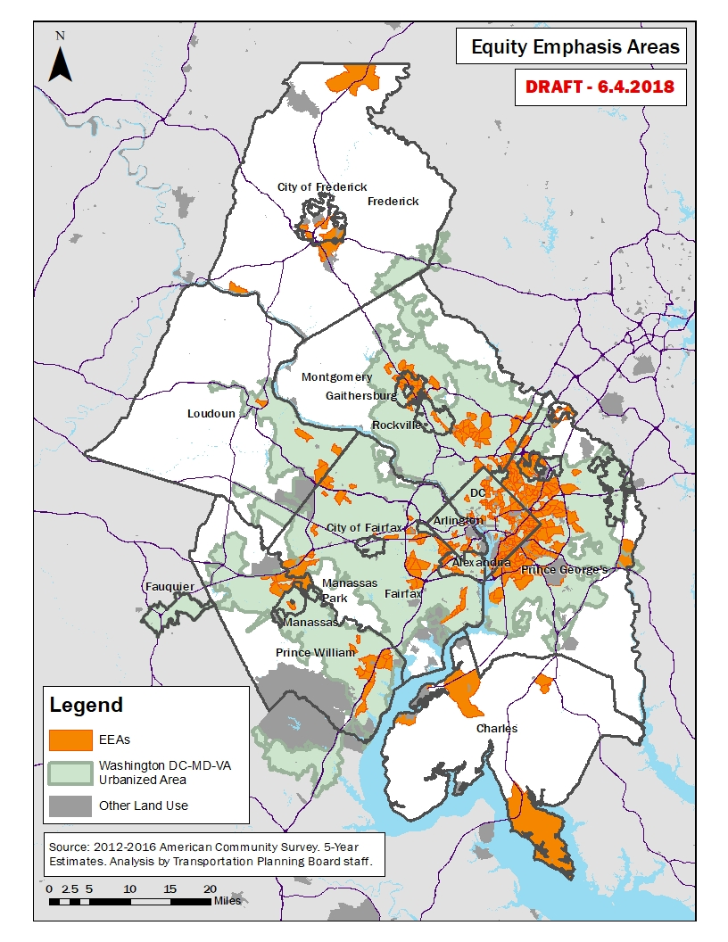
Figure 5: Equity Emphasis Areas and the Washington DC-MD-VA Urbanized Area

Geographic Eligibility: The Washington DC-VA-MD Urbanized Area

To be eligible for the 5310 Enhanced Mobility program funds administrated by COG/TPB, federal rules require that a project or service must benefit populations residing in the Washington DC-VA-MD Urbanized Area as defined by the 2010 Census, shown in Figure 2. The TPB planning area, also shown in Figure 2, encompasses most of the Washington DC-MD-VA Urbanized Area, but not all of it, and there are areas within the TPB planning area that are not in the Washington DC-MD-VA Urbanized Area.

An interactive web-based map was created to assist potential applicants in determining if their proposed project is in the Washington DC-VA-MD Urbanized Area; this interactive online map shows both the boundary for the DC-VA-MD Urbanized Area and zip codes in the region. Interested applicants can pan and zoom throughout the region to ensure their proposed project falls within the required area. The map can be found at http://www1.mwcog.org/tpbcoordination/resources/geography.asp.

For project proposals that serve populations living outside the Washington DC-VA-MD Urbanized Area, agencies can apply for the 5310 Enhanced Mobility Funds apportioned to Maryland Transit Administration (MTA) and Virginia Department of Rail and Public Transportation (DRPT) for Small Urbanized and Rural Areas.
Figure 6: Flow of Funds for the Enhanced Mobility Program

Appendix A: Members of the TPB ACCESS For ALL Advisory Committee

First | Last | Organization | City | St
Tomi | Adeleke | Virginia Department of Transportation | Richmond | VA
Christiaan | Blake | WMATA | Washington | DC
Harriet | Block | Jewish Council for the Aging | Rockville | MD
Shawn | Brennan | Montgomery County DHHS / Aging & Disability | Rockville | MD
Rosa | Carillo | Multicultural Community Service | Washington | DC
Daria | Cervantes | The Arc of Montgomery County | Rockville | MD
Raka | Choudhury | District Department of Transportation | Washington | DC
Janet | Cornick | MDOT Office of Civil Rights | Washington | DC
Charlie | Crawford | Represents people with disabilities | Rockville | MD
Thomas | Curtis | Maryland Department of Disabilities | Baltimore | MD
Sandra | Dent | Southern Maryland Center for Independent Living, Inc. | Mechanicsville | MD
David | Do | Mayor’s Office on Asian and Pacific Islander Affairs | Washington | DC
Paul | Donahue | Every Citizen Has Opportunities (ECHO) | Leesburg | VA
Naaji | Drayton | Seabury Resources for Aging | Washington | DC
Rikki | Epstein | The Arc of Northern Virginia | Falls Church | VA
Richard | Ezike | Union of Concerned Scientists | Washington | DC
William | Farrell | Shepard’s Center of Oakton-Vienna | Vienna | VA
Deborah | Fisher | CHI Centers, Inc. | Hillandale | MD
Nicole | Goines | Federal City Council | Washington | DC
John | Hartline | Tri-County Council for Maryland | Hughesville | MD
Lessie | Henderson | Prince George’s Advocates for Community-Based Transit | Hyattsville | MD
Roger | Hoskins | Represents older adults |  | VA
Sandra | Jackson | Federal Highway Administration | Washington | DC
Jennifer | Kanarek | NV Rides | Fairfax | VA
Kacy | Kostiuk | Chair and TPB Member | Takoma Park | MD
James | Lewis | City of Alexandria Traffic & Parking Board and Transportation Commission | Alexandria | VA
Robert | Malone | The Arc of Prince George’s County | Largo | MD
Leslie | Martin | Virginia Department of Transportation – Northern District | Fairfax | VA
Nechama | Masliansky | So Others May Eat (S.O.M.E.) | Washington | DC
Alexa | Mavroidis | Arlington Transit Advisory Committee Accessibility Subcommittee | Arlington | VA
Susie | McFadden-Resper | DC Office of Disability Rights | Washington | DC
Melissa | McGill | Federal Transit Administration. Region 3 DC Metro Office | Washington | DC
Angela | Miller | Direct Action (for People with Disabilities) | Washington | DC
Glenn | Millis | WMATA - Office of ADA Policy & Planning | Washington | DC
Aleksandra | Miskovic | Essex House Apartment Tenants Association | Takoma Park | MD
Jeanna | Muhoro | Fairfax County Department of Neighborhood/Community Services | Fairfax | VA
Sam | Oji | Montgomery County DOT | Rockville | MD
Dennis | Paddeu | Healthy Generations Area Agency on Aging | Fredericksburg | VA
Era | Pandya | Montgomery County Public Schools (works with children in low-income families) | Montgomery County | MD
Karen | Randolph | District Department of Transportation | Washington | DC
Mark | Rawlings | District Department of Transportation | Washington | DC
Doris | Ray | ENDependence Center of Northern Virginia | Arlington | VA
Brenda | Richardson | Woman Like Us | Washington | DC
Lorena | Rios | Hispanic Chamber of Commerce of Northern Virginia | Reston | VA
Kate | Robb | American Public Health Association | Washington | DC
Jeffrey | Schaeffer | Liberty Transportation Corporation | Washington | DC
Neil | Sherman | Virginia Dept. of Rail & Public Transportation (DRPT) | Richmond | VA
Shiva | Shrestha | Maryland State Highway Administration | Baltimore | MD
Karen | Smith | The Arc of Greater Prince William | Woodbridge | VA
Kari | Snyder | Maryland Department of Transportation | Hanover | MD
Roy | Spooner | Yellow Cab Company of DC. Inc. | Washington | DC
Rev. Gloria | Swieringa | Prince George's County Commission for Individuals with Disabilities | Ft. Washington | MD
Kevin | Thornton | Prince George's County DPWT – The Bus | Upper Marlboro | MD
Ron | Vaughn | New Horizons Supported Services, Inc. | Upper Marlboro | MD
Robert | Werth | Diamond Transportation Services, Inc. | Springfield | VA
Andrew | Wexler | Arlington County Department of Environmental Services | Arlington | VA
Norman | Whitaker | Virginia Department of Transportation – Northern Virginia District | Fairfax | VA
Angela | White | Greater DC-Maryland National MS Society | Washington | DC
Monica | White | Maryland Transit Administration | Baltimore | MD

Appendix B: competitive selection criteria

Criterion | Possible Points
Coordination Among Agencies  Coordination of services with other organizations can include providing service to clients of multiple agencies, coordinated purchasing, joint project planning and operation. | 25
Responsiveness to TPB’s Coordinated Human Service Transportation Plan  Up to 12 points will be awarded based on how many Priority Projects in the Coordinated Plan that the project application addresses, and up to 8 points on how well the application responds to the strategies. | 20
Institutional Capacity to Manage & Administer an FTA grant  This criterion considers the availability of sufficient management, staff and resources to implement an FTA grant, stable and sufficient sources of funds to provide required match and if applicable, past grant performance. | 20
Project Feasibility  Proposed activities are consistent with the objectives of funding, application clearly spells out how a project will be implemented, with defined roles and responsibilities, and include an action plan with milestones that is achievable within the 2-year timeframe. | 15
Regional Need and Equity Emphasis Areas  Up to 5 points will be awarded for applications that propose to serve more than one jurisdiction, and up to 5 points will be awarded for projects that propose to serve Equity Emphasis Areas in the Washington DC-VA-MD Urbanized Area | 10
Customer Focus  To what extent does the applicant demonstrate an awareness of the needs of a targeted population group and how will customers be involved in the development and implementation of the proposed activity. | 10
Maximum Total Points | 100

Appendix C: Inventory of Specialized Services

(In the accessible version of the draft Coordinated Plan document, the inventory can be found in a separate Excel file )

Appendix D: Regional Demographic Profile of Transportation-Disadvantaged Groups

This Appendix provides 2016 data from the 2012-2016 American Community Survey (ACS) on the numbers and spatial locations for transportation-disadvantaged population groups the Coordinated Plan helps serve.

Transportation-disadvantaged groups are defined as populations lacking financial, physical, or language ability to provide their own transportation and/or have difficulty accessing public transportation.

Based on Census data, the population groups in this Appendix are defined as:

Below the Poverty Level

Individuals whose income is below the official poverty line depending on family size.^{i}

1 person = $12,486 per year

4 people = $24,339 per year
- Low-Income Population

Individuals whose income is between 100 to 150 percent of the poverty level. For a family of four an annual income of $36,509 or below is considered low income.

1 person = $18,729 per year

4 people = $36,509 per year

Limited English Speakers include individuals who identify as speaking English less than “very well.”^{ii}

Persons with Disabilities include individuals with any type of physical, sensory, and/or cognitive disability. For individuals under 5, hearing and vision difficulty is used to determine disability. Individuals between 5 and 14 also include cognitive, ambulatory, and self-care difficulties. Individuals 15 years of age and older includes the five categories and independent living difficulty.^{iii}
- Older Adults are individuals 65 years of age and over.
Geographic area includes the Transportation Planning Board (TPB) planning area and the Washington, DC Urbanized Area (see Figure D-1). In instances where the Urbanized Area falls outside the TPB planning area only tracts associated with the Urbanized Area were included. As a result, the geographic area includes portions of Fauquier County, VA, Stafford County, VA, Anne Arundel County, MD, and Carroll County, MD.

Figure D-1: TPB Planning and Urbanized Area

More than 8 percent of residents lived below the poverty level in 2016 and an additional 13.8 percent were classified as low-income (see Table D-1 and Figure D-2). In the same year, 8 percent of persons had a disability and over 11 percent of people were 65 years of age and over. Individuals with Limited English Proficiency make up 11 percent of the population.
Figures D-3 to D-6 show the spatial locations of transportation-disadvantaged population groups in the region.
Table D-1: Transportation-Disadvantaged Populations in the Washington Region, 2016
Population Group | Region | Percent of Region ⁽¹⁾
Below the Poverty level | 453,211 | 8.4%
Low-Income or below | 746,062 | 13.8%
Persons with Disabilities | 434,562 | 8.0%
Older Adults (65 and over) | 603,497 | 11.1%
Limited English Speakers | 563,092 | 11.0%
Total Population | 5,480,782
Source: 2012-2016 U.S. Census American Community Survey; numbers are for the TPB Planning and Urbanized Areas (see definition on page 2). ⁽¹⁾ Due to each groups’ unique sampling “Percent of Region” will not compute with Total Population.

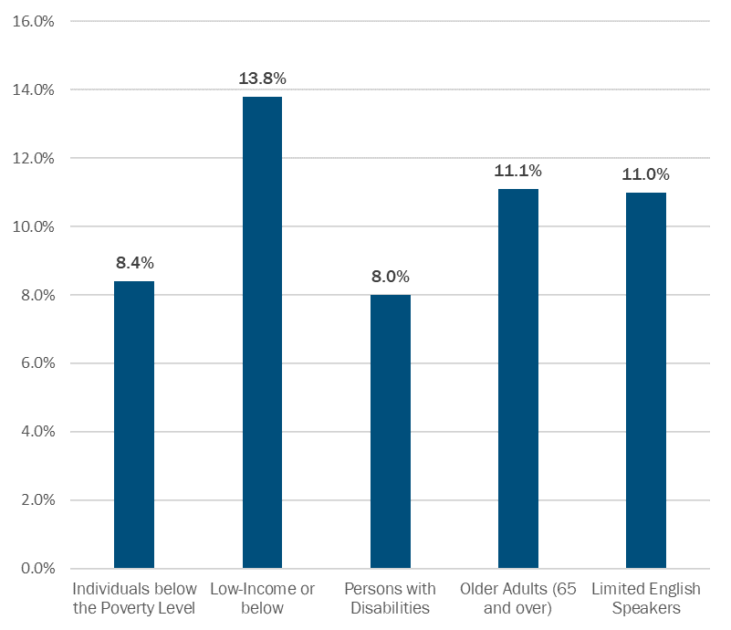
Figure D-2: Regional Demographic Profile of Transportation-Disadvantaged Populations in the Washington Region

Source: 2012-2016 U.S. Census American Community Survey; numbers are for the TPB and Urbanized Area (which includes small portions of Stafford County, VA, Anne Arundel County, MD, and Carroll County, MD).

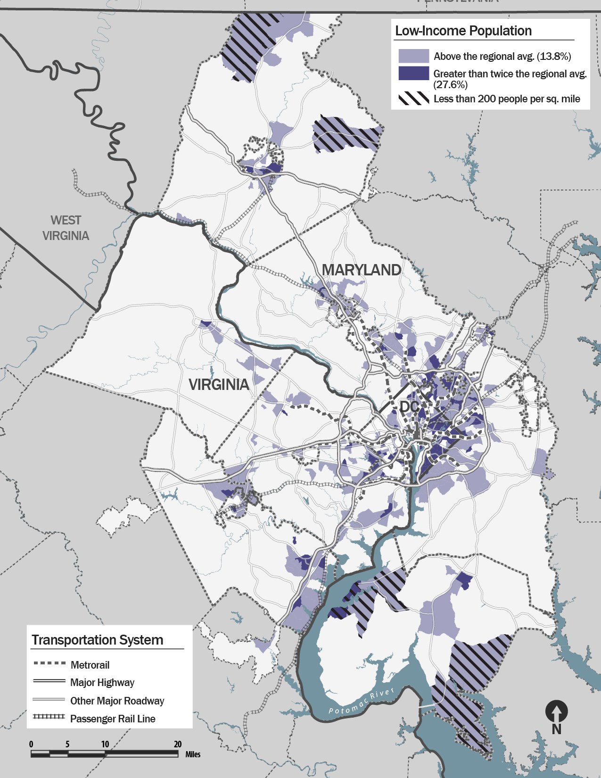
Figure D-3: Low-Income Population, 2016

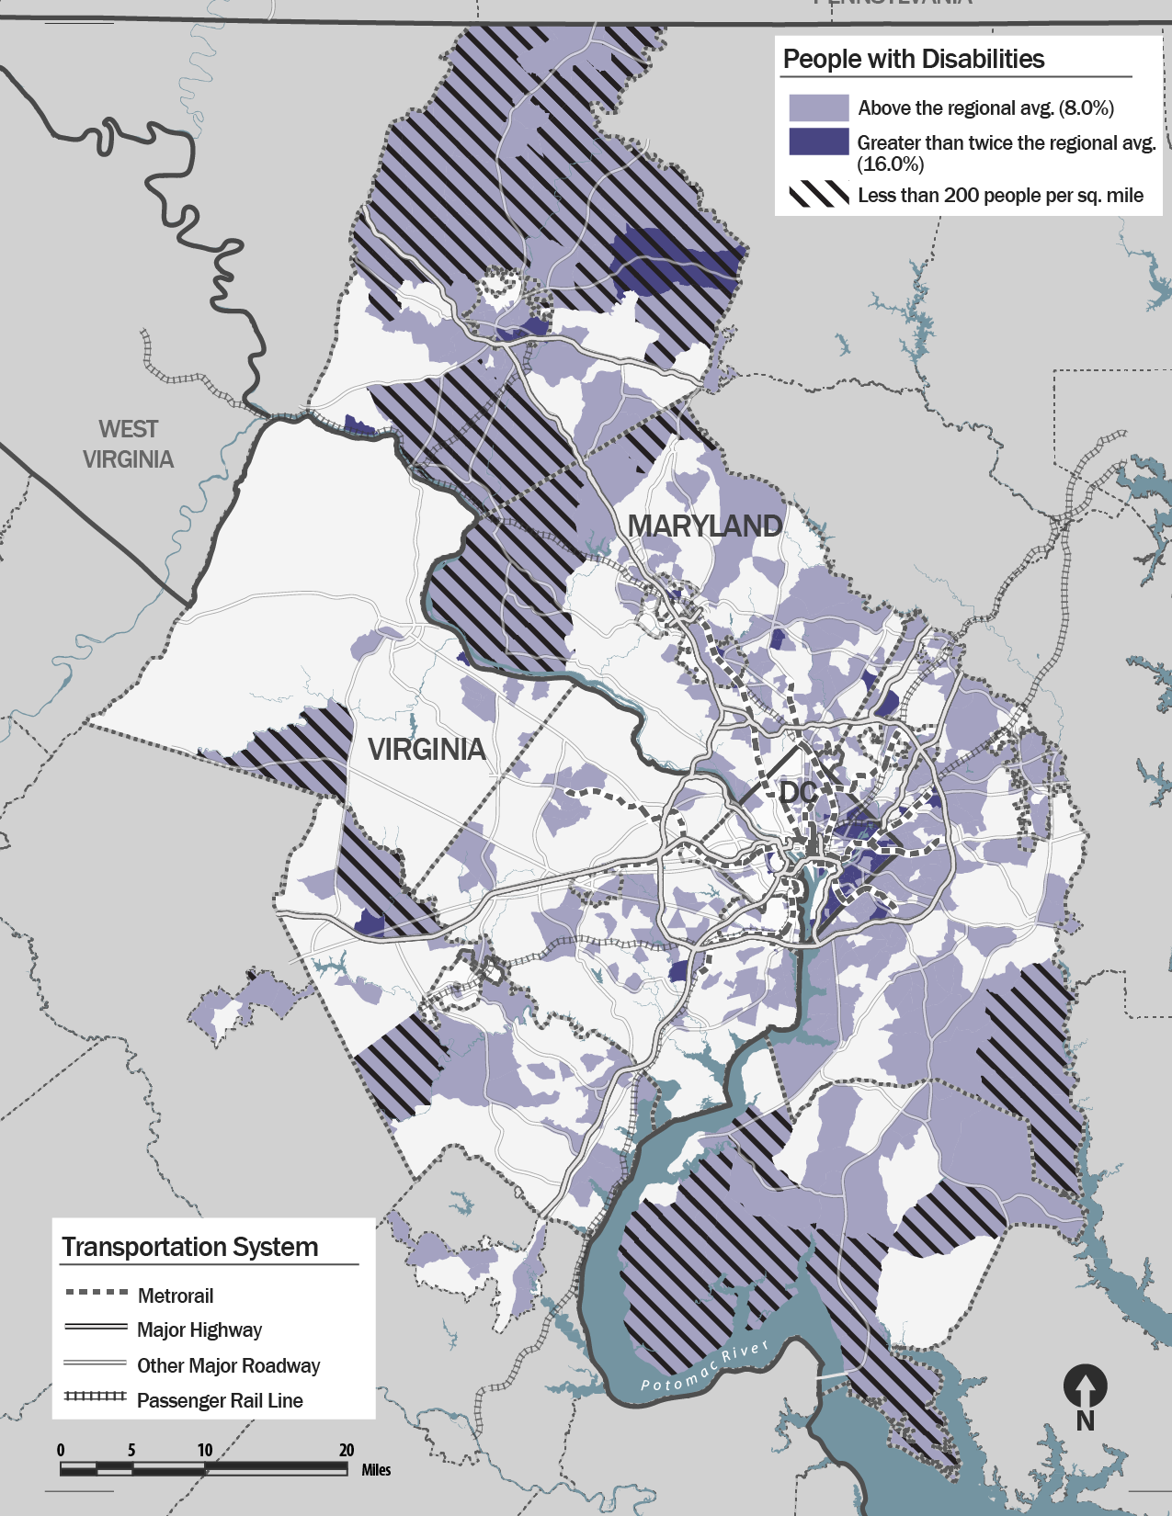
Figure D-4: People with Disabilities, 2016
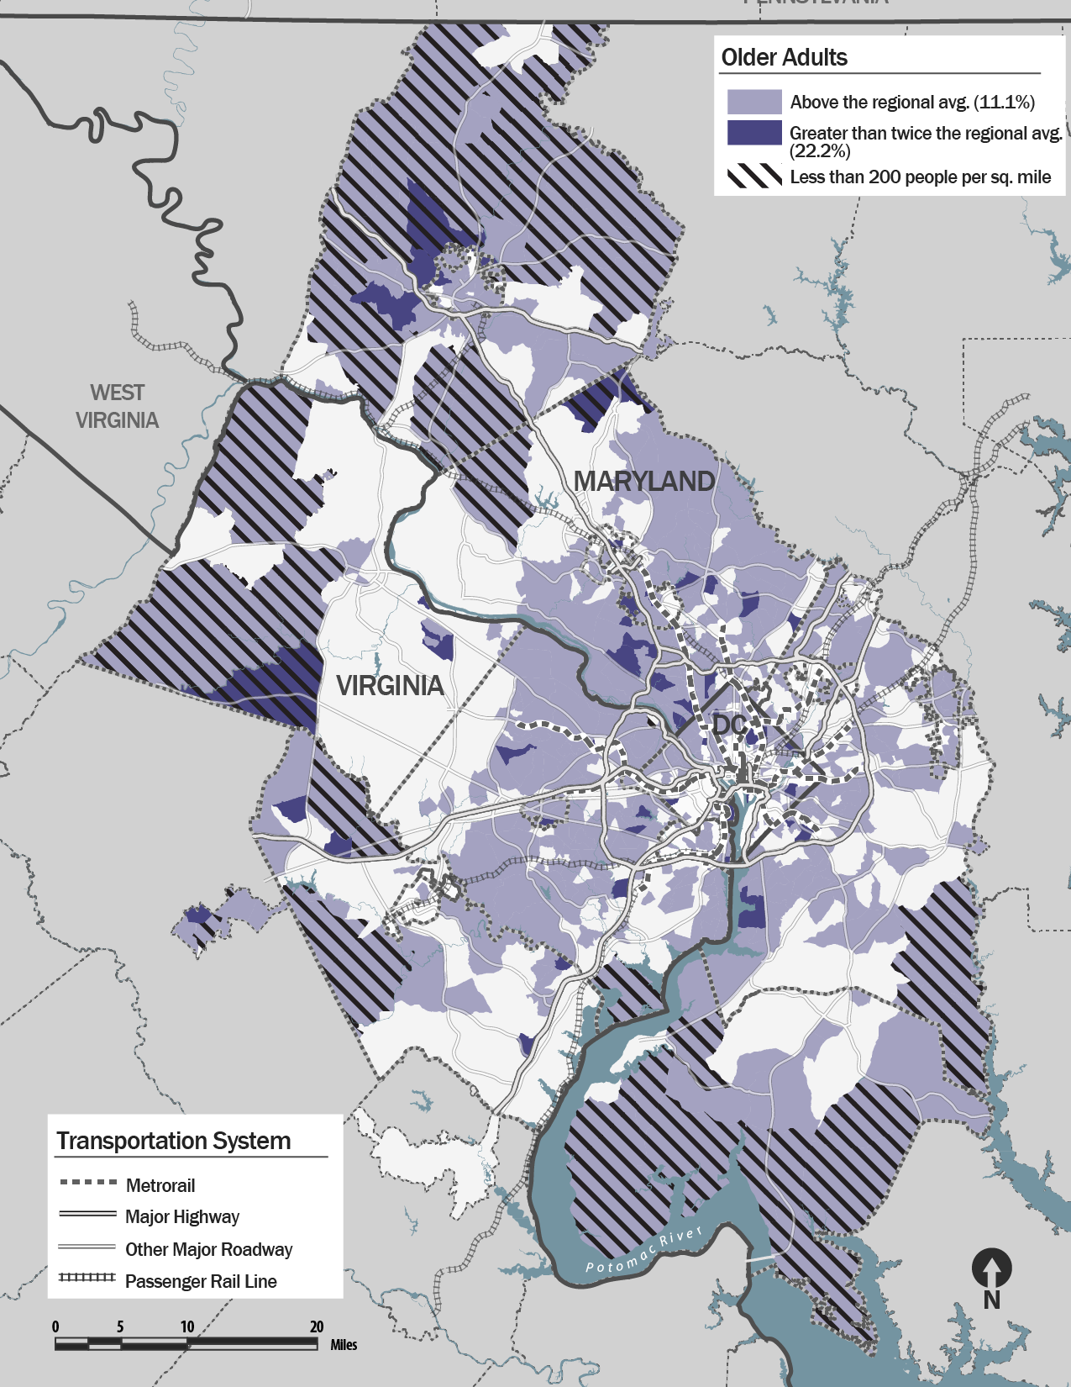
Figure D-5: Older Adult Population, 2016
(Age 65 and older)
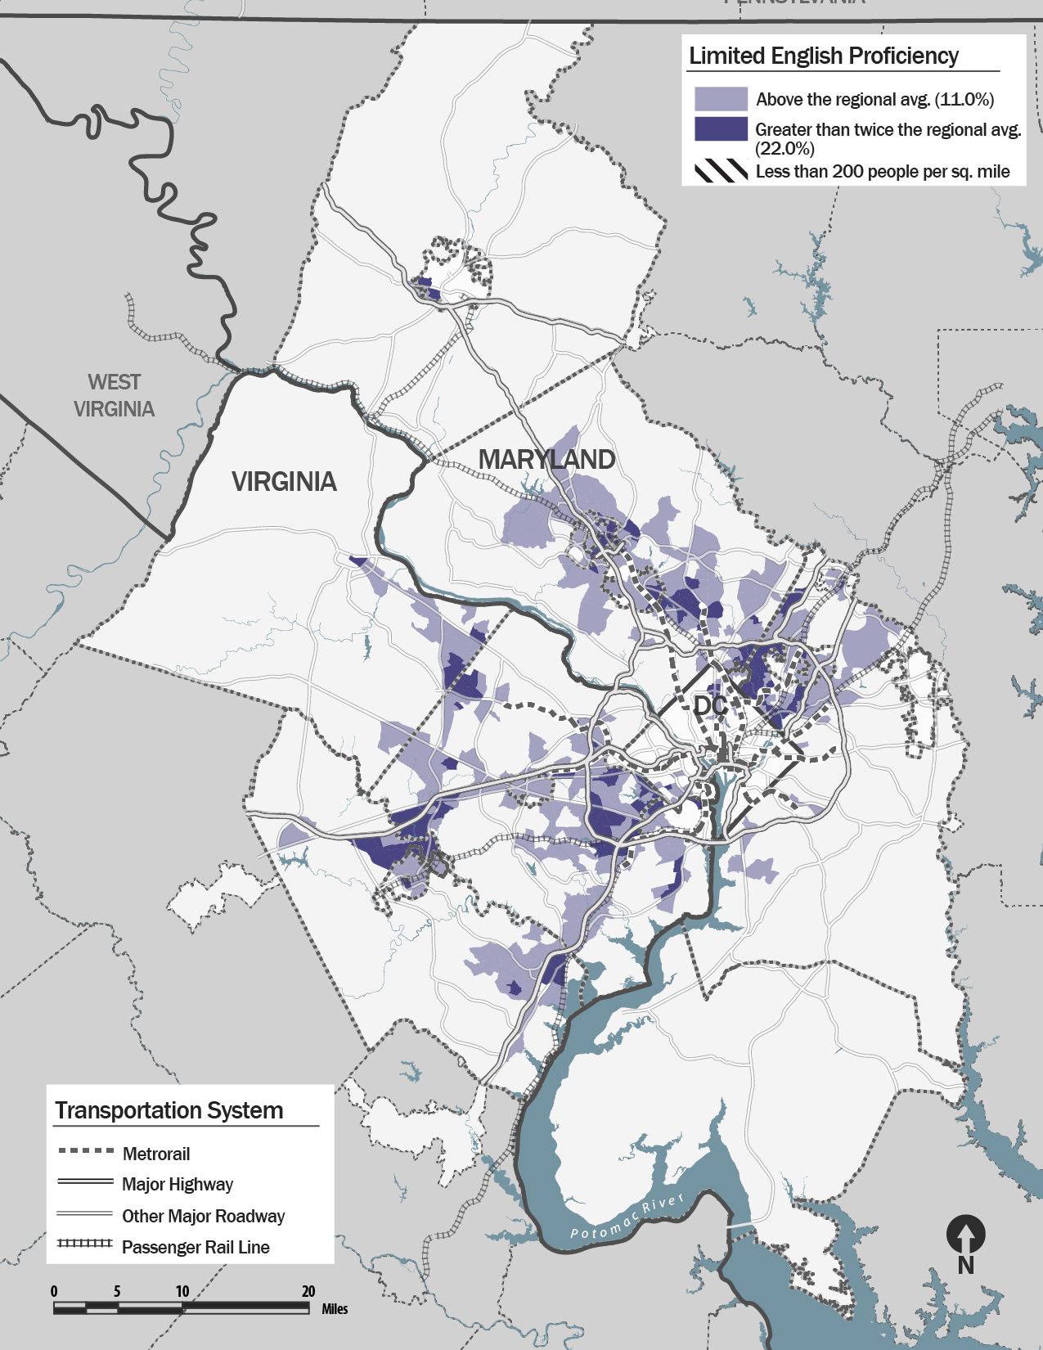
Figure D-6: Limited English Proficiency Population, 2016

Endnotes
^{i} U.S. Census. 2016. “Poverty thresholds.” https://www.census.gov/data/tables/time-series/demo/income-poverty/historical-poverty-thresholds.html.
^{ii} Shin, Hyon B. and Rosalind Bruno. October 2003. “Language Use and English-Speaking Ability: 2000.” U.S. Census. Pg. 2. Accessed March 13, 2018. http://www.census.gov/prod/2003pubs/c2kbr-29.pdf.
^{iii} Beginning with the 2008 ACS, the Census significantly revised the questions to determine disability. These changes affected the populations identified and it is not recommended to compare 2008 and newer figures to prior data, including 2000 Decennial. For more information, please see:
U.S. Census. “How Disability Data are Collected.” American Community Survey. https://www.census.gov/topics/health/disability/guidance/data-collection-acs.html;
For detailed definitions of the six disability categories (Hearing, Vision, Cognitive, Ambulatory, Self-care, and Independent living difficulty) see: U.S. Census. 2016. “American Community Survey and Puerto Rico Community Survey; 2016 Definitions.” Pg. 56-57. https://www2.census.gov/programs-surveys/acs/tech_docs/subject_definitions/2016_ACSSubjectDefinitions.pdf

Appendix E: TPB Resolution RXX-2019 Approving Update to the Coordinated Plan November 16, 2018

(RESOLUTION TO BE INSERTED)

Source: https://www.transit.dot.gov/funding/grants/coordinated-public-transit-human-services-transportation-plans
Source: https://www.transit.dot.gov/funding/grants/enhanced-mobility-seniors-individuals-disabilities-section-5310
Source: https://www.transit.dot.gov/funding/grants/coordinated-public-transit-human-services-transportation-plans
Source: http://www.ncsl.org/research/transportation/human-services-transportation-coordination.aspx
FTA’s Mobility Management brochure can be found at https://www.transit.dot.gov/ccam/resources/mobility-management-brochure
FTA Circular 9070.1G Page I-4.
Right to mobility is defined as getting from the door of where you are through the door of where you need to go.
To learn more about the Equity Emphasis Areas, visit www.mwcog.org/transportation/planning-areas/fairness-and-accessibility/environmental-justice/equity-emphasis-areas/

