DRAFT
Strategic Assessment of the Greater Washington Region’s Economic Competitiveness:
Status Update for COG’s Housing Directors Advisory Committee Members

- Update of the Region Forward Coalition’s Baseline Progress Report (measures regional performance related to 28 targets found in Region Forward, a long-range vision plan adopted by COG and its member governments in 2010);

- In 2015, the COG Board of Directors chose to focus on the theme of economic competitiveness; selected 30 updated indicators to report on progress since the Baseline Report. Those data points selected for review which relate to housing affordability are listed below.

Indicators related to Housing Affordability:

- Beginning in 2012, the housing and transportation costs in the Regional Activity Centers will not exceed 45% of area median income. (Existing target)
  - Revised in 2015 to add figure for entire region for context (H + T for Activity Centers and H + T for entire region)
2013 Data* | Activity Centers | Rest of MWCOG
At Area Median Income
Average H + T Cost as a Percent of Income | 36.9% | 44.5%
Percent of ACs with H + T Cost below 45% of Income | 84.3%
Percent of HHs in Block Groups with H + T Cost below 45% of Income | 86.5% | 56.8%
At 80% of Area Median Income
Average H + T Cost as a Percent of Income | 45.6% | 55.0%
Percent of ACs with H + T Cost below 45% of Income | 37.9%
Percent of HHs in Block Groups with H + T Cost below 45% of Income | 52.5% | 25.9%
Source: Center for Neighborhood Technology, Housing + Transportation Index
*A variety of data inputs are used but the most recent year used is 2013.

- Percentage of the region’s subsidized affordable units located in Activity Centers. (see map below)

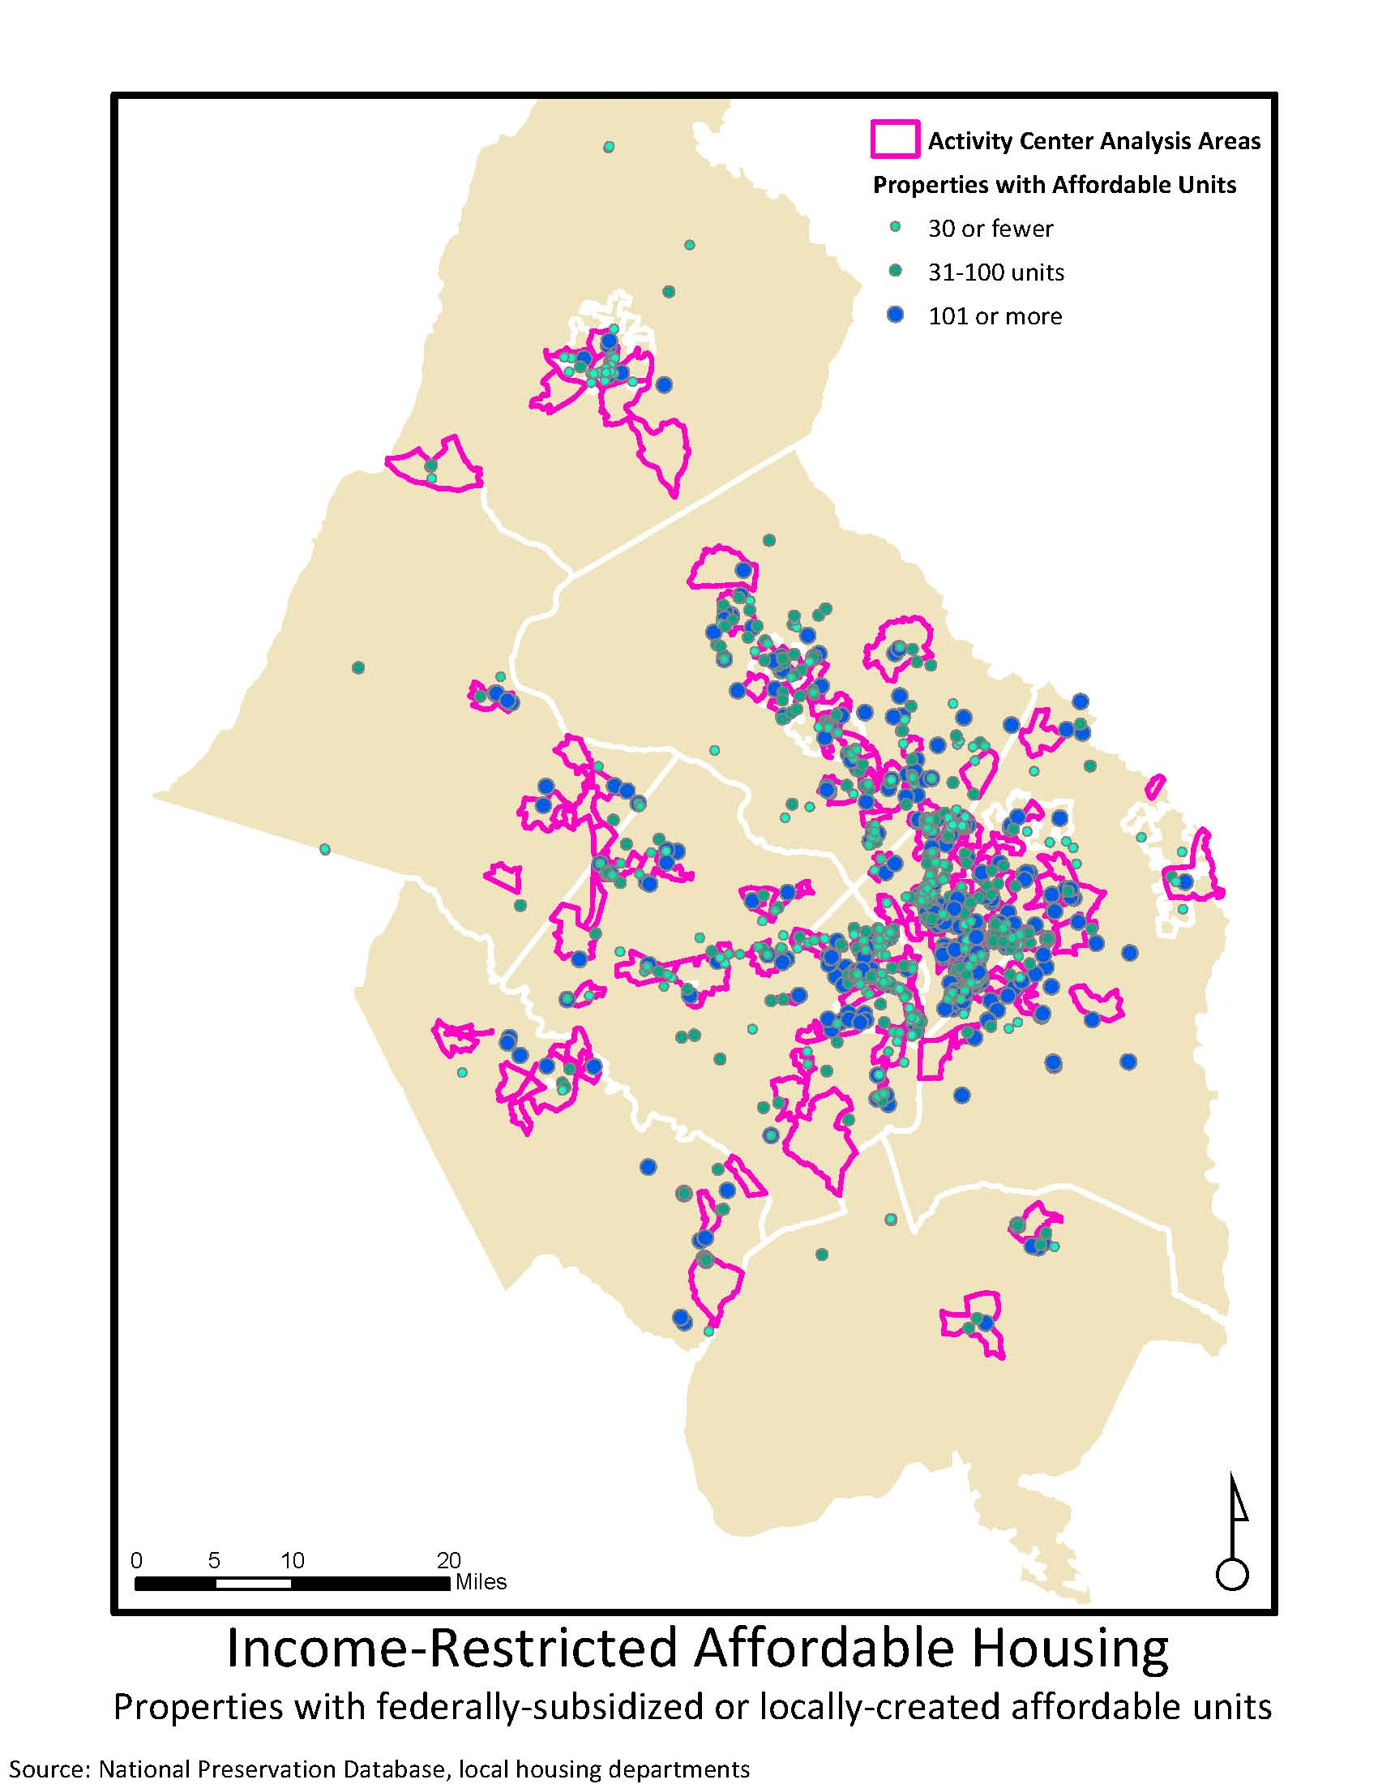

- The region will maintain a minimum of 30% of the region’s housing stock affordable to households earning less than 80% of regional median income, including 10% of units affordable to very-low income households (31-50% AMI) and 10% of units affordable to extremely low-income households (0-30% AMI).

percentage of rental units affordable at or below 80% AMI |  |  |  | 73.1%
 | % affordable to very low income (30-50% AMI) |  |  | 51.8%
 | % affordable to extremely low income (0-30% AMI) |  |  | 15.0%
percentage of ownership units affordable at or below 80% AMI |  |  |  | 25.0%
 | % affordable to very low income (30-50% AMI) |  |  | 11.8%
 | % affordable to extremely low income (0-30% AMI) |  |  | 3.8%
total renter and owner units |  |  |  | 1,852,700
total (rental + ownership) units affordable at or below 80% AMI |  |  |  | 806,500
 | % - regional total (rental & homeownership) |  |  | 43.5%
total units affordable to Very Low Income (30-50% AMI) |  |  |  | 353,800
 | % affordable to very low income (30-50% AMI) |  |  | 19%
total units affordable to ELI |  |  |  | 150,500
 | % affordable to extremely low income (0-30% AMI) |  |  | 8%

NOTE: From the Housing Security Study, page 29: "Together, more than half of the Washington region's 714,500 rental units were potentially affordable to very low or extremely low income households. However, a substantial share of affordable units were not available to very low or extremely low income renters because they were occupied by households with higher incomes." From page 47: "As with rentals, higher-income owners were crowding out lower-income households. Of the 43,500 units in the region affordable to an extremely low income, first-time homebuyer, 32,100, or 74 percent, were occupied by an owner with a higher household income than was needed to afford the units. Higher-income households occupied approximately 69 percent of units affordable to the very low income and 66 percent of those affordable to the low income. Crowding out by higher-incomeowners reduced the supply of affordable and available units for all lower-income groups."

- Housing Cost-Burdened Renter Households

- Housing Cost-Burdened Owner Households

