Facility Miles
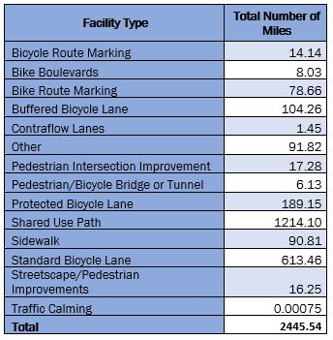
Facility Types picked to perform analysis on
- Bicycle Boulevards
- Protected Bicycle Lanes
- Shared Use Paths
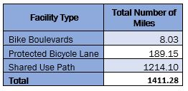
Analysis of Employment and Population Totals within Half and Two-Mile Buffers
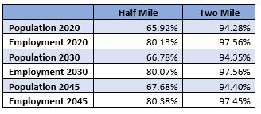
Activity Centers
Number of projects that pass through an Activity Center – 432
Activity Centers with Bicycle/Pedestrian Projects in them – 90.7%
Equity Emphasis Areas
Number of projects that pass through an Equity Emphasis Area – 293
EEA with Bicycle/Pedestrian Projects in them – 71.8%
TAFA Walk Sheds
Number of projects that pass through a TAFA Walk Shed – 74
TAFA Walk Sheds with Bicycle/Pedestrian Projects in them – 85.7%

