metropolitan washington 2030 climate and energy action plan - Draft

A collaborative implementation plan of the Climate, Energy and Environment Policy Committee (CEEPC) to move toward a carbon neutral and resilient region.

September 2020

Metropolitan Washington climate action plan

Prepared by the Climate, Energy and Environment Policy Committee (CEEPC)

Adopted on [November 18, 2020]

About COG

The Metropolitan Washington Council of Governments (COG) is an independent, nonprofit association that brings area leaders together to address major regional issues in the District of Columbia, suburban Maryland, and Northern Virginia. COG’s membership is comprised of 300 elected officials from 24 local governments, the Maryland and Virginia state legislatures, and U.S. Congress.

Credits

Editor: Maia Davis, Timothy Masters, Katherine Dyer, Benjamin Butterworth

Contributing Editors: Steve Walz, Jeffrey King, Michael Steinhoff

Design: Megan Goodman

Acknowledgements

[External support described here. To be inserted]

Accommodations Policy

Alternative formats of this document are available upon request. Visit [www.mwcog.org/accommodations](http://www.mwcog.org/accommodations) or call (202) 962-3300 or (202) 962-3213 (TDD).

TITLE VI NONDISCRIMINATION POLICY

The Metropolitan Washington Council of Governments (COG) fully complies with Title VI of the Civil Rights Act of 1964 and related statutes and regulations prohibiting discrimination in all programs and activities. For more information, to file a Title VI related complaint, or to obtain information in another language, visit www.mwcog.org/nondiscrimination or call (202) 962-3300.

El Consejo de Gobiernos del Área Metropolitana de Washington (COG) cumple con el Título VI de la Ley sobre los Derechos Civiles de 1964 y otras leyes y reglamentos en todos sus programas y actividades. Para obtener más información, someter un pleito relacionado al Título VI, u obtener información en otro idioma, visite www.mwcog.org/nondiscrimination o llame al (202) 962-3300.

Copyright © 2020 by the Metropolitan Washington Council of Governments

TABLE OF CONTENTS

iNTRODUCTION 1

COG and the Region 1

COG’s Climate and Energy Program 3

the plan 10

Purpose and Scope 10

Plan Elements 11

Stakeholder Engagement 12

Implementation and Monitoring 13

greenhouse gas emissions 14

Inventory 14

Business-As-Usual Projections 16

Scenarios 17

Regional climate mitigation strategy 18

Moving Toward Zero 18

Transportation and Land Use 43

climate risks and vulnerabilities 44

Assessment Overview 44

Climate Hazards, Risks and Impacts 46

regional climate resilience strategy 55

Moving Toward Resilience 55

Mitigation-Resilience Co-Benefits 64

**CONCLUSIONS** 67

**AppendiCES** (In Separate Attachment)

Figures and Tables

Figure 1: COG Region and Member Local Jurisdictions 1

Table 1: State Goals, Commitments and Legislation that Support GHG Reduction 9

Figure 2: Metropolitan Washington GHG Trends and Goals 14

Figure 3: Metropolitan Washington GHG Emissions by Activity 15

Figure 4: Drivers of Metropolitan Washington GHG Changes 16

Figure 5: Metropolitan Washington Business-As-Usual Projections 17

Figure 6: Metropolitan Washington “What Would It Take” Scenario Results 17

Table 2: Metropolitan Washington Priority Collaborative Mitigation Actions 18

Figure 7: Equity Emphasis Areas and Energy Burden 22

Figure 8: How Community Choice Aggregation Works 29

Figure 9: Waste Management Hierarchy 38

Table 3: Climate Risk Sourcing Matrix 44

Table 4: Risk Level of Hazards in Metropolitan Washington 45

Table 5: Metropolitan Washington Adaptive Capacity Degree of Challenge 46

Figure 10: Extreme Heat Days and Equity Emphasis Areas 47

Figure 11: Number of Projected Days Over 95°F from 1950 until 2095 48

Figure 12: Projected Number of Days per Year with Over 3 Inches of Precipitation 50

Figure 13: Equity Emphasis Areas and FEMA’s 100-Year Floodplains 51

Figure 14: Equity Emphasis Areas and NOAA Sea Level Rise Projections High Scenario (2080 6ft) 52

Figure 15: Satellite Image of Snowmageddon 54

Table 6: Metropolitan Washington Priority Collaborative Resilience Actions 56

iNTRODUCTION

COG and the Region

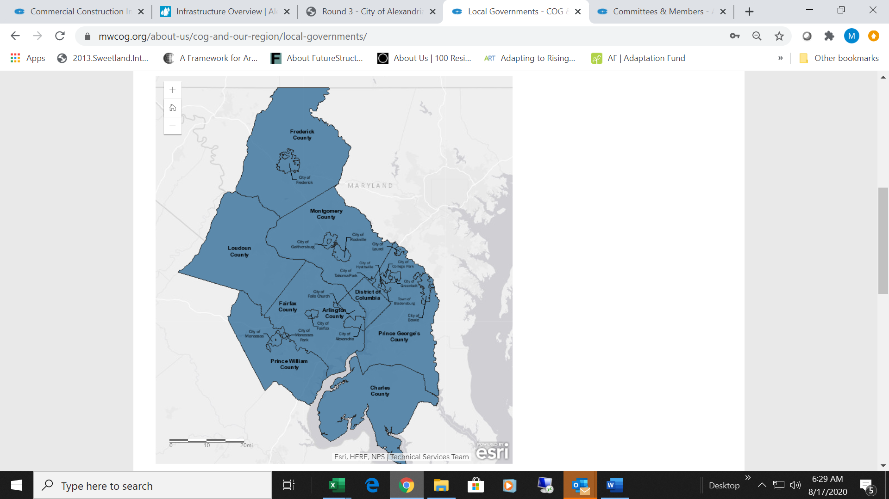Metropolitan Washington is a diverse and dynamic region home to more than five million people and one of the nation's largest economies. The Metropolitan Washington Council of Governments (COG) is an independent, nonprofit association comprised of 24 jurisdictions featuring urban, suburban, and rural communities across metropolitan Washington that range in size from about 10,000 to more than one million residents (Figure 1).

Figure 1: COG Region and Member Local Jurisdictions

COG is a center for partnerships to facilitate sustainable growth, a well-maintained transportation system, clean air, water, and land, safe and healthy communities, and a vibrant economy. This work is guided by COG’s comprehensive Region Forward Vision, a commitment to bettering the region, shared by residents, business and nonprofit leaders, and elected officials across metropolitan Washington. These goals also encourage leaders to think about the regional impact of local decisions. The *Region Forward* goals are:[1]

|  |  |
| --- | --- |
|  | Climate and Energy   * We seek a significant decrease in greenhouse gas (GHG) emissions, with substantial reductions from the built environment and transportation sector. * We seek efficient public and private use of energy region-wide, with reliance upon renewable energy and alternative fuels for buildings, vehicles, and public transportation. |
|  | Environment   * We seek to maximize protection and enhancement of the region’s environmental resources by meeting and exceeding standards for our air, water, and land. * We seek preservation and enhancement of our region’s open space, green space, and wildlife preserves. |
|  | * Transportation * We seek a broad range of public and private transportation choices for our region which maximizes accessibility and affordability to everyone and minimizes reliance upon single occupancy use of the automobile. * We seek a transportation system that maximizes community connectivity and walkability and minimizes ecological harm to the region and world beyond. |
|  | * Land Use * We seek the enhancement of established neighborhoods of differing densities with compact, walkable infill development, rehabilitation and retention of historic sites and districts, and preservation of open space, farmland, and environmental resource land in rural areas. * We seek transit-oriented and mixed-use communities emerging in Activity Centers that will capture new employment and household growth. |
|  | Housing   * We seek a variety of housing types and choices in diverse, vibrant, safe, healthy, and sustainable neighborhoods, affordable to persons at all income levels. * We seek to make the production, preservation, and distribution of affordable housing a priority throughout the region. |
|  | Economy   * We seek a diversified, stable, and competitive economy, with a wide range of employment opportunities and a focus on sustainable economic development. * We seek to minimize economic disparities and enhance the prosperity of each jurisdiction and the region as a whole through balanced growth and access to high-quality jobs for everyone. * We seek to fully recognize and enhance the benefits that accrue to the region as the seat of the national government and as a world capital. |
|  | Health and Human Services   * We seek communities in which every person enjoys health and well-being. |
|  |  |
|  | Education   * We seek to provide greater access to the best education at all levels, from pre-kindergarten to graduate school. * We seek to make our region a pre-eminent knowledge hub, through educational venues, workforce development, and institutional collaboration. |
|  | Public Safety   * We seek safe communities for residents and visitors. * We seek partnerships that manage emergencies, protect the public health, safety, welfare, and preserve the lives, property, and economic well-being of the region and its residents. |

Equity

* We recognize equity is achieved when all people are fully able to participate in the region’s economic viability, contribute to the region’s readiness for the future and connect to the region’s assets and resources.
* We seek fairness and justice in the formation of priorities, policy, and programs.
* We will be anti-racist, actively oppose racism, and will advance equity in our work together across the region.

The Board of Directors is COG’s governing body and is responsible for its overall policies. A wide network of policy, technical, and advisory committees, partnerships, and programs advance COG’s work to achieve the *Region Forward Vision*.

COG’s Climate and Energy Program

BACKGROUND [2]

In 2007, the Metropolitan Washington Council of Governments (COG) celebrated its 50th anniversary. As part of its 50th anniversary year, the COG Board of Directors examined the extraordinary changes that took place during the first half century of COG’s existence and how COG grew up along with the region and helped shape its growing and vibrant communities. The Board then set its sights on the next fifty years. It recognized global climate change as a profound force fundamental to defining the decades ahead. The Board resolved that the region would become a leader in the growing national and international effort to combat this major challenge to the region’s quality of life.

On April 11, 2007, the Board adopted Resolution R31-07, creating a regional climate change initiative. In its resolution, the Board stated: “The failure to reduce greenhouse gases can undermine the quality of life in our region and its economic and environmental sustainability.” The Board action called for creating a one of the nation’s first regional climate change programs that would include developing a greenhouse gas inventory, setting regional goals, identifying best practices for reducing emissions, advocating policies at the federal and state levels, making recommendations on regional climate change policy, and recommending a structure to guide COG’s efforts in the future.

By adopting R31-07, the COG Board established one of the first regional climate and energy programs in the United States and placed itself front and center on the national landscape of local jurisdictions and states taking leadership action on climate change. Resolution R31-07 established a Climate Change Steering Committee (CCSC) to guide the initiative. The committee’s work ultimately led to the development of the National Capital Region Climate Change Report.

The National Capital Region Climate Change Report includes a 2005 baseline regional GHG inventory, examines potential climate change impacts, evaluates mitigation and adaptation strategies and establishes regional GHG emission reduction goals of: 10 percent below business as usual projections by 2012 (bringing regional emission back down to 2005 levels), 20 percent by 2020 and 80 percent by 2050 (below the 2005 baseline). The COG Board of Directors adopted this report and its goals with Resolution R60-08 on November 12, 2008. The Board also established the Climate, Energy and Environment Policy Committee (CEEPC) to move the region toward meeting the regional GHG emission reduction goals.

Climate, Energy and Environment Policy Committee

The CEEPC guides the COG region in taking action to meet regional GHG emission reduction goals. CEEPC supports the *Region Forward Vision* by providing leadership and advising the COG Board on climate change, energy, green building, alternative fuels, solid waste and recycling issues, and by supporting area governments as they work together to meet regional goals.[3]

CEEPC includes representatives from COG’s member local governments, state environmental and transportation agencies, state legislatures, the Air and Climate Public Advisory Committee (ACPAC), federal and regional agencies, electric and gas utilities, environmental organizations, business organizations, and members of the academic community. Several subcommittees, technical working groups, and partners provide essential input and support to CEEPC, including:[4]

* The Climate and Energy Legislative Committee leads the development of the COG Board’s annual legislative priorities for climate and energy and advocates at the state and federal levels for policies and programs that support regional GHG emission reduction and enhances climate resilience. This committee consists of a sub-group of the local elected officials appointed to CEEPC.
* The Air and Climate Public Advisory Committee (ACPAC) provides a meaningful opportunity for appointed members of the public to advise CEEPC on climate and energy issues and initiatives. ACPAC's members represent diverse community interests and opinions from across the region. Members have various backgrounds including business/industry, education/scientific, environmental/health and civic organizations.
* The Built Environment and Energy Advisory Committee (BEEAC) serves as a technical advisory committee to CEEPC. Membership includes local government energy managers, green building program managers, sustainability coordinators and regional stakeholders, such as Metro. The group serves as a forum for discussion, sharing/learning, and monitoring of energy and green building issues in the region.
* The Regional Emergency Support Function #12 (RESF-12) is an energy committee coordinated by BEEAC members in cooperation with COG’s Homeland Security and Public Safety Program. The group is responsible for coordinating with state and local agencies and emergency response teams to maintain continuous and reliable energy supplies through preventive measures, restoration, and recovery actions.
* The Regional Tree Canopy Committee (RTCC) is dedicated to maintaining a healthy tree and forest canopy in the face of climate change and an ever-changing landscape of air quality and stormwater management regulations. Committee members include local foresters and climate, air quality and stormwater experts who work together to facilitate a unified approach to tree and forest canopy management efforts.
* The Solid Waste Managers and Recycling Committees are comprised of COG member local jurisdiction representatives working on solid waste and recycling. Members come together to share best practices and lessons learned as well as tackle regional challenges such as commercial recycling, recycling markets, and advancing organics composting infrastructure in the region.
* The Greater Washington Region Clean Cities Coalition (GWRCCC) works with vehicle fleets, fuel providers, community leaders and stakeholders to reduce petroleum use in transportation. Initially launched and housed as a COG program, the GWRCC grew to a separate private-public partnership that still closely collaborates with COG to advance deployment of zero emission vehicles.[5]
* A plethora of Ad-Hoc Work Groups have been established to operate for limited timeframes or come and go as needed to advance significant new initiatives or address members’ needs. Examples of work group focuses have been establishing greenhouse gas accounting methodologies; developing model energy engagement programs; developing an electric vehicle readiness plan for the region; developing model solar permitting and inspections checklists and review processes; training for and developing model commercial PACE (Property Assessed Clean Energy) programs, policies and procedures; and much more.

PROGRESS

Since its inception, CEEPC has adopted short-term plans to set priorities and spur action. Each plan builds off the last, to help move the region toward its goals to reduce GHG emissions, enhance resilience, and address the newest practices and member needs. CEEPC consistently pushes the bar for the outcomes they want to see for the region and then members work to help accomplish those outcomes. There has been a tremendous amount of effort in the region on climate and energy action the last 10-15 years and while it would be difficult to capture it all in this plan, some highlights of commitments, accomplishments and initiatives are provided. Some examples of overall progress include:[6]

* The region surpassed its 2012 goal of 10 percent reduction in greenhouse gas (GHG) emissions below business as usual projections, bringing regional emission back down to 2005 levels. Overall emissions region-wide have decreased 13 percent between 2005 and 2018, despite a 19 percent growth in population. An immense undertaking is still needed to meet the GHG reduction goals moving forward.
* As of 2018, 13 percent of total regional electricity consumption came from renewables. This equates to more than 8.9 million MWHs of renewables.
* The region has surpassed both CEEPC's 2016 goal of 5,000 grid-connected renewable energy systems in the region and its 2020 goal of 30,000 systems. Distributed renewable energy deployment has grown at a tremendous rate from less than 470 systems in 2009 to more than 44,000 systems in 2019 operating with more than 479 megawatts of capacity.
* Buildings with a higher level of environmental performance are verified through programs such as LEED, ENERGY STAR, EarthCraft, Passive House and Living Buildings Challenge. The number of these certified high-performance buildings have grown from 3 buildings in 2005 to 4,198 buildings in the region as of summer 2019.
  + Metropolitan Washington is consistently ranked in the top few metropolitan areas for ENERGY STAR rated buildings. In 2020, the Washington D.C. metro area was ranked 2nd for ENERGY STAR certified buildings.[7]
  + Maryland and Virginia are consistently ranked in the top 10 states for LEED development. In 2019, Maryland was ranked 6th and Virginia was ranked 7th for gross square footage of new space LEED certified. Although the District of Columbia is not officially included in the state rankings, the rankings recognize that the District had more LEED development than any state in the 2019 rankings.[8]
* Hybrid and electric vehicles owned in the region have grown from 11,843 hybrids in 2005 to 123,826 hybrid and electric vehicles in 2016. Only 8,225 of these vehicles are plug-in (PHEV) or all electric (BEV) that need to plug into charging stations. As of 2016, hybrid and electric vehicles together account for 3 percent of all light duty vehicles in the region.
* Owners of plug-in and all electric vehicles need to be supported with a robust network of charging stations. Charging stations locations in the region increased from 124 in 2012 to 852 in 2019. The 852 station locations include 2,424 charging plugs.
* The regional recycling rate, one indicator to track progress towards zero waste, has increased from approximately 33 percent in 2005 to 47 percent in 2016.

Regional Initiatives

COG’s Climate and Energy Program provides support and resources to communities seeking to implement policies, programs and initiates to reduce GHG emissions and enhance resilience. Types of support may include capacity building and training, data and tools, research, planning, policy/program development, project feasibility assessments, advocacy, and cooperative procurement. Areas of focus for the COG Climate and Energy Program have been greenhouse gas accounting, efficiency and green building, renewables, energy financing, energy infrastructure, clean fuel vehicles, emergency preparedness, urban tree canopy, recycling and waste management, climate resilience planning, cooperative procurement, equity, and engagement. COG local jurisdictions, states, and stakeholders work together to learn from experts and each other and to help facilitate implementation at-scale. Some examples of our collaborative work include:

* Greenhouse Gas Accounting: Since its inception, CEEPC has made it a priority for all COG member jurisdictions to conduct GHG inventories to track progress towards emission reduction goals. COG’s GHG inventory work provides for completeness, consistency, accuracy, replicability, transparency, and quality control for all 24 COG members and the region. In addition, COG continues to support enhancements to national protocols for community-scale inventories and development of tools to support decision-making.[9]
* Green Building: COG’s Intergovernmental Green Building Group (IGBG) was established in 2005 and lead development of the Regional Green Building Policy that the COG Board adopted in 2007. It called for all new local government construction to achieve Leadership in Energy and Environmental Design (LEED) Silver Certification and all commercial construction to be LEED Certified. The policy and IGBG encouraged and supported wide-spread adoption of local green building policies that have significantly influenced green building development in the region. IGBG eventually merged with COG’s Energy Advisory Committee to form BEEAC where continued capacity building, training and encouragement of enhanced green building policies continues.[10]
* Renewables: Coordinated bulk procurement initiatives helped result in more than 31 megawatts of solar deployment as of 2016. In 2010, the EPA GPP, COG and its members partnered to conduct 170 on-site solar feasibility assessments at public facilities and coordinated on bulk solar procurements. Under the U.S. Department of Energy SunShot Initiative, COG and its members partnered to adopt model solar permitting and inspection guidelines and launch solar co-ops in a dozen communities, many of which have continued to launch additional co-ops rounds.[11]
* Energy Financing: The Mid-Atlantic PACE Alliance (MAPA) is a partnership between stakeholders in Virginia, Maryland, and the District of Columbia - including COG - to accelerate the implementation of Commercial Property Assessed Clean Energy (C-PACE) programs and projects in the region. C-PACE is a financing mechanism for owners of commercial property to fund energy-related property improvements with no upfront costs. The MAPA Toolkit offers comprehensive program development guidelines for local governments. More than 10 PACE Programs have been launched and 35 projects in the region have been financed as of summer 2020 by C-PACE programs.[12]
* Energy Infrastructure: The accomplishments of CEEPC and its members have also earned the region recognition as a White House Climate Action Champion. This designation made COG and its members eligible for targeted federal technical assistance and grant funding from 2014 – 2016. One way COG leveraged this opportunity was to conduct local clean energy infrastructure assessments at 6 sites across the region to determine the feasibility of microgrids, combined heat and power (CHP), geothermal or net zero energy development. Two examples of progress at these sites include the Falls Church School Campus is developing a net zero energy ready school campus with geothermal and the Washington Hospital Center is seeking funding for microgrid deployment.
* Clean Fuel Vehicles: In 2015, COG partnered with Vision Fleet to develop opportunity assessments to maximize overall fleet efficiency for four local government vehicle fleets, including the District of Columbia, Alexandria, Prince George’s County and Frederick County. Complete light-duty fleet inventories included detailed, vehicle-specific total cost of ownership estimates and more efficient, cost-effective substitutes for each vehicle. The comprehensive assessment recommendations were both quantitative and qualitative to maximize financial and fuel savings and reduce carbon emissions through electric vehicle deployment, car-sharing programs, strategic right-sizing, or increase asset utilization.[13]
* Emergency Preparedness: COG has been doing energy emergency coordination since the 1970s gas shortage crisis and the development of the 1973 Metropolitan Washington Tri-State Energy Emergency Coordination Agreement. Regional plans and coordination over the years have addressed energy conservation and management, natural gas emergency alerts, and energy emergencies. The most recent plan addressing energy emergencies is the 2010 Regional Emergency Coordination Plan. Over the years, COG has coordinated several energy emergency exercises with emergency responders, local energy managers, and energy and water utilities.
* Urban Tree Canopy: CEEPC formed a Tree Canopy Subcommittee to further recommendations of the 2018 Tree Canopy Management Strategy. The Subcommittee is developing a “cook book” of model tree ordinance provisions, recommendations for minimum percent tree canopy coverage for differing land use types, and a Regional Tree Canopy Acton Plan.
* Recycling and Waste Management: COG works with local waste management and recycling program managers, waste management and recycling companies, and other stakeholders to share best practices, market conditions, and other information to assist optimization of local waste management and recycling practices. COG sponsors the annual Go Recycle public information program and the America Recycles Day program with schools across the region.
* Climate Resilience Planning: COG is currently coordinating with the U.S. Army Corps of Engineers Baltimore District and local cost-share partners on a coastal storm risk management study to evaluate the performance of current flood protection infrastructure along the northern Virginia bank of the Potomac and its tidal tributaries. The project includes analyzing tidal flooding risks and developing designs for new flood protection systems–including green and gray infrastructure–to reduce to risk to northern Virginia communities and built assets.[14]
* Cooperative Procurement: The basic objective of COG’s Cooperative Procurement Program and our Mid-Atlantic Purchasing Team (MAPT) is to reduce costs through economies of scale created through volume buying. The COG Rider Clause provides the opportunity for members to join existing awards and avoid the need to do in-house bidding. CEEPC and its members have leveraged the program and rider clause for procurements such as solar, energy efficient lighting, electric vehicles, and climate planning.[15]
* Equity: Adopted by CEEPC in 2017, the Environmental Justice Toolkit provides guidance to policymakers on incorporating social equity, cultural sensitivity, and community health considerations into air quality, climate, and energy planning. Environmental justice has been a priority of ACPAC and members took the lead on developing the toolkit to help communities address issues of equity, access to decision makers, and meaningful engagement of the public, when making decisions that affect the local and regional environment.[16]
* Engagement: COG’s Climate and Energy Leadership Awards, coordinated by ACPAC, recognizes organizations that develop climate stewardship projects and programs that  
  engage and serve the region’s underserved communities. Over the last 6 years, the awards program has highlighted a broad range of climate solutions for their unique engagement practices as well as their results, creativity, and replicability.[17]

Local Goals and Commitments

COG’s *Region Forward* Vision focuses on creating a more prosperous, accessible, livable, sustainable, and equitable metropolitan Washington. All COG local jurisdiction members in 2010 signed onto the *Region Forward* goals by adopting via their local governing body (i.e. city council, county commission). The climate and energy goals include commitments to reducing GHG emissions and the efficient use of energy, with reliance on renewable energy and alternative fuels.

The majority of COG members have adopted specific local GHG emission reduction goals that align with the COG goals adopted by the Board in 2008. The Cities of Alexandria, Frederick and Takoma Park as well as Frederick and Montgomery Counties have declared climate emergencies that commit to achieving more aggressive GHG goals sooner. For example, Montgomery County’s Emergency Climate Mobilization Resolution established goals for the County to reduce GHG emissions to 80 percent below 2005 levels by 2027 and to 100 percent by 2035. The other jurisdictions who have declared emergencies, as well as the District of Columbia and Arlington County, also have committed to carbon neutrality by 2035 or 2050.

Additionally, more than half of COG members committed to the We’re Still In Pledge, a commitment to support climate action to meet the Paris Agreement. Several COG members have also made commitments to reduce GHG emissions to initiatives such as the Global Covenant of Mayors for Climate and Energy, Climate Mayors, and much more.

For a complete list of local GHG reduction goals, climate action plans, and commitments, see Appendix C: List of Metropolitan Washington GHG Emission Reduction Plans and Goals and Appendix D: COG Member Collaborative Climate Program Commitments. Sample highlights of local actions to support reaching their goals are weaved into the Mitigation and Resilience Strategy sections of this plan.

State Goals and Commitments

Table 1 shows the State Goals and Commitments that are currently in place. Renewable Portfolio Standards (RPS) are the most impactful tool to reduce the amount of fossil fuel-generated electricity on the grid. The District of Columbia, Maryland, and Virginia have all adopted aggressive RPS goals. The District of Columbia, Maryland and Virginia have adopted buildings codes that drive greater energy efficiency in the built environment. Additionally, the District of Columbia and Maryland are part of the Regional Greenhouse Gas Initiative (RGGI), which establishes a regional cap on the amount of carbon dioxide (CO2) emissions that can be emitted by power plants. This is achieved through the issuance of tradable CO2 allowances. Virginia is set to join RGGI on January 1, 2021. The District of Columbia, Maryland, and Virginia are all participating in the Transportation Climate Initiative (TCI). This initiative is a collaboration of 12 states and the District, which seeks to reduce carbon emissions from the transportation sector.

Table 1: State Goals, Commitments and Legislation that Support GHG Reduction

|  |  |  |  |
| --- | --- | --- | --- |
| Goals/Commitments | District of Columbia | Maryland | Virginia |
| Greenhouse Gas Reduction Goals* | 50% Reduction below 2006 levels by 2032 | 40% Reduction below 2006 levels by 2030 | N/A |
| Carbon Neutral by 2050 | N/A | N/A |
| Renewable Portfolio Standards | 100% by 2032 | 50% by 2030, and 100% by 2040 | 30% by 2030, and 100% by 2050 |
| Adopted Building Codes:** | | | |
| International Energy Conservation Code (IECC) | 2015 IECC | 2018 IECC | 2015 IECC |
| International Green Construction Code (IgCC) | 2012 IgCC | 2018 IgCC | N/A |
| Regional Greenhouse Gas Initiative (RGGI) Participation | ✔ | ✔ | Pending - Virginia is scheduled to join RGGI in January 2021 |
| Transportation Climate Initiative (TCI) Participation | ✔ | ✔ | ✔ |

*Greenhouse Gas Reduction Goals reflected in Table 1 are state-level goals and do not reflect COG’s regional GHG reduction goals or more aggressive goals made by local jurisdictions in the metropolitan Washington region.

**All Building Codes reflected in Table 1 have amendments made at the state level.

For a complete list of state GHG reduction goals, commitments and legislation that support GHG reduction, see Appendix D: COG Member Collaborative Climate Program Commitments and Appendix E: List of State Legislation Supporting GHG Emission Reduction in Metropolitan Washington.

the plan

Purpose and Scope

According to the Intergovernmental Panel on Climate Change (IPCC), a body of the United Nations that assesses the science related to climate change, the world is already experiencing the impacts of 1 degree of global warming above pre-industrial levels. Additionally, the IPCC notes that more severe climate impacts could be avoided if global warming is limited to 1.5 degrees Celsius. Globally emissions need to fall by 45 percent from 2010 levels by 2030 and net zero by 2050 in order to limit global warming to 1.5 degrees Celsius. The IPCC acknowledges rapid and far reaching transitions are needed world-wide in order to limit global warming.[18]

The greenhouse gas (GHG) emission reduction goals adopted by the COG Board on October 14, 2020 align with the level of effort called for by the IPCC to limit global warming to 1.5 degrees Celsius. The goals established by the COG Board include the following:

* Mitigation:
  + Reduce Regional GHG emissions 50 percent by 2030, below 2005 levels; and
  + Achieve carbon neutrality region-wide by 2050.

* Resilience:
  + Become a Climate-Ready Region by 2030; and
  + Achieve Regional Resilience by 2050.[19]

The purpose of this plan is to establish priority collaborative actions for CEEPC members to work on together over the next ten years to help move the region towards meeting the 2030 goals. All the actions in the plan are voluntary; the success of the plan will depend on active regional collaboration and implementation. This plan focuses on the actions of the CEEPC; however, the plan also recognizes transportation and land use actions being undertaken by other COG committees that contribute to these climate goals. Achieving the regional goals would require unprecedented, aggressive cross-sectoral action from all 24 COG member local jurisdictions, as well as our state and federal partners.

GUIDING PRINCIPLES

Ten principles guide this Plan’s voluntary collaborative climate action implementation process. These principles reflect CEEPC’s commitment to environmental quality, economic prosperity, and equity. As climate leaders, CEEPC is committed to the following principles:

1. Collective Action: We will continue to work together to leverage our impact and facilitate application at scale.
2. Effective Partnerships: We will continue to share best practices, learn together, and coordinate on implementation to advance regional transformation.
3. Lead by Example: We have a continued commitment to internal implementation of long-term solutions to reduce the climate impacts of our operations.
4. Integration: We understand climate action is inherently multidisciplinary and will promote cross-department coordination, including in areas such as equity, health, and economic development.
5. Flexibility: We understand the need for flexibility in how our public agencies and stakeholders across the District of Columbia, Maryland, and Virginia work to achieve regional GHG goals.
6. Transparency: We will continue to measure and report progress in a manner easily understandable by all.
7. Innovation: We support a just transition to a clean energy economy through the application of innovative technology, policies, and processes by public and private sectors.
8. Community Leadership: We will continue to educate, motivate, and empower action from our community’s institutions, businesses, non-profits, and residents.
9. Inclusive Engagement: We commit to inclusive community engagement and equitable provision of climate and energy programs and services.
10. Advocacy: We will continue to support state and federal policies and programs that protect the human and environment health of our communities.

GLOBAL COVENANT OF MAYORS FOR CLIMATE AND ENERGY

In 2019, COG was selected as a Regional and Metro Scale Climate Leader by the Global Covenant of Mayors for Climate and Energy (GCoM). GCoM provides a framework of global best practices for climate planning. CEEPC became a GCoM Signatory, committing to follow the framework for the development of this Plan. GCoM has provided COG with guidance and technical assistance to ensure this Plan follows the GCoM framework.[20]

The GCoM framework requires inventories, targets, and plans of Signatories to follow their global best practices. The framework breaks the planning process into two areas. The first addresses baseline conditions and mitigation actions to reach regional GHG emission reduction goals. The second involves completion of a regional Climate Risk and Vulnerability Assessment (CRVA) and identification of resiliency actions to reduce the risk and make the region more climate change ready.

In addition, this Plan incorporates GCoM’s priority for providing improved access to secure, sustainable, and affordable energy. While the protocol has not been fully defined for North American energy markets, it accommodates addressing equitable access to clean and secure renewable power sources at affordable prices and providing energy-efficient housing to all sectors of the market.

Plan Elements

There are four core elements to this Plan, including:

* Greenhouse Gases: This section of the plan provides a summary of regional GHG inventory trends from 2005 – 2018, business-as-usual (BAU) GHG emission projections through 2030, and technical scenario showing what it will take for the region to reach GHG reductions of 50 percent below 2005 levels by 2030.
* Climate Mitigation Strategy: This section of the plan identifies CEEPC’s priority collaborative mitigation actions to move the region toward achieving the GHG emission reduction goal of 50 percent by 2030, below 2005 levels. The action areas include Planning, Equity, Clean Electricity, Zero Energy Buildings, Zero Emission Vehicles, Zero Waste, and Sequestration.

* Climate Risks and Vulnerabilities: This section of the plan provides a summary of the Regional Climate, Risk and Vulnerability Assessment (CRVA). The CRVA evaluates climate hazards including extreme heat, drought, lightning and thunderstorms, flash and riverine flooding, coastal flooding and extreme winter conditions. The CRVA also evaluates factors impacting adaptive capacity, such as infrastructure conditions and maintenance, access to basic services, and public health.
* Climate Resilience Strategy: This section of the plan identifies CEEPC’s priority collaborative climate resilience actions to move the region toward achieving the goal of becoming a Climate-Ready Region 2030. The action areas include Planning, Equity, and Resilient Infrastructure.

Stakeholder Engagement

The core stakeholder groups engaged during the development of the Metropolitan Washington 2030 Climate and Energy Action Plan were COG’s Air and Climate Public Advisory Committee (ACPAC), the Built Environment and Energy Advisory Committee (BEEAC), and the Climate, Energy and Environment Policy Committee (CEEPC). These bodies and its members work together to implement the Plan’s recommendations both locally and regionally. ACPAC serves as the public advisory committee to CEEPC and BEEAC serves as the technical advisory committee to CEEPC. CEEPC is the COG policy committee on climate and energy and the lead advisor on these issues to the COG Board. The COG Board establishes the overarching climate goals for ACPAC, BEEAC and CEEPC to work towards and is the final authority adopting regional goals. More information about these bodies can be found in the Introduction section of this Plan.

At its September 25, 2019 meeting, CEEPC became a GCoM Signatory and officially launched the development of the 2030 Plan. As one of the first regions in the U.S. to commit to follow GCoM’s framework, CEEPC pledged to implement policies and undertake measures to reduce GHG emissions, prepare for the impacts of climate change, increase access to sustainable energy, and track progress toward these objectives. CEEPC also reviewed the scope and timeline for the 2030 Regional Climate and Energy Action Plan that was developed to align with the GCoM framework. In advance of the September CEEPC meeting, CEEPC advisory committees, ACPAC and BEEAC, had the provided input and offer support for the GCoM commitment and scope for the Plan.[21]

In November 2019, ACPAC, BEEAC and CEEPC members held a joint 2-day Climate Planning Work Session. The first day was dedicated to mitigation where the group reviewed progress towards regional 2020 goals and new drafts of the region’s GHG emissions business-as-usual (BAU) projections and 2030 low carbon scenarios. The second day was dedicated to resilience where the group discussed the draft regional climate risk and vulnerability assessment (CRVA). Over the 2-day session, participants provided input on the challenges, opportunities and next steps related to regional goals, collaborative actions, sustainable energy access and equity for both mitigation and resilience.[22]

Based on input from the November Work Session, revisions were made to the BAU projections, scenarios and CRVA and goals and a preliminary list of priority collaborative actions were developed. Due to the outbreak of the COVID-19 pandemic, stakeholder engagement was pushed back by a month and stakeholder engagement for the remainder of the planning process moved to virtual platforms in leu of in-person engagement. Virtual stakeholder engagement sessions to move the Plan toward adoption included:[23]

* In April 2020, ACPAC, BEEAC and CEEPC members were invited participate in a virtual work session to review preliminary list of goals and actions for the 2030 Plan.
* In May 2020, CEEPC hosted a roundtable discussion on local climate goals, actions and progress. The impacts and effects of COVID-19 on climate planning and implementation were discussed.
* In June 2020, a technical Q&A webinar was held to review and provide input on BAU and scenario revisions.
* In July 2020, members of ACPAC, BEEAC and CEEPC had the opportunity to provide input on the revised 2030 Plan goals at their respective virtual meetings.
* In September 2020, the COG Board received an update on the planning process and potential goals.
* In September 2020, ACPAC, BEEAC and CEEPC reviewed the draft plan and draft resolution to the COG Board on updated regional climate goals. CEEPC approved the resolution to the COG Board.
* In October 2020, the COG Board reviewed and adopted the recommended resolutions from CEEPC, thus, establishing the most aggressive regional climate goals in the U.S.
* In November 2020, CEEPC approved the final 2030 Plan.
* In December 2020, COG submitted to the Plan to GCoM and became the first region in the U.S. to fully complete and meet the GCoM requirements for global best practices in climate planning.

After each work session for the Plan, stakeholders were provided a comment period to allow time for further review and written comments.

Implementation and Monitoring

CEEPC and its advisory committees will follow the Guiding Principles identified above to work together to support implementation of this plan. For the region to meet the regional climate change goals, aggressive local actions and on-the-ground change will need to occur across the entire region. Additionally, the goals cannot be met if the climate injustices faced by underserved, potentially vulnerable communities are not addressed head-on. All climate action and implementation need to occur with an equity lens. The purpose of stakeholders voluntarily coming together to collaborate on action across the region, is to leverage our impact and facilitate innovation and action at scale.

In order to monitor progress toward the Plan’s goals, COG will report out on progress every two years. As a GCoM Signatory, CEEPC developed this Plan to follow global best practices in climate planning, which includes reporting progress to GCoM every two years on implementation and progress on both mitigation and resilience. While the reporting survey template changes year-to-year and data availability may vary, progress reported may include greenhouse gas emissions, examples of local and regional action, and examples of implementation progress on this Plan’s priority collaborative actions. This biennial update on progress will provide an opportunity to discuss progress with CEEPC and its advisory committees, discuss needs and new issues, and adjust next steps, as needed.

greenhouse gas emissions

Inventory

Since its inception, the Climate, Energy and Environment Policy Committee (CEEPC) has made it a priority to track progress toward local and regional greenhouse gas (GHG) emission reduction goals. The ability to develop relevant, robust sets of inventories supports decision-making around policies and programs that reduce emissions. COG has completed GHG inventories for 2005, 2012, 2015, and 2018 to track progress towards the goals of 10 percent below the business as usual emissions projections by 2012 (back down to 2005 emission levels) and 20 percent below 2005 emissions by 2020.

COG’s greenhouse gas inventories show that the region’s progress to date towards the above goals has been mixed. The region exceeded its 2012 goal but is lagging on progress towards its 2020 goal. The most recent inventory indicates that 2018 GHG emissions in the region decreased by approximately 13 percent below 2005 levels. Despite a 19 percent growth in population, GHG emissions reduced from 71.8 million metric tons of carbon dioxide equivalent (MMTCO2e) in 2005 to 62.6 MMTCO2e in 2018. Per capita emissions decreased 27 percent between 2005 and 2018 from 15.6 metric tons of carbon dioxide equivalent (MTCO2e) in 2005 to 11.4 MTCO2e in 2018. Expedited and concerted actions will be needed throughout the region to achieve future goals of 50 percent GHG emission reduction by 2030 and carbon neutrality by 2050 (Figure 2).

Figure 2: Metropolitan Washington GHG Trends and Goals

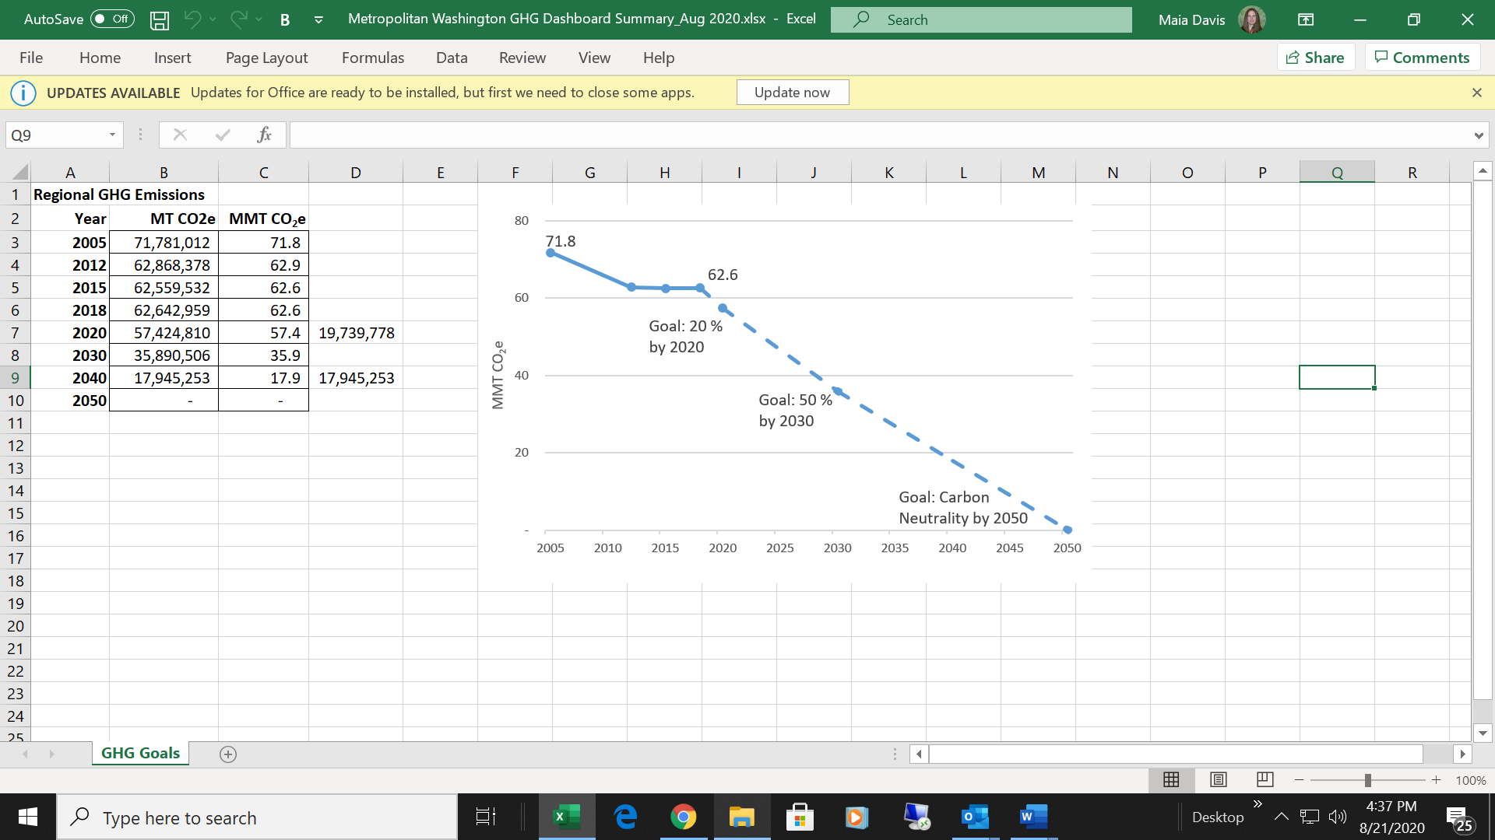

EMISSIONS ACTIVITIES

The inventories measure GHG-emitting activities undertaken by residents, businesses, industry, and government located in Metropolitan Washington, as well as emissions from visitors. More than 90 percent of metropolitan Washington’s GHG emissions come from residential and commercial building energy consumption and transportation. Building energy consumption accounts for 50 percent and 42 percent is from transportation. The remainder of emissions comes from other activities and sources including solid waste, wastewater treatment, agriculture and fugitive emissions (Figure 3).

Figure 3: Metropolitan Washington GHG Emissions by Activity

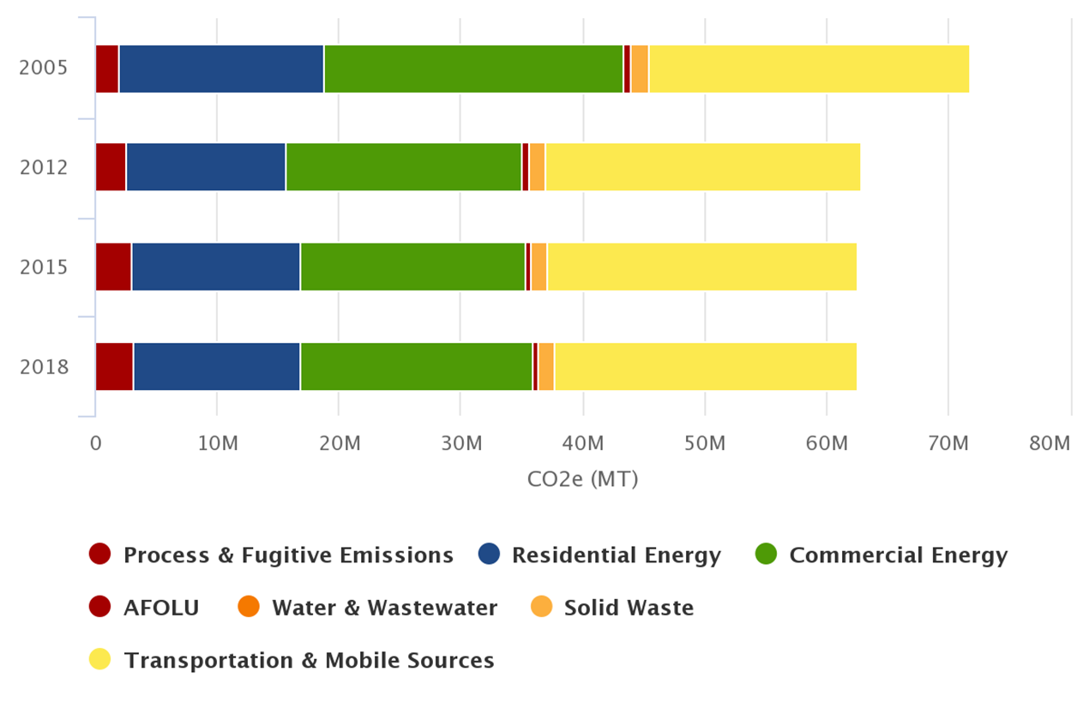

Source: ICLEI’s ClearPath, an online greenhouse gas inventory tool.

METHODOLOGY

The inventories have been developed to be compliant with both the U.S. Communities Protocol for Accounting and Reporting Greenhouse Gas Emissions (USCP), Global Protocol for Community-Scale Greenhouse Gas Inventories (GPC), and Global Covenant of Mayors (GCoM) reporting framework. COG mainly follows the calculation guidance from USCP as the USCP identifies sources of data widely available to communities in the US. COG uses ICLEI’s ClearPath tool Community Scale Inventory Module for preparing GHG inventories, which is consistent with both US and global accounting protocols.[24]

COG makes every effort to capture a complete and accurate picture of GHG trends across the region, while also providing for a consistent methodology that is replicable across communities and inventory years. COG inventories follow an activities-based approach, meaning emissions are calculated based on the result of activities happening in each of the COG members’ communities. Local results are totaled to create a picture for the region as a whole. For a detailed description of the methodology, see Appendix F: Greenhouse Gas Inventory Methodology.

DRIVERS OF GHG CHANGE

ICLEI’s GHG Contribution Analysis Tool evaluates the biggest drivers influencing GHG performance of cities, counties and regions. The tool provides for a deeper understanding of what is driving emissions changes between GHG inventory years to help identify and prioritize more effective actions to reduce GHG emissions. COG was a partner on a national team under the U.S. Department of Energy Cities Leading through Energy Analysis and Planning (CLEAP) Program to develop the Contribution Analysis model and toolkit.[25]

The metropolitan Washington GHG Contribution Analysis results in Figure 4 shows what has driven increases and decreases in emissions between inventory years 2005 and 2018. The main drivers increasing emissions (red bars) include growth in population, commercial space, and hydrofluorocarbons (HFCs). Driving down emissions (blue bars) is mainly a cleaner grid, cleaner cars and reduced vehicle miles traveled (VMT) per person.

Figure 4: Drivers of Metropolitan Washington GHG Changes

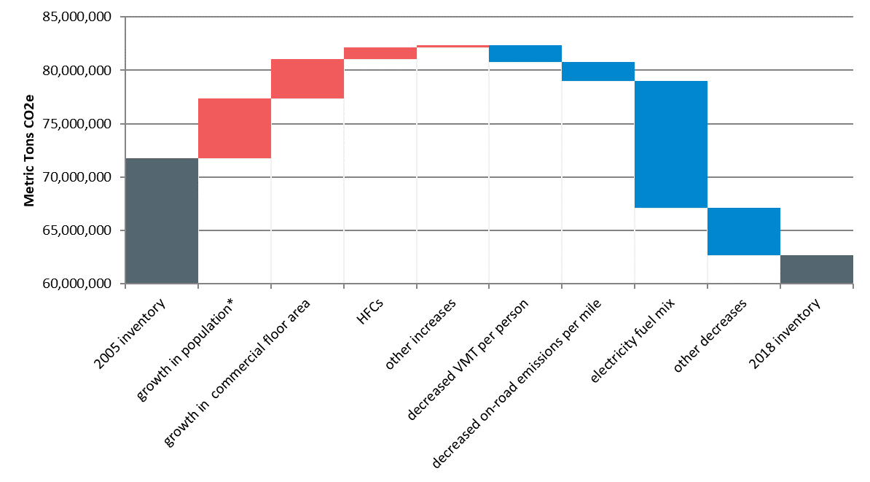

*Includes effects of population on residential energy, VMT and waste generation.

Business-As-Usual Projections[26]

Business-as-usual (BAU) projections provide a baseline scenario for future GHG emissions. BAU projections take into account driving factors such as growth in population, housing and commercial development and the impact they will have on future GHG emissions. BAU projections reflect policies and practices that have been in place and implemented to-date to reduce GHG emissions, but do not incorporate any additional GHG emission reductions from anticipated future action.

The metropolitan Washington BAU scenario for this Plan projected emissions out to 2030. Based on the assumptions used, total emissions overall remained flat between 2015-2030. Figure 5 shows the region’s anticipated BAU emissions projected out to 2030. See Appendix G: BAU and 2030 Scenario Assumptions for a summary table on the assumptions.

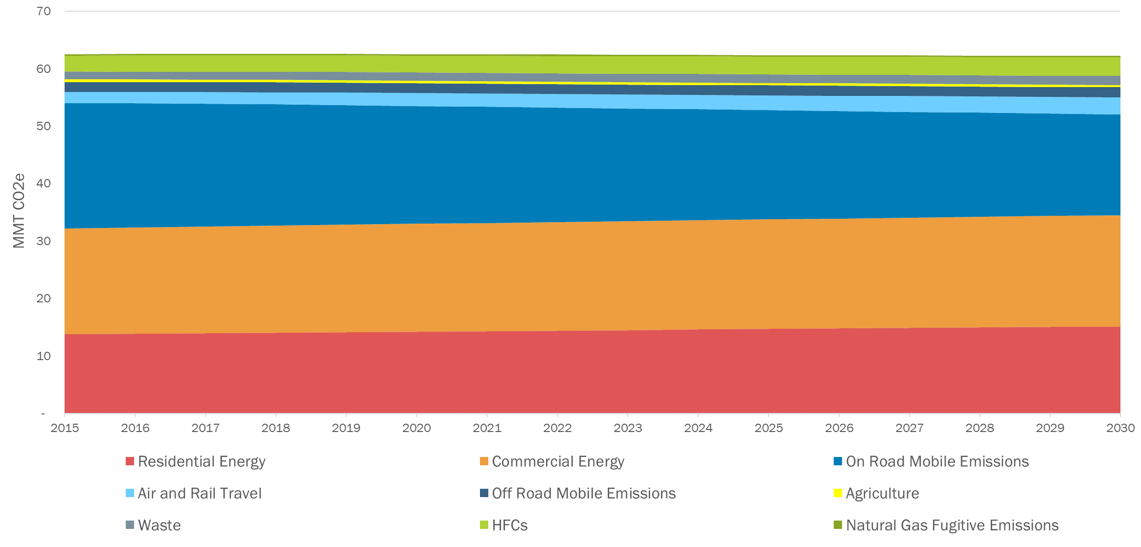

Figure 5: Metropolitan Washington Business-As-Usual Projections

2030 Scenario

This scenario for this Plan analyzes the technical potential of "What Would It Take" for metropolitan Washington to reach a 50 percent reduction in GHG emissions from 2005 levels to 2030. This scenario leverages results from a previous scenario analysis conducted in 2015 by the Ad-Hoc Multi-Sector Work Group and results have been updated based on new data and progress since that time.

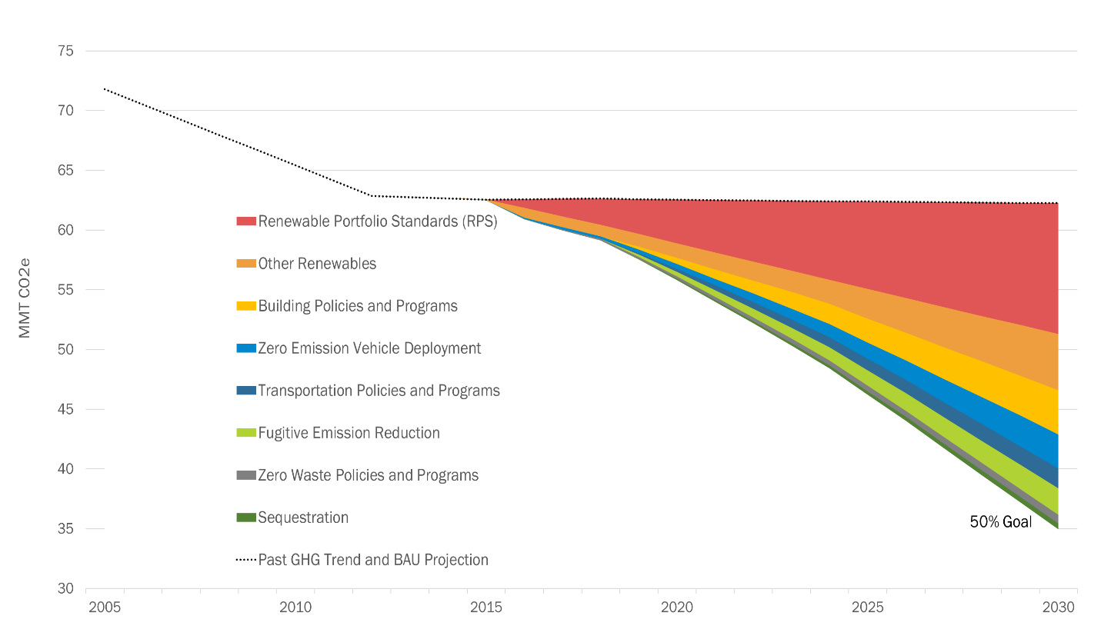Figure 6 shows a summary of the results to the “What Would It Take” scenario to reduce emissions 50 percent by 2030. The implementation of state Renewable Portfolio Standards will have the most significant impact on reducing emissions. Considerable action across local, regional, state and national levels will be needed. See Appendix G: BAU and 2030 Scenario Assumptions for a summary table on the assumptions.[27]

Figure 6: Metropolitan Washington “What Would It Take” Scenario Results

Regional climate mitigation strategy

Moving Toward Zero

The Regional Mitigation Strategy includes collaborative actions to support the region in achieving the greenhouse gas (GHG) emission reduction goals of 50 percent by 2030, below 2005 levels, and carbon neutrality by 2050. In order to move the region toward net zero emissions the region needs to emphasize an equitable transition to clean electricity, zero energy buildings, zero emission vehicles and zero waste as well as enhance the net benefits of sequestration.

Priority Collaborative mitigation Actions

The climate action areas included in the Regional Climate Mitigation Strategy address Planning, Equity, Clean Electricity, Zero Energy Buildings, Zero Emission Vehicles, Zero Waste, and Sequestration. Within these action areas are high-level priority actions for CEEPC and its members to focus on through 2030. All actions are voluntary. Actions have a 1-page description that includes:

* An action overview with example policies, programs, or projects;
* How the action supports regional GHG emission reduction goals;
* Identifies what level of implementation is needed by 2030 and beyond (based on the “What Would It Take” scenario to reduce emissions 50 percent by 2030);
* Examples of how COG and local jurisdiction efforts that can support implementation (it’s not an exhaustive list); and
* How the action benefits other *Region Forward* goals.

Table 2 is a summary of the climate action areas and priority collaborative actions described in this strategy. While these actions focus on what the Climate, Energy and Environment Policy Committee (CEEPC) members can do together to move the region towards the 50 percent by 2030 goal, other bodies at COG are also implementing action that support GHG emission reduction. After the action descriptions, this section includes a summary of regional transportation and land use planning efforts that also address climate change.

Table 2: Metropolitan Washington Priority Collaborative Mitigation Actions

|  |  |  |
| --- | --- | --- |
| Climate Action Area | Action ID | Priority Collaborative Action |
| Planning | PL - 1 | Advance Climate Planning and Track Progress |
| Equity | EQ - 1 | Enable Equitable Planning Practices |
| EQ - 2 | Prioritize Sustainable Energy Access for All |
| Clean Electricity | CE - 1 | Advocate for Aggressive Renewable Portfolio Standards |
| CE - 2 | Accelerate Development of On-Site Renewables |
| CE - 3 | Accelerate Deployment of Battery Storage |
| CE - 4 | Accelerate Development of Microgrids for Critical Infrastructure |
| CE - 5 | Accelerate Development of Large-Scale Off-Site Renewables |
| CE - 6 | Advocate for and Implement Community Choice Aggregation |
| Zero Energy Buildings | ZEB - 1 | Expand Building Benchmarking Requirements |
| ZEB - 2 | Accelerate Deep Building Retrofits |
| ZEB - 3 | Enhance Green Building Codes and Policies to Facilitate Net Zero Energy Building Development |
| ZEB - 4 | Expand Proper Disposal and Leak Detection of Refrigerants |
| Zero Emission Vehicles | ZEV - 1 | Expand Light-Duty Electric Vehicle Deployment |
| ZEV - 2 | Accelerate Electrification of Medium- and Heavy-Duty Vehicles |
| ZEV - 3 | Build Out Regional Electric Vehicle Charging Network |
| Zero Waste | ZW - 1 | Implement Curbside Organics Recycling Programs |
| ZW - 2 | Reduce Solid Waste Generation |
| ZW - 3 | Build Markets for Circularity |
| Sequestration | SQ - 1 | Strategically Plant New Trees on Publicly Owned Land |
| SQ - 2 | Enhance Regulatory Capacity to Manage Tree Canopy and Forest Protection |
| SQ - 3 | Enhance Tree Planting and Preservation on Privately Owned Lands |

PL-1: advance climate planning and track progress

Action Overview

Local jurisdictions play a central role in the global effort to reduce GHG emissions. Climate action planning provides local jurisdictions with the direction needed to achieve the overarching vision and goals for the community while also curbing GHG emissions. The United Nations states that climate action plans should be ambitious, inclusive and fair, comprehensive and integrated across sectors, relevant and actionable, evidence-based, transparent and verifiable. Conducting GHG inventories is an important part of measuring changes over time to track progress toward goals.[28]

The City of Bowie develops climate action plans in 5-year intervals and tracks progress annually. Bowie’s Vision for 2030 includes GHG emission to be 50 percent below 2015 levels, more than half of energy consumption comes from renewables and one-third of privately owned vehicles are electric. Government action is being led by an intergovernmental Sustainability Staff Team and community action is led by a Mobilization Team comprised of a diverse group of community leaders. COG develops the City’s community-scale inventories to track progress toward the plan’s goals.[29]

Level of Implementation Needed to Reach Overall GHG Goal:   
Developing and implementing equity-focused climate plans and tracking progress through GHG inventories lays the foundation for reducing GHG emissions 50 percent below 2005 levels by 2030.

Supporting Overall GHG Reduction Goal

With more than 90 percent of total GHG emissions in the region associated with the built environment and transportation, implementation of plans to reduce emissions from these sectors have the potential to significantly reduce emissions. Local jurisdictions and the region cannot monitor progress if it is not measured; therefore, GHG inventories are an important piece of supporting GHG emission reduction goals.

How COG Can Support

* Complete GHG emission inventories at milestone dates to measure local and regional progress. Follow and help advance U.S. and global best practices for inventories.
* Develop and incorporate net emissions, from sources such as forests/trees and renewable procurement, in COG inventory work to better track progress toward carbon neutrality.
* Update GHG Contribution Analyses for new inventory years to evaluate what is driving GHG change across the region.
* Support jurisdictions in climate planning initiatives, including equitable climate policy, program and decision-making processes.
* Support tracking of local and regional goals, plans, and progress. Share and encourage best practices.

How Member Jurisdictions Can Support

* All COG member jurisdictions should adopt GHG emission reduction goals.
* All COG member jurisdictions should adopt climate/energy plans.
* Adopt climate emergency policies.
* Review COG community-scale inventory work and modify local results, where appropriate. Conduct local government operations inventories.
* Educate public on GHG impacts to the community and engage community in equitable solutions.

*Region Forward* Co-Benefits:

* Equity: Engage all parts of the community in climate planning initiatives. COG Equity Emphasis Areas can be leveraged as a resource for equitable engagement opportunities.

EQ-1: ENABLE EQUITABLE PLANNING PRACTICES

Action Overview

Integrating equity into all components of planning practices is critical to ensuring that climate policies and programs address the concerns of all community members, particularly those in underserved communities. Underserved communities have been disproportionately impacted by environmental exposures, including ambient air pollution and climate-change-related health impacts. This trend will continue unless planning processes at all levels of government make addressing these historical inequities central to climate change decision-making processes.[30]

To support communities looking for guidance on best practices for incorporating equity considerations in planning processes, COG released the Environmental Justice Toolkit (EJ Toolkit) in 2017. The EJ Toolkit is intended to be a resource on government measures, practices, and policies aimed at creating cooperative solutions to issues of fair and just treatment and equitable access in the development, application, and enforcement of environmental policies.[31]

Level of Implementation Needed to Reach Overall GHG Goal:   
In order to meet the overall GHG reduction goal, equity will need to be a central component of planning practices for all member jurisdictions.

Supporting Overall GHG Reduction Goal

Achieving the region’s overall GHG emissions reduction goals will not be possible without the implementation of equitable planning processes that fully integrate the concerns and needs of disadvantaged communities. Engaging and activating these communities will be critical to achieving these goals.

How COG Can Support

* Continue to support local jurisdictions on racial equity planning and integrating climate planning within this context.
* Continue to identify and share tools, datasets, and resources, such as Equity Emphasis Areas and the Environmental Justice Toolkit, to help jurisdictions define what equity means in their local context and engage underserved communities.[32]
* Continue to share best practices through regional meetings and materials on how to perform equitable engagement and planning processes and how to design climate action equitably.

How Member Jurisdictions Can Support

* Develop an equity plan that incorporates addressing climate impacts to vulnerable populations.
* Develop a process for mainstreaming equitable community engagement during climate and energy projects and planning processes.
* Provide accessible and meaningful engagement opportunities for underserved communities and develop a shared understanding of community needs.
* Support community leadership development in underserved communities.
* Provide data, information, and resources to underserved communities and engage community members in citizen science so they are a part of developing relevant data for their community.

*Region Forward* Co-Benefits:

* Economy**:** Equitable advancement of the clean economy includes supporting green job training programs and providing economic benefits to disadvantaged communities through investment in green infrastructure and sustainable housing.
* Health and Human Services: With a more equitable approach to planning, some health and climate risks can be addressed in underserved communities that experience the highest risk.

EQ-2: PRIORITIZE SUSTAINABLE ENERGY ACCESS FOR ALL

Action Overview

Ensuring that all residents and local businesses have access to sustainable and affordable energy is key to reducing GHG emissions while simultaneously ensuring that underserved communities are well positioned to achieve economic stability and improve their overall quality of life. Historically, there have been significant disparities in renewable energy deployment based on race and ethnicity. For example, even when adjustments for household income and homeownership rates are made, black and Hispanic residents are significantly less likely to install and reap the cost savings benefits of rooftop solar photovoltaics (PV) systems. [33]

Overall “energy burden,” or the percentage of household incomes that goes towards energy costs, is also a significant concern for underserved communities. Across the region, underserved communities spend a larger portion of income on home energy cost than other residents. Figure 7 shows that mean energy burden across census tracts in Equity Emphasis Areas (EEAs) is 6.6 percent higher than all other census tracts in the region. Metropolitan Washington EEAs, identified by COG and its members, include communities that have a higher than average concentration of low-income, minority populations, or both. Ensuring equitable energy access to underserved communities ensures energy burdens don’t limit residents’ ability to choose between paying energy bills or living essentials.[34]

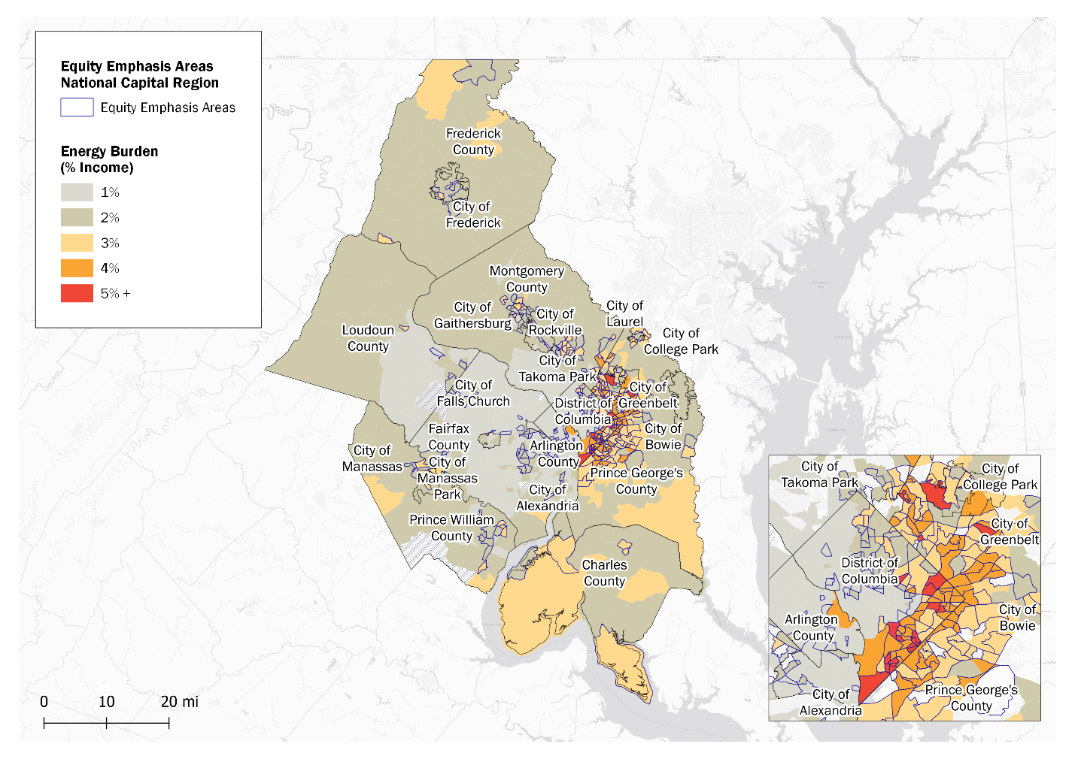

Source: US Department of Energy Low-Income Energy Affordability Data (LEAD) Tool and COG Equity Emphasis Areas

Figure 7: Equity Emphasis Areas and Energy Burden

Jurisdictions can enact policies and programs that aim to increase access to sustainable energy and reduce energy burden. For example, D.C.’s Solar for All program, established in 2016, aims to provide 100,000 low-to-moderate income families with the benefits of locally generated clean energy and help reduce their energy bills 50 percent by 2032. The program is funded through the District’s Renewable Energy Development Fund. At the state level, Maryland’s community solar program has a low-income “carve-out,” meaning that about 125 megawatts (MW) of the total 418 MW statewide cap is set aside for projects focused on low- and moderate-income customers. The carve-out increases the attractiveness of these projects to potential developers and increases the overall likelihood that these projects will be built.[35]

Level of Implementation Needed to Reach Overall GHG Goal:   
Increasing deployment of on-site renewables in underserved communities will be critical to reaching the overarching target of 3.4 percent of total electricity supply being provided by on-site solar PV by 2030.

Supporting Overall GHG Reduction Goal

Investing in the deployment of solar PV and energy efficiency improvements in underserved communities has the potential to both decrease the emissions associated with electricity consumption and reduce total energy consumption associated with buildings in these areas. Since over 35 percent of total GHG emissions in the region are associated with the electricity consumption, increasing access to sustainable and affordable energy has significant potential to reduce emissions.

How COG Can Support

* Identify priority populations or areas that are energy burdened and could benefit most from solar PV investment and energy efficiency improvements.

How Member Jurisdictions Can Support

* Develop and implement energy efficiency and renewable energy programs for low income households.
* Engage with underserved communities to identify a shared understanding of community needs and share available resources for building energy improvement programs and incentives.
* Support clean energy economy and workforce development in underserved communities.

*Region Forward* Co-Benefits:

* Economy:Low-income populations in the region are disproportionately burdened by the cost of energy and are least likely to have the capital or support to upgrade their homes to be more energy efficient. A focus on supporting these communities will reduce costs while reducing regional GHG emissions.
* Health and Human Services:Energy bills can be highest in the summer as temperatures rise and cooling demand increases. With reduced energy cost burdens, lower income households may be able to afford to run cooling equipment throughout the summer, protecting occupants from extreme heat and the associated health risks.

CE-1: Advocate for Aggressive renewable Portfolio Standards

Action Overview

A Renewable Portfolio Standard (RPS) is a regulatory measure that requires a certain proportion of the state’s energy to come from renewable sources including solar, wind, and other alternatives to fossil fuel electricity generation. It is the most successful method of increasing the amount of renewable electricity generated within a grid system and drives greater deployment of renewable energy projects.[36]

In 2018, the District of Columbia updated its RPS, requiring 100 percent of electricity sales to come from renewable energy sources by 2032 with a 10 percent solar carveout by 2041. In 2019, Maryland updated its RPS, requiring 50 percent of electricity sales in the state to come from renewable sources by 2030. It also includes a solar carveout of at least 14.5 percent by 2030, and at least 1,200 MW of offshore wind by 2030. In 2020, Virginia passed the Clean Economy Act, which requires that 100 percent of electricity sales in the state comes from renewable sources by 2045 or 2050 (depending on the utility classification). This is a significant increase from the state’s previous RPS, which only established a voluntary 15 percent RPS goal by 2025.[37]

Level of Implementation Needed to Reach Overall GHG Goal:   
By 2030, states and utilities are able to continue adding renewable generation capacity to achieve the following percentages of renewable energy in terms of overall grid mix: Washington D.C. (87 percent), Maryland (50 percent), and Virginia (35 percent).

Supporting Overall GHG Reduction Goal

Carbon-intensive fossil fuels remain responsible for a significant percentage of total electricity generation provided to the regional grid. In 2015, utility supplied renewable energy in metropolitan Washington made up over 8 percent of electricity sales that year. With aggressive RPS goals, this percentage will grow significantly in the coming decades With 36 percent of total GHG emissions in the region associated with electricity consumption, state RPS programs that accelerate the deployment of renewable energy on the region’s grid is crucial for reducing GHG emissions.[38]

How COG Can Support

* Continue to support strong state-level RPS and encourage REC markets.
* Encourage solar carve-outs in RPS policies to support solar project development in the region.

How Member Jurisdictions Can Support

* Continue to support strong state-level RPS and encourage REC markets.

*Region Forward* Co-Benefits:

* Economy: RPS sends a signal to utilities and businesses to increase renewable energy investment.
* Health and Human Services:By decreasing market demand for fossil-fuel electricity generation technologies, RPS can decrease criteria air pollutants and associated adverse health impacts.

CE-2: Accelerate development of On-site renewables

Action Overview

On-site renewable energy systems can both reduce electricity costs for local residents and businesses and increase the percent of renewable electricity supplied to the regional grid. Local governments have several tools available for increasing the capacity of renewables installed in their communities including directly installing renewables on government facilities, mandating or incentivizing renewables on newly constructed buildings in the community, implementing solar co-ops, and meeting EPA Green Power Partnership (GPP) requirements.

A number of local governments have installed solar on municipal buildings, including the District of Columbia, Montgomery County, Prince George’s County, the City of Bowie, and others. Solarize NoVA is a community-based outreach initiative sponsored by the Northern Virginia Regional Commission (NVRC) that facilitates the deployment of solar energy to homes and businesses in Northern Virginia. Through bulk purchasing and free solar site assessments, they have played a prominent role in more than 370 solar energy systems installed in Northern Virginia, totaling 3.9 megawatts of capacity.[39]

Level of Implementation Needed to Reach Overall GHG Goal:   
By 2030, on-site renewables will account for 2 percent of total electricity supply in the region. This is equivalent to needing 200,000 more rooftop solar systems.

Supporting Overall GHG Reduction Goal

Carbon-intensive fossil fuels remain responsible for a significant percentage of total electricity generation provided to the regional grid. On-site renewable installations help to reduce the region’s reliance on these fossil fuel resources. With 36 percent of total GHG emissions in the region associated with electricity consumption, local policies and programs to accelerate the deployment of on-site renewables have the potential to significantly reduce emissions.

How COG Can Support

* Support member jurisdictions:
  + Adopt solar-ready new construction ordinances or incentive programs;
  + Form and operate solar cooperatives and support associated solar mapping effort; and
  + Install renewable energy systems on schools and municipal infrastructure.
* Provide clean energy feasibility assessments at key facilities (campuses, hospitals, etc.).

How Member Jurisdictions Can Support

* Establish residential and commercial new construction ordinances or incentives that require the installation of solar or solar-ready construction to enable solar installation at a later date.
* Provide or promote incentives to encourage installation of solar in the community.
* Form new or expand existing solar cooperatives.
* Install renewable energy systems on all new and existing municipal buildings and facilities.
* Achieve and maintain EPA GPP at government operations and community levels.

*Region Forward* Co-Benefits:

* Economy and Equity:On-site renewable systems can reduce the financial burden associated with energy costs. Incentives and cooperative campaigns can be designed to maximize participation rates among economically disadvantaged communities.
* Public Safety:When paired together, on-site renewable systems and battery storage systems have the potential to supply electricity during grid outages and add to grid resilience by decreasing peak loads and stress on the distribution system.

CE-3: Accelerate Deployment of Battery Storage

Action Overview

Battery storage deployment supports renewable energy as it has the capability of reliably supplying renewable energy to the grid when there is high demand. One of the main barriers to renewable energy being widely adopted has been the challenge of on-demand operation and providing a “baseload” of power to the grid. When renewables are deployed with battery storage, energy load reliability is dramatically improved. An additional benefit of battery storage deployment is that it boosts the resilience of facilities where it is deployed.[40]

Virginia’s Grid Transformation & Security Act of 2018 allows Dominion Energy to invest in up to 30 megawatts of battery storage pilot projects. In 2020, Dominion has had four battery storage pilot projects approved, which will pave the way for additional energy storage technology projects needed to support the company's commitment to achieve net zero carbon and methane emissions by 2050, increase renewable energy deployment and improve grid reliability.[41]

Level of Implementation Needed to Reach Overall GHG Goal:   
By 2030, to realize the full emission reduction and grid stabilization potential of on-site solar photovoltaics (PV) installed across the region, approximately 10 percent of PV installations will need to be paired with battery storage systems.

Supporting Overall GHG Reduction Goal

Carbon-intensive fossil fuels remain responsible for a significant percentage of total electricity generation provided to the regional grid. Battery storage deployment reduces the region’s reliance on these fossil fuel resources, while bolstering the region’s resilience. With 36 percent of total GHG emissions in the region associated with electricity consumption, local policies and programs to accelerate the deployment of battery storage have the potential to support significant GHG emissions reductions.

How COG Can Support

* Support state and national incentives and opportunities that enhance battery storage deployment in the region.
* Identify on-site and grid-scale battery storage deployed in the region.
* Partner on grant applications or provide contract support for project planning and implementation support.

How Member Jurisdictions Can Support

* Advocate for utility-scale battery storage deployment.
* Implement battery storage pilot initiatives at public facilities.
* Provide or promote incentives to community for energy storage systems.
* Incorporate community energy infrastructure needs, goals, and strategies in master plans, comprehensive plans, and small area plans.

*Region Forward* Co-Benefits:

* Economy and Equity: Battery storage programs and incentives has the potential to provide cost savings to local governments, businesses and economically disadvantaged. Accelerating battery storage installations also has the potential to create high quality jobs in the region.
* Public Safety: Battery storage has the potential to supply electricity during grid outages and add to grid resilience for critical facilities (e.g. hospitals, schools, nursing homes) and in underserved communities.

CE-4: Accelerate Development of Microgrids for Critical Infrastructure

Action Overview

A microgrid is a localized energy grid with its own control system, allowing it to disconnect from the traditional grid and operate autonomously, as well as connect to the grid and act as a distributed power resource. Microgrids can provide a form of energy resilience and independence for local residents and businesses due to their ability to “island” from the larger grid. This is especially important for critical infrastructure when energy is needed during blackouts or other interruptions in service. Additionally, microgrids can provide a way to secure energy access to vulnerable populations.[42]

Montgomery County has installed a microgrid project at the County’s Public Safety Headquarters, as part of a comprehensive effort to ensure the resiliency of critical public services during major electric distribution system outages. The project includes multiple clean energy technologies, which will reduce GHG emissions by 5,900 metric tons annually. Montgomery County has also installed a microgrid at the County’s Correctional Facility, which will reduce GHG emissions by 950 tons annually.[43]

Level of Implementation Needed to Reach Overall GHG Goal:   
Development of microgrids at critical facilities like schools and hospitals will help the region achieve needed 2030 implementation levels for on-site renewable energy and battery storage and improve overall resilience.

Supporting Overall GHG Reduction Goal

Microgrids provide resilience through their localized power sources. These power sources are largely renewable and are often combined with energy storage systems. This reduces reliance on the larger grid, which provides a significant power from carbon-intensive fossil fuels. With 36 percent of total GHG emissions in the region associated with electricity consumption, greater numbers of microgrids has the potential to significantly reduce emissions.

How COG Can Support

* Support the identification and selection of critical infrastructure for microgrid implementation.
* Partner on grant applications or provide contract support for project planning, feasibility, and implementation support.
* Support state incentives and opportunities to help facilitate microgrid deployment.
* Coordinate with members and partners to reduce barriers to deployment.

How Member Jurisdictions Can Support

* Assess feasibility of and implement microgrids at critical infrastructure.
* Coordinate with utilities and critical infrastructure partners to deploy microgrid solutions that support potentially vulnerable populations and underserved communities.

*Region Forward* Co-Benefits:

* Public Safety and Equity:Microgrids have the potential to supply electricity during grid outages and add to grid resilience for most critical facilities (e.g. hospitals, schools, nursing homes) and in underserved communities.
* Education: Schools present great opportunity for microgrids and add renewable energy to schools, increase resilience and help to educate students and community members on benefits of microgrids.

CE-5: Accelerate Development of Large-Scale, Off-Site Renewables

Action Overview

Large-scale, off-site renewable energy systems can reduce electricity costs for local governments, businesses and residents while increasing the percent of renewable electricity supplied to the regional grid. Power purchase agreements (PPAs) are the main vehicle for providing large-scale renewable energy to the grid. A PPA is an arrangement between a third-party developer, who installs, owns, and operates an energy system on a customer’s property; and the customer, who purchases the system’s electricity. Additionally, a renewable energy credit (REC) is an instrument that can be used to substantiate renewable energy claims. RECs represent the rights to environmental, social, and other non-power attributes of renewable energy.[44]

At the end of 2019, Fairfax County announced contracts with multiple solar PPA service providers, which will allow for the installation of solar arrays at government, school, and park sites. This initiative is the largest of its kind in Virginia to date and has the potential to save the County more than $60 million in electricity costs, while supporting the County’s greenhouse gas reduction goals. Similarly, Frederick County entered into a PPA with Tesla for a solar array on the County’s landfill.[45]

Level of Implementation Needed to Reach Overall GHG Goal:   
By 2030, 9.5 percent of total electricity supplied in the region will need to come from 100 percent renewable electricity procured through contractual instruments, including PPAs and RECs. This 9.5 percent of renewables will be achieved through a combination of Community Choice Aggregation (CCAs) and PPAs and RECs outside of CCAs.

Supporting Overall GHG Reduction Goal

Carbon-intensive fossil fuels remain responsible for a significant percentage of total electricity generation provided to the regional grid. With 36 percent of total GHG emissions in the region associated with electricity consumption, local governments have the potential to significantly reduce emissions through PPAs for renewable energy. This expands the delivery of renewable energy to government facilities, as well as local businesses and other stakeholders seeking to procure more renewable energy.

How COG Can Support

* Examine the possibility of regional demand aggregation.
* Attempt cooperative purchasing initiatives or energy purchasing consortia.

How Member Jurisdictions Can Support

* Establish PPA(s) to provide clean electricity to local government facilities, potentially aggregating demand with other local jurisdictions or large local businesses to reduce cost.
* Encourage large, local businesses to investigate PPAs.

*Region Forward* Co-Benefits:

* Economy and Equity: The are potential cost savings to local governments, businesses, and economically disadvantaged, if they are sought out in PPA partnerships. Accelerating large-scale solar installations also has the potential to create high quality jobs in the region.
* Health and Human Services: By decreasing market demand for fossil-fuel electricity generation technologies, CCAs can decrease criteria air pollutants and associated adverse health impacts.

CE-6: Advocate for and implement Community Choice Aggregation

Action Overview

Figure 8: How Community Choice Aggregation Works

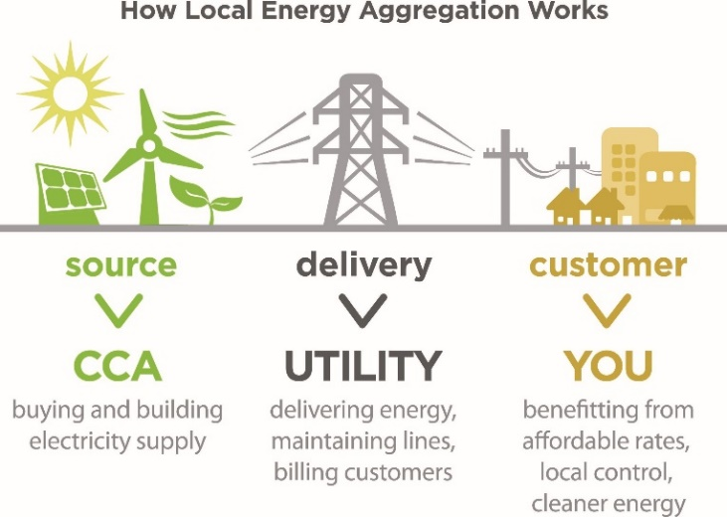Community Choice Aggregation (CCA) – sometimes referred to as Municipal Aggregation or Community Choice Energy - programs enable local governments to pool the electricity load of residents and businesses within the community and procure electricity on their behalf (Figure 8). CCAs provide local jurisdictions with greater control over their electricity generation mix and the opportunity to increase the percentage of renewables within the mix at potentially lower energy prices. Additionally, CCA programs can provide a platform for increasingly advanced methods for supplying customers with renewable electricity and investing in local distributed energy projects.[46]

In March 2020, the Maryland House of Delegates passed HB 561 that sets the path for allowing Montgomery County to establish CCA pilot program, potentially opening the door for additional CCAs across the state. Virginia Code § 56-589 allows municipalities in the state to establish CCAs.[47]

Level of Implementation Needed to Reach Overall GHG Goal:   
In addition to state-level RPS requirements and renewable electricity generated on-site, an additional 9.5 percent of total electricity supplied in the region will need to come from 100 percent renewable electricity by 2030 procured through contractual instruments, including PPAs and RECs.

Supporting Overall GHG Reduction Goal

Because CCAs enable local jurisdictions to determine the percent of electricity from renewable sources supplied to residents and businesses, they have the potential to significantly reduce electricity emissions, which account for 36 percent of the region’s total GHG emissions. Most CCAs operate on an “opt-out” basis, meaning residents and businesses are automatically enrolled in the program with the option to not participate. This leads to high participations rates, furthering their GHG emissions reduction potential.

How COG Can Support

* Advocate for policies to help overcome barriers to CCA adoption in Maryland and Virginia.
* Leverage COG Cooperative Procurement Program to fast-track local implementation.

How Member Jurisdictions Can Support

* Advocate for State policy to support authorization of CCAs and reduce barriers to CCA adoption.
* Implement and share best practices from CCA pilot programs, where applicable

*Region Forward* Co-Benefits:

* Economy and Equity: CCAs have the potential to lower electricity costs to residents and businesses, helping to reduce economic disparities and make the economy more competitive.[48]
* Health and Human Services: By decreasing market demand for fossil-fuel electricity generation technologies, CCAs can decrease criteria air pollutants and associated adverse health impacts.

ZEB-1: Expand building benchmarking requirements

Action Overview

Benchmarking programs applicable to municipal, commercial, and multifamily buildings enable building managers to measure the energy efficiency of their building against comparable buildings from across the region and identify buildings that could benefit most from energy efficiency improvements. Benchmarking programs can be voluntary or mandatory, include energy and/or water consumption, and can be customized by square footage and building type.

The vast majority of building benchmarking ordinances rely on the use of the EPA’s ENERGY STAR Portfolio Manager, a free online benchmarking tool that helps building managers track data and measure progress using a 1-100 ENERGY STAR scoring system. Both Washington D.C. and Montgomery County have enacted benchmarking ordinances that apply to commercial and multifamily buildings over 50,000 square feet and to buildings owned and operated by the jurisdiction. Although Virginia State law currently prohibits mandatory benchmarking ordinances, Arlington County benchmarks and discloses all County facilities and has offered support, training, energy challenges, and incentives for commercial and multi-family buildings.[49]

Level of Implementation Needed to Reach Overall GHG Goal:   
By 2030, assuming 30 percent of buildings receiving deep energy retrofits have been benchmarked, approximately 117 million square feet of multi-family and commercial space will need to have been benchmarked.

Supporting Overall GHG Reduction Goal

Through the identification of inefficient buildings, a benchmarking ordinance can be effective in driving increased participation in existing energy audit and efficiency programs. Since over 24 percent of total GHG emissions in the region are associated with commercial and municipal buildings, there is significant potential to reduce emissions from benchmarked buildings.

How COG Can Support

* Share best practices and lessons learned from existing benchmarking programs and provision of materials including policy/program implementation and resource guides.
* Advocate for legislation in Virginia to enable jurisdictions to adopt benchmarking ordinances.

How Member Jurisdictions Can Support

* Develop and implement or expand government operations building benchmarking initiatives (applicable in MD, VA, DC).
* Develop and implement or expand community commercial and multifamily building benchmarking ordinances (applicable in MD, DC) or provide financial or development incentives (such as floor-to-area ration, streamlined permitting, tax incentives, etc.) to buildings that agree to annual benchmarking (applicable in MD, VA, DC).
* Utilize benchmarking program as a mechanism to drive increased participation in existing government or utility energy audit and energy efficiency incentive programs.
* Promote voluntary benchmarking for commercial and multifamily buildings through marketing and outreach campaigns, providing guidance, technical support and promoting cost savings.

*Region Forward* Co-Benefits:

* Environment: Benchmarking programs can also help to identify buildings that use water inefficiently and preservation of water resources remains a *Region Forward* priority.
* Economy and Equity:Benchmarking programs leading to more energy efficient multifamily and commercial buildings reduce the financial burden associated with energy costs.

ZEB-2: Accelerate deep building retrofits

Action Overview

Deep energy retrofits aim to reduce energy consumption in buildings by at least 50 percent by taking a systems-thinking approach that evaluates interactions between different components of a building. Deep retrofit improvements include improvements to the building envelope through additional insulation, air sealing, and window replacements and upgrades to or replacements of inefficient heating, cooling, and hot water systems.

While deep retrofits result in higher cost savings, they also require higher up-front cost. For this reason, it is critical to provide attractive financing options to property owners through programs such as Commercial Property Assessed Clean Energy Financing (C-PACE), green banks, state and utility energy efficiency incentives, and programs tailored to retrofit low-income housing. All of these types of financing options exist in the region. More than 10 PACE Programs have been launched and 35 projects in the region have been financed thus far by C-PACE programs. The District of Columbia and Montgomery County have established green banks. Arlington Energy Masters is a program focused on low-income retrofits. Expanded participation in existing programs and new programs, particularly targeting low-income residents and businesses, are needed to accelerate retrofits.[50]

Level of Implementation Needed to Reach Overall GHG Goal:   
Annually, 2 percent of all residential and commercial buildings will need to receive a deep retrofit to support the region in meeting the 2030 GHG emission reduction goals.

Supporting Overall GHG Reduction Goal

By addressing financial barriers to capital-intensive deep energy retrofits, C-PACE and green banks can be effective in significantly reducing heating and cooling loads of commercial, municipal, and residential buildings. Since more than half of all GHG emissions in the region are associated with the built environment, deep energy retrofits have significant potential to reduce emissions.

How COG Can Support

* Provide technical guidance and support to assist local jurisdictions in expanding participation in existing and new energy efficiency programs.
* Facilitate regional sharing of net zero energy code language for building retrofits.

How Member Jurisdictions Can Support

* Retrofit existing public facility(ies) to net zero energy.
* Offer innovative energy financing solutions for residential or commercial sectors (e.g. green bank, PACE, loan loss reserves, etc.).
* Promote state and utility incentives and technical assistance for residential and commercial deep energy retrofits. Consider supplementing with local incentives.
* Expand programs that implement deep energy improvements in affordable housing.

*Region Forward* Co-Benefits:

* Environment: Energy efficiency programs can also help to identify buildings that use water inefficiently.
* Economy and Equity:Improving the energy efficiency reduces the financial burden associated with energy costs for both residents and local businesses. Accelerating retrofit work also has the potential to create high quality jobs in the region.
* Health and Human Services: Green buildings with enhanced ventilation help to increase indoor air quality, reduce illness, and improve productivity.[51]

ZEB-3: Enchance Green Building Codes and Policies to Facilitate Net Zero Building DevelopmeNt

Action Overview

Green building codes are laws established by states or local jurisdictions applying to newly constructed buildings or major renovations that mandate increased levels of energy efficiency and often include a requirement for the inclusion of on-site renewable energy systems. Green building codes can help to accelerate the adoption of net zero buildings – those that produce as much energy as they use - across the region.

Maryland, Virginia, and the District of Columbia have all adopted building codes that incorporate energy efficiency components outlined in the International Energy Conservation Code (IECC) and the American Society of Heating, Refrigeration, and Air-Conditioning Engineers (ASHRAE) standards. While local jurisdictions in Maryland are permitted to pass more stringent codes that exceed state minimum standards (“stretch codes”), local jurisdictions in Virginia are not. Member jurisdictions in Maryland, including Montgomery County and City of Rockville, have a history of adopting codes that are more stringent than those required by the state. Currently, Montgomery County is in the process of adopting the 2018 International Green Construction Code (IGCC). [52]

Level of Implementation Needed to Reach Overall GHG Goal:   
All jurisdictions will need to implement building codes that require net zero energy standards in new construction by 2030, through either adoption of local stretch codes or compliance with potential future state requirements that mandate net zero construction.

Supporting Overall GHG Reduction Goal

Adopting more stringent building codes, both at the state and local level, can be effective in significantly reducing the total energy consumption and increasing the level of on-site renewable energy generation of commercial, municipal, and residential buildings. Since half of all GHG emissions in the region are associated with the built environment, green building codes have significant potential to reduce emissions.

How COG Can Support

* Convene technical experts and facilitate information exchange that enable creation of policies and programs and address barriers to action.
* Coordinate local government input to the national model energy code development process.
* Encourage adoption of building codes and incentives to facilitate net zero building construction.

How Member Jurisdictions Can Support

* Participate in the national energy code development process.
* Adopt policy for all new local public facilities to be net zero energy.
* Adopt net zero energy codes or incentives for private development.
* Include net zero energy goals and strategies in master, comprehensive, and small area plans.
* Establish a net zero energy building district or portfolio.[53]
* Provide education and training on new and advanced green construction standards.

*Region Forward* Co-Benefits:

* Environment: Building codes can be designed to address both energy and water efficiency.
* Health and Human Services: Green buildings with enhanced ventilation help to increase indoor air quality, reduce illness, and improve productivity.[54]
* Public Safety:As net zero building codes continue to deemphasize reliance on natural gas in new construction, the risks associated with natural gas leaks and explosions will decrease.

ZEB-4: eXPAND pROPER dISPOSAL AND lEAK dETECTION OF rEFRIGERANTS

Action Overview

Refrigerants are chemicals found in a variety of building equipment – including air conditioners, refrigerators, and freezers – that absorb and release heat to enable chilling. Refrigerant gasses are a significant source of GHG emissions because of their high global warming potential (GWP).

The Kigali Amendment to the Montreal Protocol is an international agreement between 99 countries and the European Union to gradually reduce the consumption and production of hydrofluorocarbons (HFCs), the group of chemicals most commonly used today for refrigeration. The United States has not ratified the Kigali Amendment. In the absence of federal regulations, Maryland and Virginia have taken action. In 2020, Maryland Department of Environment proposed regulations to reduce use of HFCs 25 percent by 2030 and Virginia approved a law requiring its Air Pollution Control Board to adopt HFC restrictions modeled after the EPA’s Significant New Alternative Policy (SNAP) Rules that were overturned by a federal court in 2017.[55]

Level of Implementation Needed to Reach Overall GHG Goal:   
By 2030, refrigerant emissions will need to be reduced by 66 percent through a combination of 1) Leak detection and related upgrades to systems like refrigerators and HVAC systems, and 2) A phase out of high-GWP HFCs at the state level.

Supporting Overall GHG Reduction Goal

Advocating for increasingly aggressive state policies, educating private businesses on refrigerant management best practices, and adopting these same best practices in government operations can significantly reduce emissions associated with refrigerant leaks. A small yet growing portion of total GHG emissions in the region are associated with refrigerants and advancing refrigerant policies and best practices has significant potential to reduce these emissions.

How COG Can Support

* Share best practices through regional meetings and materials (fact sheets, resource guides etc.).
* Organize advocacy efforts to help advance legislation at state and district level restricting the use of HFCs.
* Develop education on proper handling, disposal, and leak detection for high GWP refrigerants from coolers, air conditioners, and other appliances.

How Member Jurisdictions Can Support

* Support advocacy efforts.
* Institute best practices in refrigerant management in government operations, including leak detection and monitoring, leak reporting, reporting and record keeping and retrofitting or retiring older systems.
* Promote awareness and climate impacts of proper disposal techniques and refrigerant management best practices.

*Region Forward* Co-Benefits:

* Economy and Equity: Many upgrades to reduce refrigerant leakages also improve the overall energy efficiency of equipment. Accelerating the detection of leaks and retrofitting of equipment would help these businesses save money and also create high quality refrigerant technician jobs.
* Public Safety: Leaks of some refrigerants, including freon, pose a serious health risk.

ZEV-1: Expand light-duty Electric Vehicle Deployment

Action Overview

A number of barriers are currently preventing the adoption of light-duty electric vehicles (EVs), including vehicle cost, limited number of models available, lack of consumer awareness, long charging times and the lack of capable charging infrastructure. However, as EV technology advances and the EV market matures, these obstacles are breaking down. The cost of EVs are decreasing as battery prices continue to decline, the number and range of available models is increasing as manufacturers become more heavily invested in EV development, and the speed of charging continues to increase with the expanded deployment of level 2 and DC fast charging stations.[56]

Continuing to overcome these barriers will be critical to rapidly increasing the number of EVs on the road and will require action at the state, regional and local levels. Several local jurisdictions have taken steps to electrify government fleets. For example, Montgomery County has purchased 39 battery electric vehicles (BEVs). Also, Alexandria has committed to the purchase of only electric of hybrid gas/electric general purpose sedans and is undertaking a pilot to test the feasibility of electric and hybrid police cruisers.[57]

Level of Implementation Needed to Reach Overall GHG Goal:   
By 2030, of the approximately 4.1 million light duty vehicles on the road in the region, 34 percent or 1.4 million of those vehicles will need to be battery electric (BEV) or plug-in hybrid-electric (PHEV).

Supporting Overall GHG Reduction Goal

Light-duty on-road vehicles are responsible for 60 percent of transportation emissions in the region. As the regional electricity supply continues to increasingly rely on renewable sources of generation, the emission reduction potential of EVs compared to internal combustion vehicles continues to increase. With 24 percent of total GHG emissions in the region generated by light-duty, fossil fuel on-road vehicles, local policies and programs to accelerate the adoption of EV passenger vehicles have the potential to significantly reduce emissions.

How COG Can Support

* Support aggregation of demand via COG Cooperative Purchasing Program and local EV buying coops. Coordinate closely with Clean Cities, Washington Area New Dealers Association (WANADA), and electric EV supply equipment (EVSE) industry.
* Advocate for state and national incentives for purchasing EVs.

How Member Jurisdictions Can Support

* Implement community-wide EV buying co-ops.
* Promote state and national incentives for purchasing EVs.
* Adopt green fleet policy or fleet management plan to transition fleets to zero emission vehicles and participate in cooperative procurement opportunities for public fleets.

*Region Forward* Co-Benefits:

* Economy and Equity: Fuel and maintenance cost savings associated with EVs, combined with battery production prices continuing to drop, have the potential to make EVs a more cost-effective option compared to internal combustion vehicles. Programs and policies to promote EV ownership should prioritize disadvantaged communities.[58]
* Health and Human Services: Use of gasoline, and particularly diesel, to power passenger vehicles is a major cause of criteria air pollutants and associated adverse health impacts. EVs, which release no tailpipe emissions, can help to significantly reduce local air pollution.

ZEV-2: Accelerate electrification of medium- and heavy-duty vehicles

Action Overview

In recent years, light-duty electric vehicles have achieved significant market penetration. However, electrification of medium- and heavy-duty vehicles (MHDVs) remains in the early phases and technological advancements are needed for electric MHDV to be deployed at scale. By electrifying MHDV public fleets and working collaboratively with private fleets to pursue fleet electrification, COG member jurisdictions and regional partners can advance electric MHDVs in the region.[59]

Bolstered by significant levels of federal and state funding, busses are one application where MDHV electrification has made progress. In 2020, 15 states, including Maryland, and the District of Columbia announced a joint memorandum of understanding committing to work collaboratively to accelerate the market for electric MHDVs with the goal of ensuring that 100 percent of new MHDV sales be zero emissions by 2050, with an interim goal of 30 percent by 2030. Local transit agencies including the D.C. Circular, Frederick County TransIT, and Montgomery County’s RideOn have deployed electric busses. Through a partnership with Dominion, Virginia localities, including Arlington, Alexandria, Fairfax County and Prince William County are deploying electric school buses as part of a plan to move Virginia towards all-electric school bus fleets by 2030.[60]

Level of Implementation Needed to Reach Overall GHG Goal:   
By 2030, approximately 7 percent of medium-duty and 6 percent of heavy-duty vehicles will need to be battery electric vehicles (BEVs) or plug-in hybrid-electric vehicles (PHEVs).

Supporting Overall GHG Reduction Goal

MHDVs are responsible for 25 percent of transportation emissions in the region. As the regional electricity supply continues to increasingly rely on renewable sources of generation, the emission reduction potential of EVs compared to internal combustion vehicles continues to increase. With 10 percent of total GHG emissions in the region generated by MHDVs, local policies and programs to accelerate the adoption of electric MHDVs have the potential to significantly reduce emissions.

How COG Can Support

* Advocate for state and national actions and incentives to fund MHDV electrification.
* Support partners with grant applications to advance electric MHDV deployment.
* Support Clean Cities, local jurisdictions, and industry partners in engaging and educating local industry on opportunities and incentives to electrify their MHDV fleets.

How Member Jurisdictions Can Support

* Transition public fleet MHDVs to electric.
* Connect local private fleets with partners and opportunities to educate and incentivize transition to electric.

*Region Forward* Co-Benefits:

* Health and Human Services:MDHV diesel vehicles are a key source of local air pollution.[61] To reduce localized air pollution, electrification prioritization should be given to vehicles that primarily operate in underserved communities with a concentration of industries.
* Economy and Equity: Expanding EV charging infrastructure to support electrification of MHDVs can create high quality electrician and construction industry jobs.

ZEV-3: BUILD OUT REGIONAL ELECTRIC VEHICLE Charging Network

Action Overview

A critical barrier to the accelerated adoption of electric vehicles (EVs) by residents and businesses in the region is a lack of adequate EV charging stations. Enabling access to EV charging, especially at home, the workplace and along key corridors for long-distance trips, is critical to reducing drivers’ fear of running out of electricity before reaching a destination (‘range anxiety’).

Local governments have several tools available for accelerating the build out of the EV charging network, including directly installing EV charging at publicly owned facilities, mandating or incentivizing newly constructed buildings in the community to accommodate EV charging, and developing EV infrastructure plans to guide deployment. The City of Frederick adopted a Plug-In EV Infrastructure Implementation Plan to establish a roadmap for enhancing the network of EV charging infrastructure across the City to meet future demand. Arlington County and community partners have implemented combined solar and EV charger buying cooperatives.[62]

Level of Implementation Needed to Reach Overall GHG Goal:   
By 2030, assuming 50 percent of EV drivers have access to at-home charging, the region will need an estimated 71,000 workplace level 2, 42,000 public level 2, and 7,600 DC fast chargers to support 34 percent of all light duty vehicles being EVs.

Supporting Overall GHG Reduction Goal

As the regional electricity supply continues to increasingly rely on renewable sources of generation, the emission reduction potential of EVs compared to internal combustion vehicles continues to increase. With 34 percent of total GHG emissions in the region generated by fossil fuel on-road vehicles, local policies and programs to accelerate the build out of the EV charging network have the potential to significantly reduce emissions.[63]

How COG Can Support

* Support jurisdictions in adopting EV-ready new construction ordinances or incentives.
* Conduct regional EV gap analysis to identify most critical gaps in EV charging network.
* Support state/national incentives for EV charging deployment and technology advancement.
* Support local EV planning initiatives.

How Member Jurisdictions Can Support

* Require new developments to install EV infrastructure or be EV-Ready.
* Provide or promote incentives for EV infrastructure deployment in the community.
* Develop EV infrastructure plans for community deployment.
* Develop EV infrastructure strategy for the public fleet and deploy EV infrastructure at public facilities, garages, and refueling facilities.
* Partner with utilities or other EV infrastructure providers to deploy in the community.
* Implement innovative pilot initiatives to advance new technologies, including vehicle-to-grid, regenerative power, and solar-powered EV infrastructure.

*Region Forward* Co-Benefits:

* Equity:Plans to build out EV charging should prioritize disadvantaged communities to ensure equitable access to charging.
* Health and Human Services: Use of gasoline, and particularly diesel, to power passenger vehicles is a major cause of criteria air pollutants and associated adverse health impacts. EVs, which release no tailpipe emissions, can help to significantly reduce local air pollution.

ZW-1: Implement CURBSIDE organics RECYCLING programs

Action Overview

Curbside organic compositing enables residents and businesses to have separated, organic waste collected with regular trash and recycling collection. This organic waste, including food scraps and yard trimmings, is then directed to dedicated organic composting sites, opposed to landfill or waste-to-energy (WTE) facilities, where it is used to produce nutrient-rich soil additives for growing foods and plants.

Prince George’s County’s Organic Composting Facility is the largest municipal installation of its kind on the East Coast. The County launched a food scraps curbside collection pilot from December 2017 to January 2019 with approximately 200 households from four diverse communities. An estimated total of 112,000 pounds or 56 tons of food scraps were collected and diverted from the landfill in 14 months. The program is now expanding to 3,000 households and plans county-wide deployment in the next two to three years. Alexandria, Arlington County, Washington D.C. and several additional jurisdictions provide dedicated locations for residents to drop off food scraps.[64]

Level of Implementation Needed to Reach Overall GHG Goal:   
By 2030, curbside compositing will need to be expanded significantly to support the region in diverting 80 percent of all materials (including composting and recycling) from landfills and WTE facilities.

Supporting Overall GHG Reduction Goal

Organic material that decomposes under anaerobic (without oxygen) conditions present in a landfill causes large amounts of methane (CH4) – a GHG 25 times more power than carbon dioxide (CO2) – to be released into the atmosphere. However, under the aerobic (with oxygen) conditions present at a compositing facility, the breakdown of organic material does not produce methane because methane-producing microbes are not active in the presence of oxygen.[65] More than 2 percent of total GHG emissions in the region are associated with solid waste disposal to landfills and WTE facilities and curbside organic recycling programs has the potential to reduce emissions in the waste sector.

How COG Can Support

* Aggregate regional demand for curbside organic recycling collection to bring down costs associated with contracted waste haulers and development/expansion of composting facilities.
* Facilitate regionally shared composting projects.

How Member Jurisdictions Can Support

* Implement compositing programs.
* Invest in composting infrastructure.
* Install compost collection bins/sites outside multi-unit dwellings and public facilities.

*Region Forward* Co-Benefits:

* Land Use: Diverting organics from landfills decreases the amount of overall waste sent to landfills and, as a result, the amount of open space occupied by landfills.
* Economy and Equity:Expanding curbside compositing programs and the development of compositing facilities will create jobs across the region in the waste hauling and construction industries. To ensure equitable access to curbside composting, disadvantaged communities should be prioritized for pilot initiatives and program expansion.

ZW-2: Reduce Solid Waste Generation

Figure 9: Waste Management Hierarchy

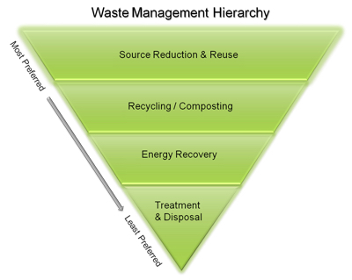Action Overview

Reducing solid waste generation prevents waste from being sent to landfill or waste-to-energy (WTE) facilities. Reducing waste at the source is the most preferred waste management strategy (Figure 9). This can be done through behavior change or by reusing items, reducing packaging, redesigning wasteful products, and buying in bulk. Recycling is another strategy for reducing solid waste, where products are recycled into raw materials and then remanufactured into new products. [66]

The Prince William County Eco-Park, including the landfill and compost facility, is an example of transforming waste into a resource that produces energy, recovers and recycles, and provides opportunities for education. Annually, more than 52,000 tons of waste is diverted from the landfill for recycling, while an additional 40,000 tons of yard waste is composted. In addition, the Eco-Park will soon have a solar energy generating facility on-site as well as food composting.[67]

Level of Implementation Needed to Reach Overall GHG Goal:

By 2030, local residents and businesses addressing their consumption and disposal patterns will be critical to support the region in diverting 80 percent of all materials from landfills and WTE facilities. Additionally, by 2030, single-use plastics will need to be banned in the majority of jurisdictions to support the 80 percent diversion target.

Supporting Overall GHG Reduction Goal

Reducing solid waste generation reduces the amount of waste that is sent to landfill or WTE facilities, thereby reducing solid waste GHG emissions. WTE facilities burn garbage and typically generate electricity from the combustion of solid waste, which also produces GHG emissions. More than 2 percent of total GHG emissions in the region are associated with solid waste disposal to landfills and WTE facilities. Minimizing waste generation reduces emissions, while contributing to a cleaner, healthier region.

How COG Can Support

* Support coordination on more direct measures at reducing waste above and beyond the more common approach of plastic and paper bag fees.
* Continue Go Recycle Campaign and incorporate education to consumers on problems associated with single-use packaging.

How Member Jurisdictions Can Support

* Implement single-use plastic and polystyrene bans.
* Invest in waste collection systems and infrastructure, including recycling facilities, and improve waste collection services in underserved communities.

*Region Forward* Co-Benefits:

* Land Use: Reducing the amount of waste sent to landfills decreases the amount of open space occupied by landfills.
* Economy and Equity: Investments in waste collection systems and infrastructure has the potential to create local jobs in the waste and construction industries.
* Equity: Focusing on expanding and improving on waste collection services offered to historically underserved communities can help improve the communities’ overall quality of life.

ZW-3: Build Markets for Circularity

Action Overview

Building markets for circularity encompasses principles that eliminate waste and pollution, while fostering economic productivity through the reuse of materials set aside as waste. The more traditional linear economy is where resources are taken, made into products, and discarded when no longer needed. Circular economy markets can reduce waste, while also creating jobs and supporting economic prosperity.[68]

Fairfax, Arlington, Loudoun, and Prince William Counties and the City of Alexandria have partnered together to recover and recycle glass waste in Northern Virginia. There are currently 36 purple glass-only drop-off containers located across these jurisdictions that serve to collect glass waste, which is then brought to Fairfax County’s “Big Blue” processing plant. The plant crushes glass bottles and jars into sand and gravel, which can then be used for paving, construction, and landscaping, as well as stormwater control applications. Some glass is also sent out of state to be turned into bottle glass and other projects.[69]

Level of Implementation Needed to Reach Overall GHG Goal:

By 2030, local residents and businesses addressing their consumption patterns and maximize reuse of materials will be critical to support the region in diverting 80 percent of all materials from landfills and WTE facilities.

Supporting Overall GHG Reduction Goal

Building markets for circularity reduces the amount of waste that is sent to landfill or waste-to-energy (WTE) facilities, thereby reducing solid waste GHG emissions. WTE facilities burn garbage and typically generate electricity from the combustion of solid waste, which also produces GHG emissions. More than 2 percent of total GHG emissions in the region are associated with solid waste disposal to landfills and WTE facilities.

How COG Can Support

* Identify potential to build markets for circular economy products and services, as well as recovered materials in public works projects.
* Continue Go Recycle Campaign and incorporate education to consumers on circular economy.

How Member Jurisdictions Can Support

* Implement strategies and good practices for circular consumption.
* Incentivize exchange programs and markets for second-hand products.
* Promote repair and restoration services.
* Set up programs for training and employment in the circular economy.

*Region Forward* Co-Benefits:

* Land Use: Promoting circular consumption, exchange programs, and markets for second-hand products reduces the amount of waste sent to landfills and decreases the amount of open space occupied by landfills.
* Economy and Equity: Businesses and programs that make use of recovered materials have the potential to reduce emissions, with the added benefit of increasing economic productivity.
* Education: Establishing programs for training in the circular economy will provide significant educational value to the community.

SQ-1: Strategically Plant New Trees on Publicly Owned Land

Action Overview

Carbon sequestration is the process by which atmospheric CO2 is absorbed by trees and other vegetation through photosynthesis and stored as carbon in biomass, including trunks and roots. Because trees and vegetation absorb CO2, they are known as ‘carbon sinks’ – reservoirs that absorb more carbon than they release. Carbon sinks help to offset other sources of GHG emissions, including those derived from the combustion of fossil fuels.[70]

The most direct way that member jurisdictions can increase levels of carbon sequestration in their communities is by taking action to expand tree canopies on publicly owned lands – including parks, buildings and facilities. Developing a tree inventory can serve as a critical, first step for jurisdictions to assess the baseline tree canopy cover and prioritize publicly owned properties that could accommodate and benefit from additional tree canopy. Over three quarters of COG member jurisdictions have completed a tree canopy assessment and have established a tree canopy cover goal. Leveraging nonprofit partners and community volunteers to play a key role in the inventorying, planting, and stewardship of trees on public lands will be key to achieving these canopy cover goals. For example, “ReLeaf” partners, including Arlington and Fairfax ReLeaf, have been instrumental in organizing volunteers to plant thousands of trees along public highways and public lands.[71]

Level of Implementation Needed to Reach Overall GHG Goal:   
Planting trees on land owned by jurisdictions will be critical to supporting the overall target of increasing regional tree canopy cover 2.4 percent above 2012 levels by 2030.

Supporting Overall GHG Reduction Goal

Expanding the tree canopy on publicly owned lands can help offset emissions from difficult-to-eliminate fossil fuels, including those combusted to heat buildings. As regional emissions continue to decrease, and difficult-to-eliminate emissions make up a larger share of total emissions, having the ability to offset emissions through sequestration will be critical.

How COG Can Support

* Host trainings and workshops among regional volunteer groups to share best practices.

How Member Jurisdictions Can Support

* Inventory trees on publicly owned land.
* Identify areas on publicly owned lands appropriate and available for additional planting.
* Provide base funding to support volunteer tree stewardship of existing and newly planted trees on publicly owned lands.
* Maintain or improve community initiatives supporting tree management or planting.

*Region Forward* Co-Benefits:

* Environment: Tree preservation improves air and water quality.[72]
* Land Use: Tree preservation is directly linked to preservation of open space, green space, and wildlife habitat.
* Health and Human Services and Equity: Tree preservation reduces health risks by improving air quality, improving water quality, and reducing urban heat island effects. Tree planting should be prioritized in disadvantaged communities with limited access to parks and green spaces.[73]

SQ-2: Enhance regulatory capacity to manage tree canopy and forest protection

Action Overview

Ensuring that member jurisdictions programs are structured in such a way to provide tree canopy and forest protection initiatives with adequate regulatory capacity is critical to achieving the region’s carbon sequestration goals. Establishing tree canopy cover goals and a tree canopy management policy, allocating adequate staff time and budget, and consistent monitoring are needed to reach these goals. One method for ensuring that member jurisdictions are on the right path for developing regulatory capacity is through participation in the Tree City USA designation process.[74]

The majority of COG member jurisdictions have established tree canopy goals and earned the Tree City USA designation. Several member jurisdictions have also taken additional key steps to adequately fund tree canopy initiatives. For example, to ensure adequate funding is available for monitoring, inspection, and enforcement of tree canopy regulations, Falls Church’s Zoning Ordinance requires owners to deposit a cash bond in an escrow account prior to the issue of building or development permits. Additionally, the City of Frederick recently launched the Tree Frederick Program, a 50-50 cost share program to help residents cover the costs of planting trees and make progress towards the city’s 40 percent tree canopy cover goal.[75]

Level of Implementation Needed to Reach Overall GHG Goal:   
Ensuring sufficient regulatory capacity for tree canopy and forest protection initiatives will be critical to supporting the overall target of increasing regional tree canopy cover 2.4 percent above 2012 levels by 2030.

Supporting Overall GHG Reduction Goal

Increasing regulatory capacity to manage tree canopy programs can help offset emissions from difficult-to-eliminate fossil fuels, including those combusted to heat buildings. As regional emissions continue to decrease, and difficult-to-eliminate emissions make up a larger share of total emissions, having the ability to offset emissions through sequestration will be critical.

How COG Can Support

* Provide technical assistance resources to assist common tree canopy program management issues among COG members.

How Member Jurisdictions Can Support

* Adopt a tree canopy/forest cover goal.
* Earn and maintain Tree City USA designation.
* Define a tree canopy management policy in local regulations.
* Dedicate budget and staff time to manage tree planting and preservation initiatives.
* Define annual progress monitoring and reporting requirements.

*Region Forward* Co-Benefits:

* Environment: Tree preservation improves air and water quality.[76]
* Land Use:Tree preservation is directly linked to preservation of open space, green space, and wildlife habitat.
* Health and Human Services and Equity: Tree preservation reduces health risks by improving air quality, improving water quality, and reducing urban heat island effects. Tree planting should be prioritized in disadvantaged communities with limited access to parks and green spaces.[77]

SQ-3: enhance tree planting and preservation on privately owned lands

Action Overview

One of the most effective strategies for expanding tree canopy coverage in the region is through the provision of incentives and funding mechanisms that encourage landowners to protect their trees. Options available to member jurisdictions include mitigation banking, adopt-a-tree programs, memorial trees programs, and incentives for planting trees to achieve specific environmental or ecological goals.[78]

During the construction and development process, many jurisdictions require the replacement of trees that have been damaged or removed. In cases where this is not possible, tree banking enables developers or landowners pay into a dedicated tree planting fund which then uses the funds to plant trees in an alternative location. In Prince George’s County, for example, developers or landowners are required to purchase credits from a woodland conservation bank if requirements cannot be met on-site. These woodland conservation banks are land that has been intentionally preserved as perpetual woodlands to satisfy the conservation requirements of other properties in the county.[79]

Level of Implementation Needed to Reach Overall GHG Goal:   
Providing incentives and funding mechanisms to support tree planting and preservation will be critical to supporting the overall target of increasing regional tree canopy cover 2.4 percent above 2012 levels by 2030.

Supporting Overall GHG Reduction Goal

Increasing tree canopy through incentives and funding can help offset emissions from difficult-to-eliminate fossil fuels, including those combusted to heat buildings. As regional emissions continue to decrease, and difficult-to-eliminate emissions make up a larger share of total emissions, having the ability to offset emissions through sequestration will be critical.

How COG Can Support

* Develop a Regional Urban Forest Action Plan.
* Develop fundraising guidebook and resources for interested COG members.
* Support COG members in identifying priority co-benefit areas with tree planting and preservation.
* Support COG members' in calculating and establishing canopy goals for major land use categories.

How Member Jurisdictions Can Support

* Calculate and establish tree canopy goals for major land use categories.
* Establish local tree planting and preservation incentives, funding mechanisms and policies.
* Establish on-site and off-site metrics for tree preservation such as tree mitigation banks or funds.
* Create or enhance adopt-a-tree and memorial tree programs to expand funding sources.

*Region Forward* Co-Benefits:

* Environment: Tree preservation improves air and water quality.[80]
* Land Use: Tree preservation is directly linked to preservation of open space, green space, and wildlife habitat.
* Housing: Providing alternatives to on-site tree preservation compliance enables denser housing development near transit/activity centers while still preserving trees.
* Health and Human Services and Equity:Tree preservation reduces health risks by improving air quality, improving water quality, and reducing urban heat island effects. Tree planting should be prioritized in disadvantaged communities with limited access to parks and green spaces.[81]

Transportation and Land Use

[To be inserted]

climate risks and vulnerabilities

Assessment Overview

In 2018, The Intergovernmental Panel on Climate Change (IPCC) released the *Global Warming of 1.5°C*, an IPCC special report, highlighting that the world is already experiencing the impacts of 1°C warming above pre-industrial levels but more severe climate impacts could be avoided if global warming is limited to 1.5 degrees Celsius. If the rate of warming continues, 1.5°C warming is likely to occur between 2030 and 2052 with more frequent and severe extreme weather events becoming even more prevalent.[82]

As the IPCC noted internationally, metropolitan Washington is also experiencing the impacts of a changing climate. Observations in metropolitan Washington show that temperatures and the water surface level in the Potomac River have been rising and will continue to rise. Extreme weather events and increases in the number of extreme heat and cold days will increase risks to health, energy usage patterns, plant and animal habitats, and infrastructure. These changes are also affecting stormwater, drinking water, and wastewater. Implementing regional adaptation strategies are necessary in order to reduce the impacts of climate change.[83]

A climate risk and vulnerability assessment (CRVA) was conducted for metropolitan Washington with the goal of understanding the climate hazards that face region and assessing the likelihood and impact of current and future hazards on the region. Climate change may increase the frequency or severity of climate hazards in metropolitan Washington, including extreme heat (high day and night temperatures), drought, flooding (flash, riverine, and coastal), lightning and thunderstorms, and extreme winter conditions.

Methodology

The regional CRVA methodology is based on the Global Covenant of Mayors for Climate and Energy (GCoM) framework. GCOM is a global alliance of cities and local governments that support voluntary action to address climate change and ensure a low emission, climate resilient future.[84] The CRVA identifies and describes current and anticipated climate hazards the metropolitan Washington faces. As shown in Table 3**,** each hazard is assigned a risk level, based on probability and level of consequence (probability x consequence). After the hazard risks are identified, an assessment is conducted to determine the future change in intensity and frequency, and the timeframe over which this will occur: Immediately, Short Term (by 2025), Medium Term (by 2050), and Long Term (After 2050).

Table 3: Climate Risk Sourcing Matrix

|  |  |  |  |  |
| --- | --- | --- | --- | --- |
|  | Probability | | | |
| Consequence |  | Low (1) | Moderate (2) | High (3) |
| High (3) | 3 | 6 | 9 |
| Moderate (2) | 2 | 4 | 6 |
| Low (1) | 1 | 2 | 3 |

Next, vulnerabilities were assessed to determine the degree in which the people, systems, sectors, and systems are susceptible to current and future climate impacts. The impacts assessed include but is not limited to: services lost, environmental impact, property damages, public health threats, economic loses, and other disruptions to day-to-day operations. For each hazard, relevant population groups in the region were identified that are most vulnerable to future climate hazards and impacts. Finally, for each hazard, factors were assessed that may impact the region’s adaptive capability.

To conduct the CRVA relevant climate studies and reports were leveraged followed by stakeholder engagement in climate planning work sessions. Both the research and stakeholder engagement informed the final CRVA results to determine the adaptive capability of the region. The findings of the CRVA provides guidance to the priority collaborative resilience actions identified in this Plan.

Summary Results

As shown in Table 4, the most prominent climate hazards facing metropolitan Washington include extreme heat and flash and riverine flooding. More frequent extreme heat days will lead to public health concerns, increase energy demand, travel disruptions, and maintenance and infrastructure damages. With more frequent and intense storms, flash and riverine flooding will increase disruptions and damages to infrastructure and emergency services, and further threaten vulnerable populations.

Table 4: Risk Level of Hazards in Metropolitan Washington

|  |  |  |  |
| --- | --- | --- | --- |
| Hazard | Probability | Consequence | Risk |
| Extreme Heat | 3 | 3 | 9 |
| Drought | 2 | 3 | 6 |
| Flooding (Flash and Riverine) | 3 | 3 | 9 |
| Coastal Flooding | 3 | 2 | 6 |
| Lightning/Thunderstorm | 3 | 2 | 6 |
| Extreme Winter Conditions | 2 | 3 | 6 |

The region must adapt to climate change. Adaptive capacity is defined as “the ability of systems, institutions, humans and other organisms to adjust to potential damage, to take advantage of opportunities or to respond to consequences."[85] Table 5 shows the degree of challenge identified for each sector evaluated in the CRVA. Infrastructure conditions pose the highest degree of challenge due to the impacts on maintenance costs, aging facilities, interoperability, and increased demand. Resilient critical infrastructure is essential to the well-being, health, and safety of the people in metropolitan Washington. Implementing resilient measures for all critical infrastructure by 2050 is necessary in order to respond to a changing climate.

Table 5: Metropolitan Washington Adaptive Capacity Degree of Challenge

|  |  |
| --- | --- |
| Factor | Degree of Challenge |
| Infrastructure Conditions/Maintenance | High |
| Access to Basic Services | Moderate |
| Access to Healthcare | Moderate |
| Public Health | Moderate |
| Housing | Moderate |
| Poverty | Moderate |
| Community Engagement | Moderate |
| Environmental Conditions | Moderate |
| Economic Health | Low |

VULNERABLE POPULATIONS

Climate change will impact people and communities differently. Potentially vulnerable populations may include low-income, minority, marginalized groups, women and girls, persons in sub-standard housing, people with limited English proficiency, the elderly, children, people with chronic health problems, or disabled persons. Where possible, the regional CRVA overlays the Equity Emphasis Areas (EEAs) developed originally for transportation planning and evaluation of communities with more health challenges with climate risks as a starting point to identify potentially vulnerable populations. Metropolitan Washington EEAs, identified by COG and its members, include communities that have a higher than average concentration of low-income, minority populations, or both. As vulnerable populations face greater risks, their consideration and inclusion in climate change planning is essential to ensure equitable distribution of benefits. Creating resilient communities is only possible when inclusion of vulnerable populations needs is met.[86]

Climate Hazards, Risks and Impacts

Extreme Heat

Extreme heat occurs when temperatures that occur in the summertime are significantly higher or more humid than the average temperature the area typically experiences. Extreme heat has a high probability of occurring in metropolitan Washington and poses a high threat to human life. [87]

Heat is the number one cause of weather-related injuries and fatalities in the region. In 2019, 53 days at or above 90°F and 13 days at or above 95°F were recorded at Dulles International Airport. Across the region, Figure 10 shows the average number of extreme heat days from 1986- 2016 overlaid with EEA’s in the region. EEAs are more heavily burdened by extreme heat. The median number of extreme heat days a year in the region is 8.61 days, the median in EEAs is 8.75 days. Potentially vulnerable populations may face barriers such as access to air conditioning, housing, and cooling centers. Populations that rely on electronic medical devices and refrigerated medication face a greater risk during power outages from extreme heat days. Populations that reside in urban areas, are more at risk due to urban heat island effects. [88]

Figure 10: Extreme Heat Days and Equity Emphasis Areas

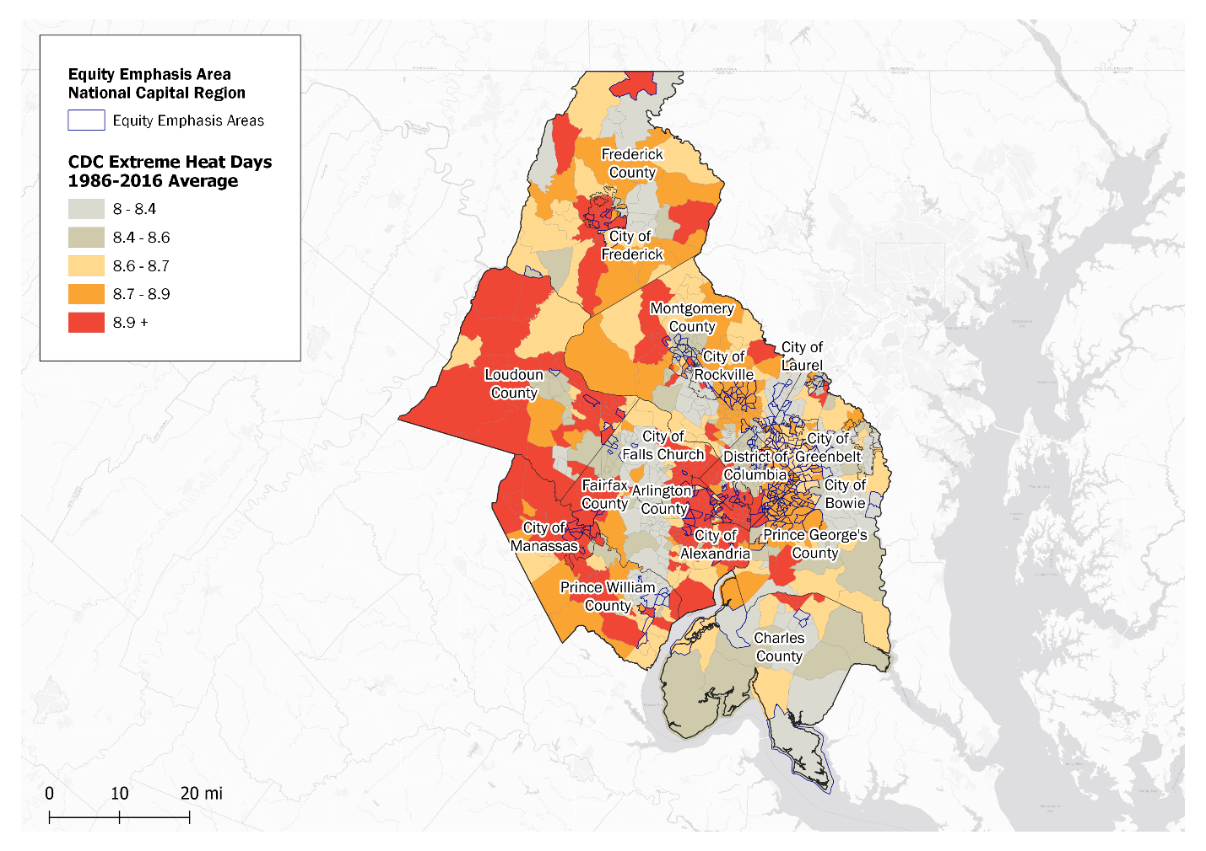

Source: Centers for Disease Control and Prevention (CDC) National Environmental Public Health Tracking Network Analysis Data Explorer and COG Equity Emphasis Areas

The number of extreme heat days will increase by 2025, with extreme both heat days and heat waves occurring more frequently. As seen in Figure 11, the National Oceanic and Atmospheric Administration (NOAA) Climate Explorer shows the number of days per year with temperatures greater than 95°F from 1950 to 2095, the red and blue fill indicates the range of future projected temperatures under high and low emissions scenarios, respectively. The data indicates a significant increase in the projected number of heat days; that the number of days per year with temperatures above 95°F may reach more than 50 to 100 days by 2065 under the high emissions scenario. [89]

Similarly, the Climate Ready DC Plan projects that the District of Columbia would experience 40 to 75 days with temperatures above 95°F by 2080 under a high emission scenario.[90]

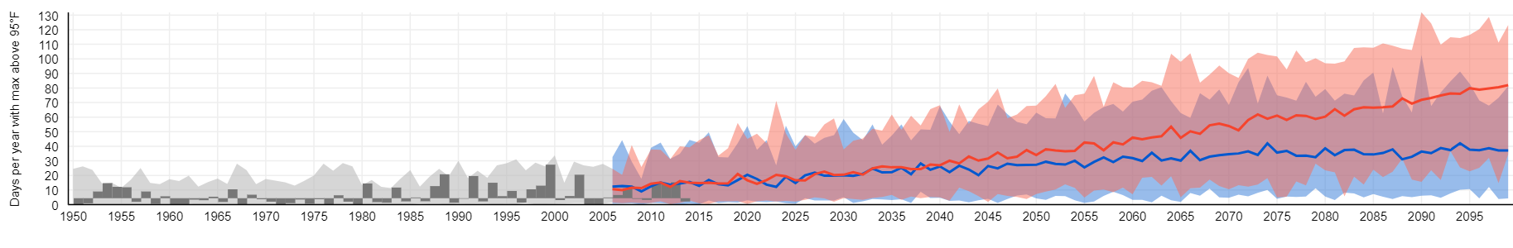

Source: NOAA Climate Explorer

Figure 11: Number of Projected Days Over 95°F from 1950 until 2095

Extreme heat presents challenges to infrastructure. Extreme heat can lead to more frequent travel disruptions, increased road surface damage and pavement softening, increase in rail infrastructure deterioration from buckling and expansion, impact aviation runways and plane takeoff, and impact electrical infrastructure (i.e. sagging lines). An increase in the number of extreme heat days may accelerate deterioration of other assets such as buildings, bridges, and vegetation, and increase cost of maintenance. Higher temperatures will result in increased cooling costs and energy demands and disruptions and damages to utility infrastructure.

Increased days of extreme heat can also lead to higher ozone pollution levels and could make it more difficult for the region to attain or maintain attainment with National Ambient Air Quality Standards (NAAQS) for ozone. High heat, unhealthy air days can trigger heat stroke, respiratory problems, heat exhaustion, hyperthermia, and death. The elderly, small children, persons with chronic diseases, persons with allergies, low-income populations, and outdoor workers are especially vulnerable to heat-related illnesses. An increase and prolonged number of extreme heat days will increase the transmission of diseases, making a longer tick and mosquito season common and increase the likelihood of vector-borne diseases. By the 2060s, the season could begin three weeks earlier in Virginia than it did from 1992 to 2007.[91]

Drought

Drought is affected by the number of precipitation-free days and warmer temperatures, causing greater evaporation and evapotranspiration. Drought can cause dry weather patterns, low water supply, and can affect agricultural crops. While upstream reservoirs provide some protection from drought for metropolitan Washington, the region is particularly at risk due to the heavy reliance on the Potomac River as the primary source of potable water. Some jurisdictions are 100 percent reliant on water withdrawals from the Potomac River. Conditions in the Potomac River Basin frequently differ between the upper and lower portions of the Basin. Drought has a moderate probability of occurring but has a high consequence of impact in the region on the water supply and agricultural systems.[92]

Although droughts account for a small percentage of hazards in the region, impacts can be severe. In September 2010, due to unusually dry conditions, COG’s Drought Coordination Committee (DCC) declared a drought ‘WATCH”; The WATCH ended when Tropical Storm Nicole hit the region. Since 2000, several smaller community water systems have briefly declared WARNING or EMERGENCY stages due to limited rainfall and less resilient water supply systems. In October 2019, The October 1, 2019 U.S. Drought Monitor for the Potomac Watershed indicated that abnormal dryness (D0) and moderate drought (D1) exist throughout the region due to an unusually hot and dry September.[93]

By 2050, droughts may occur more frequently and be prolonged, with an increased intensity.As most of the region’s drinking water comes from the free-flowing Potomac River, more frequent and intense droughts may increase the demand of water, lower base flows in the Potomac River watershed, and degrade water quality. The food and agriculture sector may face reduced crop yield and crop losses. Vulnerable populations are at a high risk, due to the indirect impacts of the disruptions of agriculture and water systems.[94]

Flash and Riverine Flooding

Flash flooding occurs when the ground exceeds the ability to absorb heavy or excessive rainfall. Riverine flooding occurs when excessive rainfall causes high flow rates and water levels to rise over the top of riverbanks. This may occur due to thunderstorms, combined rainfall and snowmelt, ice jam, or heavy rain from tropical storms. Flash and riverine flooding have a high probability and high consequence of impact, posing a high risk to public health, transportation, water supply and sanitation, and properties. Coastal storm surge has a lower probability and medium consequence in metropolitan Washington.[95]

The region has experienced many flash and riverine flooding events. In 2006, Washington D.C., experienced several days of intense rainfall, equivalent to a 200-year storm. The precipitation overwhelmed the storm sewer system. Several Federal agencies, Smithsonian museums including the National Gallery, and the Washington Metropolitan Area Transportation Authority (WMATA) had severe impacts to their operations, buildings, and infrastructure. In addition to damages to infrastructure and businesses, the event caused disruptions to critical services. A couple other notable examples of flash and riverine include May 2018 flash flooding in Frederick and July 2019 flash flooding in Northern Virginia. [96]

The frequency and intensity of heavy precipitation events are likely to increase.Figure 12**,** shows precipitation projections will occur at a higher range than historical records, demonstrating the possibility of more frequent heavy precipitation events. A 100-year precipitation event could become a one in 25-year event by mid-century, and a one in 15-year event by the 2080's.[97]

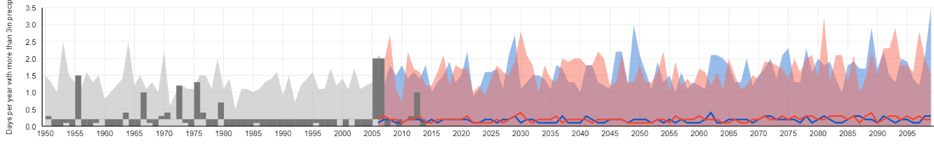

Source: NOAA Climate Explorer

Figure 12: Projected Number of Days per Year with Over 3 Inches of Precipitation

An increase in the number and intensity of flash and riverine flooding may cause disruptions to the transportation and energy sector including flooding roadways, physical damages, loss and disruption to critical and emergency services, and wide-scale power outages. Sewer systems may be damaged due to the overwhelming level of water and pollution from storm water runoff may increase a degradation of water quality and shoreline loss.

Individuals with lower socioeconomic status, such as low-income households, persons in sub-standard housing, and unemployed persons are more likely to have limited resources that may hinder their ability to prepare for flooding and evacuate before and during an event. Persons with disabilities, the elderly, persons with chronic conditions, and language barriers are also at risk during flood events. Persons residing in flood zones are at risk for loss of property and injuries. As seen in Figure 13, Federal Emergency Management Agency’s (FEMA) 100-year floodplains run through more than 60 percent of Equity Emphasis Areas (EEAs), where currently approximately 1 million people reside. Also notable, is that more than half of the region’s EEAs are within the Anacostia watershed (mainly in the District of Columbia and western border of Prince George’s County). These areas can serve as a starting point for local jurisdiction to work with these communities to further identify potentially vulnerable populations, how they will be impacted by riverine flooding, and how to address their needs.[98]

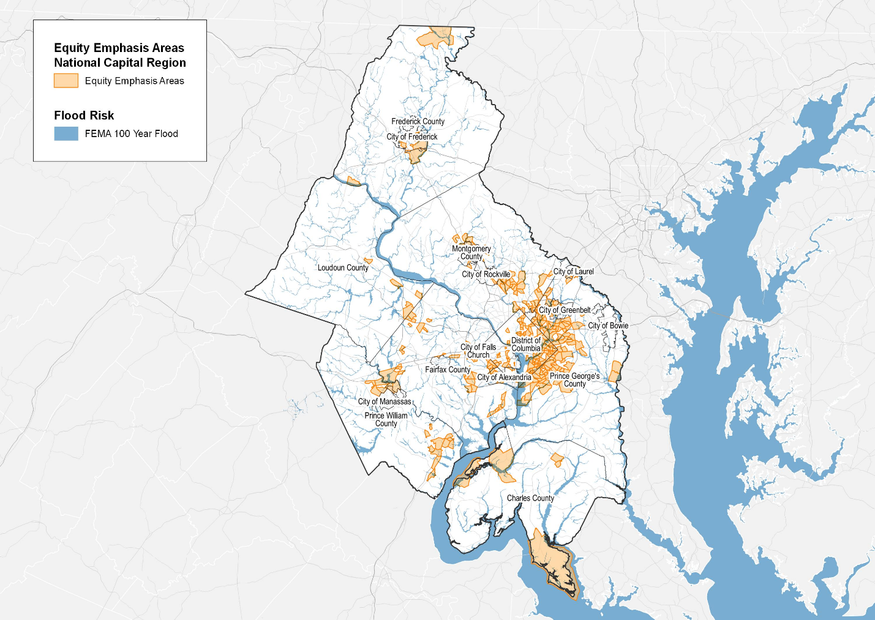

Source: FEMA and COG Equity Emphasis Areas

Figure 13: Equity Emphasis Areas and FEMA’s 100-Year Floodplains

Coastal Flooding

Coastal flooding can occur in the form of nuisance or tidal flooding during extreme high tides and during coastal storms that produce intense rain, storm surges and high waves. Coastal flooding poses a risk to human health including injuries, death, and illnesses associated with contaminated water including diarrhea and stomach illnesses.[99] Coastal flooding poses risks to transportation services, infrastructure, residential housing, businesses, and the economy.

In the past 90 years, the Potomac and Anacostia River, both tidal rivers have experienced 11 inches of sea level rise. Nuisance flooding has increased over 300 percent along the riverfront. Effects of sea level rise are observable, including shoreline erosion and deterioration of tidal wetlands. Recent examples of coastal flood events include impacts of Hurricane Isaac (2003), the 2006 Mid-Atlantic Storm and Tropical Storm Lee (2011). [100]

The region may experience more intense and more frequent coastal flooding impacts. The District of Columbia could experience 2 to 6 feet of additional sea level rise towards the end of the century. Increases in sea level rise will cause tidal and nuisance floods with more severe impacts and a reduction of time in between floods. Storm surge floods will be more threatening in the long term with added sea level rise.[101]

Coastal areas in metropolitan Washington contain a critical convergence of infrastructure (water, energy, and communication utilities, transportation hubs, facilities and buildings) that the region’s local governments, businesses, institutions, and communities depend upon. The region is also home to many federal buildings, military installations, national security facilities, and significant national monuments and cultural treasures. As sea level rises, the coastline may change and critical infrastructure that was previously not at risk may face a greater risk of flooding from storm surges. More frequent and intense coastal flooding may impact these infrastructure and facilities potentially causing damage, disruptions, and economic losses.

Coastal flooding puts vulnerable populations that live and work near the coast at a higher risk. Populations with socioeconomic barriers, including low-income households, the elderly, persons in sub-standard housing, and individuals with language barriers face greater challenges to prepare and respond to flood events. Figure 14 demonstrates the number of EEAs that fall within NOAA’s high sea level rise projections (6ft). More than 10 percent of EEAs will be affected by a 6-foot sea level rise. More than 100,000 people currently live in these EEAs. These areas can serve as a starting point for local jurisdictions to work with these communities to further identify potentially vulnerable populations, how they will be impacted by coastal flooding, and how to address their needs.[102]

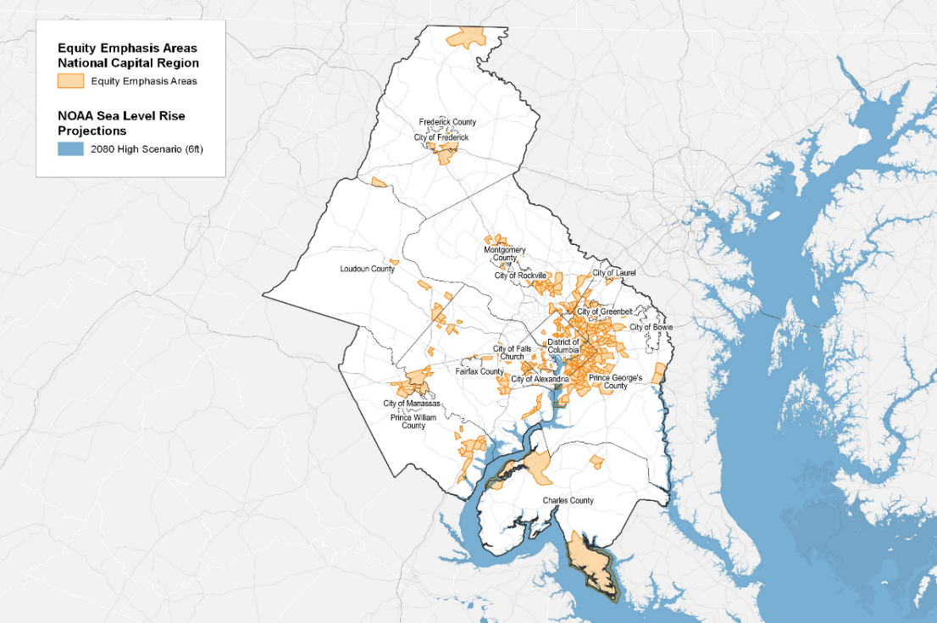

Source: NOAA and COG Equity Emphasis Areas

Figure 14: Equity Emphasis Areas and NOAA Sea Level Rise Projections High Scenario (2080 6ft)

Severe Thunderstorms/Lightning

A thunderstorm is a combination of precipitation, thunder, and lightning.

A severe thunderstorm may additionally include hail, wind gusts of 50 knots or more or may even form into a tornado. Severe thunderstorms may also cause flooding. Severe thunderstorms and lightning have a high probability of occurring with a moderate level of impact.

The June 2012 Derecho that hit the region was a violent thunderstorm with winds recorded at upwards of 85 mph. The storm demonstrated the consequences of climate impacts on infrastructure failures. Millions of people experienced power outages for several days during a heatwave. The Washington Suburban Sanitary Commission (WSSC) experienced power loss at Potomac and Patuxent filtration plants and at more than 50 of its facilities. Transportation routes were blocked due to downed trees and power lines. The Derecho event resulted in communication infrastructure damages and 9-1-1 outages affected more than 1.5 million people in Northern Virginia and 68,000 people in the District of Columbia.[103]

In October 2012, the region experienced sustained winds and heavy rain during Superstorm Sandy. Impacts were lessened due the region not being directly hit, pre-landfall preparedness, and coordination during response and recovery operations. During Sandy, the region experienced flooding, power outages, downed power lines and trees. The Potomac and Patuxent Water Filtration Plants maintained full power; however, other water utilities experienced short power outages, flooding, or sewer overflows. Washington Metropolitan Area Transit Authority (WMATA) suspended Metrorail and bus services for two days.[104]

With rising temperatures, severe thunderstorms and lightning have a high probability to occur more frequently by 2025. Future projections show the frequency and intensity of extreme precipitation events are projected to increase from 10 days per year with 1 inch of rain in a 24-hour period, to 11 days in the 2020s and 12 days by 2050. The number of days per year with more than 2 inches of rainfall per 24-hour period is expected to increase from 1 day to 3 days by the 2020s and 3.5 days by the 2050s.[105]

More frequent and intense severe storms will cause additional impacts to energy, transportation, water, and communication services and assets. Power outages and transportation disruptions will occur due to extreme rainfall events and downed trees. Severe thunderstorms and lightning pose a public health challenge, as power outages can disrupt medical services and emergency response. More intense rainfall can damage and overwhelm water infrastructure. More frequent lightning will increase fire risk. Additionally, an increasing electric fleet may be impacted by power outages.

Long-term power outages particularly pose challenges to potentially vulnerable populations including the elderly, persons with chronic conditions, persons who rely on electric medical equipment, homeless, and those reliant on refrigerated medication. Prolonged power outages pose public health challenges and can become life threatening during heat waves and extreme cold events.

Extreme Winter Conditions

Extreme winter conditions are a combination of heavy snow, blowing snow or dangerous wind chills. Extreme winter storms can create blizzards which causes low visibility due to blowing snow and wind. Ice storms occur when at least 0.25 inches of ice accumulates on an exposed surface.[106] The region may see increases risk of ice storms as winter temperatures rise and more storms will occur near 32°F in temperature. Extreme winter conditions have a moderate probability and a high consequence, as these events pose a life-threatening risk to human health and life.

The region has experienced extreme winter conditions resulting in loss of life, significant economic impacts, and infrastructure damages. Recent winter storms events affecting metropolitan Washington include: Snowzilla (2016), Carmageddon (2011), Snowmageddon (2010), and Snowpocalypse (2009). As seen in Figure 15**,** the February 2010 severe winter storm named Snowmageddon impacted the Atlantic coastline, dropping several feet of snow in metropolitan Washington. Washington's Dulles Airport recorded 32.4 inches of snow. A State of Emergency was declared in Washington D.C, Virginia, and Maryland. Widespread power outages occurred with hundreds of thousands without power. The Federal government and schools in the region were closed for several days. Infrastructure damages and disruptions to transportation routes occurred due to excessive snow on roadways, downed trees, abandoned vehicles and vehicle accidents. It took several days to clear roads and pedestrian paths after the storm.[107]

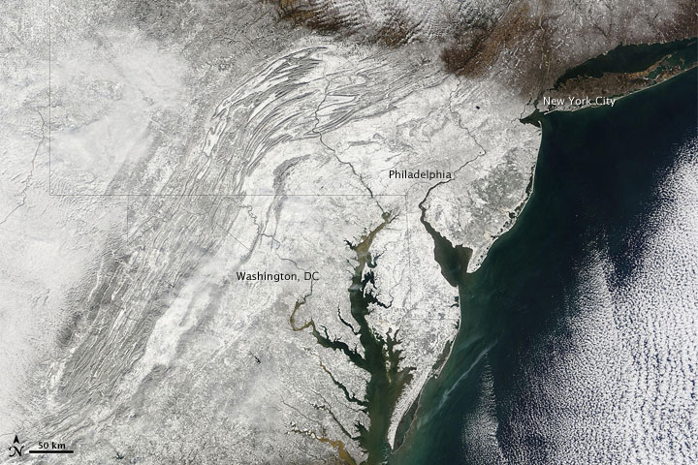

Source: National Aeronautics and Space Administration (NASA) Terra Satellite

Figure 15: Satellite Image of Snowmageddon

Extreme winter conditions will occur more frequently and increase in intensity by 2025. While average annual temperatures are increasing, extreme winter events and cold snaps may continue to occur. Extreme winter conditions cause impacts to both infrastructure and people. Infrastructure can experience road surface damages and closures resulting in travel disruptions and higher maintenance costs. Roadway accidents, injuries, and fatalities are likely to coincide with winter conditions. Energy infrastructure may experience transmission structure failures resulting in power outages for many customers. Extreme cold temperatures pose a public health risk especially to persons facing homelessness, low-income households, the elderly, and persons with chronic conditions who rely on daily access to services.

regional climate resilience strategy

Moving Toward Resilience

The Regional Climate Resilience Strategy includes collaborative actions to support the region in achieving the climate resilience goals of becoming a Climate Ready Region by 2030 and a fully Resilient Region by 2050. In order to move the region toward becoming more resilient, the region needs to ensure that all populations are included and prioritize resilience of the region’s most vulnerable populations.

Climate Ready by 2030

Recognizing everything cannot be implemented at once due to the significant capital outlay required for resilience, the region first needs to be climate ready. Climate ready involves metropolitan Washington undertaking five key components:

1. Local climate risks have been assessed and climate planning is incorporated into all government plans.
2. Climate risks are being communicated across governmental offices and to the public, with a particular emphasis on empowering diverse populations.
3. Climate planning is actively being incorporated into government operations.
4. All communities are implementing actions to reduce climate risks.
5. Establish the necessary plans, networks, funding, and other actions to ensure implementation of full resilience by 2050.

Climate Resilient by 2050

By 2050, this Plan calls for the region to be fully climate resilient. To do so, the region must have the ability to adapt and absorb against disturbances caused by current and future, acute and chronic climate impacts and successfully maintain essential functions. This will be realized when”

1. The region is a network of resilient and socially connected people, governments, and institutions that have constructed resilient communities. (Resilient people = resilient communities).
2. Measures have been implemented across the region to mitigate against current and future climate impacts.

* All critical infrastructure and functions are climate resilient.
* Resilient solutions to protect public health and safety, particularly of potentially vulnerable populations, have been deployed.

1. The region is monitoring measures to address current and future climate risks and vulnerabilities.

Priority Collaborative resilience Actions

The climate action areas included in this Regional Climate Resilience Strategy address Planning, Equity, and Resilient Infrastructure. Within these action areas are high-level priority actions for the Climate, Energy and Environment Policy Committee (CEEPC) and its members to focus on through 2030. All actions are voluntary. Actions have a 1-page description that includes:

* An action overview with example policies, programs, or projects;
* How the action supports regional resilience goals;
* Identifies what level of implementation is needed to meet by 2030 and beyond;
* Examples of how COG and local jurisdiction efforts that can support implementation (it’s not an exhaustive list); and
* How the action benefits other *Region Forward* goals.

Table 6 is a summary of the climate action areas and priority collaborative actions described in this strategy. The actions are based on the needs identified in the regional climate risk and vulnerabilities assessment described in the previous section of this Plan. While these actions focus on what CEEPC members can do together to move the region towards the climate resilience goals, other metropolitan planning bodies at COG including the Transportation Planning Board, Region Forward Coalition, Chesapeake Bay and Water Resources Policy Committee, the Anacostia Watershed Restoration Partnership, the Water Security Work Group, Critical Infrastructure Working Group, National Capital Region Homeland Security Executive Committee, and planning and housing director committees, also need to implement action that enhance climate resilience.

Table 6: Metropolitan Washington Priority Collaborative Resilience Actions

|  |  |  |
| --- | --- | --- |
| Climate Action Area | Action ID | Priority Collaborative Action |
| Planning | PL - 2 | Support Capacity Building for Climate Resilience Planning |
| PL - 3 | Develop Integrated Approach to Climate Resilience Planning |
| PL - 4 | Update Local Regional Plans to Address Climate Risks |
| Equity | EQ - 3 | Support Engagement of the Public on Climate Risks, with a Particular Emphasis on Potentially Vulnerable Populations |
| EQ - 4 | Support Equitable Secure Energy Access |
| Resilient Infrastructure | RI - 1 | Support Establishment of Resilience Hubs |
| RI - 2 | Improve the Resilience of Critical Infrastructure |
| RI - 3 | Implement Measures to Equitably Address Urban Heat Island |
| RI - 4 | Enhance Green Infrastructure Networks |
| RI - 5 | Implement Measures to Reduce Flood Risk |

PL-2: Support Capacity Building for Climate Resilience Planning

Action Overview

Metropolitan Washington is home to 24 diverse local jurisdictions that have unique capabilities, availability, and resources for climate resilience planning. To ensure an equitable climate resilient future, capacity building will require greater coordination, coherence, and integration. This is especially important to address climate hazards that have impacts that are felt across the region simultaneously. Communicating and capacity building will need to be mainstreamed across local government departments to achieve a common understanding of climate risks amongst all government staff.

To improve resiliency, the region’s local govenrments need to continue to collaborative with a network of external organizations to support capacity building and training on climate resilience. One example effort is how COG coordinated from 2012 – 2014 with the National Aeronautics and Space Administration (NASA), National Capital Planning Commission (NCPC), US General Services Administration (GSA), US Global Change Research Program (GCRP), and the Smithsonian Institution to bring federal, regional and local agencies in the region together to learn about climate impacts, conduct and share agency-level vulnerabilities assessments, and identify common solutions.

Level of Implementation Needed to Address Climate Risks   
COG members participating regularly in capacity building on climate risks and resilience strategies will help the region be Climate Ready by 2030. This action addresses all climate risks including extreme heat, drought, flooding (flash, riverine, and coastal), lightning/ thunderstorms and extreme winter conditions.

Supporting A Climate Ready Region

The impacts of a changing climate are already evident in the region, with an increasing number of extreme heat days, change in precipitation patterns, and an increase in the severity of storms. Continuing to capacity build, provide training, and grow resilience expertise among government staff, non-governmental organizations, academic partners and the community is crucial to reaching climate readiness by 2030. Continuing to grow and identify avenues for integrated climate trainings and capacity-building resources, will support local level resiliency planning.

How COG Can Support

* Continue to grow capacity building through workshops and committee meetings, and coordinate with members and partners to increase opportunities for training.
* Develop and implement a pilot training series for climate planning for local government staff.

How Member Jurisdictions Can Support

* Encourage active participation in climate planning training initiatives.
* Provide training and capacity-building across governmental departments and sectors to address climate risks and resiliency planning.

*Region Forward* Co-Benefits:

* Equity: Jurisdictions with limited resources would benefit from capacity to increase regional knowledge of heightened climate impacts on vulnerable populations in the region.

PL-3: Develop Integrated Approach to Climate Resilience planning

Action Overview

Regional consensus on climate planning projections and climate resilience definitions, metrics and design standards will provide a common framework for resilience planning across the region. With 24 local governments located in two states and the District of Columbia, availability of funding and resources differs across the region. Many programs would benefit from sharing of climate materials that will assist in incorporating resilience in local and regional plans. Increasing regional collaboration will allow metropolitan Washington to pool resources that benefits local governments and the region to leverage expertise from a variety of climate planning sources.

To address climate risks, the coordination and sharing of activities, best practices, consistent forward-looking climate science, and technical resources to enhance local and regional capacity is essential. The region has substantial networks, notable examples collaborative work in the region include the District of Columbia’s Silver Jackets, Northern Virginia Regional Commission’s Resiliency Planning Work Group, and National Oceanic and Atmospheric Administration’s Climate Resiliency Workgroup.

Level of Implementation Needed to Address Climate Risks   
Developing a regional consensus on climate projections and climate resilience definitions, metrics, and design standards is an important step towards becoming a Climate Ready Region by 2030. This action addresses all climate risks including extreme heat, drought, flooding (flash, riverine, and coastal), lightning/ thunderstorms and extreme winter conditions.

Supporting A Climate Ready Region

Reducing vulnerabilities to human life, infrastructure, ecosystems, and the economy require a collaborative response, as climate projections and impacts of extreme events cross jurisdictional boundaries. Adopting an integrated approach and consensus on climate projections, forward-looking climate science, and resilient design standards by the region will better align climate planning efforts.

How COG Can Support

* Continue sharing of best practices with local governments, federal and state agencies, businesses, non-governmental organizations, and the academic community to address climate risks, planning, modeling, and standards development.
* Continue to identify avenues for shared contractual support for climate planning, feasibility, and implementation.
* Develop a regional consensus on projections on climate risks and definitions to use in planning.
* Develop regionally appropriate climate resilient design standard guidelines.

How Member Jurisdictions Can Support

* Provide expertise and sharing of best practices of resiliency planning.
* Integrate common climate projections, metrics and resilient design standards across all departments.
* Design new and rehabilitated infrastructure to meet future-looking climate conditions.

*Region Forward* Co-Benefits:

* Equity: The region is a network of diverse local governments with various levels of resources and need. Growing climate networks and encouraging information sharing will assist in creating an equitable resilient future.

PL-4: Update local and Regional Plans to Address Climate Risks

Action Overview

Climate projections in metropolitan Washington show more frequent and severe weather events will occur, which can lead to larger disruption of critical services and increased threat to human life. To ensure the region is prepared for climate-related disasters and possesses the ability to recover quickly, climate projections, risks and actions to reduce risks to potentially vulnerable populations need to be mainstreamed into all government plans, including but not limited to emergency plans, hazard mitigation plans, comprehensive plans, transportation plans, stormwater and watershed plans, and capital improvement plans. Mainstreaming occurs when climate considerations are a part of the overall planning process rather than outliers not central to policy and investment decisions. [108]

In 2017, Prince George’s County adopted an updated Hazard Mitigation Plan to incorporate climate planning data. Within the plan’s flood-related hazard analyses, a variety of climate data was used including data from the Maryland Department of Natural Resources Coast Smart program. The Coast Smart Flood Hazard Analysis of sea level rise on the Potomac and Patuxent Rivers was used to conduct a coastal flooding analysis and to map potential sea level rise.[109]

Level of Implementation Needed to Address Climate Risks   
In order to become a Climate Ready Region by 2030, COG and its members will need to update all plans to address climate risks. This action addresses all climate risks including extreme heat, drought, flooding (flash, riverine, and coastal), lightning/ thunderstorms and extreme winter conditions.

Supporting A Climate Ready Region

The climate is changing, and all government departments will need to have the ability to anticipate, address, and adapt to new and changing climate risks in order to reduce impacts on people, critical services, infrastructure, and the economy. All government offices need to understand how climate risks and impacts affect their ability to do their job and continue to provide services to the community.

How COG Can Support

* Review and update regional emergency response and other relevant plans to reflect climate-risks and projections.
* Incorporate future climate projections and risks into regional emergency response exercises.
* Host a training series on how to incorporate resilience into all types of government plans.

How Member Jurisdictions Can Support

* Incorporate climate projections and climate risks into emergency and other government plans.
* Actively reach out to ensure participation by vulnerable groups in disaster preparedness, response, and recovery programs.
* Explore how communities outside floodplains may be impacted by sea level rise, precipitation projections, and future flood risks.
* Assess long-term energy resilience planning into energy and other plans and guidelines.
* Update zoning, building codes, ordinances, and the development review process to ensure new development is more resilient to forward-looking local climate impacts.

*Region Forward* Co-Benefits:

* Public Safety and Equity:Integrating climate strategies with emergency preparedness will enhance region’s ability to prepare for and recover from disasters and meet the needs of the most vulnerable populations.
* Economy**:** Integrating climate projections into emergency plans can reduce economic damages from disasters.

EQ-3: Support engagement of the public on Climate Risks, with an Emphasis on potentially vulnerable populations

Action Overview

Metropolitan Washington is at risk to a range of threats - extreme heat, flooding, winter storms, drought, and lightning and thunderstorms. Engaging local communities to discuss climate risks and solutions is an important step to achieving common understanding of climate risks and enhancing the resilience of local communities and its people. Potentially vulnerable populations face a heightened risk to climate change while simultaneously can be the hardest groups to reach. Therefore, emphasis must be taken to strengthen engagement initiatives to these communities.

The District and the Georgetown Climate Center conducted a year-long community engagement process in the neighborhoods surrounding the Watts Branch Tributary of the Anacostia River. The effort sought to create an inclusive and empowering process where residents living in the climate-vulnerable parts of the District could self-determine a vision for a resilient and sustainable community. The project relied on an “Equity Advisory Group” (EAG) of residents that provided recommendations around the implementation of actions that support the Ward 7 residents.[110]

Level of Implementation Needed to Address Climate Risks

All local governments need to engage the public, with an emphasis on engaging and empowering potentially vulnerable communities, to support the goal of becoming a Climate Ready by 2030. This action addresses all climate risks including extreme heat, drought, flooding (flash, riverine, and coastal), lightning/ thunderstorms and extreme winter conditions.

Supporting A Climate Ready Region

Climate change will impact the region’s most vulnerable populations disproportionately. Adapting to these risks rely heavily on the development of accessible and meaningful engagement opportunities with these populations. Typical outreach strategies may not be reaching our most vulnerable residents. Communication efforts must be expanded to ensure climate risk communications are accessible, digestible, and empower diverse communities to understand risks, and engage in the dialogue on resilience measures to ensure an equitable climate future.

How COG Can Support

* Support information sharing of best practices and region-specific messaging for effective community outreach strategies to diverse communities.
* Provide region-wide information identifying vulnerable populations such as transportation Equity Access Areas and community level health impact data.

How Member Jurisdictions Can Support

* Integrate climate projections, risks, and strategies into existing community outreach programs.
* Further build partnerships with community groups and leaders to improve communication and engagement strategies.
* Engage potentially vulnerable communities in assessing their vulnerabilities (social, ecological, economic, public health) to climate impacts.
* Provide direct assistance (technical and financial) to potentially vulnerable populations.
* Develop metrics to measure the effectiveness of outreach efforts with diverse communities.

*Region Forward* Co-Benefits:

* Equity: Asvulnerable populations are disproportionally impacted by climate impacts, furthering efforts to engage with diverse communities helps ensure a regional equitable climate future.

EQ-4: Support Equitable Secure Energy AccesS

Action Overview

Energy equity ensures the fair distribution of energy supply to all residents regardless of socio-economic status, accessibility, and affordability. As the region transitions to a clean energy economy, the most vulnerable populations in our region must have access to secure and affordable clean energy to ensure an equitable climate future for all. Vulnerable populations may have less ability to respond to or recover from climate impacts. Secure and reliable energy access, especially during and after extreme events, will assist in reducing economic and social disparities in our region.

In 2019, the Arlington County Board adopted the Community Energy Plan that establishes equity as a focus to inform design, investment and implementation of the plan. The plan ensures equitable access to a clean, reliable, and secure grid for vulnerable populations and low-to-moderate income communities.[111]

Level of Implementation Needed to Address Climate Risks

Implementing mechanisms to ensure equitable secure energy access for all will help grow towards the goal of a climate resilient region by 2050 through empowering the notion of resilient communities. This action addresses climate risks of extreme heat, flooding (flash, riverine, and coastal), lightning/ thunderstorms and extreme winter conditions.

Supporting A Climate Ready Region

As climate change puts an increasing stress on energy infrastructure, ensuring systems and assets are resilient to flooding, extreme heat, and extreme weather events while providing accessible and affordable clean energy to all residents is critical to provide life-saving services before, during, and after acute events and in response to chronic conditions. Future climate impacts in metropolitan Washington will require a reliable and resilient energy system that can withstand frequent and severe climate events while delivering affordable and reliable energy to all residents including the most vulnerable in our communities.

How COG Can Support

* Support information sharing of best practices for equitable access to secure, affordable clean energy.
* Advocate for state and federal actions to enhance access to secure, affordable clean energy.

How Member Jurisdictions Can Support

* Implement local government energy assurance planning initiatives in potentially vulnerable communities.
* Coordinate with utilities and promote electric grid and natural gas pipeline hardening, bulk fuel suppliers to promote resilient supply chains, and prioritize infrastructure improvements in potentially vulnerable communities.
* Prioritize microgrid deployment in potentially vulnerable communities.
* Ensure potentially vulnerable communities will have access to basic services during power outages.

*Region Forward* Co-Benefits:

* Equity:Vulnerable populations are disproportionally affected by climate impacts. Furthering efforts to provide equitable secure energy access ensures all residents have access to an equitable future.

RI-1: Support Establishment of Resilience Hubs

Action Overview

A resilience hub is a community-serving accessible facility that provides community-building activities, steady state support to local residents, and life-saving resources before, during, and after climate events. Resilience hubs not only provide safe haven for residents during extreme events but provide year-round support to improve local adaptive capacity and foster community building. Additionally, resilience hubs can be energy independent, which proves vital energy supply during power outages and extreme weather events, including emergency heating and cooling, charging ability, and storing of emergency medication and equipment.[112]

As part of Washington D.C.’s comprehensive efforts to implement Climate Ready DC, the Department of Energy and Environment (DOEE) is working with the Ward 7 community to develop a neighborhood-scale resilience hub in a trusted space by the community. Ward 7 faces disproportional climate risks compared to the majority of the city. The resilience hub will provide yearlong community support as well as emergency services and resources during crises.[113]

Level of Implementation Needed to Address Climate Risks   
Establishment of resilience hubs in vulnerable communities to serve the people most impacted by climate change will help the region achieve full resilience by 2050. This action addresses all climate risks including extreme heat, drought, flooding (flash, riverine, and coastal), lightning/ thunderstorms and extreme winter conditions.

Supporting A Climate Ready Region

Vulnerable populations face an increased risk to climate hazards and may have limited resources to adapt to a changing climate. Within vulnerable neighborhoods, residents may lack access to resources necessary to prepare for and recover from climate events. During extreme events, resilience hubs can provide lifesaving supplies (food, water, power, etc.). Resilience hubs enhance social cohesion within communities by shifting power to local communities to establish community-driven climate resilience.

How COG Can Support

* Partner on grant applications and provide engineering support through regional contracts.
* Coordinate the sharing of best practices through workshops and materials (fact sheet, resource guides etc.).

How Member Jurisdictions Can Support

* Identify most climate vulnerable communities and assess the potential to establish resilience hubs in those communities.
* Leverage relationships with community organizations and leaders to identify needs of the community and implement resilience hubs and other neighborhood-scale resilience solutions.
* Partner with energy providers to develop resilience hubs with an uninterruptable energy supply.

*Region Forward* Co-Benefits:

* Equity: Resilience hubs empower local communities by shifting segments of decision-making efforts to members of the community.

RI-2: Improve the Resilience of Critical Infrastructure

Action Overview

The consequences to metropolitan Washington’s energy, water, transportation, and communication systems from climate impacts are life threatening and may cause long-term physical and economic damages. Extreme events, such as Hurricane Sandy and Derecho event of 2012, severely impacted the region’s ability to provide critical services during times of crisis. Priority critical infrastructure, such as hospitals and 9-1-1 centers, will need to further implement measures that increase resilience to continue to operate and serve the community during and after disasters. As climate change further strains the regions aging infrastructure, implementing measures to ensure critical infrastructure is resilient to a changing climate is essential.

As part of a comprehensive effort to ensure the resilience of critical public services during major outages, Montgomery County installed a microgrid at its Public Safety Headquarters (PSHQ). The project features 2 megawatts of solar photovoltaic parking lot canopies, an 800-kilowatt Combined Heat and Power (CHP) system, electric vehicle charging stations and a cyber security system.[114]

Level of Implementation Needed to Address Climate Risks   
Assessing critical infrastructure now is essential in order to establish the necessary actions to ensure all critical infrastructure and functions as climate resilient in the region by 2050. This action addresses all climate risks including extreme heat, drought, flooding (flash, riverine, and coastal), lightning/ thunderstorms and extreme winter conditions.

Supporting A Climate Ready Region

As existing infrastructure ages and populations grows, infrastructure will need to be replaced, upgraded, and expanded. Climate projections show as the number of hot and cold days will be increasing, more frequent and severe extreme weather events may impact infrastructure. Water utility, and energy utility infrastructure that already incur sizable maintenance costs and risks may face an increased strain and will require upgrades and design standards that take into consideration future climate projections.

How COG Can Support

* Support systematic planning for protection of critical infrastructure identified through the COG Critical Infrastructure Working Group.
* Increase capacity to utilize Federal Emergency Management Agency (FEMA) Pre-Disaster Mitigation Program funding and identify other sources of funding.
* Coordinate the sharing of feasibility studies and best practices for measures to increase resilience of critical infrastructure.
* Partner with local governments on risk studies.

How Member Jurisdictions Can Support

* Assess vulnerability of critical infrastructure for transportation, communication, energy, and water system assets.
* Flood proof critical water, stormwater, and wastewater systems to reflect climate projections.
* Revise infrastructure design standards to be more resilient to heat, flooding, and other climate impacts.

*Region Forward* Co-Benefits:

* Public Safety: Implementing resilient measures to existing infrastructure ensures public safety entities can provide lifesaving services during extreme events.

RI-3: Implement measures to equitably Address Urban Heat Island

Action Overview

Heat is one of the leading causes of weather-related injuries and fatalities in metropolitan Washington. As extreme heat days become more prevalent, the region will face a high threat from extensive heat waves. Extensive development within metropolitan Washington has resulted in a significant number of areas with impervious surfaces and limited tree canopy. Populations residing in these areas, especially vulnerable peoples, will be more severely impacted by extreme heat. [115]

The District of Columbia is taking many steps to reduce the impacts of the urban heat island effect. The District’s Urban Tree Canopy Plan aims to increase a healthy tree canopy cover to 40 percent by 2032. The District’s RiverSmart Green Roof Rebate Program offers rebates between $10-15 per square foot to promote the voluntary installation of green roofs. The green roofs help reduce the urban heat island effect and improve stormwater management practices.[116]

Supporting A Climate Ready Region

Level of Implementation Needed to Address Climate Risks   
Reducing the impacts of extreme heat and the urban heat island effect assists the region in becoming Climate Ready by 2030. This action primarily addresses the climate risk of extreme heat but can also flooding (flash, riverine, and coastal) risks.

Extended periods of extreme heat can result in loss of human life, power outages, and infrastructure damages. The elderly, low-income persons, persons with allergies and underlying health conditions are especially vulnerable to extreme heat. As development increases in metropolitan Washington, incorporating cooling strategies that prioritizes vulnerable populations is essential to reduce the urban heat island effect. Implementing passive cooling mechanisms such as tree canopy and vegetation will substantially reduce risks to human life without increasing the regions reliance on energy. [117]

How COG Can Support

* Strategically coordinate the planting of new trees to expand the regional tree canopy to lower ambient air temperatures during summer months.[118]
* Prioritize and assess funding opportunities for implementation measures including cool and green roofs, and green walls.
* Support urban heat island and vulnerability mapping across the region.

How Member Jurisdictions Can Support

* Develop thermal mapping to identify urban heat island hot spots, impacted vulnerable populations, and potential areas for mitigation strategies.
* Assess existing and future cooling centers based on extreme heat projections and needs of vulnerable populations. Consider factors including accessibility, language interpreters, backup power support, medical assistance, and food and water supplies.
* Support urban forestry programs to maximize tree canopy in vulnerable communities.
* Implement cool and green roofs, and green walls.

*Region Forward* Co-Benefits:

* Health and Human Services:Urban tree canopy can improve air quality, reduce mental distress, and may have positive health effects.[119]
* Equity: Tree planting should be prioritized in vulnerable communities with limited access to parks and green spaces.[120]

RI-4: ENHANCE GREEN INFRASTRUCTURE NETWORKS

Action Overview

Protections against climate-driven risks can take the form of hard infrastructure improvements such as flood walls or constructing resilience hubs, or nature-based, resilient green infrastructure networks to restore and manage natural ecosystem functions to increase capacity to adapt to a changing climate. Green infrastructure is an interconnected network of waterways, wetlands, woodlands, wildlife habitats, and other important natural areas. An interconnected system of natural areas protects biodiversity, enhances natural community resiliency, and buffers the impacts of development—all while providing multiple public benefits. In some contexts, the term green infrastructure refers to low impact development and stormwater management, or recreational trail networks. For the purposes of this measure, green infrastructure relates to land cover and waterways.[121]

There are several ways to enhance nature-based, resilient green infrastructure network, such as green infrastructure plans, natural resource management plans, or green space plans. Prince George’s County’s Green Infrastructure Plan identifies existing green infrastructure elements throughout the county and proposes conservation mechanisms to preserve, protect, and enhance these elements. Fairfax County Natural Resource Management Plan focuses on protecting and enhancing natural capital, restoring ecosystems and fostering stewardship.[122]

Level of Implementation Needed to Address Climate Risks   
Resilient green infrastructure can reduce the impacts of extreme heat and flooding to support the region in becoming Climate Ready by 2030.

Supporting A Climate Ready Region

Resilient green infrastructure can reduce the need for hard infrastructure improvements. The region has existing nature-based protections, such as the parkland located along many of the region’s waterways and existing urban tree canopy that can be expanded on.

How COG Can Support

* Work with partners to evaluate coastal, inland and overland flooding risks and options to use green infrastructure and natural systems to reduce climate risks.

How Member Jurisdictions Can Support

* Design and plan for resilient green infrastructure before development occurs.
* Implement a plan to preserve and enhance ecologically valuable green spaces in urban, suburban and rural areas, such as a green infrastructure plan, natural resource management plan, or green space plan.
* Invest in nature-based, resilient green infrastructure network solutions to reduce risk from flooding and extreme heat.

*Region Forward* Co-Benefits:

* Equity: Resilient green infrastructure enhancements should be prioritized in vulnerable communities with limited access to parks and green spaces.

RI-5: IMPLEMENT measures TO Reduce flood risks

Action Overview

Changes in the frequency and severity of flooding, and sea level rise will require the region to adapt to an increasing flood risks that threatens the regions ability to provide water, energy, and transportation services. Reducing risks to flooding is heavily influenced by the amount and type of development, shore protection measures, site and building design, stormwater drainage infrastructure, nature-based solutions (wetlands, vegetation, etc.), structural (floodwalls, levees, bulkheads etc.,) and non-structural measures (relocation, zoning and flood insurance) and other resilience flood measures. The region relies on shared infrastructure for water, communications, energy, and transportation services; therefore, each entity/system within our region is only as protected as the weakest link in the regional infrastructure system.[123]

The City of Alexandria is undertaking a multi-year capital flood project on the city’s waterfront to reduce flooding and improve stormwater collection and transport. Some of the measures include elevating areas that frequently flood, a new bulkhead and elevated walkway, and integrating low flood walls to protect against the 10-year flood.[124]

Supporting A Climate Ready Region

Level of Implementation Needed to Address Climate Risks   
Incorporating measures to reduce flood risks green can reduce the impacts of flooding and support the region in becoming Climate Ready by 2030.

Flooding is a main hazard of concern in metropolitan Washington. More frequent and severe precipitation events and water level rise, aging infrastructure, and rapid development and population growth will strain stormwater and sewer collection systems. The impacts of flooding are expected to be exacerbated with a changing climate, leading to asset damage and deterioration, threatening operability of critical infrastructure, increasing stormwater runoff, and property damage.

How COG Can Support

* Work with partners to evaluate coastal, inland and overland flooding risks and options to reduce flood risks.
* Support legislation and funding opportunities that address flood control and management, water quality programs, and stormwater management in the region.

How Member Jurisdictions Can Support

* Identify at-risk facilities based on flooding and sea level rise. Prioritize resilience strategies based on age of facilities and critical need.
* Incorporate nature-based solutions, non-structural, and structural measures strategies to reduce flood risks.
* Increase the resilience of water, stormwater, and wastewater system. Secure investments for green and grey infrastructure to improve the capacity of these systems.
* Prioritize existing properties vulnerable to flooding for buyout programs and easements.
* Adopt and implement green street policies and programs.

*Region Forward* Co-Benefits:

* Economy and Equity:Incorporating resilience measures can limit the financial impacts of flooding events and reduce the burden to vulnerable populations.
* Health and Human Services: Incorporating resilience measures can decrease pollution from stormwater runoff into rivers and streams and reduce associated adverse health impacts.

Mitigation-Resilience Co-Benefits

Responding to climate change requires addressing both mitigation and resilience strategies. Mitigation strategies primarily focus on reducing the causes of climate change, while resilience strategies center around limiting the impacts of climate change and adapting to a new climate. Many of the mitigation and resilience actions provide co-benefits that reduce greenhouse gas emissions and reduce vulnerabilities to the negative consequences of climate change.

As climate events become more severe and frequent, incorporating actions that have both mitigation and resilience benefits is even more invaluable. This is addressed in a number of areas in this Plan.

* Efforts to enhance tree canopy provides both mitigation benefits via carbon sequestration and reduced energy consumption due to shading during the cooling season and resilience benefits via minimizing the urban heat island effect. Additionally, efforts to enhance tree canopy provide water quality environmental benefits as it reduces stormwater runoff into surface waters and enhances the qualities of and increases the value of open space.
* Public education efforts about climate change can use resiliency risks as a more tangible example of why climate change should be addressed. The longer-term benefits of mitigation may be less apparent to the public. Using resiliency, particularly tied to current events, such as floods from heavy summer storms or hurricanes, a derecho, or the increased western United States fires, as a way to open the door can more effectively enable people to see the direct effects on their lives. This then can be used to motivate mitigation action.
* Resilience hubs both can provide a short-term benefit to communities during an acute event and serve as an example of mitigation actions. One factor driving adoption of distributed solar is the presence of other distributed solar in a community. New adopters may become more comfortable to adopt the technology when the see neighbors, either houses or businesses, successfully using on-site solar. Incorporating on-site solar into resiliency hubs serves to address resiliency risks and meet mitigation goals.
* Accelerating deployment of battery storage similarly serves both resiliency and mitigation goas. Battery storage improves resiliency by providing for emergency power when alternative energy systems cannot produce. They also enhance mitigation as they can increase the use of renewable energy by storing excess generation for later use.
* Property Assessed Clean Energy (PACE) financing is one tools to increase the adoption of deep building retrofits, an important mitigation goal. PACE financing is now eligible in some jurisdictions as a funding source for resiliency improvements such as floodproofing.
* One of the keys to market circularity is to use what otherwise would be a waste material as an input to other systems. One method to provide for circularity is to provide energy production from wastes. These actions can reduce net greenhouse gas emissions while providing an electricity source that can serve as a black-start resource if needed after loss electric generation and transmission. In its simplest form, black-start resources are able to start when the rest of the grid goes dark, which can then be used to bring the rest of the grid’s resources back online.

This discussion address some of the co-benefits of mitigation and resiliency strategies. As is true of most systems, energy systems are so inter-related that other mitigation actions will enhance resiliency, and vice-a-versa, although in a less direct manner.

**CONCLUSIONS**

Climate change is a major environmental issue affecting both human health and natural ecosystems. COG's Climate and Energy Program is one of the nation's first initiatives to address climate change on a regional level. The regional effort is led by the Climate, Energy and Environment Policy Committee (CEEPC) and guided by this Action Plan. Communities in the region are already implementing renewable energy and energy efficiency initiatives, facilitating electric vehicle adoption, and other programs to help reduce greenhouse gas (GHG) emissions. This Action Plan further provides a roadmap for collaborative action by COG, its members and stakeholders communities to facilitate a move toward zero energy buildings, zero emission vehicles, and zero waste. COG will continue to work with its regional partners to meet the 2030 goals of reducing GHG emissions 50 percent below the 2005 levels and becoming a Climate Ready Region. The next ten years of action will set the stage for the 2050 vision for a carbon neutral, resilient metropolitan Washington.

**AppendiCES**

See separate attachment for appendices.

1. Metropolitan Washington Council of Governments. (2016). *COG and Our Region webpage*. Washington D.C. Retrieved from <https://www.mwcog.org/about-us/cog-and-our-region/>.

   Metropolitan Washington Council of Governments. (2016). *Region Forward Goals webpage*. Washington D.C. Retrieved from <https://www.mwcog.org/community/planning-areas/regional-planning/region-forward/goals/>.
2. Metropolitan Washington Council of Governments. (2008). *National Capital Region Climate Change Report*. Washington D.C. Retrieved from <https://www.mwcog.org/documents/2008/11/12/national-capital-region-climate-change-report-climate-change/>.
3. Metropolitan Washington Council of Governments. (2016). *Climate, Energy, and Environment Policy Committee Webpage*. Washington D.C. Retrieved from <https://www.mwcog.org/committees/climate-energy-and-environment-policy-committee/>.
4. *ibid*

   Metropolitan Washington Council of Governments. (2020). *Environmental Committees Webpage*. Washington D.C. Retrieved from <https://www.mwcog.org/environment/committees/>.
5. Greater Washington Region Clean Cities Coalition. (2020). *GWRCCC Home Webpage*. Washington D.C. Retrieved from <http://www.gwrccc.org/>.
6. Metropolitan Washington Council of Governments. (2019). *Climate and Energy Progress Dashboard*. Washington D.C. Retrieved from <https://www.mwcog.org/environment/data-and-tools/climate-and-energy-progress-dashboard/>.
7. ENERGY STAR. (2020). *2020 ENERGY STAR Top Cities*. Retrieved from <https://www.energystar.gov/buildings/topcities>.
8. US Green Building Council. (2019). *Top Ten States for LEED*. Washington D.C. Retrieved from <https://www.usgbc.org/resources/top-ten-states-leed-2019>.
9. Metropolitan Washington Council of Governments. (2019). *Greenhouse Gas Inventories Webpage*. Washington D.C. Retrieved from <https://www.mwcog.org/environment/planning-areas/climate-and-energy/greenhouse-gas-inventories/>.
10. Metropolitan Washington Council of Governments. (2011). *2010 Regional Climate and Energy Action Workplan Progress Report*. Washington D.C. Retrieved from <https://www.mwcog.org/documents/2015/12/01/annual-climate-and-energy-progress-report-climate--energy-climate-change-energy/>.
11. Metropolitan Washington Council of Governments. (2016). *White House Climate Action Champions Solar Case Study*. Washington D.C. Retrieved from <https://www.mwcog.org/documents/2016/3/2/climate-action-champion-solar-case-study/>.
12. Metropolitan Washington Council of Governments. (2019). *Energy Efficiency Webpage*. Washington D.C. Retrieved from <https://www.mwcog.org/environment/planning-areas/climate-and-energy/high-performance-buildings/>.
13. Metropolitan Washington Council of Governments. (2015). *April 1, 2015 EV Work Group Meeting Documents*. Washington D.C. Retrieved from <https://www.mwcog.org/events/2015/04/01/ev-work-group-meeting/>.
14. Metropolitan Washington Council of Governments. (2019). *Climate Resilience Webpage*. Washington D.C. Retrieved from <https://www.mwcog.org/environment/planning-areas/climate-and-energy/climate-preparedness/>.
15. Metropolitan Washington Council of Governments. (2020). *Cooperative Purchasing Webpage*. Washington D.C. Retrieved from <https://www.mwcog.org/purchasing-and-bids/cooperative-purchasing/>.
16. Metropolitan Washington Council of Governments. (2017). *Environmental Justice Toolkit*. Washington D.C. Retrieved from <https://www.mwcog.org/newsroom/2017/08/10/new-toolkit-provides-resources-to-ensure-equity-in-clean-air-and-climate-policies/>.
17. Metropolitan Washington Council of Governments. (2019). *Climate and Energy Leadership Awards Webpage*. Retrieved from <https://www.mwcog.org/environment/planning-areas/climate-and-energy/climate-awards/>.
18. Intergovernmental Panel on Climate Change. (2018). *Summary for Policymakers of IPCC Special Report on Global Warming of 1.5 Degrees Celsius*. Retrieved from <https://www.ipcc.ch/2018/10/08/summary-for-policymakers-of-ipcc-special-report-on-global-warming-of-1-5c-approved-by-governments/>.
19. Resilience goals are further described in the Climate Resilience Strategy Section
20. Metropolitan Washington Council of Governments. (2019). *Region received global recognition for leading the way on climate.* Washington D.C. Retrieved from <https://www.mwcog.org/newsroom/2019/09/25/region-receives-global-recognition-for-leading-the-way-on-climate/>.
21. Metropolitan Washington Council of Governments. (2019). *Region receives global recognition for leading the way on climate*. Washington D.C. Retrieved from <https://www.mwcog.org/newsroom/2019/09/25/region-receives-global-recognition-for-leading-the-way-on-climate/>.

    Metropolitan Washington Council of Governments. (2019). *CEEPC September 25, 2019 Meeting Documents*. Washington D.C. Retrieved from <https://www.mwcog.org/events/2019/9/25/climate-energy-and-environment-policy-committee-meeting/>.
22. Metropolitan Washington Council of Governments. (2019). *Climate Planning Work Session Meeting Documents*. Washington D.C. Retrieved from <https://www.mwcog.org/events/2019/11/20/climate-planning-work-sessions/>.
23. Metropolitan Washington Council of Governments. (2019-2020). *Environment Meetings and Events.* Washington D.C. Retrieved from <https://www.mwcog.org/environment/meetings-and-events/>.
24. ICLEI. (2019). *U.S. Community Protocol for Accounting and Reporting of Greenhouse Gas Emissions Version 1.2*. Retrieved from <https://icleiusa.org/publications/us-community-protocol/>.

    ICLEI. (2020). *ClearPath Webpage*. Retrieved from <https://icleiusa.org/clearpath/>.

    World Resources Institute, C40, and ICLEI. (2014). *Global Protocol for Community-Scale Greenhouse Gas Emission Inventories*. Retrieved from <https://ghgprotocol.org/greenhouse-gas-protocol-accounting-reporting-standard-cities>.
25. ICLEI. (2018). *GHG Contribution Analysis Webpage*. Retrieved from <https://icleiusa.org/ghg-contribution-analysis/>.
26. Intergovernmental Panel on Climate Change. (2018). AR5 Annex II Glossary. Retrieved from <https://www.ipcc.ch/site/assets/uploads/2018/02/WGIIAR5-AnnexII_FINAL.pdf>.

    Metropolitan Washington Council of Governments. (2019). *Climate Planning Work Session Meeting Documents*. Washington D.C. Retrieved from <https://www.mwcog.org/events/2019/11/20/climate-planning-work-sessions/>.
27. Metropolitan Washington Council of Governments. (2016). *Multi-Sector Approach to Reducing Greenhouse Gas Emissions in the Metropolitan Washington Region Final Technical Report.* Washington D.C. Retrieved from <https://www.mwcog.org/documents/2016/08/01/multi-sector-approach-to-reducing-greenhouse-gas-emissions-in-the-metropolitan-washington-region-final-technical-report/>.

    Metropolitan Washington Council of Governments. (2019). *The Future of Housing in Greater Washington*. Washington D.C. Retrieved from <https://www.mwcog.org/documents/2019/09/10/the-future-of-housing-in-greater-washington/>.

    National Renewable Energy Laboratory. (2018). *Electrification Futures Study: Scenarios of Electric Technology Adoption and Power Consumption for the United States*. Golden, CO. Retrieved from <https://www.nrel.gov/analysis/electrification-futures.html>.

    Derived from ICF. (2020). Study on the Use of Biofuels (Renewable Natural Gas) in the Greater Washington, D.C. Metropolitan Area. Fairfax, VA. Retrieved from <https://washingtongasdcclimatebusinessplan.com/>.
28. United Nations Human Settlements Programme. (2015). *Guiding Principles for Climate Action Planning*. Nairobi. Retrieved from <http://e-lib.iclei.org/wp-content/uploads/2016/02/Guiding-Principles-for-City-Climate-Action-Planning.pdf>.
29. City of Bowie, (2020). *Climate Action Webpage*. Bowie, MD. Retrieved from <https://www.cityofbowie.org/897/Climate-Action>.
30. US Global Change Research Program. (2018). *Fourth National Climate Assessmen*t. Washington D.C. Retrieved from https://nca2018.globalchange.gov/.
31. Metropolitan Washington Council of Governments. (2017). Environmental Justice Toolkit. Washington D.C. Retrieved from https://www.mwcog.org/documents/2017/07/27/environmental-justice-toolkit/.
32. Metropolitan Washington Council of Governments. (2018). *Equity Emphasis Areas for TPB's Enhanced Environmental Justice Analysis*. Washington D.C. Retrieved from <https://www.mwcog.org/transportation/planning-areas/fairness-and-accessibility/environmental-justice/equity-emphasis-areas/>.
33. Sunter, D.A., Castellanos, S. & Kammen, D.M. (2019). *Disparities in rooftop photovoltaics deployment in the United States by race and ethnicity*. Retrieved from https://www.nature.com/articles/s41893-018-0204-z.
34. United States Department of Energy. (2018). *Low-Income Energy Affordability Data (LEAD) Tool*. Retrieved from <https://www.energy.gov/eere/slsc/maps/lead-tool>.

    Metropolitan Washington Council of Governments. (2018). *Equity Emphasis Areas for TPB's Enhanced Environmental Justice Analysis*. Washington D.C. Retrieved from <https://www.mwcog.org/transportation/planning-areas/fairness-and-accessibility/environmental-justice/equity-emphasis-areas/>.
35. District Department of Energy and Environment. *Solar For All Webpage*. Washington D.C. Retrieved from <https://doee.dc.gov/solarforall>.
36. National Renewable Energy Laboratory. (2019). *Renewable Portfolio Standards Webpage*. Retrieved from <https://www.nrel.gov/state-local-tribal/basics-portfolio-standards.html>.
37. National Conference of State Legislatures. (2020). *State Renewable Portfolio Standards and Goals Webpage*. Retrieved from <https://www.ncsl.org/research/energy/renewable-portfolio-standards.aspx>
38. Metropolitan Washington Council of Governments. (2016). *Multi-Sector Approach to Reducing Greenhouse Gas Emissions in the Metropolitan Washington Region: Renewable Energy Supplemental Analysis. Technical Report*. Washington D.C.
39. Solarize NoVA. (2020). *About Solarize NoVA Webpage*. Fairfax, VA. Retrieved from <https://solarizenova.org/about-us>.
40. National Renewable Energy Laboratory. (2018). *Valuing the Resilience Provided by Solar and Battery Energy Storage Systems*. Golden, CO. Retrieved from <https://www.nrel.gov/docs/fy18osti/70679.pdf>.
41. Dominion Energy. (2019). *Dominion Energy Announces Battery Storage Pilot Projects Webpage*. Richmond, VA. Retrieved from <https://news.dominionenergy.com/2019-08-06-Dominion-Energy-Announces-Battery-Storage-Pilot-Projects>.
42. Department of Energy. (2014). How Microgrids Work Webpage. Washington D.C. Retrieved from <https://www.energy.gov/articles/how-microgrids-work>.
43. Montgomery County Government. (2020). *Microgrids* *Webpage*. Rockville, MD. Retrieved from <https://www.montgomerycountymd.gov/dgs-oes/Microgrids.html>.
44. EPA Green Power Partnership. (2020). *Solar Power Purchase Agreements Webpage*. Washington D.C. Retrieved from <https://www.epa.gov/greenpower/solar-power-purchase-agreements>.
45. Fairfax County. (2019). *Fairfax County Awards Solar Power Purchase Agreement Contracts, Launches Large-Scale Renewable Energy Initiative Webpage*. Fairfax, VA. Retrieved from <https://www.fairfaxcounty.gov/environment-energy-coordination/cleanenergy/news/fairfax-county-awards-solar-power-purchase-agreement>.
46. City of Santa Monica. (2017). *How Local Energy Aggregation Works*. Santa Monica, CA. Retrieved from: <https://www.santamonica.gov/blog/santa-monica-community-choice-aggregation>.
47. LegiScan. (2020). *Maryland House Bill 561*. Retrieved from <https://legiscan.com/MD/bill/HB561/2020>.

    Virginia Clean Energy. (2020). CCA in Virginia. Retrieved from <https://www.virginiacleanenergy.org/cca-in-virginia.html>.
48. U.S. Environmental Protection Agency. (2020). Community Choice Aggregation Webpage. Washington D.C. Retrieved from <https://www.epa.gov/greenpower/community-choice-aggregation#:~:text=Prices%20for%20electricity%20under%20CCAs,communities%20and%20current%20market%20trends.>
49. ENERGY STAR. *Interactive maps for energy benchmarking data, programs, and policies*. Retrieved from <https://www.energystar.gov/buildings/program-administrators/state-and-local-governments/see-federal-state-and-local-benchmarking-policies>.

    District Department of Energy and Environment. *Energy Benchmarking Webpage*. Washington D.C. Retrieved from <https://doee.dc.gov/energybenchmarking>.

    Montgomery County. (2020). *Building Energy Benchmarking Webpage*. Rockville, MD. Retrieved from <https://www.montgomerycountymd.gov/green/energy/benchmarking.html>.

    American Council for an Energy-Efficient Economy. (2017). *State and Local Policy Database: Arlington County, VA*. Retrieved from <https://database.aceee.org/city/arlington-county-va>.
50. Metropolitan Washington Council of Governments. (2019). *Energy Efficiency Webpage*. Washington D.C. Retrieved from <https://www.mwcog.org/environment/planning-areas/climate-and-energy/high-performance-buildings/>.

    DC Green Bank. (2019). Potential Financial Products. Washington D.C. Retrieved from <https://dcgreenbank.org/about-us/>.

    Montgomery County Green Bank. (2019-2020). *Montgomery County Green Bank Programs Webpage*. Rockville, MD. Retrieved from <https://mcgreenbank.org/all-programs/>.

    EcoAction Arlington. (2020). *Energy Masters Webpage*. Arlington, VA. Retrieved from <https://www.ecoactionarlington.org/community-programs/energy-masters/>.
51. Allied Environmental Consultants Limited. (2019). *Green Building – A Tool to Improve Employees’ Health and Productivity*. Retrieved from <https://gresb.com/green-building-tool-improve-employees-health-productivity/>.
52. Montgomery County Council. (2017). *Resolution No.: 18-894*. Rockville, MD. Retrieved from <https://www.montgomerycountymd.gov/COUNCIL/Resources/Files/res/2017/20170919_18-894.pdf>.

    City of Rockville. (2020). *Article XIV. Green Building Regulations*. Rockville, MD. Retrieved from <https://www.rockvillemd.gov/DocumentCenter/View/50/building_code_15_XIV?bidId=>.

    Stuart Kaplow. (2020). *2018 IgCC Poised to be Adopted for the First Time*. Cockeysville, MD. Retrieved from <https://www.greenbuildinglawupdate.com/2020/08/articles/igcc/2018-igcc-poised-to-be-adopted-for-the-first-time/>.
53. World Resource Institute. (2019). *Accelerating Building Decarbonization: Eight Attainable Policy Pathways To Net Zero Carbon Buildings For All*. Retrieved from <https://www.wri.org/publication/accelerating-building-decarbonization#:~:text=Buildings%20For%20All-,Accelerating%20Building%20Decarbonization%3A%20Eight%20Attainable%20Policy%20Pathways%20to,Zero%20Carbon%20Buildings%20For%20All&text=The%20report%20identifies%20eight%20pathways,demand%20and%20cleaning%20energy%20supply>.
54. Allied Environmental Consultants Limited. (2019). *Green Building – A Tool to Improve Employees’ Health and Productivity*. Retrieved from <https://gresb.com/green-building-tool-improve-employees-health-productivity/>.
55. UN environment programme. (2020). *Kigali Amendment hist milestone 100th ratification, boosting climate action*. Nairobi. Retrieved from <https://www.unenvironment.org/news-and-stories/press-release/kigali-amendment-hits-milestone-100th-ratification-boosting-climate>.

    Maryland Department of Environment. (2020). *Maryland moves to phase out hydrofluorocarbons and reduce methane*. Baltimore, MD. Retrieved from <https://news.maryland.gov/mde/2020/08/17/maryland-moves-to-phase-out-hydrofluorocarbons-and-reduce-methane-emissions/>.

    North American Association of Food Equipment Manufacturers. (2020). *Colorado, Virginia join efforts to phase down HFCs*. Chicago, IL. Retrieved from <https://www.nafem.org/news/colorado-virginia-join-efforts-to-phase-down-hfcs/>.
56. International Energy Agency. (2020). *Global EV Outlook 2020*. Paris. Retrieved from <https://www.iea.org/reports/global-ev-outlook-2020>.
57. Montgomery County Government. (2020). *Green Fleet Webpage*. Rockville, MD. Retrieved from <https://www.montgomerycountymd.gov/DGS-FMS/GreenFleet.html>.

    City of Alexandria. (2019). *City Manager’s Message February 19, 2019*. Alexandria, VA. Retrieved from <https://www.alexandriava.gov/uploadedFiles/budget/info/budget2020/Section%2002%20-%20City%20Manager%20Message.pdf>.
58. International Energy Agency. (2020). *Global EV Outlook 2020*. Paris. Retrieved from <https://www.iea.org/reports/global-ev-outlook-2020>.
59. U.S. Department of Energy. (2019). *Medium- and Heavy-Duty Vehicle Electrification: An Assessment of Knowledge and Gaps*. Retrieved from <https://info.ornl.gov/sites/publications/Files/Pub136575.pdf>.
60. *Ibid*

    California Air Resources Board. (2020). 15 states and the District of Columbia join forces to accelerate bus and truck electrification. Sacramento, CA. Retrieved from <https://ww2.arb.ca.gov/news/15-states-and-district-columbia-join-forces-accelerate-bus-and-truck-electrification>.

    ARLnow.com. (2020). *APS Adding Two Electric School Buses to Fleet, Thanks to Dominion*. Arlington, VA. Retrieved from <https://www.arlnow.com/2020/01/16/aps-adding-two-electric-school-buses-to-fleet-thanks-to-dominion/>.

    Steve Bohnel. (2020). *Frederick County leading the way in incorporating green technology for bus fleet*. Frederick, MD. Retrieved from <https://www.fredericknewspost.com/news/politics_and_government/levels_of_government/county/council/frederick-county-leading-the-way-in-incorporating-green-technology-for-bus-fleet/article_c9825770-4b46-5e71-9e05-9777cc2c840d.html>.

    Mark Kane. (2018). *Washington D.C. Deploys Proterra Electric Buses Across Nation’s Capital*. Miami, FL. Retrieved from <https://insideevs.com/news/337789/washington-dc-deploys-proterra-electric-buses-across-nations-capital/>.

    Pete Muntean. (2020). *Electric buses in Maryland could make Virginia and DC go green, too*. Gaithersburg, MD. Retrieved from <https://www.wusa9.com/article/traffic/electric-buses-montgomery-county-rideon-public-transit-system/65-d93495b7-9222-48b8-8344-94e00479e8dc>.
61. California Air Resources Board. (2020). *Overview: Diesel Exhaust and Health Webpage*. Sacramento, CA. Retrieved from <https://ww2.arb.ca.gov/resources/overview-diesel-exhaust-and-health>.
62. City of Frederick. (2018). *A Resolution Concerning The Adoption Of A Plug-In Electric Vehicle Charging Infrastructure Implementation Plan*. Frederick, MD. Retrieved from <https://www.cityoffrederickmd.gov/DocumentCenter/View/10005/18-04-Concerning-the-Adoption-of-a-Plug-in-Electric-Vehicle-Charging-Infrastructure-Implementation-Plan?bidId=>.

    Arlington County. (2020). Arlington Initiative To Rethink Energy Webpage. Arlington County, VA. Retrieved from <https://environment.arlingtonva.us/energy/>.
63. Model for of the U.S. Department of Energy Electric Vehicle Infrastructure Projection Tool (EVI-Pro) Lite. Retrieved from <https://afdc.energy.gov/evi-pro-lite>.
64. Metropolitan Washington Council of Governments. (2019). *Officials applaud local actions advancing regional climate goals*. Washington D.C. Retrieved from <https://www.mwcog.org/newsroom/2019/10/10/officials-applaud-local-actions-advancing-regional-climate-goals/>.
65. Greenhouse Gas Protocols. *Global Warming Potential Values*. Retrieved from <https://www.ghgprotocol.org/sites/default/files/ghgp/Global-Warming-Potential-Values%20%28Feb%2016%202016%29_1.pdf>.

    U.S. Environmental Protection Agency. (2020). *Basic Information about Landfill Gas Webpage*. Washington D.C. Retrieved from <https://www.epa.gov/lmop/basic-information-about-landfill-gas>.
66. U.S. Environmental Protection Agency. (2017). *Sustainable Materials Management: Non-Hazardous Materials and Waste Management Hierarchy Webpage*. Washington D.C. Retrieved from <https://www.epa.gov/smm/sustainable-materials-management-non-hazardous-materials-and-waste-management-hierarchy>.
67. Prince William County. (2015). *EcoPark Webpage*. Prince William County, VA. Retrieved from <https://www.pwcgov.org/government/dept/publicworks/trash/Pages/Eco-Park.aspx>.

    Prince William County. (2015). County Landfill *EcoPark Presentation to the Board of County Supervisors*. Prince William County, VA. Retrieved from <http://www.pwcgov.org/government/dept/publicworks/trash/Documents/Energy%20Park%20Update%20-%20Stakeholders%20Jan%202015%20v3.pdf>.
68. Ellen MacArthur Foundation. (2017). *What is a Circular Economy?* United Kingdom. Retrieved from <https://www.ellenmacarthurfoundation.org/>.
69. Fairfax County. (2020). *Public Works and Environmental Services - Glass*. Fairfax County, VA. Retrieved from <https://www.fairfaxcounty.gov/publicworks/recycling-trash/glass>.

    Fairfax County. (2019). *Regional Approach to Glass Recycling Leads to Creation of the Purple Can Club*. Fairfax County, VA. Retrieved from <https://www.fairfaxcounty.gov/publicworks/news/regional-approach-glass-recycling-leads-creation-purple-can-club>.
70. U.S. Environmental Protection Agency. Carbon Storage in Forests. Retrieved from https://cfpub.epa.gov/roe/indicator_pdf.cfm?i=86.
71. Metropolitan Washington Council of Governments. (2018). Tree Canopy Management Strategy. Washington D.C. Retrieved from <https://www.mwcog.org/documents/tree-canopy-management-strategy/>.
72. National Recreation and Park Association. (2010). *Air Quality Effects of Urban Trees and Parks*. Retrieved from <https://www.nrpa.org/globalassets/research/nowak-heisler-research-paper.pdf>.
73. The Nature Conservancy. (2017). Funding Trees for Health: An Analysis of Finance and Policy Actions to Enable Tree Planting for Public Health. Arlington, VA. Retrieved from https://www.nature.org/content/dam/tnc/nature/en/documents/Trees4Health_FINAL.pdf.
74. Arbor Day Foundation. (2020). *Tree City USA Standards*. Lincoln, NE. Retrieved from <https://www.arborday.org/programs/treecityusa/standards.cfm>.
75. Municode Falls Church. *Sec. 48-1180. - Tree canopy coverage required for single-family residential development*. Retrieved from <https://library.municode.com/va/falls_church/codes/code_of_ordinances?nodeId=PTIICOOR_CH48ZO_ARTVSURE_DIV8LA_S48-1180TRCACORESIMIREDE>.

    Hannah Himes. (2020). *2020 Tree Frederick Program tree order forms now available*. Retrieved from <https://www.fredericknewspost.com/news/economy_and_business/agriculture/2020-tree-frederick-program-tree-order-forms-now-available/article_e5bc9cdf-745a-552d-a671-7e65b8cf9f3f.html>.
76. National Recreation and Park Association. (2010). *Air Quality Effects of Urban Trees and Parks*. Retrieved from <https://www.nrpa.org/globalassets/research/nowak-heisler-research-paper.pdf>.
77. The Nature Conservancy. (2017). Funding Trees for Health: An Analysis of Finance and Policy Actions to Enable Tree Planting for Public Health. Arlington, VA. Retrieved from https://www.nature.org/content/dam/tnc/nature/en/documents/Trees4Health_FINAL.pdf.
78. Metropolitan Washington Council of Governments. (2018). Tree Canopy Management Strategy. Washington D.C. Retrieved from <https://www.mwcog.org/documents/tree-canopy-management-strategy/>.
79. The Maryland-National Capital Park and Planning Commission and Prince George’s County planning Department. (2010). *Environmental Technical Manual*. Retrieved from <http://www.pgplanning.org/DocumentCenter/View/1072/Environmental-Technical-Manual---September-22-2010-PDF?bidId=>.
80. National Recreation and Park Association. (2010). *Air Quality Effects of Urban Trees and Parks*. Retrieved from <https://www.nrpa.org/globalassets/research/nowak-heisler-research-paper.pdf>.
81. The Nature Conservancy. (2017). Funding Trees for Health: An Analysis of Finance and Policy Actions to Enable Tree Planting for Public Health. Arlington, VA. Retrieved from https://www.nature.org/content/dam/tnc/nature/en/documents/Trees4Health_FINAL.pdf.
82. Intergovernmental Panel on Climate Change. (2018). *Summary for Policymakers of IPCC Special Report on Global Warming of 1.5 Degrees Celsius*. Retrieved from <https://www.ipcc.ch/2018/10/08/summary-for-policymakers-of-ipcc-special-report-on-global-warming-of-1-5c-approved-by-governments/>.
83. Metropolitan Washington Council of Governments. (2014). *Building A Climate Resilient National Capital Region*. Washington D.C. Retrieved from <https://www.mwcog.org/about-us/newsroom/2014/10/02/building-a-climate-resilient-national-capital-region-climate-change-climate-resiliency/>.

    District Department of Energy and Environment. (2016). *Climate Ready D.C.* Washington D.C. Retrieved from <https://doee.dc.gov/climateready>.
84. Global Covenant of Mayors for Climate and Energy. (2018). *Global Covenant of Mayors Common Reporting Framework*. Retrieved from <https://www.globalcovenantofmayors.org/wp-content/uploads/2019/04/FINAL_Data-TWG_Reporting-Framework_website_FINAL-13-Sept-2018_for-translation.pdf>.
85. Ibid
86. Metropolitan Washington Council of Governments. (2018). *Equity Emphasis Areas for TPB's Enhanced Environmental Justice Analysis*. Washington D.C. Retrieved from <https://www.mwcog.org/transportation/planning-areas/fairness-and-accessibility/environmental-justice/equity-emphasis-areas/>.
87. Centers for Disease Control and Prevention. (2017). *Extreme Heat Webpage.* Retrieved from <https://www.cdc.gov/disasters/extremeheat/heat_guide.html>.
88. Metropolitan Washington Council of Governments Air Quality Staff. *Calculated Number of Heat Days in – Preliminary Monthly Climate Data, Dulles International Airport.* Retrieved from <https://w2.weather.gov/climate/index.php?wfo=lwx>.

    Metropolitan Washington Council of Governments. (2013). *Summary of Potential Climate Change Impacts, Vulnerabilities and Adaptation Strategies*. Washington D.C. <https://www.mwcog.org/documents/2013/07/01/summary-of-potential-climate-change-impacts-vulnerabilities-and-adaptation-strategies-climate-change/>.

    Metropolitan Washington Council of Governments. (2018). *Equity Emphasis Areas for TPB's Enhanced Environmental Justice Analysis*. Washington D.C. Retrieved from <https://www.mwcog.org/transportation/planning-areas/fairness-and-accessibility/environmental-justice/equity-emphasis-areas/>.

    Centers for Disease Control and Prevention. (2018). *National Environmental Public Health Tracking Network Data Explorer*. Atlanta, GA. Retrieved from <https://ephtracking.cdc.gov/>.
89. Northern Virginia Regional Commission. (2018). *Resilient Critical Infrastructure: A Roadmap for Northern Virginia*. Fairfax, VA. Retrieved from <https://www.novaregion.org/1354/Resiliency-Planning>.

    National Oceanic and Atmospheric Administration. *The Climate Explorer*. Retrieved from <https://crt-climate-explorer.nemac.org/>.
90. District Department of Energy and Environment. (2016). *Climate Ready D.C.* Washington D.C. Retrieved from <https://doee.dc.gov/climateready>.
91. Natural Resources Defense Council, Inc. (2018). *Climate Change and Health in Virginia*. Washington D.C. Retrieved from <https://www.nrdc.org/sites/default/files/climate-change-health-impacts-virginia-ib.pdf>.
92. National Oceanic and Atmospheric Administration, National Centers For Environmental Information. *Definition of Drought Webpage*. Asheville, NC. Retrieved from <https://www.ncdc.noaa.gov/monitoring-references/dyk/drought-definition#:~:text=Hydrological%20drought%20occurs%20when%20low,many%20months%20of%20meteorological%20drought.>

    Metropolitan Washington Council of Governments. (2013). *Summary of Potential Climate Change Impacts, Vulnerabilities and Adaptation Strategies*. Washington D.C. Retrieved from <https://www.mwcog.org/documents/2013/07/01/summary-of-potential-climate-change-impacts-vulnerabilities-and-adaptation-strategies-climate-change/>.
93. Ibid

    Metropolitan Washington Council of Governments. (2019). *Regional Drought and Water Supply Status*. Washington D.C. Retrieved from <https://www.mwcog.org/documents/2019/11/01/regional-drought-and-water-supply-status--drinking-water-drought-wise-water-use-campaign/>.
94. Centers for Disease Control and Prevention. (2018). *Preparing for The Health Effects of Drought – A Resource Guide For Public Health Professionals*. Retrieved from <https://www.cdc.gov/nceh/hsb/cwh/docs/CDC_Drought_Resource_Guide-508.pdf>.

    Centers for Disease Control and Prevention. (2020). *Droughts and Public Health in the U.S*. Retrieved from https://www.cdc.gov/nceh/multimedia/infographics/drought_public_health.html.
95. National Oceanic and Atmospheric Administration. *Severe Weather 101 Webpage*. Retrieved from <https://www.nssl.noaa.gov/education/svrwx101/floods/>.
96. National Capital Planning Commission. (2008). *Report on Flooding and Stormwater in Washington, D.C.* Washington D.C. Retrieved from <https://www.ncpc.gov/docs/Flooding_and_Stormwater_in_Washington_DC_Jan2008.pdf>.

    Federal Triangle Stormwater Study Working Group. (2011). *Companion Report: Federal Triangle Stormwater Drainage Study*. Washington D.C. Retrieved from <https://www.fema.gov/doc/about/employees/federal_triangle_stormwater_drainage_study_companion_report.pdf>.
97. District Department of Energy and Environment. (2016). *Climate Ready D.C.* Washington D.C. Retrieved from <https://doee.dc.gov/climateready>.

    National Oceanic and Atmospheric Administration. *The Climate Explorer*. Retrieved from <https://crt-climate-explorer.nemac.org/>.
98. Metropolitan Washington Council of Governments. (2018). *Equity Emphasis Areas for TPB's Enhanced Environmental Justice Analysis*. Washington D.C. Retrieved from <https://www.mwcog.org/transportation/planning-areas/fairness-and-accessibility/environmental-justice/equity-emphasis-areas/>.
99. Centers for Disease Control and Prevention. (2017). *Coastal Flooding, Climate Change, and Your Health: What you Can Do to Prepare*. Retrieved from <https://www.cdc.gov/climateandhealth/pubs/CoastalFloodingClimateChangeandYourHealth-508.pdf>.
100. District Department of Energy and Environment. (2016). *Climate Ready D.C.* Washington D.C. Retrieved from <https://doee.dc.gov/climateready>.
101. Ibid

     Boesch, D.F., W.C. Boicourt, R.I. Cullather, T. Ezer, G.E. Galloway, Jr., Z.P. Johnson, K.H. Kilbourne, M.L. Kirwan, R.E. Kopp, S. Land, M. Li, W. Nardin, C.K. Sommerfield, W.V. Sweet. (2018). *Sea-level Rise: Projections for Maryland 2018*. University of Maryland Center for Environmental Science, Cambridge, MD. Retrieved from <https://www.umces.edu/sea-level-rise-projections>.

     Centers for Disease Control and Prevention. (2017). *Coastal Flooding, Climate Change, and Your Health: What you Can Do to Prepare*. Retrieved from <https://www.cdc.gov/climateandhealth/pubs/CoastalFloodingClimateChangeandYourHealth-508.pdf>.

     Metropolitan Washington Council of Governments. (2013). *Summary of Potential Climate Change Impacts, Vulnerabilities and Adaptation Strategies*. Washington D.C. <https://www.mwcog.org/documents/2013/07/01/summary-of-potential-climate-change-impacts-vulnerabilities-and-adaptation-strategies-climate-change/>.
102. Metropolitan Washington Council of Governments. (2018). *Equity Emphasis Areas for TPB's Enhanced Environmental Justice Analysis*. Washington D.C. Retrieved from <https://www.mwcog.org/transportation/planning-areas/fairness-and-accessibility/environmental-justice/equity-emphasis-areas/>.
103. Water Environment Research Foundation. (2014). *Water/Wastewater Utilities and Extreme Climate and Weather Events. Case Studies on Community Response, Lessons Learned, Adaptation, and Planning Needs for the Future*. Alexandria, VA. Retrieved from <https://cpo.noaa.gov/sites/cpo/SARP/CC7C11%20web.pdf>.

     Public Safety and Homeland Security Bureau and Federal Communications Commission. (2013). *Impact of the June 2012 Derecho on Communications Networks and Services Report and Recommendations*. Retrieved from <https://docs.fcc.gov/public/attachments/DOC-318331A1.pdf>.
104. Water Environment Research Foundation. (2014). *Water/Wastewater Utilities and Extreme Climate and Weather Events. Case Studies on Community Response, Lessons Learned, Adaptation, and Planning Needs for the Future*. Alexandria, VA. Retrieved from <https://cpo.noaa.gov/sites/cpo/SARP/CC7C11%20web.pdf>.

     Dominion Energy. (2012). *News Release: Dominion Virginia Power Working To Restore Service To Customers Affected By Hurricane Sandy*. Richmond, VA. Retrieved from <https://news.dominionenergy.com/2012-10-30-Dominion-Virginia-Power-Working-To-Restore-Service-To-Customers-Affected-By-Hurricane-Sandy>.

     Government of the District of Columbia, Executive Office of the Mayor, Office of Communications. (2012). *Press Release Mayor Gray Applauds the President’s Signature of D.C. Disaster Declaration for Superstorm Sandy Damage*. Washington D.C. Retrieved from <https://hsema.dc.gov/sites/default/files/dc/sites/hsema/release_content/attachments/Hurricane_Sandy_Disaster_Delcaration_Signed_Release_FINAL.pdf>.
105. District Department of Energy and Environment. (2016). *Climate Ready D.C.* Washington D.C. Retrieved from <https://doee.dc.gov/climateready>.
106. National Oceanic and Atmospheric Administration National Severe Storms Laboratory. *Severe Weather 101: Types of Winter Weather Webpage.* Norman, OK. Retrieved from <https://www.nssl.noaa.gov/education/svrwx101/winter/types/>.
107. National Aeronautics and Space Administration Goddard Space Flight Center. (2010). *Heavy Snow around US Capital*. Greenbelt, MD. Retrieved from <https://earthobservatory.nasa.gov/images/42568/heavy-snow-around-us-capital>.

     Melissa Nord, Topper Shutt, Howard Bernstein, Miri Marshall. (2020). *10 years ago Snowmaggedon hit DC*. Washington D.C. Retrieved from <https://www.wusa9.com/article/weather/weather-blog/65-95aa5889-d90c-4974-b6b5-547538429d06>.
108. District Department of Energy and Environment. (2016). *Climate Ready D.C.* Washington D.C. Retrieved from <https://doee.dc.gov/climateready>.

     Centers for Disease Control and Prevention. (2015). *Planning for an Emergency: Strategies for Identifying and Engaging At-Risk Groups. A guidance Document for Emergency Managers*. Retrieved <https://www.cdc.gov/nceh/hsb/disaster/atriskguidance.pdf>.
109. Prince George’s County and City of Laurel. (2017). Hazard Mitigation Plan Update. Retrieved from <https://www.princegeorgescountymd.gov/2623/Hazard-Mitigation-Plan>.
110. Metropolitan Washington Council of Governments. (2018). *Area government, organizations recognized for efforts to reduce emissions and increase energy efficiency*. Washington D.C. Retrieved from <https://www.mwcog.org/newsroom/2018/10/10/area-government-organizations-recognized-for-efforts-to-reduce-emissions-and-increase-energy-efficiency/>.
111. Arlington County. (2019). *Community Energy Plan*. Arlington, VA. Retrieved from <https://arlingtonva.s3.amazonaws.com/wp-content/uploads/sites/13/2019/10/Final-CEP-CLEAN-003.pdf>.
112. Urban Sustainability Directors Network. *Resilience Hubs*. Retrieved from <http://resilience-hub.org/>.

     Maryland Energy Administration. (2019). *Resiliency Hubs Webpage*. Baltimore, MD. Retrieved from <https://energy.maryland.gov/Pages/Resiliency-Hub.aspx>.
113. Georgetown Climate Center. (2018). *Ward 7 Equity Advisory Group presents community recommendations for climate action in the District of Columbia*. Washington D.C. Retrieved from <https://www.georgetownclimate.org/articles/ward-7-equity-advisory-group-presents-community-recommendations-for-climate-action-in-the-district-of-columbia.html>.
114. Montgomery County Government. (2020). *Public Safety Headquarters Microgrid*. Rockville, MD. Retrieved from <https://www.montgomerycountymd.gov/dgs-oes/MGP-PSHQ.html>.
115. Metropolitan Washington Council of Governments. (2013). *Summary of Potential Climate Change Impacts, Vulnerabilities and Adaptation Strategies*. Washington D.C. <https://www.mwcog.org/documents/2013/07/01/summary-of-potential-climate-change-impacts-vulnerabilities-and-adaptation-strategies-climate-change/>.
116. District Department of Energy and Environment. *Trees In the District Webpage*. Washington D.C. Retrieved from <https://doee.dc.gov/trees>.

     District Department of Energy and Environment. *Green Roofs in the District of Columbia Webpage*. Washington D.C. Retrieved from <https://doee.dc.gov/greenroofs>.
117. Centers for Disease Control and Prevention. (2019). *Extreme Heat Webpage*. Retrieved from <https://www.cdc.gov/disasters/extremeheat/index.html>.
118. Metropolitan Washington Council of Governments. (2018). *Tree Canopy Management Strategy*. Washington D.C. Retrieved from <https://www.mwcog.org/documents/tree-canopy-management-strategy/>.
119. United States Department of Agriculture. (2018). *Urban Nature for Human Health and Well-Being*. Retrieved from <https://www.fs.usda.gov/sites/default/files/fs_media/fs_document/urbannatureforhumanhealthandwellbeing_508_01_30_18.pdf>.
120. The Nature Conservancy. (2017). *Funding Trees for Health: An Analysis of Finance and Policy Actions to Enable Tree Planting for Public Health*. Arlington, VA. Retrieved from https://www.nature.org/content/dam/tnc/nature/en/documents/Trees4Health_FINAL.pdf.
121. Maryland-National Capital Park and Planning Commissions. *Approved Green Infrastructure Master Plan Webpage*. Riverdale, MD. Retrieved from <https://www.mncppc.org/1266/Approved-Green-Infrastructure-Master-Pla>.

     Natural Resources Spatial Analysis Lab. (2020). *Green Infrastructure Planning Basic Principles*. Athens, GA. Retrieved from <http://narsal.uga.edu/projects/green-infrastructure-planning/basic-principles/>.

     Virginia Department of Conservation and Recreation. (2020). *Virginia ConvervationVisio*n. Richmond, VA. Retrieved from <https://www.dcr.virginia.gov/natural-heritage/vaconvision>.

     Green Infrastructure Center. *How Can You Engage in Green Infrastructure Planning?* Scottsville, VA. Retrieved from <http://www.gicinc.org/methodsmain.htm>.

     The Conservation Fund. (2016). *Greenspace in Megaregions: Collective Action for Green Infrastructure*. Arlington, VA. Retrieved from <https://www.conservationfund.org/blog/cities/1431-greenspace-in-megaregions-collective-action-for-green-infrastructure>.
122. Maryland-National Capital Park and Planning Commissions. *Approved County-wide Green Infrastructure Master Plan*. Riverdale, MD. Retrieved from <https://www.mncppc.org/1266/Approved-Green-Infrastructure-Master-Pla>.

     Fairfax County Park Authority. (2014). *Natural Resource Management Plan*. Fairfax, VA. Retrieved from <https://www.fairfaxcounty.gov/parks/sites/parks/files/assets/documents/naturalcultural/nrmp012914.pdf>.
123. Metropolitan Washington Council of Governments. (2017). *Metropolitan Washington, District of Columbia Coastal Storm Risk Management Study*. Washington D.C. Retrieved from <https://www.mwcog.org/file.aspx?&A=Dn%2FAgm1KZw5D6SIxSenzT0IKC3AsIbGGzY3V5jV5Gv4%3D>.

     Metropolitan Washington Council of Governments. (2015). *State of the Region Infrastructure Repor*t. Washington D.C. Retrieved from <https://www.mwcog.org/documents/2016/2/18/state-of-the-region-infrastructure-report/>.
124. City of Alexandria. (2019). *Flood Mitigation Implementation*. Alexandria, VA. Retrieved from <https://www.alexandriava.gov/special/waterfront/default.aspx?id=85880>.