

Friday, January 25, 2013

****11:00 - 1:30 pm**** • ****Lunch provided – pick up upon arrival****

COG Board Room (third floor) • 777 North Capitol Street NE, Washington, DC

***Please note that COG and our building partners have implemented new security procedures for visitors:*** *Visitors and vendors to the building will be required to sign in to the visitor registration system, Lobby Guard. Visitors to COG should plan to arrive 10-15 minutes before their meeting to allow time to scan their government issued ID or manually type their information into Lobby Guard.*

AGENDA

1. **Welcome and Announcements | *15 minutes***

Mary Hynes, Member, Arlington County Board, and Chair, Region Forward Coalition

* COG Board and Region Forward Coalition Leadership Changes
* New Region Forward Website
* Green Complete Streets Policy
* 2013 Coalition Meeting Dates

**PROSPERITY**



1. ***Economy Forward* Implementation | *15 minutes***

Chuck Bean, COG Executive Director

Paul DesJardin, COG DCPS Director

At its October meeting, the Coalition responded to *Economy Forward: A Call to Action to Spur Economic Growth and Competitiveness in Metropolitan Washington,* which tasks the Coalition with several key products that will drive COG’s 2013 work program: the Activity Centers Strategic Investment Plan (currently underway), an Industry and Labor Market Analysis, and a Regional “Branding” initiative. The Coalition’s feedback from today’s meeting will be used to develop an Implementation Plan that will be submitted to the COG Board for approval at their March meeting.

**Action: Receive Briefing**

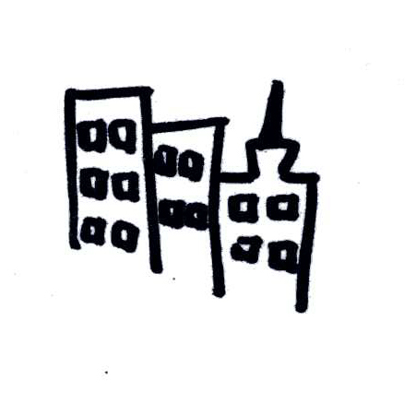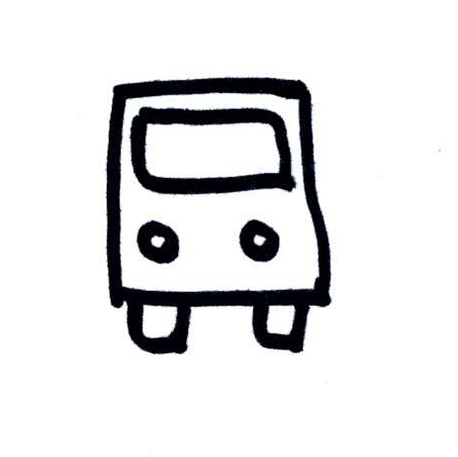

1. **Preliminary Results from the Activity Center Strategic Investment Plan | *50 minutes***

*Harriet Tregoning, DC Office of Planning – Moderator*

Mariela Alfonzo, Urban Imprint

Chris Yake, Reconnecting America

Launched last fall, the Activity Center Strategic Investment Plan will provide a roadmap to guide public and private stakeholders in making strategic, coordinated investments in the region’s Activity Centers. To date, COG and its partners have collected and begun analyzing detailed physical and economic data on the 90+ Activity Centers in the study. Harriet Tregoning will provide an overview of the project, including applications and outreach strategy. Mariela Alfonzo will introduce State of Place™, the tool she developed to rate neighborhood walkability and its related economic benefits, and will present scoring and profiles for selected Activity Centers in the region. Chris Yake will discuss the next phases of the project: developing place typologies based on shared characteristics and creating detailed recommendations on the type, scale, and timing of investments that will have the greatest impact.

**Action: Provide feedback on Activity Center profiles and project outreach strategy**

1. **Roundtable on Labor Market and Economic Development Trends | 60 *minutes*** 

*Jim Dinegar, Greater Washington Board of Trade – Moderator*

Ellen Harpel, Center for Regional Analysis, George Mason University

Terry Holzheimer, Arlington County Economic Development

Jason Sartori, National Center for Smart Growth, University of Maryland

Jim Dinegar will lead a roundtable discussion on current industry and labor market trends in the region aimed at highlighting recent research and activities and identifying gaps that the Industry and Labor Market Analysis should fill. Ellen Harpel and Jason Sartori will provide key findings from their recent studies, and Terry Holzheimer will discuss workforce challenges related to employer needs. Information from the panelists and feedback from the Coalition will be used to refine the approach to completing the Industry and Labor Market Analysis for *Economy Forward*.

**Action: Provide input and direction on gaps in workforce and industry knowledge and the scope of Industry and Labor Market Analysis**

1. **Other business |*10 minutes***

Chair Hynes, Coalition Members

**Region Forward Coalition Meeting Dates:**

**FRIDAY, APRIL 26th**

**Symposium – Summer / Date TBD**

**FRIDAY, SEPTEMBER 27th**

**FRIDAY, NOVEMBER 29th**

MCj02933200000[1]Reasonable accommodations are provided for persons with disabilities. Please allow 7 business days to process requests. Phone: 202.962.3300 or 202-962.3213 (TDD). Email: [accommodations@mwcog.org](mailto:accommodations@mwcog.org). For details: [www.mwcog.org](http://www.mwcog.org).