City of Alexandria, VA – Affordable Housing Best Practice: Jackson Crossing

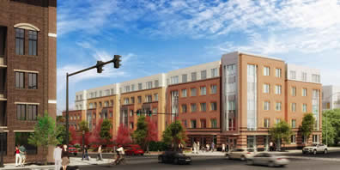
Jackson Crossing, located at the intersection of East Reed Avenue and Jefferson Davis Highway/Route 1, across from Potomac Yard, is currently under construction with an anticipated delivery date of mid-October 2015. The 78-unit affordable apartment complex is AHC's first development in Alexandria. Jackson Crossing will serve households with incomes at 60% or less of the area median income. Approved by City Council in January 2013, the project has one, two and three-bedroom apartments, including several accessible units. In addition to underground parking for residents, building amenities include a rooftop patio, onsite management, and a community space. AHC is coordinating resident services for the property, including educational programming for children. AHC’s land assemblage includes a city-owned parcel that was donated by the City. Alexandria has also provided loans (including a predevelopment loan) totaling $2.5 M to complete AHC’s financing package which includes low income housing tax credits and private loans.
Alexandria housing best practices incorporated at Jackson Crossing include:
- A public-private partnership between nonprofit developer, AHC, and the City
- Use of public land for affordable housing
- Significant City financial investment to leverage other public and private sources
- Transit oriented affordable housing development in an amenity rich area – bus/bus rapid transit and future metro accessibilty; proximity to jobs, retail and services at Potomac Yard
- Parking Reduction to right-size parking (lessening project cost and increasing potential open space)
- Robust community engagement and education to achieve consensus and support for affordable housing development in a neighborhood that was traditionally opposed to “more” affordable housing

