Multimodal Coordination for Bus Priority Hotspots

Task 3 Technical Memorandum:
Field Verification of Hotspots

Prepared for the National Capital Region Transportation Planning Board (TPB)
CONTENTS

1 INTRODUCTION 1
1.1 Purpose of Analysis 1
1.2 Top 30 Hotspots 1
2 FIELD VERIFICATION PROCESS 6
2.1 Methodology 6
2.2 Summary of Evaluation 6
2.2.1 District of Columbia 7
2.2.1.1 Two Recommended Locations 9
2.2.1.2 Eight Non-Recommended Locations 15
2.2.2 Maryland 21
2.2.2.1 Three Recommended Locations 23
2.2.2.2 Seven Non-Recommended Locations 33
2.2.3 Virginia 39
2.2.3.1 Two Recommended Locations 41
2.2.3.2 Eight Non-Recommended Locations 48
Appendix A: Bus Priority Hot Spot Study Task 3 Field Notes A-1

TABLES
Table 1: Top Ten DC Hotspots 1
Table 2: DC Hotspots Eliminated from Consideration 2
Table 3: Top Ten Maryland Hotspots 2
Table 4: Maryland Hotspots Eliminated from Consideration 3
Table 5: Top Ten Virginia Hotspots 4
Table 6: Virginia Hotspots Eliminated from Consideration 4
Table 7: Summary of Field Verification Findings for DC Hotspots 7
Table 8: Daily Bus Volumes Through the 14th Street Hotspot 10
Table 9: Daily Bus Volumes Through the North Capitol Street Hotspot 13
Table 10: Summary of Field Verification Findings for Maryland Hotspots 21
Table 11: Daily Bus Volumes Through the Veirs Mill-Reedie-Amherst Hotspot 24
Table 12: Daily Bus Volumes Through the Piney Branch Road Hotspot 28
Table 13: Daily Bus Volumes Through the Annapolis Road Hotspot 33
Table 14: Summary of Field Verification Findings for Virginia Hotspots 39
Table 15: Daily Bus Volumes Through the Van Dorn Street Hotspot 42
Table 16: Daily Bus Volumes Through the Glebe Road Hotspot 46

FIGURES
Figure 1: Locations of Top Ten DC Hotspots 8
Figure 2: Southbound 14th Street Approaching Park Road 9
Figure 3: Southbound North Capitol Street service road approaching New York Avenue 12
Figure 4: Detail of the North Capitol Street hotspot 14
Figure 5: Bus Bunching on SB 16th Street at U Street 19
Figure 6: Location of Top Ten Maryland Hotspots 22
Figure 7: Traffic Queues on Reedie Drive EB 23
Figure 8: Highly Protected Pedestrian Crossing of Reedie Drive at Triangle Lane 23
Figure 9: Detail of Veirs Mill-Reedie-Amherst Hotspot 26
Figure 10: Mid-block Bus Stop along Piney Branch 27
Figure 11: Detail of Piney Branch Hotspot 29
Figure 12: Mid-block Bus Stop on Annapolis Road 30
Figure 13: Detail of Annapolis Road Hotspot 32
Figure 14: Bus Bunching on EB East-West Highway Approaching Colesville Road 35
Figure 15: Location of Top Ten Virginia Hotspots 40
Figure 16: Detail of Van Dorn Street Hotspot 43
Figure 17: Existing Bus Pull-out on NB Glebe Rd 44
Figure 18: Potential Configuration for Queue Jump on NB Glebe Road 45
Figure 19: Detail of Glebe Road Hotspot 47

INTRODUCTION

Purpose of Analysis
This memo summarizes the results of the field verification process undertaken for the TPB Bus Hotspots Study. The focus of this effort was to field review the top 30 hot spot sites surfacing from the Task 2 hot spot screening process, and identify the top six sites to take into concept design, cost estimating, and more detailed impact assessment. The field review covered sites in the District of Columbia, Maryland, and Northern Virginia. Different teams comprised of staff from Parsons Brinckerhoff and Sabra Wang conducted the field review.

The analysis and six preferred sites for concept design will be reviewed and confirmed with the TPB Regional Bus Subcommittee and M&O ITS Committee at their March 27, 2012 and April 10, 2012 meetings respectively.

Top 30 Hotspots
The initial hotspot database creation effort ranked roadway segments’ applicability to this study by a weighted bus delay “score” combining average bus speed and density of bus service. Groups of highly-ranked road segments in close proximity were combined into “hotspots,” which were then ranked against each other based upon the average bus delay scores of the segments that comprise them. This process resulted in three lists of the top 15 hotspots in each jurisdiction (DC, Maryland, and Virginia), for a total of nine ranked lists. The lists were ranked by AM Peak, PM Peak, and all-day delays respectively.
Through a study team work session on January 25, 2012 and subsequent consultation with TPB and WMATA staff, incorporating comments from WMATA and state DOTs, the study team weighed the various rankings and determined the top ten hotspots in each jurisdiction to be advanced to the field verification stage. In some cases, hotspots that scored highly in the database were removed from consideration due to parallel study efforts, planned improvements, or known conditions in the area. Several hotpots were eliminated because the team knew that buses were laying over in those locations, thus skewing average speeds downward.
Table 1 through Table 6 document the process of winnowing the initial lists to the top 30 hotspots.

Table 1: Top Ten DC Hotspots
Street(s) | From | To | Ranking in database
 |  |  | All day | AM | PM
Virginia Avenue NW | E St | D St | 1 | 2
9th St NE | Bunker Hill Rd | Monroe St | 8 |  | 13
Wisconsin Ave NW & Q St |  |  | 9
7th St and Pennsylvania Ave NW | I-395 | 13th St | 10 | 14 | 3
Connecticut Ave NW | K St | Jefferson Pl | 11 |  | 2
14th St NW | Corcoran | Otis St | 13 | 10 | 8
Thomas Circle (southern half) and 14th St (to L) |  |  | 15 |  | 9
13th St | H St | K St |  | 4 | 5
16th St | K St | Shepherd St |  | 12
North Capitol Street | New York Ave | P Street | [Not in database – suggested by WMATA]

Table 2: DC Hotspots Eliminated from Consideration
Street(s) | From | To | Rationale
M Street/ Pennsylvania Ave NW | Wisconsin Ave | Washington Circle | This segment passes through the high pedestrian traffic of Georgetown. Higher bus speeds may not be desirable here, and options would be very limited.
Dupont Circle |  |  | Too complex to analyze given the scope of this study.
8th St SE | E St | M St | High pedestrian traffic in the Barracks Row area. Higher bus speeds may not be desirable here.
Franklin Square, as well as separate segments on H & I Sts NW |  |  | Already the subject of an ongoing study.
K St NW (Two segments) | 13th | Connecticut Ave | Already the subject of an ongoing study.
11th St NW | Pennsylvania Ave | I St | WMATA indicated that this segment was not a problem.

Table 3: Top Ten Maryland Hotspots
Street(s) | From | To | Ranking in database
 |  |  | All day | AM | PM
Georgia Ave | 13th St | Colesville Rd | 2 | 4 | 4
River Rd | Paint Branch Dr |  | 3 | 14
Veirs Mill Rd/Reedie Dr/Amherst Ave | Georgia Ave | MD 193 | 4 | 12 | 8
Fenton St | MD 410 | Colesville Rd | 5 | 6 | 7
East-West Hwy | Georgia Ave | Connecticut Ave | 6 | 7 | 5
Piney Branch Rd | MD 193 | Sligo Ave | 7 | 10 | 10
Carroll Ave | Maple St | Ethan Allen Rd | 11 |  | 14
Hungerford Dr | N Washington St | Ivy League Ln | 13
Annapolis Rd | Finns Ln | Riverdale Rd | 15 | 9 | 15
Wayne Ave | Georgia Ave | Colesville Rd |  | 1 | 1

Table 4: Maryland Hotspots Eliminated from Consideration
Street(s) | From | To | Rationale
Loop comprised of Willard/Western/Wisconsin |  |  | Low bus speeds likely due to bus layover activity at this location.
Baltimore Ave | Pineway | Fordham | This segment likely identified due to data irregularities, as it is only a few yards long. This area could be a substitute for one of the selected segments, but the area to the north (U-MD campus) should be studied, not at Pineway/Fordham.
Suitland Metro Loop |  |  | Areas on Metro Station footprint should not be studied. Bus layover likely accounts for slow speeds. Queuing issues more appropriately addressed by WMATA through a Metro Station Access study.
Colesville Rd | MD 410 | I-495 | Reversible lanes already in use, too constrained for physical or operational improvements
Monroe St/Monroe Pl | Jefferson St | Rockville Pike | Low bus speeds likely due to bus layover activity at this location.
Lebanon Rd | MD 193 | MD 650 | Low bus speeds likely due to bus layover activity at this location.

Table 5: Top Ten Virginia Hotspots
Street(s) | From | To | Ranking in database
 |  |  | All day | AM | PM
Wilson Blvd | Fort Myer Dr | Moore St | 5 |  | 15
Lynn St | Key Bridge | 19th St | 9 | 6 | 8
Joyce St | Columbia Pike | Army Navy Dr | 10
Gallows Rd | Belleforest Dr | Inova Hospital Gray Entrance | 12 | 12
Army Navy Dr | Eads St | Joyce St | 14 (6)* | 4 (11)*
SB Glebe Rd @ Arlington Blvd | EB on and off ramps | WB on and off ramps |  | 2 | 1
Patriot Dr | Lafayette Forest Dr | Heritage Dr |  | 5
Eisenhower Ave | Van Dorn St | Van Dorn Metro Station |  | 8
Van Dorn St | Eisenhower Ave | Franconia Rd | [Not in database – suggested by Fairfax County]
Rte 123 | Jermantown Rd | Folin Ave | [Not in database – suggested by Fairfax County]
* Segment was expanded to include intersection with Eads St. Rankings in parentheses are for Eads street segment identified during Task 2.

Table 6: Virginia Hotspots Eliminated from Consideration
Street(s) | From | To | Rationale
Arlington Blvd | Washington Blvd WB off-ramp | End Overpass | Highway segment
Lee Hwy WB | Lynn St | Fort Myer Dr | Multiple hotspots were identified in the Rosslyn area. In addition, Arlington County has an ongoing project to redesign the street network in the Rosslyn area.
N Stuart St | Fairfax Dr | Wilson Blvd | Separate study by Arlington County and WMATA underway.
Fashion Blvd | Ring Rd | VA 7 | Highly constrained by mall traffic and turning movements, no signalized intersections to work with.
Arlington Blvd | SB off-ramp to Glebe | Opposite side of Glebe | Arlington Blvd (US 50) is a limited-access highway at this point Prior to the field verification phase of the study, a decision was made not to study highway segments, but rather to limit the study to surface streets.
S Eads St | Army Navy Dr | IS 395 | Combined with Army-Navy Dr hot spot.
Columbia Pike | Walter Reed Dr | Greenbrier St | Separate study underway.
EB Fairfax Dr | Stuart St | Randolph St | Separate study underway.
Leesburg Pike | Glen Carlyn Rd | Thorne Rd | Separate study underway.
Jefferson Davis Hwy NB | Reed Ave | 20th St | Separate study underway.
Thorne Rd | Leesburg Pike | Seven Corners Center | Low bus speeds likely due to bus layover activity at this location (Seven Corners Transit Center).

FIELD VERIFICATION PROCESS

Methodology
The field verification process initiated with a desktop inventory and assessment of existing traffic operations at the top 30 hot spot sites. Sabra Wang headed this effort, and put together summary data and diagrams for each site that included weekday AM and PM peak hour period turning movements and level of service at signalized intersections, intersection lane configuration, bus stop locations, and bus routings. An overall data collection worksheet was also prepared to record information on the presence and condition of sidewalks, crosswalks, pedestrian signals, curb ramps, bicycle lanes, bus stop amenities, parking restrictions, roadway and bus stop lighting, posted speed limits, and overall roadway width and specific lane widths.

The field review of the 30 sites was conducted during a two-week period: February 6-8 and February 20-22, 2012. Based on the initial desktop review, a critical peak period (either AM or PM) from a traffic operations standpoint was identified for each site, which then became the field survey period. 2-4 person teams were assembled to conduct the field review. This included both senior staff members with extensive experience in transit priority treatment application, who focused on making observations in the field, as well as more junior staff who served as recorders.

A video camera was also mounted on the survey vehicle to provide a video record of conditions associated with a couple of travel time runs undertaken in each direction at each site during the particular survey period.

Summary of Evaluation
This section contains brief summaries of each hotspot evaluated during the field verification phase, with greater detail provided for those hotspots selected to be moved forward to the conceptual design phase. At each location evaluated, the study team evaluated the potential for improvements in four areas:
- Physical improvements include any changes to dedicate portions of the right of way to transit vehicles, including bus lanes, bus-only roadways, or queue-jumps. Potential for physical improvements was given the highest priority in selecting hotspots to be moved forward.
- Operational Changes encompass any improvements solely in the realm of the transit operators, including relocation of stops, adjustments to headways or re-routing of bus lines.
- Signal Timing improvements include adjustments to signal phasing or transit signal prioritization implementation.
- Long-term Planning considerations were captured for those locations where known coming changes to the vicinity will have a notable impact on all transit services. This is a recognition that conditions documented in 2012 may be notably different in the near future due to projects that we know are coming. Examples among the hotspots reviewed include the Silver Spring Transit Center, and the multiple redevelopment projects ongoing in the Gallows Road corridor. Long-range planning considerations in some cases were viewed as reducing a hotspot’s prospects for this study, but was not viewed as disqualifying.

District of Columbia

Table 7: Summary of Field Verification Findings for DC Hotspots
Street(s) | Rankings |  |  | Potential for Improvements
 | All day | AM | PM | Physical Improvements | Operational Changes | Signal Timing | Long-term planning
Virginia Avenue NW, E St to D St | 1 | 2
Wisconsin Ave NW & Q St | 9 |  |  | ◇ | ◇
7th St NW/SW, I-395 to Pennsylvania Ave | 10 | 14 | 3 |  |  | ◇
Connecticut Ave NW, K St to Jefferson Pl | 11 |  | 2
14th St NW, Corcoran St to Otis St | 13 | 10 | 8 | ◆ | ◆
Thomas Circle (southern half) and 14th St NW (to L) | 15 |  | 9
13th St NW, H St to K St |  | 4 | 5 | ◇
Georgia Avenue NW, Upshur St to New Hampshire Ave |  | 9 |  | ◇ |  | ◇
16th St NW, K St to Shepherd St |  | 12 |  |  | ◆
North Capitol St, New York Ave to P St |  |  |  | ◆ |  | ◆
◇ = some potential for improvements
◆ = strong potential for improvements
= Recommended for development of conceptual design

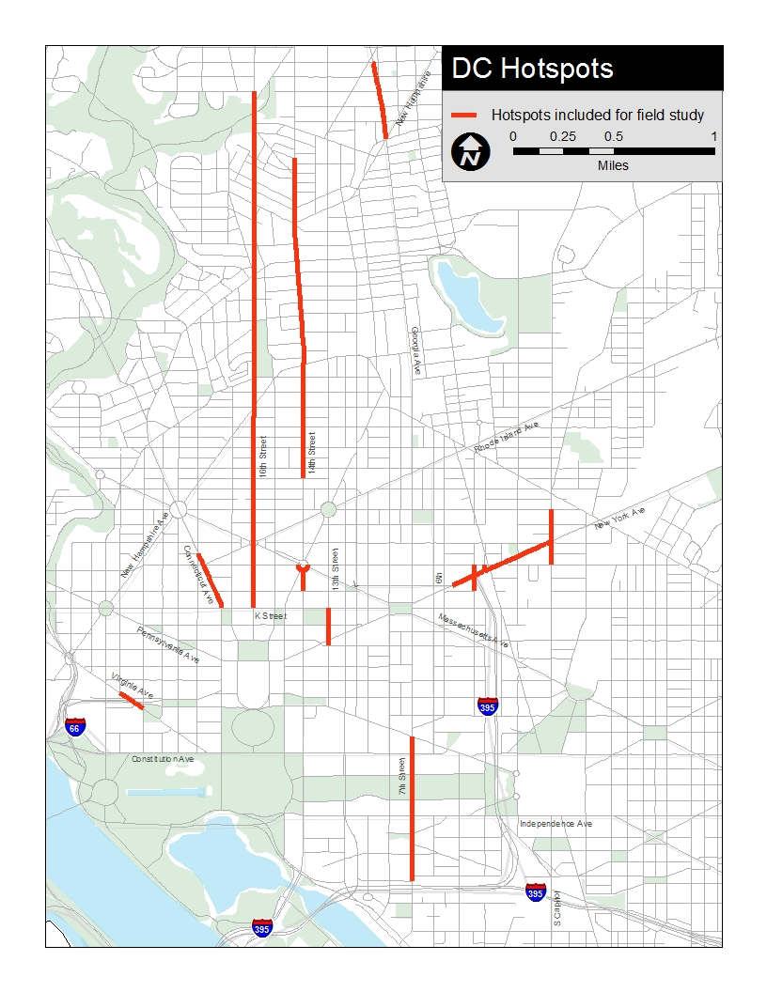
Figure 1: Locations of Top Ten DC Hotspots

Two Recommended Locations

14th Street NW, between Corcoran Street to Otis Street
Problems Observed (PM Peak)
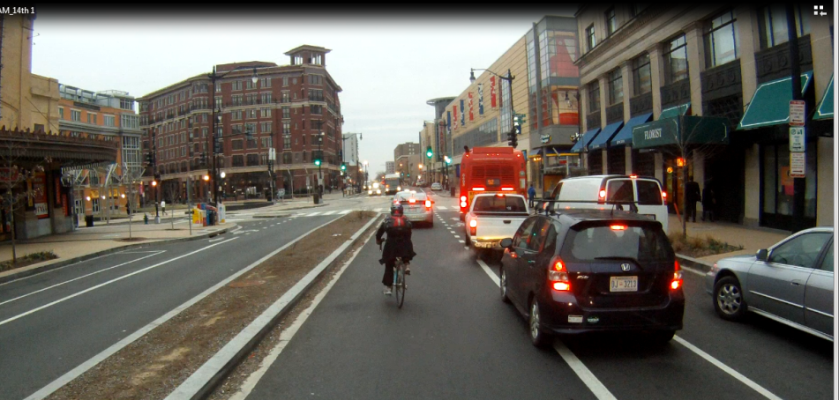
This segment of roadway is a primary north-south arterial from the Central Business District up through Columbia Heights. The roadway cross section changes from a two-lane section north of Park Road, a three-lane section between Harvard Street and Park Road, and a four-lane section south of Harvard Street. Full-time on-street parking is provided in most of the segment, as well as continuous bicycle lanes. Three bike share stations and one zip car lot are also provided within the study segment.
Figure 2: Southbound 14th Street Approaching Park Road
In the northbound direction in the PM peak hour, traffic congestion was observed northbound between Harvard Street and Kenyon Street/ Park Road, and in the AM southbound between Park Road and Otis Place. In these stretches, it was observed that most vehicles including buses required several traffic signal cycles to clear the intersection thus resulting in slow travel speeds. Outside of this segment no vehicle congestion was observed in either peak hour.
In addition, pedestrian activity and bus boardings/ alightings were notably heavy at the Irving Street intersection/ Columbia Heights Metro Station. The gravity of ridership appeared to be strongest between downtown and the Columbia Heights Metro station, as in the AM peak hour the Circulator and Metrobus routes 52 and 53 were observed to be standing room only. Less than five minute headways were observed and bunching of the 52 and 53 was also observed.
Potential Physical Improvements
- Remove the bike lanes and install a bus only lane in one direction from Irving Street to Logan Circle (all or part). This option could provide a dedicated transit lane in one direction along 14th Street. Bicycles could share the lane in one direction but would no longer have dedicated space to ride in the other direction. This option is likely to meet significant resistance from the bicycling community. However, this recommendation is put forward for consideration under the supposition that the 15th Street cycle track may be able to absorb some of the cycling traffic south of V Street. Bicycle traffic volumes for both streets will need to be reviewed. The configuration of travel lanes for autos under this scenario would remain unchanged.
- Restrict parking along 14th Street from Irving Street to Logan Circle during rush hour to create a bus only lane. This option could provide a dedicated transit lane in each direction during peak hours, but would impact available parking in an area with much commercial activity. The configuration of travel lanes for autos under this scenario would remain unchanged.
Potential Transit Operations Improvements
- Many bus stops are near-side, relocating these stops to the far side may increase bus speeds by eliminating the potential to stop twice when approaching a traffic signal.
- Bus stop density in several stretches was high – nearly one stop every block. Consolidation of bus stops may increase bus speeds by reducing the number of stops.
Potential Signal Timing Improvements
- Review signal timing at 14th Street/ Park Road/ Kenyon Street to determine if SB queuing can be reduced.
Long-Term Planning Considerations
  - In previous studies, DDOT has recommended a bus only lane and express bus service in this corridor.
  - This corridor is the subject of an ongoing study of the 50s-Line. Concepts developed in Task 4 will need to be coordinated with findings of that study.

Table 8: Daily Bus Volumes Through the 14th Street Hotspot
 | Corcoran St to Columbia Rd |  | Columbia Rd to Otis Pl
 | NB | SB | NB | SB
Total: | 266 | 262 | 164 | 160
52, 53, 54 | 164 | 160 | 164 | 160
Circulator Green Route | 102 | 102 | 0 | 0

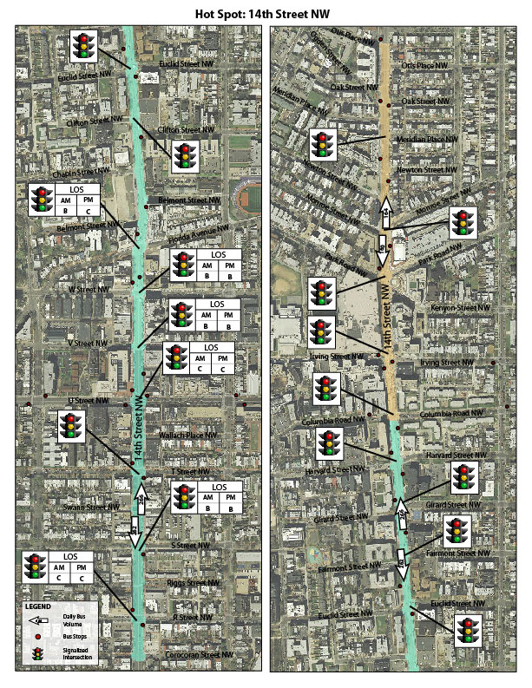h Street detail map – to be inserted 3/21.

Figure 3: Detail of 14th Street Hotspot

North Capitol Street: New York Avenue to P Street
Problems Observed (AM Peak)
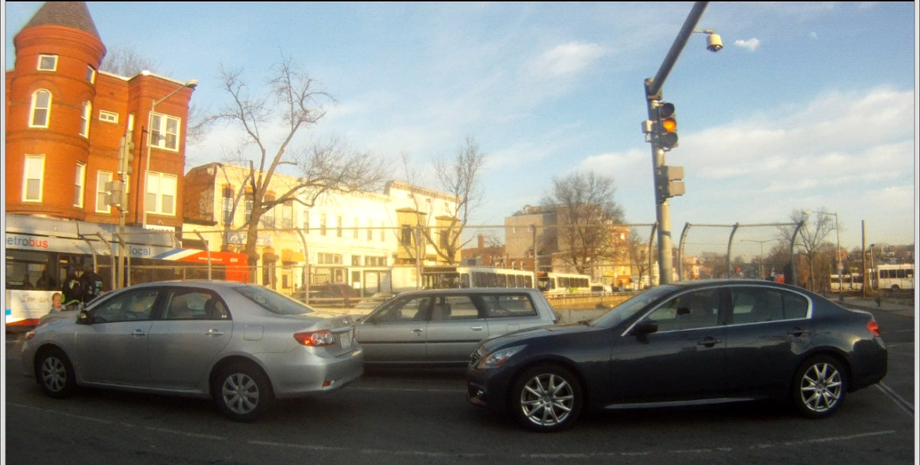
Although it was not ranked in the top 15 based on recorded bus travel speeds, New York Avenue was flagged by WMATA and serves as a connection between two major highways (US 50 and I-395). The study team determined that while there was congestion on New York Avenue, the location with the most potential for improvements was actually the service lanes of North Capitol Street north of New York Avenue.
Figure 3: Southbound North Capitol Street service road approaching New York Avenue
The six-lane undivided cross section of New York Avenue is highly congested, with westbound AM queues spilling back from 4th Street/ I-395 past Florida Avenue. Vehicles were observed to wait through several traffic signal cycles to pass through an intersection, and often blocked intersection prohibiting side street traffic from entering New York Avenue.
The study segment serves Metrobus Routes P6 and 90, 92, 93. In the westbound direction the P6 originates along southbound North Capitol Street and then turns right onto westbound New York Avenue and then left onto southbound 4th Street. In the eastbound direction, the P6 originates from northbound 4th Street and turns right onto eastbound New York Avenue, veers right onto M Street and then turns left onto North Capitol Street. Bus stop activity was very low along all observed stops along New York Avenue. The 90, 92, 93 buses have been rerouted for the last two years from the intersection of Florida Avenue and New York Avenue due to changes DDOT made to the geometry of the intersection which no longer accommodate buses. The 90s Route buses now operate southbound on North Capitol Street and then turn left onto eastbound New York Avenue before continuing on with a soft right onto Florida Avenue. This rerouting has added significant running time to the 90s Route buses, particularly because they frequently must wait for several light cycles to make the left onto New York Avenue. Once they turn left onto eastbound New York Avenue, there is an immediate red light which contributes to the backups and congestion at the intersection.
The intersection of North Capitol Street and New York Avenue is a grade separated intersction. Through traffic along North Capitol Street passess underneath New York Avenue. The vertical grade separation runs from approximately P Street to M Street. The P6 bus, along with several other Metrobus routes (96, and 80) use the North Capitol Street service road as there are several bus stops serving adjacent commercial and residential lane uses. The bus stops along this segment of North Capitol Street were busy – with 15+ boardings observed, and the P6 southbound bus was observed to be full with standing room only.
Buses (and vehicles) using the southbound service lane to turn onto New York Avenue (or continue through along North Capitol Street) were significantly delayed (up to 10 minutes) due to the congestion along New York Avenue. The queue along the southbound service road spilled back nearly to the mainline lanes along North Capitol Street.
Potential Physical Improvements
- Install a bus only lane along the North Capitol Street service road
This option would require restricting parking at least in peak hours and could provide a dedicated transit lane to allow buses to bypass queued vehicles. However, a bus only signal phase may be required due to conflicting turns.
Potential Transit Operations Improvements
- None – the feasibility of rerouting the P6 southbound to avoid the intersection of New York and North Capitol Street was examined but alternatives routes such as P Street and 1st Street NW were not suitable
Potential Signal Timing Improvements
- Review signal timing at New York Avenue/ North Capitol Street to determine if SB queuing can be reduced.
- Include a bus-only signal phase on southbound North Capitol Street at New York Avenue to accommodate turning buses in advance of general traffic.
- Deploy a Point Control Traffic Officer to reduce intersection blockage.
- Synchronize the two sets of lights on New York Avenue at the NB & SB North Capitol Street lanes to provide a green phase for buses that have just turned left from North Capitol Street to New York Avenue.
Long-Term Planning Considerations
None

Table 9: Daily Bus Volumes Through the North Capitol Street Hotspot
 | P Street to New York Avenue
 | NB | SB
Total: | 123 | 121
80 | 76 | 76
P6 | 47 | 45

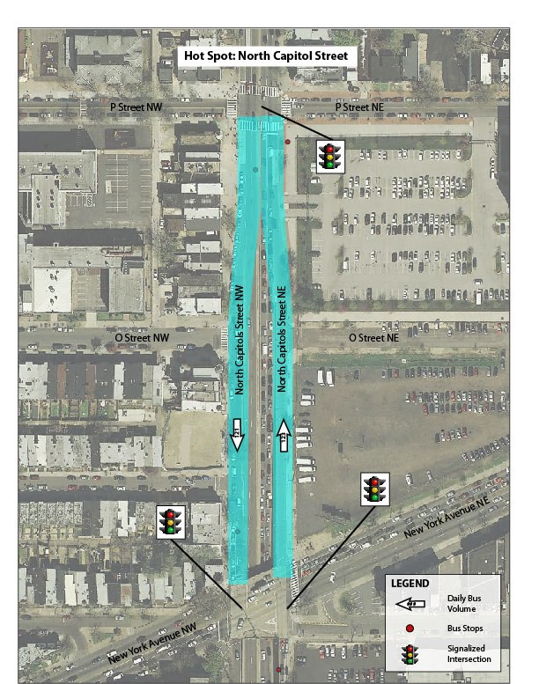
Figure 4: Detail of the North Capitol Street hotspot

Eight Non-Recommended Locations

Virginia Avenue
Problems Observed (AM Peak)
Observations at Virginia Avenue NW & E Street NW indicate that this location’s bus speeds recorded in the hotspot database were artificially low. The primary reason is likely the Metrobus layover location on NB Virginia Avenue just before E Street, at which several buses were observed to layover up to 20 minutes. The buses laying over here likely bring down the average speed of Metrobus routes considerably. No significant issues were observed at this location, and so it is removed from consideration.
Potential Physical Improvements
None
Potential Transit Operations Improvements
None
Potential Signal Timing Improvements
None
Long-Term Planning Considerations
None

Georgia Avenue, NW: Upshur Street to New Hampshire Avenue
Problems Observed (PM Peak)
Traffic congestion observed during the weekday afternoon peak period at the Upshur and Kansas Avenue intersections at the north end. The short block in between these two intersections causes the potential for vehicles, including buses, backing up through the Upshur intersection northbound during the afternoon peak. Also some queues for northbound buses at the New Hampshire intersection wanting to access the stop at the Georgia Avenue – Petworth Metrorail station. Curb extensions on Georgia Avenue preclude any extended bus lane opportunity.
Potential Physical Improvements
None
Potential Transit Operations Improvements
- Restriction of parking on east side of Georgia Avenue in block south of New Hampshire Avenue, and creation of bus bypass lane into far side bus stop in front of Metrorail station.
Potential Signal Improvements
- Signal timing modifications at Upshur and Kansas Avenue intersections
Long-Term Planning Implications
Strategy for transit signal priority implementation along Georgia Avenue

Wisconsin Ave NW & Q Street
Problems Observed (PM Peak)
Observations at Wisconsin Avenue and Q Street indicate that peak-period traffic conditions at this location were consistent with an urban commercial corridor, with low speeds but minimal queues. Some minor delays were noted for southbound bus traffic that could be addressed through physical changes. It appears that congestion and bus delays may be higher during off-peak periods, when parking is permitted along Wisconsin Avenue. However, removal of this parking during off-peak periods does not appear feasible due to the needs of the adjacent land uses, and so this location is removed from consideration.
Potential Physical Improvements
It may be possible to offset the centerline north of Q Street a few feet to the east, allowing southbound vehicles to pass stopped buses more readily. Additionally, a narrow median strip preventing left turns from Wisconsin Avenue into the gas stations on either side may prevent queueing.
Potential Transit Operations Improvements
None
Potential Signal Timing Improvements
None
Long-Term Planning Considerations
None

7th Street SW/NW – I-395 to Pennsylvania Avenue
This location bisects the Washington Mall and is home to a large number of bus routes, including local WMATA routes and suburban commuter routes. A large number of US government offices are located in this immediate area, and appears to be mainly responsible for the significant passenger boarding activity. Through multiple observations of the corridor, only very minor issues were observed. As part of these observations, it was noted that there is an existing bus lane located on 7th St to the north of Pennsylvania Avenue, which is in need of upgrades to signage and markings. However, this area falls outside the specific limits of this hot spot location.
Problems Observed (PM Peak)
- Buses turning left from SB 7th St to EB Independence Ave were sometimes caught in a queue, and also had to maneuver across three lanes of traffic to move from their bus stop to the left turn lane.
- Friction between local and commuter buses was observed in a number of locations, due to sometimes inadequate bus stop sizing and the length of time required for commuter coaches to board through a single door.
- At the northern end of the corridor, it was noted that there is very poor coordination between the signals at Pennsylvania Ave and Indiana Ave, resulting in reduced throughput for traffic on SB 7th St in this area.
Potential Physical Improvements
- None identified.
Potential Transit Operations Improvements
- Improve placement of bus stops approaching the left turn from SB 7th St to EB Independence Ave, to make it easier for buses to make their way from the bus stop to the left turn lane.
- Consider selective lengthening of bus stops to accommodate both local and commuter boarding activity.
Potential Signal Timing Improvements
- Improve coordination between signals at Indiana Ave and Pennsylvania Avenue on 7th St, to reduce queuing and improve throughput for all vehicles (including buses).
- Consider installation of a bus-actuated left-turn phase from SB 7th St to EB Independence Ave, to reduce delays for buses waiting to make that turn.
Long-Term Planning Considerations
None

Connecticut Avenue NW – K Street to Jefferson Place
Problems Observed (PM Peak)
Observations on Connecticut Avenue between K Street and Jefferson Place did not indicate any significant congestion or delays to bus traffic. K Street was heavily congested, a situation that may have been exacerbated by adjacent construction, but this did not spill onto Connecticut Avenue. As no significant issues were observed at this location, it is removed from consideration.
Potential Physical Improvements
None
Potential Transit Operations Improvements
None
Potential Signal Timing Improvements
None
Long-Term Planning Considerations
None

Thomas Circle
Problems Observed (PM Peak)
Observations at Thomas Circle showed extremely heavy general traffic congestion, primarily in the northbound and westbound directions. Buses travelling northbound on 14th Street were heavily delayed by traffic queues extending through and back from the Circle. Changes in signal timing and phasing around the Circle may have the potential to improve general traffic operations. However, as these are network improvements and not transit improvements, this location is removed from consideration.
Potential Physical Improvements
None
Potential Transit Operations Improvements
None
Potential Signal Timing Improvements
None
Long-Term Planning Considerations
None

13th Street, NW: H to K Streets, NW
Problems Observed (AM Peak)
Observations during the weekday morning peak period revealed little congestion in this corridor, except for some traffic backup in the vicinity of the H Street and New York Avenue intersections given the short block spacing between the two intersections. Curb extensions prevent any curbside bus lane provision, though parking (metered) is restricted to off-peak periods.
Potential Physical Improvements
None
Potential Transit Operations Improvements
None
Potential Signal Improvements
- Better signal coordination through H Street and New York Avenue intersections
Long-term Planning Implications
None

16th Street NW: K Street to Sheppard Street
Problems Observed (AM Peak)
This corridor is a major arterial roadway from downtown DC to Silver Spring. In the study segment, the cross-section varies considerably. There is a five-lane section with a reversible lane from Columbia Road to Sheppard Street which provides three lanes in the peak direction and two in the off-peak. There is a five lane section between Columbia Road to Florida Avenue, which provides three lanes southbound and two lanes northbound at all times. South of Florida Avenue, the cross-section provides four travel lanes at all times.

Vehicle congestion was noted for a 30 to 45 minute period southbound in the AM peak hour between Sheppard Street and Park Road. During this time, vehicle including buses were not able to clear an intersection during one signal cycle. There was also a point control officer at the intersection of 16th and Park to assist pedestrians crossing. South of Park Avenue, there was generally good flow of traffic into the central business district.
Figure 5: Bus Bunching on SB 16th Street at U Street

Three types of bus service are provided in this corridor – local service, express service and commuter service, the latter of which does not stop at any point in the segment. Each of these buses were observed to use different travel lanes – the local bus in the curb lane, the express bus in the middle lane and the commuter bus in the left lane.

Significant bus bunching was noted for Metrobus routes S1 & S2, with observed headways of less than five minutes. Ridership on all buses was observed to be very high – standing room only on most buses. Boarding activity on bus stops in the northern portion of the corridor near Park and Irving, as well as near Columbia Road, Euclid and U Street were very high – up to 35+ persons. Some passengers were not able to board when buses stopped. Other buses that were full were observed to skip stops. When multiple buses arrived at a stop at the same time, there was often not enough curb space for them to fit to allow passengers to conveniently alight and board. Lastly, many bus stops were near side which also created additional delays.

Potential Physical Improvements
None – eliminating a lane during peak periods would have significant impact on vehicle level of service
Potential Transit Operations Improvements
- Provide greater bus capacity through higher capacity vehicles such as articulated vehicles
- Eliminate near-side stops: Many bus stops are near-side, relocating these stops to the far side may increase bus speeds by eliminating the potential to stop twice when approaching a traffic signal
- Consolidate bus stops: Bus stop density in several stretches was high – nearly one stop every block. Consolidation of bus stops may increase bus speeds by reducing the number of stops
- Review bus scheduling/ real-time bus location to reduce bus bunching, this may require a layover area
- Expand bus stop lengths to accommodate more than one bus and/ or longer buses
- Provide off-board fare payment to reduce dwell times
Potential Signal Timing Improvements
- Review signal timing through the reversible lane section to determine if SB queuing can be reduced. Due to the density of buses, and varying levels of bus service on this corridor, transit signal priority would not be an effective tool to utilize.
Long-Term Planning Considerations
- WMATA has expressed a high interest in placing a bus only lane in this corridor.
- This corridor is the subject of an ongoing DDOT traffic study.

Maryland

Table 10: Summary of Field Verification Findings for Maryland Hotspots
Street(s) | Rankings |  |  | Potential for Improvements
 | All day | AM | PM | Physical Improvements | Operational Changes | Signal Timing | Long-term planning
Georgia Ave, 13th St to Colesville Rd | 2 | 4 | 4 | ◇ |  |  | ◆
River Rd @ Paint Branch Dr | 3 | 14 |  |  | ◇ |  | ◆
Veirs Mill Rd/Reedie Dr/Amherst Ave | 4 | 12 | 8 | ◆ |  | ◆ | ◆
Fenton St, MD 410 to Colesville Rd | 5 | 6 | 7 | ◇
East-West Hwy, Georgia Ave to Connecticut Ave | 6 | 7 | 5 | ◆
Piney Branch Rd, MD 193 to Sligo Ave | 7 | 10 | 10 | ◆ | ◆
Carroll Ave, Maple St to Ethan Allen Rd | 11 |  | 14 | ◇
Hungerford Dr, Washington St to Ivy League Ln | 13
Annapolis Rd, Finns Ln to Riverdale Rd | 15 | 9 | 15 | ◆ | ◆
Wayne Ave, Georgia Ave to Colesville Rd |  | 1 | 1 |  |  |  | ◆
◇ = some potential for improvements
◆ = strong potential for improvements
= Recommended for development of conceptual design

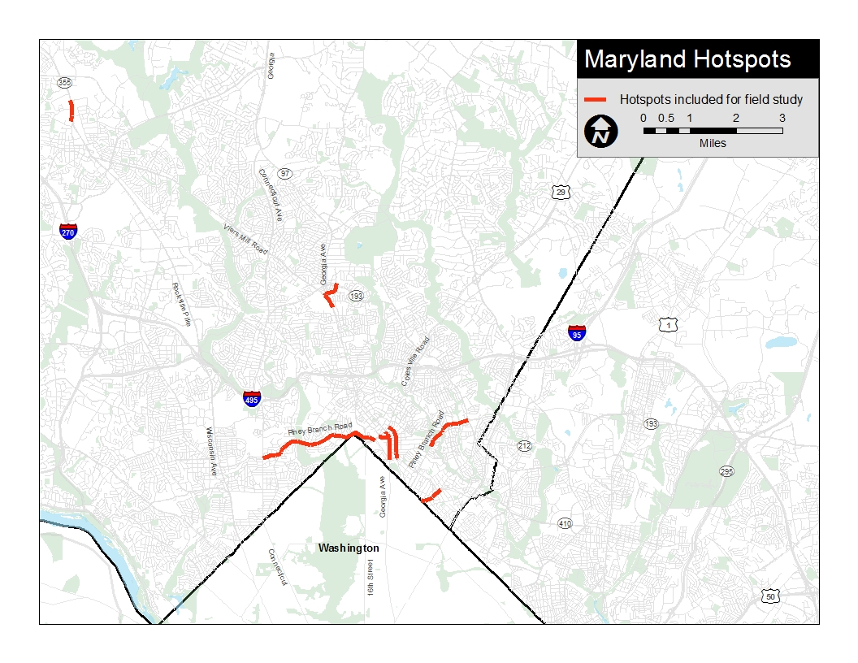
Figure 6: Location of Top Ten Maryland Hotspots

Three Recommended Locations

Veirs Mill Road-Reedie Drive-Amherst Avenue
Problems Observed (PM Peak)
The study team quickly determined that the majority of the issues within this hotspot were to be found in the segment of Reedie Drive between Veirs Mill Road and Georgia Avenue, with secondary issues occurring on Veirs Mill Road SB where buses were delayed in accessing the Wheaton Metrorail Station.
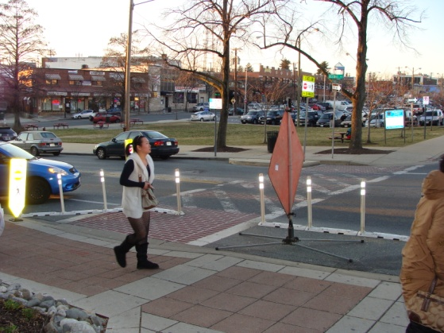
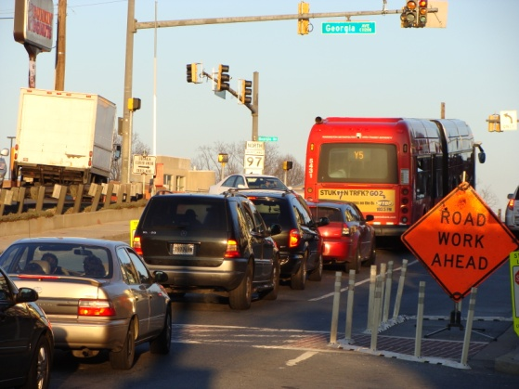
On Reedie Drive, multiple factors combine to slow traffic considerably in both directions between Georgia Avenue and Veirs Mill Road. Multiple non-signalized access points from the north (Triangle Lane, Grandview Drive) create a weaving pattern with cars turning onto and off of Reedie Drive. If a vehicle must wait to make a turn, frequently the resulting queue will back up into the next intersection behind. Additionally, the improved crosswalk at Triangle Lane results in backups. This crosswalk is heavily signed with pavement striping and bollards, but does not have a pedestrian crossing signal. As a result, pedestrians cross at random intervals that are not in synch with the signals at Georgia Avenue or Veirs Mill Road. Traffic is very accommodating, but the result is queues emanating from this mid-block location. Curbside parking further constrains the roadway and slows traffic speeds, leading to more missed signal phases by buses. Lastly, the left turn phase from Reedie onto Veirs Mill is frequently inhibited by conflicts with pedestrians crossing Veirs Mill Road, causing vehicles to miss signal phases and queues to form WB.
Figure 7: Traffic Queues on Reedie Drive EB
On Veirs Mill Road, the SB queues that form at the intersection with the mall entrance/Wheaton Metrorail Station bus loop entrance inhibit buses from being able to enter the station bus loop. Queues were observed that extend far enough to prevent buses from accessing the left turn lanes, resulting in missed left-turn cycle phases.
Figure 8: Highly Protected Pedestrian Crossing of Reedie Drive at Triangle Lane
Table 11: Daily Bus Volumes Through the Veirs Mill-Reedie-Amherst Hotspot
 | Veirs Mill south of Station Entrance |  | Veirs Mill north of Station Entrance |  | Reedie west of Station Entrance |  | Reedie & Amherst east of Station Entrance |  | Into/out of  Wheaton Station
 | NB | SB | NB | SB | EB | WB | NB/EB | SB/WB | Right Turn | Left Turn | Straight
Total: | 317 | 124 | 475 | 325 | 195 | 74 | 99 | 161 | 475 | 124 | 13
C2, C4: | 106 | 0 | 98 | 44 | 44 | 0 | 44 | 106 | 98 | 0 | 0
Q1, Q2, Q4, Q5, Q6: | 63 | 53 | 107 | 90 | 0 | 0 | 0 | 0 | 107 | 53 | 0
Y5, Y7, Y8, Y9: | 131 | 65 | 66 | 0 | 66 | 0 | 0 | 0 | 66 | 65 | 0
Ride On 7: | 0 | 0 | 4 | 4 | 4 | 4 | 4 | 4 | 4 | 0 | 0
Ride On 8: | 0 | 0 | 30 | 30 | 30 | 30 | 0 | 0 | 30 | 0 | 0
Ride On 9: | 0 | 0 | 27 | 26 | 40 | 40 | 40 | 40 | 27 | 0 | 13
Ride On 31: | 11 | 0 | 11 | 0 | 11 | 0 | 11 | 11 | 11 | 0 | 0
Ride On 34: | 0 | 0 | 55 | 54 | 0 | 0 | 0 | 0 | 55 | 0 | 0
Ride On 37: | 6 | 6 | 0 | 0 | 0 | 0 | 0 | 0 | 0 | 6 | 0
Ride On 38: | 0 | 0 | 34 | 35 | 0 | 0 | 0 | 0 | 34 | 0 | 0
Ride On 48: | 0 | 0 | 43 | 42 | 0 | 0 | 0 | 0 | 43 | 0 | 0

Potential Physical Improvements
- Conversion of Reedie Drive from Georgia Avenue to Grandview Avenue to a transit-only roadway
This approach would alleviate numerous backups. The dense street grid in the area provides ample opportunities for other traffic to avoid Reedie Drive. Triangle Lane is a low-traffic roadway that functions primarily as access to the businesses along its east side and the municipal parking along its west side, for which its access points at the north should suffice. An ancillary benefit to this approach would be a better pedestrian environment on Reedie.
- Extension of the left-turn lane from Veirs Mill Road into the Wheaton Station bus loop
Providing a longer turn lane for buses at this intersection would reduce the number of buses forced to wait through a full cycle of the light because they cannot reach the intersection during the left-turn phase. This improvement would have to come at the expense of one of the two left turn lanes for vehicles entering the mall from Veirs Mill Road. The full capacity of those lanes, however, is probably only needed on weekends during peak shopping hours.
- Removal of on-street parking on Reedie Drive (both sides) west of Triangle Lane
Ample parking is available throughout the Wheaton area, and these few parked cars constrain buses by narrowing the roadway, making the right turn from Veirs Mill Road onto Reedie Drive tighter, and inhibiting access to the bus stop on Reedie at Grandview Ave.
Potential Transit Operations Improvements
None
Potential Signal Timing Improvements
- Assess signal timing along Veirs Mill Road to determine if SB queuing can be reduced.
- Consider implementing protected phasing at the intersection of Veirs Mill Road and Reedie Drive to improve safety.
- Installation of a pedestrian signal at the midblock crosswalk on Reedie Drive that would operate in coordination with the Reedie Drive/Georgia Avenue signal. This would improve safety for pedestrians at this crossing, as well as reducing the instances in whicyh buses miss the Reedie/Georgia signal due to waiting down the block while pedestrians cross.
Long-Term Planning Considerations
The Wheaton area is expected to undergo significant change over the next several years, and implementation of improvements should take these changes into consideration. Specifically, Veirs Mill Road has been identified as a future BRT corridor by Montgomery County, and any improvements should be integrated with the physical changes foreseen in that plan. Secondly, the Wheaton station “triangle” between Georgia Avenue, Veirs Mill Road, and Reedie Drive has been identified as a high priority location by WMATA for joint development. Any improvements should take into consideration the possibilities laid out in WMATA’s Wheaton Station Access Study.

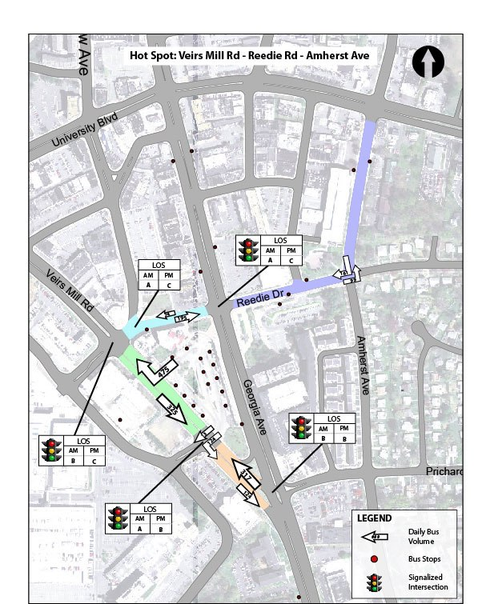
Figure 9: Detail of Veirs Mill-Reedie-Amherst Hotspot
Potential extended left-turn lane
Potential signalized pedestrian crossing
Potential transit-only roadway
Piney Branch Road: University Blvd to Sligo Avenue
Problems Observed (PM Peak)
This corridor is generally a four to five-lane cross-section that transitions to a three lane section west of Manchester Road. The corridor intersects several major cross-county roadways including MD 410, MD 193 and MD 650, and provides good connectivity between Takoma Park / Silver Spring Metro Stations and Adelphi. At these major intersections, there was congestion observed during peak hours where not all vehicles were able to clear the intersection in one traffic signal cycle.
A significant investment in bus stop amenities has recently been made in this corridor including concrete landing pads, shelters, lighting, benches and trash receptacles. However, the bus stop locations are fairly dense – in some segments near Baron, Park Crest and Devon Streets stops are located on every block to serve adjacent apartment complexes. In addition, many of these stops are near-side which could result in buses stopping twice. Bus bunching was observed in the PM peak hour on the Ride On #15 and 16 routes. However, bus stop activity was moderate to light (less than five person) throughout most of the time observed.
Figure 10: Mid-block Bus Stop along Piney Branch
The pavement condition along portions of the roadway is also fairly deteriorated, which also had a direct influence on vehicle and bus speeds. Several intersections where buses turn left off of Piney Branch such as Dale and Flower Avenue have permissive left-turn phasing (i.e. left turns are allowed without an arrow signal during a portion of the cycle). These intersections were observed to increase bus delay as traffic (including buses) waited for breaks in oncoming traffic to make their turns.

Potential Physical Improvements
- Install queue jump lanes at Dale Blvd and Flower Avenue (northbound) and University Blvd (southbound )
This option would allow buses to bypass queued vehicles by going straight through in a right-turn only lane.
- Construct northbound right-turn lane at University Blvd to improve roadway level of service and provide a bus queue jump lane in the northbound direction.
- Repave roadway
Potential Transit Operations Improvements
- Eliminate near-side stops: Many bus stops are near-side, relocating these stops to the far side may increase bus speeds by eliminating the potential to stop twice when approaching a traffic signal.
- Consolidate bus stops: Bus stop density in several stretches was high – nearly one stop every block. Consolidation of bus stops may increase bus speeds by reducing the number of stops.

Potential Signal Timing Improvements
- Provide Transit Signal Priority: at non-State roadways (Arliss, Dale Blvd, Baron Drive, Greenwood Avenue, Sligo Creek Parkway, Sligo Avenue)
  - The bus density and headways are ideally suited for TSP, and the impact on side street delay would be manageable on non-state roadways. It may also require phasing modifications to accommodate the left-turn movements.
Long-Term Planning Considerations
A portion of this corridor (University Blvd to Flower Avenue) is on the Purple Line alignment.

Table 12: Daily Bus Volumes Through the Piney Branch Road Hotspot
 | Sligo Ave to Dale Drive |  | Dale Dr to Manchester Rd |  | Manchester Rd to Flower Ave |  | Flower Ave to MD 193
 | EB | WB | EB | WB | EB | WB | EB | WB
Total: | 190 | 198 | 187 | 195 | 275 | 302 | 275 | 302
Ride On 3 | 3 | 3 | 0 | 0 | 0 | 0 | 0 | 0
Ride On 14 | 32 | 33 | 32 | 33 | 32 | 33 | 32 | 33
Ride On 15 | 0 | 0 | 0 | 0 | 88 | 107 | 88 | 107
Ride On 16 | 67 | 65 | 67 | 65 | 67 | 65 | 67 | 65
Ride On 20 | 66 | 72 | 66 | 72 | 66 | 72 | 66 | 72
Ride On 24 | 7 | 8 | 7 | 8 | 7 | 8 | 7 | 8
J4 | 15 | 17 | 15 | 17 | 15 | 17 | 15 | 17

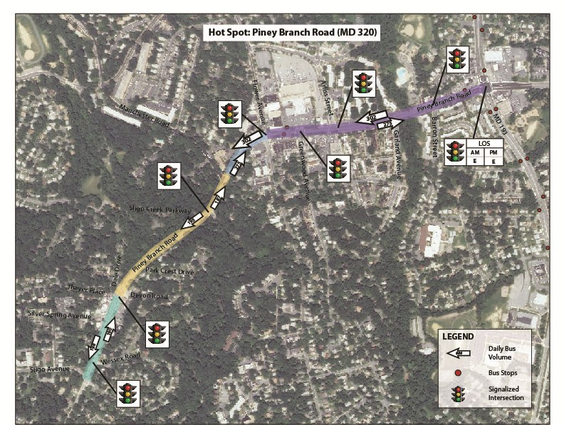
Figure 11: Detail of Piney Branch Hotspot

Annapolis Road: Finns Lane to Riverdale Road
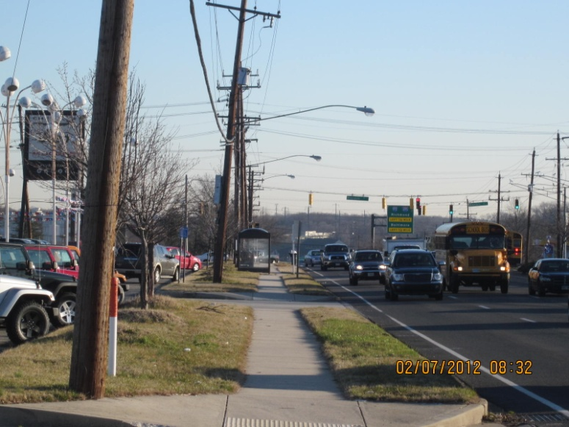
Problems Observed (AM Peak)
Figure 12: Mid-block Bus Stop on Annapolis Road
Observations during the weekday morning peak period revealed a high speed of traffic on Annapolis Road (though signed for 35 MPH, 85th percentile vehicle speed could be as high as 50 MPH). Though there was not a lot of traffic congestion observed during the survey period, this section of Annapolis Road had been previously identified for possible curbside bus lanes, converting the outside two lanes of the existing six-lane roadway to bus lanes, at least during peak periods.

A major problem observed was the proliferation of bus stops along this section of roadway, three in each direction. The two stops at the east end of the segment were very close to one another. There was an observed hazard situation associated with bus stop users (and pedestrians in general) crossing Annapolis Road mid-block, with only a four-foot median island in the roadway to provide protection. There are also old pedestrian signals at the Riverdale Road intersection.

Bus right turning movements to access the New Carrollton Metrorail station are impacted by a tight curb return on the southwest corner of the Finns Lane intersection. Buses turning eastbound from Annapolis Road onto Riverdale Road are also slowed with extensive queuing in the eastbound left turn lane.
Potential Physical Improvements
- Extend eastbound left turn lane at Riverdale Road.
- improve curb return on southwest corner of Finns Lane intersection, and/or move back stop bar on Finns Lane approach.

Potential Transit Operations Improvements
- Consolidate bus stops along segment.
- Potential conversion of curbside traffic lanes to bus lanes pending further operational analysis.
Potential Signal Improvements
- Add signal priority at Harkins Road intersection>
- Add mid-block pedestrian signal on Annapolis Road between Finns Lane and Riverdale Road.
- Add countdown pedestrian signals at Riverdale Road intersection.
Long-Term Planning Considerations
Ability to preserve general traffic operations along Annapolis Road in longer-term if peak period bus lanes are provided and there is reduced general traffic capacity from the lane conversion.
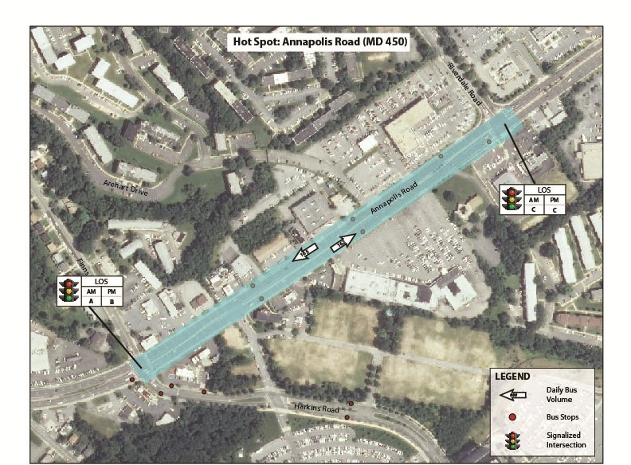
Figure 13: Detail of Annapolis Road Hotspot
Table 13: Daily Bus Volumes Through the Annapolis Road Hotspot
 | Finn Ln/Harkins Rd to Riverdale Rd
 | NB | SB
Total: | 162 | 165
The Bus 15X | 14 | 14
B24 | 4 | 21
B25 | 16 | 0
B27 | 13 | 13
F4 | 45 | 47
F13 | 20 | 17
G12, G13, G14, G16 | 50 | 53

Seven Non-Recommended Locations

Georgia Avenue: Colesville Road to 13th Street
Problems Observed (AM Peak)
Observations during the weekday morning peak period revealed little traffic congestion along Georgia Avenue at that time. On-street metered parking is restricted to off-peak periods, which has the effect of adding capacity to the roadway during the peaks. Curb extensions along corridor preclude any intersection bus queue jump opportunities.
Potential Physical Improvements
None
Potential Transit Operations Improvements
None
Potential Signal Improvements
- Improved signal timing to facilitate bus operations might be implemented
Long-Term Planning Implications
None

River Road at Paint Branch Drive
Problems Observed (AM Peak)
Observations during the weekday morning peak period revealed little delay to buses at the River Road/Paint Branch Drive intersection. There were periodically minor delays to buses leaving the College Park Metrorail station, due to waiting for a gap at the unsignalized intersection with River Road, and adjacent pedestrian crosswalk. Some impedance to incoming buses into the station from the informal kiss-n-ride along River Road, with the kiss-n-ride area within the station area closed.

Potential Physical Improvements
- Development of off-street kiss-n-ride at College Park Metrorail station
- Widen SE curb return at River/paint Branch intersection to facilitate bus right turns

Potential Transit Operations Improvements
None

Potential Signal Improvements
- Replace existing pedestrian signals with countdown signals at intersection
- Add signal at bus egress from College Park station
- Signal priority for NB buses on River Road approach

Long-Term Planning Considerations
Replacement site for College Park station kiss-n-ride operation

Fenton Street – MD 410/Burlington Avenue to Colesville Road
Problems Observed (PM Peak)
Curb extensions choke through traffic and preclude queue jump opportunities along Fenton. Curbside parking also creates some friction with traffic.
There is a bus stop in front of First Baptist Church of Silver Spring (for NB buses along Fenton Street), which causes a bus to stop in the exclusive right-turn lane. This causes conflicts between buses and right-turning vehicles. It also creates compromised safety for pedestrians attempting to cross the street because of reduced sight distance for vehicles maneuvering around buses in that lane. There is no receiving lane for possible bus bypass because parking is allowed downstream of the intersection.
Some bus bunching with RideOn Route 17 observed. Also northbound buses at Colesville intersection wanting to turn left have some difficulty in merging over to left turn lane.
Potential Physical Improvements
None
Potential Transit Operations Improvements
None
Potential Signal Improvements
- Queue jump on NB Fenton Street at Wayne Ave. – would require parking restriction
- Reconfiguration of NB Fenton lane configuration at Colesville Rd. to provide a second left turn opportunity (shared with through and right turn movement), to facilitate bus left turns without having to merge into inside lane
- Transit signal priority for SB bus left turn to MD 410 (Philadelphia Ave.)
- Provide a protected left-turn for NB buses turning onto Colesville Road
Long-Term Planning Implications
None

East-West Highway: Georgia Avenue to Connecticut Avenue
Problems Observed (PM Peak)
This corridor is generally a four-lane cross-section running between downtown Silver Spring and downtown Bethesda. Signal spacing varies between ½ and ¼ mile, and posted speeds are between 30 to 35 miles per hour. The corridor intersects several major cross-county roadways including Georgia Avenue, 16th Street, Colesville Road, Beach Drive, and Connecticut Avenue, and provides good connectivity between the Silver Spring and Bethesda Metro stations. Nearly all major intersections provide exclusive left and right turn lanes. At Colesville Road, Beach Drive and 16th Street there was congestion observed during peak hours where not all vehicles were able to clear the intersection in one traffic signal cycle. Specifically at Colesville Road, the eastbound double left-turn lane to proceed north onto Colesville Road was particularly congested, with both passenger vehicles and buses failing to clear the intersection. Part of the bus congestion was related to the need to stop along the curb along northbound Colesville Road immediately north of East-West Highway, and there was considerable congestion with multiple bus stops along this stretch. Outside of those areas, travel time was good and traffic flowed at or near the posted speeds.
Bus stops along the corridor were empty throughout most of the time observed, with the exception of the apartment complex west of 16th Street. The J3 and J1 Metrobus buses were full with standing room only in the eastbound direction. The gravity of ridership appears to be strong between downtown Bethesda and Silver Spring. This is not surprising considering the land use along the corridor is low density and primarily residential.
Figure 14: Bus Bunching on EB East-West Highway Approaching Colesville Road
Potential Physical Improvements
  - Install queue jump lanes at at Colesville Rd, 16th Street, and Beach Drive
This option would allow buses to bypass queued vehicles by going straight through in a right-turn only lane.
  - Dedicate one of the two eastbound left-turn lanes along East-West Highway at Colesville Road as bus only during peak hour.
  - A review of ultimate bus circulation plans for the Silver Spring Transit Center should also be undertaken to assess the northbound Colesville Road bus stop congestion.

Potential Transit Operations Improvements
Although bus stop activity was very light, a few recommendations are presented for consideration.
- Eliminate near-side stops: Many bus stops are near-side, relocating these stops to the far side may increase bus speeds by eliminating the potential to stop twice when approaching a traffic signal (Rosemary Hills, Washington Avenue, Grubb Road)
- Consolidate bus stops: Bus stop density in several stretches was high – nearly one stop every block (Donnybrook Rd to Ellingsworth Dr, Rocton Road). Consolidation of bus stops may increase bus speeds by reducing the number of stops

Long-Term Planning Considerations
Much of this corridor is on the Purple Line alignment

Carroll Avenue: Maple Street to Ethan Allen Road
Problems Observed (PM Peak)
Observations during the weekday peak period revealed some traffic backup on the section of Carroll Avenue between Laurel Avenue and the Takoma Metrorail station, and east of Philadelphia Avenue. There is also a sight distance constraint for the eastbound left turn from Carroll onto Philadelphia Avenue, as the curved roadway east of this intersection obstructs the view of oncoming vehicles, particularly when traffic in the right lane far side of the intersection begins to queue.

Curb extensions are provided along Carroll Avenue to improve sight distance for pedestrians crossing the street. There is a “Barnes dance” pedestrian signal treatment at the Carroll Avenue/Laurel Avenue intersection, but no significant pedestrian crossings were observed.
Potential Physical Improvements
- Could remove the limited on-street parking on Carroll Avenue between the Takoma station and Laurel Avenue during peak periods to create bus lanes in each direction, but this would require removal of one curb extension.
Potential Transit Operations Improvements
- Use westbound right turn lane on Carroll at Philadelphia Avenue as a bus queue jump, but this could impact the right turn signal overlap
Potential Signal Improvements
- Signal priority at the Carroll/Laurel intersection
Long-Term Planning Considerations
None

Hungerford Drive – Washington Street to Ivy League Lane
This location is to the north of the Rockville Metro station, adjacent to the Metro tracks connecting to Shady Grove. The general land use in the area is mixed commercial, with a large campus of Montgomery Community College located just beyond the northern end of the corridor. In general, there were no major operational problems along Hungerford Dr itself, but buses turning onto the corridor were subject to long delays as a result of very long signal cycle lengths, which also creates delays for buses turning left off of the corridor, since they must typically wait for a protected cycle.
Problems Observed (AM Peak)
- Buses turning left from NB Hungerford Dr to WB Manakee St to access the community college were subject to significant delays waiting for the protected left-turn phase.
- Buses turning from EB Manakee St onto both directions of Hungerford Dr were subject to significant delays waiting for the side street green signal. Even right-turning buses were subject to delays, due to both the length of the queue and the inability to make a right-turn-on-red due to the high volume of traffic on SB Hungerford Dr.
- Buses turning from EB N Washington St onto NB Hungerford Dr were subject to significant delays waiting for the side street green signal. Buses operated by Montgomery County Ride-On use this routing after accessing Rockville center.
- Some bus stops are in need of improvement, including addition of shelters, improved sidewalk connections, and movement from near side to far side.
- Queues were occasionally observed on SB Hungerford Dr at N Washington St.
Potential Physical Improvements
- Install queue jump/bus lane on SB Hungerford Dr approaching NB Washington St. This bus lane could also serve as an approach for vehicles using the slip lane to make the soft right from SB Hungerford Dr to WB N Washington St, who would be allowed to use the bus lane to make a right turn. This design has the potential to improve operations for both buses and general traffic, although further analysis would need to be done to determine whether SB Hungerford Dr will perform adequately with only two through lanes at this location.
Potential Transit Operations Improvements
- Improve amenities at bus stops, including shelters and improved sidewalk connections.
- Move the bus stop currently located on NB Hungerford Dr near side of the N Washington St intersection, to an existing pad located directly in front of the Giant supermarket between N Washington St and Frederick Ave. This will improve the accessibility of the stop and take advantage of existing benches installed in front of the supermarket. This may also allow for the elimination/consolidation of the stop located at Frederick Ave.
Potential Signal Timing Improvements
- Actuate turns onto Hungerford Dr based on the presence of in-service buses, to bring up the side street green more quickly if a bus is in the queue. This time could then be returned to Hungerford Dr during subsequent phases, so as to not reduce the throughput of that street. Locations to be considered for this treatment are N Washington St and Mannakee St.
- Actuate left turns from NB Hungerford Dr to WB Mannakee St, to bring up the left turn phase more quickly if a bus is in the queue.
Long-Term Planning Considerations
There is some potential for ongoing redevelopment in this corridor, based on the type and intensity of land use currently present. As this redevelopment occurs, there may be opportunities to work with developers to improve the quality of bus stop amenities, as well as the sidewalk connections. An example of this currently exists, where an Asian grocery store recently renovated an existing building, and improved the quality of their sidewalk and the safety of their driveway entrances.

Wayne Avenue: Georgia Avenue to Colesville Road
Problems Observed (AM Peak)
Wayne Avenue between Ramsey and Georgia Avenues is currently being used as a major bus layover area while the new Silver Spring Transit Center is being constructed. No major traffic congestion on Wayne was noted during the observed weekday morning peak period.
Potential Physical Improvements
- Striping for exclusive bus lanes on Wayne Avenue may be possible if final bus routing plan for the new transit center shows extensive use of Wayne by buses to access the transit center.
- Curb lane on the north side of the street currently used as a temporary bus lane for terminating routes.
Potential Transit Operations Improvements
- Final routing plan for buses associated with new transit center still to be finalized.
Potential Signal Improvements
None
Long-term Planning Implications
Final bus routing plan for transit center will dictate final set of transit priority improvements on street system within area.

Virginia
Table 14: Summary of Field Verification Findings for Virginia Hotspots
Street(s) | Rankings |  |  | Potential for Improvements
 | All Day | AM | PM | Physical Improvements | Operational Changes | Signal Timing | Long-term planning
Wilson Blvd, Ft. Myer Dr to Moore St | 5 |  | 15
Lynn St, Key Bridge to 19th St | 9 | 6 | 8
Joyce St, Columbia Pike to Army Navy Dr | 10
Gallows Rd, Belleforest Dr to Inova Hospital | 12 | 12 |  |  |  |  | ◆
Army Navy Dr, Eads St to Joyce St | 14 | 4
SB Glebe Rd @ Arlington Blvd |  | 2 | 1 | ◇ | ◇ | ◇
Patriot Dr, Lafayette Forest Dr to Heritage Dr |  | 5
Eisenhower Ave, Van Dorn St to Van Dorn Metrorail Station |  | 8 |  |  | ◇ | ◇
Van Dorn St, Eisenhower Ave to Franconia Rd |  |  |  | ◆ | ◇
Rte 123, Jermantown Rd to Folin Ave |  |  |  | ◇ |  | ◆
◇ = some potential for improvements
◆ = strong potential for improvements
= Recommended for development of conceptual design

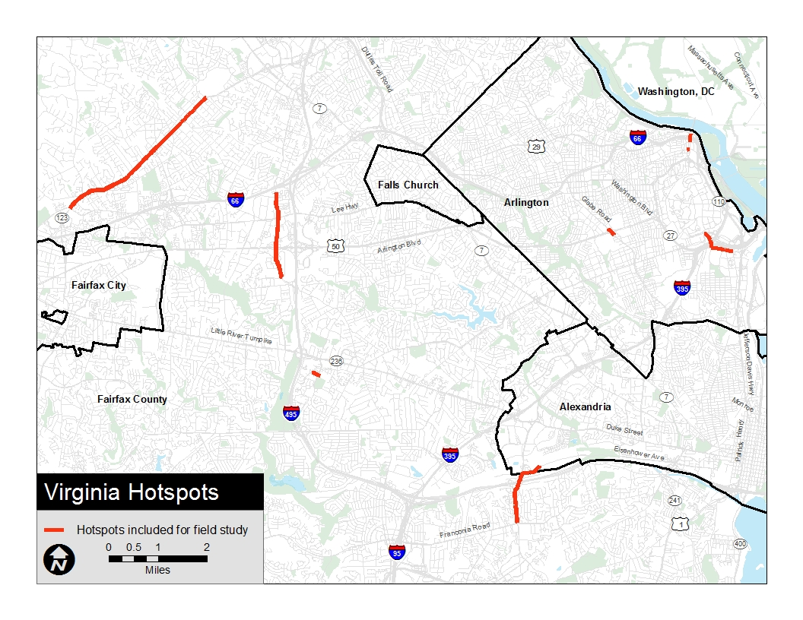
Figure 15: Location of Top Ten Virginia Hotspots

Two Recommended Locations

Van Dorn Street – Eisenhower Avenue to Franconia Road
Problems Observed (AM Peak)
Very heavy traffic congestion was noted on northbound Van Dorn Street. Beginning about 7:00 AM, queues built rapidly south from Eisenhower Avenue, extending beyond Franconia Road by 7:30, and then dissipating by 8:30 AM. Peak northbound travel time through the segment was measured at over 11 minutes, as compared to an uncongested travel time of about 4 minutes. Southbound traffic was uncongested.
Lane utilization on northbound Van Dorn Street was uneven. The two rightmost lanes, which continue through under the Capital Beltway to Eisenhower Avenue, were extremely congested, with multiple cycle failures at each intersection. However, the left lane, which feeds a dual left turn lane at the I-495 ramps, was relatively free flowing.
Buses operated in mixed traffic and were subject to the same delays as general traffic. Only two patrons were observed boarding northbound Fairfax Connector buses in the area observed, and buses did not appear to encounter any additional operational delay.
The traffic signal at Eisenhower Avenue appeared to operate on a 360-second cycle. Northbound Van Dorn Street received the majority of the green time at this intersection, but a significant split was required to service the heavy southbound left turn movement onto Eisenhower Avenue in a single lane. Green time for Eisenhower Avenue was governed by the westbound right turn volume, which although approximately equal to the westbound left turn volume, required additional green time as it was made from a single lane.
Potential Physical Improvements
- Queue jump for northbound buses at I-495 Ramp intersection, using painted gore between dual left turn lanes and through lanes with appropriate signal phasing.
- Queue jump for northbound buses at Chrysanthemum Drive, Crown Royal Drive, and Oakwood Road, either actively using existing left turn lanes with appropriate signal phasing or passively with buses travelling in less-congested left lane.
- Reconfiguration of southbound Van Dorn Ave at Eisenhower to allow dual left turns to be made during AM peak, reducing time required for this movement and thus allowing additional green time to be given to northbound movement.
Potential Transit Operations Improvements
- Limited stop service in segment to allow buses to operate in less-congested left lane rather than curb lane.
Potential Signal Timing Improvements
- Right turn overlap for westbound Eisenhower Avenue, to reduce time required for westbound phase allowing more green time to be allocated to northbound phase.
Long-Term Planning Considerations
None

Table 15: Daily Bus Volumes Through the Van Dorn Street Hotspot
 | Eisenhower Ave to Oakwood Dr |  | Oakwood Dr to Crown Royal Dr |  | Crown Royal Dr to Franconia Rd
 | NB | SB | NB | SB | NB | SB
Total: | 104 | 102 | 87 | 76 | 104 | 102
Fairfax Connector 109 (along Van Dorn St) | 14 | 8 | 14 | 6 | 14 | 8
Fairfax Connector 109 (bypass Van Dorn St) | 17 | 24 | 0 | 0 | 17 | 24
Fairfax Connector 231 | 22 | 22 | 22 | 22 | 22 | 22
Fairfax Connector 232 | 22 | 22 | 22 | 22 | 22 | 22
Fairfax Connector 321 | 29 | 0 | 29 | 0 | 29 | 0
Fairfax Connector 322 | 0 | 26 | 0 | 26 | 0 | 26

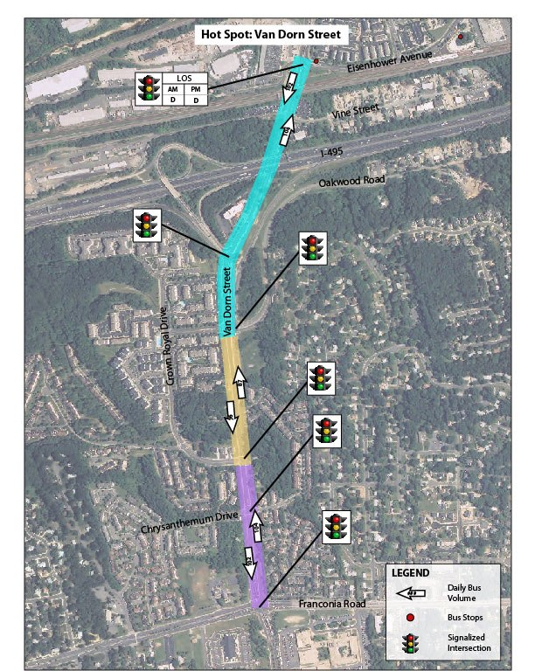
Figure 16: Detail of Van Dorn Street Hotspot

Glebe Road at Arlington Boulevard
This location is a grade separated interchange between Glebe Rd and Arlington Blvd. The interchange is generally a diamond configuration, requiring traffic signals on Glebe Rd on either side of the bridge crossing over Arlington Blvd. The exception is the movement from SB Glebe Rd to EB Arlington Blvd, where a cloverleaf loop ramp is present to avoid the need for a left turn. The opposite movement (NB Glebe Rd to WB Arlington Blvd) requires a left-turn across SB Glebe Rd traffic. A construction project to widen and enhance the bridge, improve traffic operations, and enhance bicycle and pedestrian facilities was underway at the time the observations were made, but was not directly impacting traffic operations.
Problems Observed (AM Peak)
- Traffic on NB Glebe Rd turning left onto the ramp to WB Arlington Blvd does not currently have a turning lane, resulting in queue backups when the protected left turn phase is not shown, leaving a permissive left turn against oncoming traffic. This queue reduces the NB through movement on Glebe Rd to a single lane, and also creates the lane jockeying that occurs when a shared through/left-turn lane is backed up. As a result of this queuing, traffic on NB Glebe Rd would sometimes back up for several intersections south of Arlington Blvd (to at least 2nd St S).
- Bus stops on Glebe Rd are located in pull outs on the south side of Arlington Blvd, creating a far side stop SB and a near side stop NB. These stops are equipped with shelters and sidewalks, providing a hospitable environment for waiting passengers. The pull out for the NB stop is also a right-turn lane to access EB Arlington Blvd. The SB stop is located within a driveway to access the shopping plaza in the SW quadrant of the interchange, creating potential ADA and access issues.
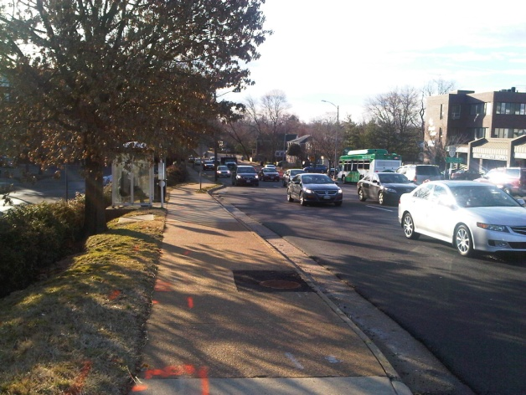
- Bus stops on the north side of the interchange are located at some distance from the interchange, and are very basic in nature (no shelters, limited sidewalks).
Figure 17: Existing Bus Pull-out on NB Glebe Rd
- The bus stop on EB Arlington Blvd is located to the east of the interchange, on a narrow strip of grass between the main line and the ramp from NB Glebe Rd. This stop is not equipped with a sidewalk/waiting pad or a shelter, and is in a very unprotected location that is inhospitable to transit passengers. There is also no paved or ADA accessible path connecting to the surrounding sidewalk network, creating a safety hazard for all users, but particularly for those with disabilities.
Potential Physical Improvements
- The Virginia Department of Transportation’s web site for this project (http://www.virginiadot.org/projects/northernvirginia/glebe_road_over_route_50.asp) indicates that the ongoing construction project observed at this location will widen the bridge over Arlington Blvd to accommodate a left-turn lane from NB Glebe Rd to WB Arlington Blvd. This should help to alleviate some of the congestion created by the current left-turn traffic queuing in the shared through/left-turn lane.
- The existing bus pull-out located on NB Glebe Rd to the south of the Arlington Blvd overpass (shown in Figure 17), could be converted into a bus-only queue jump lane. Under this configuration, once a bus has completed its service at NB bus stop, it could then pull up to the stop bar at the ramp to EB Arlington Blvd. If combined with a leading bus interval at the signal (described below), buses could then move ahead of general traffic, as shown in Figure 18. We would need to ascertain whether this configuration is compatible with the final design for the overpass reconstruction, or whether that design could be modified to make it compatible.
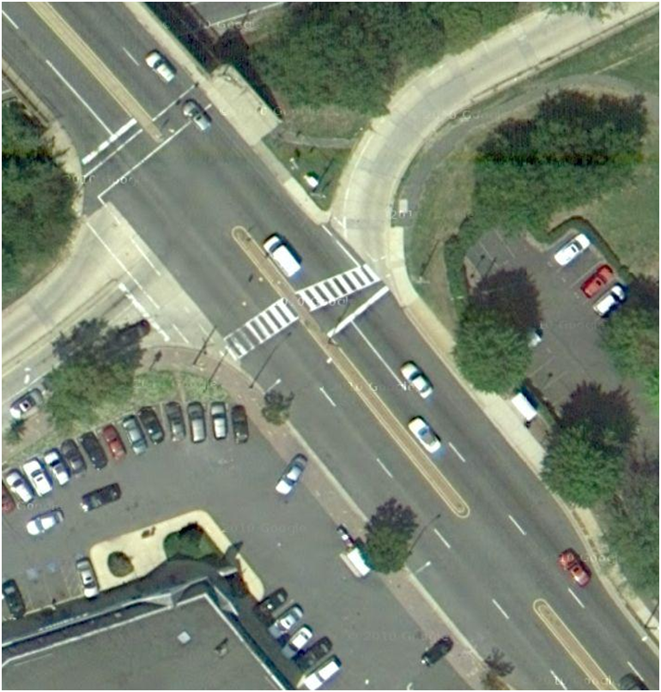Potential Transit Operations Improvements
Figure 18: Potential Configuration for Queue Jump on NB Glebe Road
- Improvements to bus stops located on Glebe Rd on the north side of Arlington Blvd to add shelters and other amenities.
- Consider improvements to the bus stop on SB Glebe Rd to the south of Arlington Blvd, to eliminate access and ADA problems associated with the driveways located in the bus stop.
- Investigate improvements to the bus stop on EB Arlington Blvd to the east of Glebe Rd, to create an accessible and safe sidewalk connection to the stop, as well as increasing the level of customer amenities.
Potential Signal Timing Improvements
- In coordination with the queue jump lane shown in Figure 2, install a leading bus interval signal to allow buses on NB Glebe Rd to move ahead of the queue of traffic stopped at the signal on the south side of the bridge. Currently, NB traffic stopped at the signal on the north side of the bridge is allowed to proceed several seconds before the traffic stopped on the south side of the bridge (at the proposed queue jump location). If buses were given an advanced green at the same time that the northern signal turns green, they could advance in front of the traffic stopped on the south side, without needing to decrease the signal split for that traffic. A more detailed signal timing analysis will be required, particularly given that the overpass reconstruction project will likely implement signal timing changes. But at a conceptual level, this signal phasing appears feasible.
Long-Term Planning Considerations
- None identified; the current bridge rehabilitation and widening project represents the likely major investment within the current planning horizon.
Table 16: Daily Bus Volumes Through the Glebe Road Hotspot
 | Arlington Blvd (WB) to Arlington Blvd (EB)
 | NB | SB
Total: | 147 | 146
Arlington Transit 41 | 61 | 62
10B | 37 | 37
23A, 23C | 49 | 47

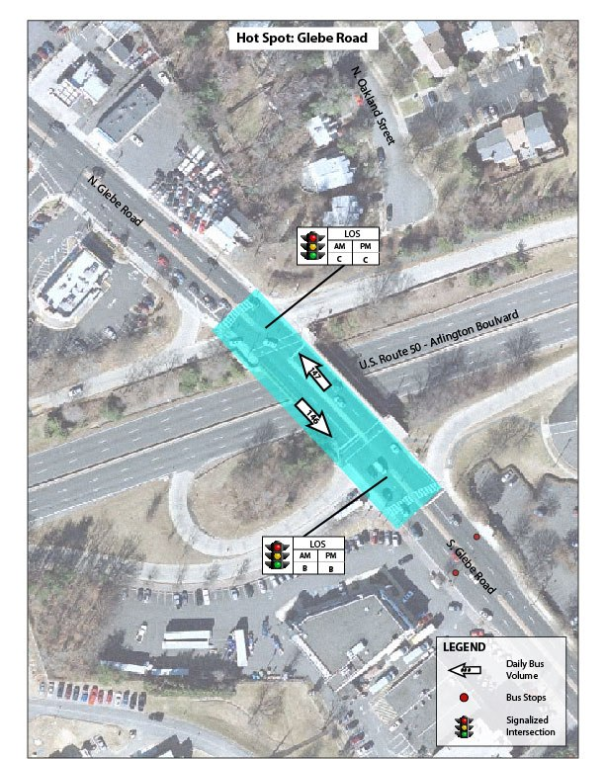

Figure 19: Detail of Glebe Road Hotspot

Eight Non-Recommended Locations

Rosslyn Metro Area – Wilson Boulevard, N. Lynn Street, and N. Moore Street
This location encompasses the streets immediately adjacent to the Roslyn Metro Station, including N Moore St, which functions as a de facto transit mall for the buses that connect to the Metro at this location. During the period of observation, N Moore St had been converted to one-way operation to accommodate construction of a private development, as well as construction on the Metro station itself. Only very minor issues were observed, as transit operations were generally smooth.
Problems Observed (PM Peak)
- Commuter buses (coaches) stopping on N Lynn St approaching 19th St N were forced to board passengers from a travel lane, as a peak period bus stop was not cleared of the parked cars that are allowed to park there at other times.
- Buses turning left from EB Wilson Blvd to NB N Nash St do not have a turn arrow, forcing them to wait for a break in traffic.
- There is sometimes a minor queue of traffic turning left from SB N Fort Myer Dr onto EB Lee Hwy, which delays buses accessing the N Moore St transit mall.
Potential Physical Improvements
- Allow buses turning left from SB N Fort Myer Dr onto EB Lee Hwy to do so from the second left-most lane, creating a through/left-turn lane, with the left turn reserved for buses only.
Potential Transit Operations Improvements
- None identified.
Potential Signal Timing Improvements
- Install protected left-turn signal for all vehicles turning left from EB Wilson Blvd to NB N Nash St.
Long-Term Planning Considerations
None

Joyce Street, Columbia Pike to Army Navy Drive
Problems Observed (PM Peak)
The identified segment of Joyce Street is a connector roadway linking the eastern end of Columbia Pike to Pentagon City, passing under I-395. It has no destinations along it other than parking for the Air Force Memorial and the Navy Annex. No major issues were observed on Joyce Street. Spillover was noted in northbound left turn lane at Columbia Pike, but no cycle failures as opposing traffic demand was light.
Potential Physical Improvements
None
Potential Transit Operations Improvements
None
Potential Signal Timing Improvements
None
Long-Term Planning Considerations
None

Gallows Road, Belleforest Drive to Inova Hospital
Problems Observed (AM Peak)
This stretch of Gallows Road exhibits significant traffic issues that do indeed slow bus traffic, but much of the delays are the result of numerous construction projects that are underway. The Gallows Road corridor is undergoing a major transition from strip retail to dense, mixed-use development. It was not felt that existing conditions in the corridor present a true picture of the operating conditions and the challenges and opportunities for bus priority.
Potential Physical Improvements
None
Potential Transit Operations Improvements
None
Potential Signal Timing Improvements
None
Long-Term Planning Considerations
This corridor should be re-examined when it has returned to a more “normal” state of traffic. Roadway widening may improve level-of service and alleviate some delays, whereas new development may generate increased traffic as well as a need for increased transit service.

Army Navy Drive, Eads Street to Joyce Street
Problems Observed (PM Peak)
The primary issues on Army Navy Drive appear to be with queues that back up from left-turns, as part of a relatively intense but brief peak from 5:00PM to 5:30PM. Vehicles turning left from EB Army Navy at the Hayes Street intersection (to access I-395 and Washington Boulevard) backed up as far as the Pentagon City Mall parking entrance. Vehicles turning left onto Army Navy from Hayes backed up enough to cause cycle failures. In spite of these issues, however, no significant bus delays were observed.
Potential Physical Improvements
None
Potential Transit Operations Improvements
None
Potential Signal Timing Improvements
None
Long-Term Planning Considerations
None

Patriot Drive – Lafayette Forest Drive to Heritage Drive
Problems Observed (AM Peak)
Observations on Patriot Drive between Lafayette Drive and Heritage Drive indicate that this location’s bus speeds recorded in the hotspot database are artificially low due to the short segment length. Buses on this queue experienced some delays approaching the signalized intersection at Heritage Drive, but with no congestion and a 60-second cycle length, total delays were minimal. However, because of the short segment length, this queue delay accounted for the majority of the travel time on this segment yielding an apparent low average speed. When coupled with the adjacent segment of Heritage Drive which was uncongested with a 35 mph speed limit, overall delays to buses in this area were minimal. As no significant issues were observed at this location, it is removed from consideration.
Potential Physical Improvements
None
Potential Transit Operations Improvements
None
Potential Signal Timing Improvements
None
Long-Term Planning Considerations
None

Eisenhower Avenue, Van Dorn Street to Van Dorn Metrorail Station
Problems Observed (AM Peak)
Eastbound buses bound for Metrorail station encountered minimal delays. One brief backup was noted of buses queuing to enter the bus turnaround. Westbound buses were noted to incur significant delay at the intersection with Van Dorn Street due to long cycle times. Queues were minimal on this approach, and no cycle failures were noted; however the signal appears to operate on a 360-second cycle, which causes long average delays for westbound buses.
Potential Physical Improvements
None
Potential Transit Operations Improvements
- Examine potential to reroute buses from the Van Dorn station to SB Van Dorn Street via Metro Road, thus avoiding the intersection where cycle delays were observed.
Potential Signal Timing Improvements
- Reduce delays for westbound buses on Eisenhower Avenue by introducing a second westbound phase at Van Dorn, actuated for buses only. This would not require any additional green time be allocated to the westbound movement, but would reduce the delay to buses resulting from the long cycle length.
Long-Term Planning Considerations
None

Rte 123, Jermantown Road to Folin Avenue
Problems Observed (AM Peak)
This is a very long corridor, the northern half of which (downtown Vienna) is markedly different in character than the southern half. In Vienna, Rte. 123 is characterized by intense auto-focused commercial development, and the delays that result are due to frequent intersections and access points to commercial parking lots along either side of the roadway. The team felt that the road cross-section in this portion of the hotspot was not wide enough to create a transit lane without seriously exacerbating the existing backups of general traffic. Queue jumps in this section would be difficult to employ, as there are generally no dedicated right-turn lanes.
Back-ups from the Vienna portion of the corridor spill into the southern portion of the hotspot, where a wider cross-section including a grass median, presents the possibility of dedicating right-of-way to buses. However, observed ridership along the entire length of the hotspot was very light and might not warrant major investments.
Potential Physical Improvements
Examine possibility of bus-only lane in southern portion of the corridor, including determination of whether ridership forecasts warrant investment.
Potential Transit Operations Improvements
Consider re-routes onto Courthouse Drive, which runs parallel to Rte. 123.
Potential Signal Timing Improvements
None
Long-Term Planning Considerations
None

Appendix A: Bus Priority Hot Spot Study Task 3 Field Notes

DC Hotspots

Virginia Avenue, NW at E Street
- Ranked 1st all-day
- Ranked 2nd AM
Date: | February 8, 2012
Time: | 7:30-8:30 AM
Weather: | Clear
Observers: | Joe Barr (PB), Brian Laverty (PB), Zach Freedman (SWA)

Physical Conditions
- The roadway has a wide right-of-way and a very large intersection.
- This is some sight restriction associated with the Virginia Avenue underpass at 23rd Street.
- Parking is permitted on Virginia Avenue only during off-peak periods.
Observations
- Metrobus routes layover on Virginia Avenue southeast of the intersection of Virginia Avenue and E Street, which likely caused the low bus speeds recorded for this corridor. Roughly 50 percent of the Metrobuses along this corridor layover here. Several operator changes were observed.
- A large number (20+ in one hour) of Loudoun and PRTC commuter buses were observed turning left from Virginia Avenue onto E Street. They appear to be deadheading back to Virginia.
- Buses must merge right onto a narrow surface street to avoid the Virginia Avenue underpass beneath 23rd Street. One instance of a conflict with automobiles was observed.
Recommendations
- There is no issue here. Aside from layovers, bus speeds throughout the area on Virginia Avenue are quite fast. The layover likely explains the results in the database, and the “slow speed” of the Metrobuses would be attributed to the commuter buses as well.

Wisconsin Avenue, NW at Q Street
- Ranked 9th all-day
Date: | February 21 2012
Time: | 4:30-5:30 PM
Weather: | Clear
Observers: | Darryl Phillips (PB), Brian Laverty (PB), Zach Freedman (SWA)

Physical Conditions
- Two northbound through lanes along Wisconsin Avenue merge into one lane beyond Q Street.
- The gas station on the westbound corner was closed during the time of the field review.
- Parking is prohibited during rush hour.
- Q Street is offset across Wisconsin Avenue, with the two legs approximately 120 feet apart.
- The cross section of Wisconsin Avenue is generally four lanes wide, with a variety of metered parking and loading operations permitted in the curb lanes north and south of Q Street outside of the peak periods.
- Wisconsin Avenue is slightly wider approaching and between the two Q Street legs, allowing two full moving lanes in each direction.
- Speed limit: 25 MPH
- There are pedestrian crosswalks at the intersection.
- There are no bicycle lane provisions.

Observations
- Vehicles turning into the gas station (especially at southbound Wisconsin Avenue and the west leg of Q Street) could impede buses operating along Wisconsin Avenue.
- The shared left turn lanes cause problems: Vehicles are queue jumping around waiting left-turn vehicles in shared left turn lanes.
- The westbound right-turn phase only overlaps half of southbound left-turn phase of the intersection.
- Traffic conditions were consistent with an urban commercial corridor: Low speeds and minimal queues, as traffic flows were generally metered by adjacent intersections.
- The traffic signal operates on a complex phasing, to allow the eastbound and westbound movements along Q Street to navigate through the double intersection without stopping. This phasing appeared to reduce the time available for the northbound and southbound traffic on Wisconsin Avenue, causing some delays for bus traffic on this route.
- In some cases, southbound buses were observed stopping at the near-side bus stop, pulling forward to the signal at the first Q Street approach, stopping and waiting for the next phase, and then stopping again at the second Q Street approach.
- The phasing at the southern Q Street approach operates with a protected left turn from Wisconsin onto Q Street, with through traffic stopped to allow a pedestrian crossing of Wisconsin Avenue. However, the two lanes on Wisconsin Avenue did not appear to have any turning designation. Through vehicles in the left lane stopped for the red ball indication caused delays for left turns that had the green arrow. These through vehicles could have operated in the right lane and thus minimized this conflict, but these vehicles appeared to be avoiding the right lane because of parking and loading operations in the next block.
- Buses that are making the right turns from Q Street and the left turns onto Q Street needed to swing wide, and generally crossed the yellow centerline while turning. While this appeared to be a potential conflict, in practice the drivers appeared to be familiar with the movement and were observed making overlapping turns cooperatively without stopping. In addition to the WMATA buses making these movements, Georgetown University shuttle buses operated using full-sized buses on frequent headways.
- Southbound buses stopping at Q Street sometimes blocked through traffic, leading to queues which sometimes delayed a following bus. While the street at this point widens to permit two lines of automobile traffic to form, passing a stopped bus required crossing the center line.
- While the gas station driveways on the east side of Wisconsin between the two legs of Q Street could potentially pose a congestion problem, this was not observed in the field.
- While bus delays along Wisconsin Avenue during the PM peak period were minimal compared to typical urban corridors, the on-street parking restriction during the evening peak period could be contributing to reduced delays. It is possible, however, that conditions may be more congested during the mid-day and later evening periods.

Recommendations
- Additional observations should be conducted of traffic operations during the mid-day and later evening periods.
- It may be possible to offset the centerline north of Q Street a few feet to the east, allowing southbound vehicles to pass stopped buses more readily.
- Review the long-term WMATA plans for dedicated peak-hour bus lane along Wisconsin Avenue.

7th Street, NW: Pennsylvania Avenue to I-395
- Ranked 10th all-day
- Ranked 14th AM
- Ranked 3rd PM
Date: | February 9, 2012
Time: | 4:30-5:30 PM
Weather: | Sunny
Observers: | Paul Silberman (SWA), Alyssa May (SWA), Joe Barr (PB), Brian Laverty (PB)
Physical Conditions
- The corridor has a wide cross section with six travel lanes.
- There is a median south of the National Mall.
- There is a long-term lane closure in the northbound direction at D Street.

Observations
- Most bus stops provide benches and shelters.
- There is a commuter bus loading area heading southbound between Independence Avenue and C Street.
- There are commuter bus loading zones on 9th and 10th Streets heading eastbound along Pennsylvania Avenue.
- Movement failures in the southbound left-turn lane onto Independence Avenue affect WMATA routes 32, 34, 36, and F19. Buses also experience delays while turning left onto Virginia Avenue.
- There is signal cycle failure on 7th Street between Indiana and Pennsylvania Avenues. This affects the near-side bus stop in southbound direction.
- Moderate boardings of 5 to 10 people were observed along stops in corridor; through the National Mall area are low-density land uses.
- The bus-only lane heading northbound on the corridor north of Pennsylvania Avenue is not well and marked and is not enforced.
A multimodal transportation hub is located at Maryland Avenue at L’Enfant Metrorail station entrance. This provides connections to Metrorail, VRE, and commuter bus (Dillons, Omni-bus, etc.) boardings in the southbound direction. High boarding counts were observed for commuter buses (25+ passengers).

Recommendations
- Consider adjusting the signal timing at various intersections throughout the corridor, particularly at Pennsylvania Avenue.
- Consider expansion of certain bus stops to better accommodate combined use by local buses and commuter buses.
- Consider moving the bus stop on southbound 7th Street approaching Independence Avenue somewhat to the north, to make it easier for buses turning left at Independence Avenue to transition across the travel lanes.

Connecticut Avenue, NW: K Street to Jefferson Place
- Ranked 11th all-day
- Ranked 2nd PM
Date: | February 23, 2012
Time: | 4:00-4:30 PM
Weather: | Clear
Observers: | Joe Barr (PB), Monique Ellis (PB), Alyssa May (SWA)

Physical Conditions
- K, L, and M Streets have metered parking.
- M through 18th Streets have no parking from 7:00 -9:30 AM and from 4:00-6:30 PM.
- Speed limit: 25 MPH
- No bicycle lanes are provided.
- Urbanized area: crosswalks, sidewalks, heavy pedestrian traffic
- Bus shelters are provided throughout the corridor.
Observations
- Congestion was observed at the K Street intersection, but not north of it.
- East/west congestion observed on K Street may have been exacerbated by construction.
- Northbound buses are delayed by vehicles waiting for pedestrians while making right turns onto K Street.
- About five patrons were seen waiting are each bus stop.
- Loading and unloading, taxi operations, and double-parked vehicles at the Mayflower Hotel temporarily impeded traffic flow, especially during periods of higher traffic volume.
- Overall, there was no significant congestion within this corridor during the observation period.
Recommendations
- Additional observations should be conducted later during the peak period.

14th Street, NW: Corcoran Street to Otis Street
- Ranked 13th all-day
- Ranked 10th AM
- Ranked 8th PM
Date: | February 23, 2012 | February 29, 2012
Time: | 5:00-5:45 PM | 7:30-8:30 AM
Weather: | Clear
Observers: | Darryl Phillips (PB), Eduardo Maeyama (PB) | Paul Silberman (SWA), Alyssa May (SWA)

Physical Conditions
- The roadway cross section varied throughout the corridor.
- There is one travel lane in each direction as well as on-street parking between Otis Place and Monroe Street.
- Between Columbia Road and Monroe Street are varying lane configurations adjacent to Columbia Heights Shopping Center.
- From Corcoran Street to Harvard Street, there are two travel lanes in each direction with parking along the curb line.
- Speed limit: 25 MPH
- Bicycle lanes are present in both directions between Corcoran Street and U Street and between Columbia Road and Otis Place.
- There are bus stops signs and shelters at some locations along the corridor.
- Many bus stops are located near-side of the intersection.
- There are curb extensions north of Park Road.
- There is dense bus stop spacing (every block) in some segment of the corridor.
Observations
- Due to the length of the corridor, only one drive trip could be made during allotted time.
- Congestion was observed to be most significant between Harvard and Kenyon Streets. However, there was less congestion on the corridor than seen along Columbia Road.
- Some bus delays were caused by poor signal progression heading northbound between Irving and Monroe Streets.
- The signal phasing at Kenyon Street appeared to be inefficient, due to the Park Road signal phase.
- No significant impacts to bus travel were noted between Corcoran and Harvard Streets. The primary delays to bus traffic appeared to be caused by the number of signals and stops in this lengthy corridor.
- There is bus bunching of the 52, 53, and 54 routes. The combined headways was observed to be less than five minute.
- The corridor has low boardings (less than five passengers observed at stops).
- The majority of boardings were at the Columbia Heights Metrorail station
- High pedestrian volumes were observed at Irving Street.
- The 52, 53, 54, and Circulator routes were observed to be full with standing room only.
- There is a strong gravity of ridership between Columbia Heights Metro station and McPherson Square
- There are three bike share stations and one ZipCar lot along the corridor. Moderate bicycle activity was observed.
- There were signal cycle failures along the corridor, with queue lengths of four to six blocks along southbound 14th Street north of Park Road.
Recommendations
- Remove one bicycle lane and install a bus-only lane in one direction, or restrict parking during peak hours to allow lane use by bus and bicycles only between Irving Street and Logan Circle.
- Review the signal timing at Park Road.
- Consolidate bus stops, relocate near side bus stops to far side stops, or consider express service along the corridor.

14th Street, NW and Thomas Circle
Date: | February 23, 2012
Time: | 4:00-4:30 PM
Weather: | Clear
Observers: | Darryl Phillips (PB), Eduardo Maeyama (PB)

Physical Conditions
- There is a signalized urban traffic signal configuration at this intersection.
- The Circle contains two lanes and a third outside lane providing direct access to approach legs of the Circle.
- There are eight signalized approaches leading up to the intersection that are less than 100 feet apart.
Observations
- Very significant congestion was noted heading north of the intersection.
- The signal phasing appeared to be designed to accommodate “through” movements (i.e. 14th Street to 14th Street, Vermont Avenue to Vermont Avenue).
- “Left turns” could not be made in one signal phase, requiring multiple stops to complete the movement.
- The short storage length between intersections limited the capacity for “left turns” to approximately four vehicles per lane per cycle.
- “Left turns” from northbound 14th Street to Massachusetts Avenue and from eastbound Massachusetts Avenue to either Vermont Avenue or 14th Street effectively blocked northbound through movements from 14th Street to 14th Street.
Recommendations
- Signal timing/phasing changes are recommended to accommodate left turns at Thomas Circle. Currently, phasing for 14th Street gives the same amount of time to northbound and southbound movements. However, southbound movement is light. Recommend terminating the southbound movement 20 seconds earlier to allow traffic heading northbound from 14th Street to continue around the circle to Massachusetts Avenue, M Street and Vermont Avenue. This should significantly reduce the overall queues as well as reduce transit delays.

New York Avenue North Capitol Street to I-395/ 4th Street NW
Date: | February 21, 2012
Time: | 7:30 to 8:30 PM
Weather: | Sunny
Observers: | Paul Silberman (SWA), Joe Barr (PB), Monique Ellis (PB)
Physical Conditions
- The cross section for this corridor is six lanes wide.

Observations
- Signal cycle failure heading eastbound along New York Avenue at I-395/4th Street.
- Signal cycle failure heading southbound at North Capitol Street at New York Avenue.
- The P6 route operates at capacity heading southbound with standing room only.
- Bus stop locations
  - Far side in eastbound direction at New Jersey Avenue
  - Near side in westbound direction at New Jersey Avenue
  - Far side in westbound direction at 4th Street
  - Near side in westbound direction at 1st Street
- Bus stops are a mix of shelters and poles.
- Bus stops along New York Avenue and M Street were empty and no boardings were observed.
- Bus stops along southbound North Capitol Street were full, with at least 15 people.
- P6 and 96 routes use M Street.
- Cannot reroute southbound P6: P Street and 1st Street are not suitable for bus traffic

Recommendations
- Adjust the signal timing to increase split on North Capitol Street.
- Implement traffic point control at the intersection of New York Avenue and North Capitol Street.
- Implement bus-only lane on southbound service road on North Capitol Street approaching New York Avenue.

13th Street, NW: 14th to K Streets
- Ranked 4th AM
- Ranked 5th PM
Date: | February 9, 2012
Time: | 7:00-7:45 AM
Weather: | Clear
Observers: | Alan Danaher (PB), Monique Ellis (PB), Alyssa May (SWA)

Physical Conditions
- Most stop have bus shelters; one pole was seen at the northwest corner of 13th and I Streets, NW
- There is off-peak metered parking in the corridor.
- There are curb extensions throughout the corridor.
- Speed limit: 25 MPH
- There are no sight distance issues.
- There are no bicycle facilities.
Observations
- Observations were extended down to H Street, NW. There is a very short block between H Street and New York Avenue. One bus could block the intersection.
Recommendations
- Consider coordinating the signals at H Street and New York Avenue because of the short block and potential for vehicles to queue through the intersection.
- Explore the potential for peak-hour exclusive bus lanes in each direction. This recommendation would need to consider the impact of underground garage access on east side of 13th Street between I and K Streets and on the west side of 13th Street between I Street and New York Avenue.

16th Street, NW: K Street to Shepherd Street
- Ranked 12th AM
Date: | February 9, 2012
Time: | 7:00-9:00AM
Weather: | Sunny
Observers: | Paul Silberman (SWA), Joe Barr (PB), Brian Laverty (PB)

Physical Conditions
- Many bus stops have shelters; most are in excellent condition.
- There is no parking allowed during rush hour south of M Street.
- There is a reversible lane along the corridor between Columbia Road and Shepherd Street.
- The is a narrow five-lane cross section between Columbia Road and Florida Avenue
- There is a third travel lane in each direction south of Scott Circle.
- There are several near-side bus stops throughout the corridor.

Observations
- Local, limited stop (Metro Express) and commuter bus services are provided in the corridor.
- There is signal cycle failure between Columbia and Spring Roads.
- There is bus bunching of Routes S1 and S2.
- Many buses are full and skipping stops along the corridor.
- 16th and U Streets were observed to have about 25 boardings.
- 16th and Park Streets were observed to have about 40 boardings.
- Route S9 has less than 10-minute headways.
- Routes S9 and S1 have standing room only.
- The roadway experiences uneven lane utilization.
- There appears to be high bus stop density along the corridor. Some noted stop locations are as follows:
  - R St to S St
  - U St to V St
  - Spring St to Perry St
  - Harvard St far-side
  - Spring St near-side
- There is strong off-peak direction ridership noted for all lines.

Recommendations
- Optimize the signal timing along the corridor (signal priority would not function well due to very high frequency of requests).
- Increase bus capacity by introducing articulated vehicles on the affected routes.
- Review ways to adjust bus scheduling and bus stop density.
- Optimize bus stop locations and expand bus stop lengths.
- Provide off-board fare payment.
- Implement a curb bus-only lane in the area of the reversible lane (Columbia Road to Shepherd Street) to take advantage of extra peak direction capacity that is available. Would need to consider feasibility of bus operations given multiple levels of service provided.

Georgia Avenue, NW: Upshur Street to New Hampshire Avenue
- Ranked 9th AM
Date: | February 9, 2012
Time: | 4:00-4:45 PM
Weather: | Clear
Observers: | Alan Danaher (PB), Monique Ellis (PB), Kyle Roberts (SWA)

Physical Conditions
- There is a mix of shelters and poles throughout the corridor. The bus stop at New Hampshire Avenue is heavily used for the transfer opportunity to Metrorail.
- Curb extensions a found throughout the corridor.
- Most blocks have metered parking from 7:00 AM-6:30 PM. A few blocks have metered parking except for residential permit parking from 7:00 AM-8:30 PM.
- Speed limit: 25 MPH
- There are no sight distance issues.
- There are no bicycle facilities.
Observations
- The observations were extended north to Kansas Avenue, NW. There is a very short block between Upshur Street and Kansas Avenue; one bus could block the intersection.
Recommendations
- Signal priority may not be feasible along this corridor. The previous transit signal priority demonstration project was not successful because of limitations in the signal priority software that allowed off-peak direction buses to request priority, thereby locking out peak direction buses.
- Consider coordinating the signals at Upshur Street and Kansas Avenue because of this short block and the potential for vehicles backing up through the intersection.
- Explore the potential for a northbound bus bypass lane on Georgia Avenue into the far side bus stop in front of the Georgia Avenue-Petworth Metrorail station (this would require PM peak hour parking restrictions).

Maryland Hotspots

Georgia Avenue: Colesville Road to 13th Street
- Ranked 2nd all-day
- Ranked 4th AM
- Ranked 4th PM
Date: | February 8, 2012
Time: | 8:07-8:45 AM
Weather: | Partly cloudy
Observers: | Alan Danaher (PB), Monique Ellis (PB), Murat Omay (SWA), Rene Lord-Attivor (SWA)

Physical Conditions
- Shelters are located throughout the majority of the corridor.
- The corridor primarily contains off-peak metered parking opportunities.
- Curb extensions are located throughout the corridor.
- Corridor speed limit: 30 MPH
- This corridor has no sight distance issues.
- No bicycle facilities were found along the corridor.
- There is a CSX/Metrorail bridge over Georgia Avenue between Blair Mill Road and Gist Avenue.
- There is a fire station on Georgia Avenue between Silver Spring and Sligo Avenues.

Observations
- Curb extensions would preclude any opportunities to implement queue jumps.
- No traffic congestion was observed during this period.
Recommendations
- Improved signal timing could facilitate bus operations along the corridor.
- Transit signal priority (transit signal priority) for left turns could be implemented at Georgia and Wayne Avenues or other intersections wherever buses turn left heading toward Silver Spring Transit Center (SSTC).

River Road at Paint Branch Drive
- Ranked 3rd all-day
- Ranked 14th AM
Date: | February 7, 2012
Time: | 7:05-7:30 AM
Weather: | Clear
Observers: | Alan Danaher (PB), Monique Ellis (PB), Kyle Roberts (SWA)

Physical Conditions
- An off-street bus loop at College Park Metrorail station—about 350 feet from the study intersection—serves as the terminus and bus layover.
- No on-street parking is allowed on all approach legs of the study intersection.
- Speed limit: 35 MPH (along Paint Branch Drive)
- No bicycle facilities were provided on the approach legs to the study intersection.
- The study intersection contains narrow crosswalks, located across the south and east legs.
- Pedestrian signal heads are provided at the study intersection, but they are not count down signals.
- The eastbound outside through lane on Paint Branch Drive becomes right-turn lane drop at the study intersection.
Observations
- Cars were seen performing kiss-and-ride operations at the southwest corner of the study intersection. This can potentially impede buses heading southbound onto River Road and into College Park Metrorail station.
- Very light traffic conditions were observed at the study intersections; all buses cleared the intersection within the green phase without having to wait for another cycle.
- Most buses going through the study intersection serve College Park Metrorail station. A few University of Maryland shuttle buses do not stop at the Metrorail station, instead traveling along Paint Branch Drive to serve other park-and-ride facilities.
- There were minor delays to buses exiting the bus terminus/layover area because of the need to wait for a gap at both the unsignalized intersection and pedestrian crosswalk across River Road immediately adjacent to the unsignalized intersection.
Recommendations
- Replace existing pedestrian signals with countdown signals.
- Consider adding a traffic signal at the unsignalized intersection to facilitate bus egress from the layover area.
- Consider implementing transit signal priority (transit signal priority) at the River Road/Paint Branch Drive intersection for southbound buses heading to and northbound buses leaving the Metrorail station
- Widen the southeast curb return at the study intersection to facilitate right turns made by local and commuter buses.
- Explore the opportunity for a long-term bus loop/bus circulation and kiss-and-ride modifications with WMATA joint development, Purple Line, and M-Squared development. In advance of the redevelopment opportunities at the station, investigate re-opening the kiss-and-ride located at the center of bus layover area to avoid the “de-facto” kiss-and-ride operation blocking the right lane on River Road.

Veirs Mill Road-Reedie Drive-Amherst Avenue: Georgia Avenue to MD 193
- Ranked 4th all-day
- Ranked 12th AM
- Ranked 8th PM
Date: | February 7, 2012
Time: | 4:30-5:30 PM
Weather: | Clear
Observers: | Joe Barr (PB), Brian Laverty (PB), Randy Burks (SWA), Alyssa May (SWA)
Physical Conditions
- There are a mix of bus shelters and stop poles throughout the corridor.
- Crosswalks and markings are faded along Reedie Road between Veirs Mill Road and Georgia Avenue.
- There are no bus bays along Veirs Mill Road except in the bus loop area.
- There are on-street parking meters along Reedie Drive and northbound Veirs Mill Road.
- There is median fencing along Veirs Mill Road across from the bus loop area.
- There is a very short block along Reedie Drive between Veirs Mill Road and Grandview Avenue.
- At the midblock pedestrian crossing along Reedie Drive (approximately 150 feet west of Georgia Avenue), flex delineators and a sidewalk extension create a choke point at the crosswalk.
- The intersection of Reedie Drive at Georgia Avenue is at the crest of a hill. Poor sight distance in both directions is created due to a vertical curvature intersection.
- No bicycle facilities are provided within the corridor.
- The cross section of Veirs Mill Road has two through lanes in each direction.
- The cross section of Reedie Drive has one through lane in each direction.
- At the west end of Reedie Drive, the two eastbound lanes suddenly merge into one lane.
Observations
- The corridor contains many pedestrians who are elderly and/or have ADA needs.
- The entire corridor is a busy pedestrian area, with many waiting at bus stops.
- Stopped buses block traffic along Georgia Avenue.
- At the intersection of Veirs Mill Road and Georgia Avenue, the northbound left-turn bay spills back into the through traffic lane.
- On Veirs Mill Road at the bus loop entrance, queued southbound through traffic often blocks the southbound left-turn bay and sometimes queues back to Reedie Drive.
- There is permissive signal phasing along Reedie Drive at Veirs Mill Road.
- There is a tight turning radius for buses on Veirs Mill Road turning right onto Reedie Drive.
- There is constant queuing along eastbound Reedie Drive from Georgia Avenue to Veirs Mill Road; these queues accumulate rapidly due to the midblock crosswalk choke point and queued vehicles often block the midblock crosswalk. A complicated weaving pattern over a short distance on westbound Reedie Drive (four intersections in less than 150 meters) also contribute to the queueing issues.
- There is frequent conflict with pedestrians for those buses turning left from Reedie Drive onto Veirs Mill Road.
- Pedestrians using the midblock crossing on Reedie Drive have to peer around queued vehicles in the eastbound lane before crossing the westbound lane
- Several pedestrians cross at undesignated locations along Reedie Drive; some even jaywalk between the midblock crosswalk and Georgia Avenue.
- There are movement failures on eastbound Reedie Drive at Georgia Avenue due to long queues and by vehicles stopping for pedestrians in the midblock crosswalk.
- Buses stopping along eastbound Reedie Drive at the Wheaton Metrorail station have no area to pull over and therefore block through traffic. Through traffic must pass in the left lane, which becomes a left-turn only lane onto Fern Street.
Recommendations
- Consider implementing a bus-only lane along Georgia Avenue, depending on the magnitude of vehicular volumes.
- Assess signal timing along Veirs Mill Road to determine if southbound queuing can be reduced.
- Consider adjusting alignment of median fencing along Veirs Mill Road to provide a longer left-turn bay into the bus loop.
- Consider implementing protected phasing at the intersection of Veirs Mill Road and Reedie Drive to improve safety.
- Consider closing Reedie Drive between Veirs Mill Road and Georgia Avenue to automobile traffic to make it a bus-only street.
- Consider eliminating on-street parking along Reedie Drive for improved queue storage and traffic flow.
- At the midblock crosswalk on Reedie Drive, consider either installing a pedestrian signal that would operate in coordination with the Reedie Drive/Georgia Avenue signal or relocating the crossing away from the Reedie Drive/Georgia Avenue intersection.
- Consider removing the flex delineator choke point and either allow two lanes of through traffic in each direction to reduce queuing or install more effective signing and markings.
- Consider using the right lane along eastbound Reedie Drive to install a bus pull-off area in front of Wheaton Metrorail station and designating the left lane as a through lane.
- Consider rerouting some buses off of Reedie Drive via University.
- Review long-term plans for Veirs Mill Road BRT corridor, Wheaton TOD, and bus loop redevelopment

Fenton Street: MD 410/Burlington Avenue to Colesville Road
- Ranked 5th all-day
- Ranked 6th AM
- Ranked 7th PM
Date: | February 8, 2012 | February 16, 2012
Time: | 4:00-4:45 PM | 4:00-6:00 PM
Weather: | Light rain | Rainy
Observers: | Alan Danaher (PB), Monique Ellis (PB) | Paul Silberman (SWA), Alyssa May (SWA)

Physical Conditions
- Several sheltered stops are provided. Most shelters are located along a one-block section of corridor between Colesville Road and Ellsworth Drive; the remainder of corridor primarily has bus stop poles.
- Near-side stops are located at Bonifant Street and northbound Sligo Avenue.
- Far-side stops are located at Silver Spring Avenue and southbound Sligo Avenue.
- Mid-block stops are located along southbound Fenton Street between Wayne Avenue and Ellsworth Drive and along northbound Fenton Street between Ellsworth Drive and Colesville Road
- Two-hour metered parking is located throughout the corridor except between Colesville Road and Ellsworth Drive. Parking is typically permitted between 7 AM to 6 PM.
- There are curb extensions at Thayer Avenue and Bonifant Street.
- Speed limit: 25 MPH
- North of Wayne Avenue, there are two southbound lanes and one northbound lane. South of Wayne Avenue, there is a three-lane roadway (including center two-way turn lane), with a parking lane in each direction. The center lane becomes an exclusive left-turn lane as it approaches an intersection.
- Along westbound MD 410 is a channelized right-turn lane heading northbound onto Fenton Street.
- There are no bicycle facilities along Fenton Street. The Green Trail crosses Fenton Street at Wayne Avenue.
- The Fenton Street cross section has one through lane in each direction south of Ellsworth Drive and two through lanes in each direction north of Ellsworth Drive.
Observations
- Curb extensions preclude queue jump opportunities along the corridor.
- There is a bus stop in front of First Baptist Church of Silver Spring (for northbound buses along Fenton Street), which causes a bus to stop in the exclusive right-turn lane. This causes conflicts between buses and right-turning vehicles. It also creates compromised safety for pedestrians attempting to cross the street because of reduced sight distance for vehicles maneuvering around buses in that lane. Additionally, there is no receiving lane for a possible bus bypass because parking is allowed downstream of the intersection at Fenton Street.
- Curbside parking creates friction with through traffic south of Wayne Avenue.
- Van Go and Silver Spring shuttle stops are located along Fenton Street.
- Most bus stops were observed to be empty; a few passengers were seen waiting at stops near the IMAX theater on Ellsworth Drive.
- Bus bunching was observed for Ride On Route 17.
- Many F6 buses were full, with standing room only.
- Northbound buses have trouble turning left onto Colesville Road due to signal phasing.
- There was no traffic congestion during this period.
Recommendations
- Explore the potential for a queue jump on northbound Fenton Street at Wayne Avenue; this would require parking restrictions at the approach to the intersection.
- Consider a possible lane reconfiguration of northbound Fenton Street at Colesville Road to provide a second left turn opportunity (shared with through and right-turn movements) to facilitate bus left turns without having to merge into inside lane.
- Consider the potential for transit signal priority for southbound buses turning left to MD 410
- Consider providing a protected left-turn phase for northbound buses turning onto Colesville Road

East-West Highway (MD 410): Connecticut Ave to Georgia Ave
- Ranked 6th all-day
- Ranked 7th AM
- Ranked 5th PM
Date: | February 8, 2012 | February 16, 2012
Time: | 4:30-6:30 PM | 4:00-6:00 PM
Weather: | Snow showers | Rainy
Observers: | Joe Barr (PB), Brian Laverty (PB) | Paul Silberman (SWA), Alyssa May (SWA)

Physical Conditions
- The is some metered parking throughout the corridor
- Speed Limit: 35 MPH
- There are no bicycle lanes along the corridor.
- There are two through lanes and turn lanes in each direction.

Observations
- Traffic generally flows well along the corridor, with the exception of cycle failures at Colesville Road and 16th Street.
- There are heavy eastbound left-turn movements at Colesville Road; the subsequent bus stop congestion along northbound Colesville Road compounds the problem.
- Queues from Colesville Road spill back into the Blair Mill Road intersection.
- Queues exist in the eastbound direction at Beach Drive
- The J3 and J1 routes consistently have standing room only.
- Most bus stops were observed to be empty: there were very few boardings and/or alightings and buses skip stops. Ridership along the corridor is direct and heavy between the Bethesda and Silver Spring CBDs.
- Buses were seen blocking the through lane eastbound on MD 410 after Connecticut Avenue.
- There appears to be high bus stop density along the corridor. Some noted stop locations are as follows:
  - Rosemary Hills: Near-Side, westbound
  - Washington Avenue/Sundale Avenue: Near-Side, westbound and far-side, eastbound
  - Grubb Road: Near-Side eastbound and westbound
  - Donnybrook Road to Ellingsworth Drive
  - Rocton Road

Recommendations
- Consider consolidating or relocating some bus stops throughout the corridor
- Make the right-most of the two eastbound left-turn lanes from East-West Highway onto Colesville Road a bus-only lane.
- Possible queue jumps locations:
  - Eastbound and westbound right-turn lanes at Colesville Road
  - Right-turn lane at MD 390
  - Westbound right-turn lane at Beach Drive

Piney Branch Road: University Boulevard to Sligo Avenue
- Ranked 7th all-day
- Ranked 10th AM
- Ranked 10th PM
Date: | February 8, 2012 | February 16, 2012
Time: | 5:00-5:45 PM | 4:00-6:00 PM
Weather: | Snow showers | Rainy
Observers: | Alan Danaher (PB), Monique Ellis (PB) | Paul Silberman (SWA), Alyssa May (SWA)

Physical Conditions
- There is a mix of bus stop shelters and poles throughout the corridor. The majority of bus stops have shelters, benches, lighting, trashcans, and concrete pads.
- There is significant pavement deterioration along the corridor.
- Much of corridor has two-way turn lanes; narrow raised medians exist elsewhere.
- Speed limit: 30 MPH at south end of the corridor
- On-street metered parking is allowed on the west side of Piney Branch Road between Thayer Place and Silver Spring Avenue.
- Narrow sidewalk conditions are found primarily south of Manchester Road.
- A pedestrian crossing with warning device is located at the bus stop near the T-intersection of Piney Branch Road and Garland Avenue.
- Bicycle lanes are present in the mid-block section near Garland Avenue near the apartments; stops and crosswalks are located on both sides of street.
- The corridor’s cross section reduces from a five-lane to three-lane roadway south of Manchester Road.
- There is permissive left-turn signal phasing at Dale Drive, Flower Avenue, and University Boulevard where there are bus turning movements.
- There is a possible sight distance issue for vehicles traveling around bend approaching Sligo Creek Parkway.
Observations
- The Purple Line will operate along a segment of corridor between Flower Avenue and University Boulevard.
- There is heavy congestion heading northbound approaching University Boulevard.
- There are several bus turning maneuvers on and off the corridor: at Dale Drive (Ride On 3), Manchester Road (Ride On 15), Flower Avenue, (J4) and University Boulevard. (Ride On 15 and J4)
- There is a near-side bus stop heading southbound at Arliss Street and a far-side bus stop heading northbound at Arliss Street.
- There was bus bunching on Routes 15 and 16.
- There appeared to be high bus stop density within the corridor. Some noted stop locations are as follows:
  - Northbound and southbound from University Boulevard to Barron Street
  - Northbound and southbound from Park Crest Drive to Devon Road
  - Northbound and southbound from Flower Avenue to Sligo Creek Parkway
- Bus stops were observed to have very few boardings and alightings; most buses had excess seating.
- The Ride On 16 route had less than five-minute headways during the observation period.
- There was cycle failure at University Boulevard.
- Manchester Road is usually blocked due to queuing.
- Buses block one through lane for most stops along the corridor.
- There are many curb cuts for shopping center driveways along the corridor.
Recommendations
- Add potential queue jumps northbound at Dale Dr and Flower Ave.
- Evaluate signal timing for improvements and potential transit signal priority at certain intersections.
- Consider a queue jump at University Boulevard, Devon Road, and Flower Ave.
- Consider bus stop consolidation and far side relocation of bus stops.
- Add transit signal priority at non-State cross-streets.
- Construct a new eastbound right-turn lane for a queue jump at University Boulevard.

Carroll Avenue: Maple Street to Ethan Allen Road
- Ranked 11th all-day
- Ranked 14th PM
Date: | February 7, 2012
Time: | 4:18-5:35 PM
Weather: | Clear, sunny
Observers: | Alan Danaher (PB), Monique Ellis (PB), Josh Smith (SWA)

Physical Conditions
- Bus stop poles are primarily located along the corridor.
- Metered parking locations:
  - North side of Carroll Avenue between Tulip and Maple Avenues
  - South side of Carroll Avenue between Maple and Westmoreland Avenues
- 7-ft parking lanes (including gutter pan) were measured near the intersections at Westmoreland Avenue and Laurel Avenue.
- Speed limit: 25 MPH east of Tulip Avenue
- Narrow sidewalks were found throughout the corridor.
- 13-ft travel lanes were measured near Westmoreland Avenue.
- Curb extensions are scattered throughout the corridor.
- 15- to 16-ft travel lane was measured near Laurel Avenue.
- There are very narrow shoulder bicycle lanes from Philadelphia to Tulip Avenues in both directions.
- 18-ft travel lanes were measured near Cedar Street.
Observations
- There are sight distance issues heading eastbound for vehicles upstream of Philadelphia Avenue: The curved roadway obstructs the view of vehicles upstream of the intersection, making it difficult to see gaps to make left turns safely. This is especially problematic when traffic in the downstream outside through lane begins to queue.
- There is a “Barnes dance” pedestrian crossing at the intersection of Carroll and Laurel Avenues. However, significant pedestrian crossings were not observed.
Recommendations
- There is the potential for transit signal priority at Laurel Avenue, but the reason for implementing “Barnes dance” at this intersection would first need to be understood.
- Consider using the right-turn lane on westbound Carroll Avenue at Philadelphia Avenue as a queue jump for buses (noting that it could affect right-turn signal overlap).
- Move the stop bar at southbound Philadelphia Avenue farther north to facilitate westbound buses turning onto that street without overlapping into the opposing lane.
- Either improve the signal timing or add transit signal priority during the PM peak period at Ethan Allen Avenue.
- Consider converting on-street parking lanes into peak period bus lanes (would require removing the curb extension at Willow Avenue).

Hungerford Drive: Washington Street to Ivy League Lane
- Ranked 13th all-day
Date: | February 7, 2012
Time: | 7:30-8:30 AM
Weather: | Clear
Observers: | Joe Barr (PB), Brian Laverty (PB), Zach Freedman (SWA)

Physical Conditions
- There are varying quality and width of sidewalks along the corridor. Some on the west side are impassible to wheelchairs. Improved sidewalks seem to have been added as part of recent developments. There is a wide sidewalk along the east side of Hungerford Drive (north of the hot spot), but it is isolated and abuts the Metro/MARC fence.
- Ride On bus stops are closely spaced on both sides of Hungerford Drive.
- The push-button pedestrian phase at Washington Street has no countdown signal.
- No on-street parking is allowed.
- No bicycle amenities are provided.
Observations
- There is a long queue to turn left from northbound Hungerford Drive onto Campus Drive just before 8:00 AM. This is likely associated with the class time at Montgomery College.
- Many buses are turning on and off Manakee Street, which reduces overall average speeds. Additionally, the turn from southbound Hungerford Drive onto Manakee Street is tight.
- The right turn from southbound Hungerford Drive onto Washington Street creates a queue of about five vehicles.
- There is a long wait for buses turning left from Washington Street onto northbound Hungerford Drive.
Recommendations
- Combine closely spaced bus stops on northbound Hungerford Drive located before and after Washington Street into one far-side stop at that intersection.
- Ad a queue jump/bus lane for buses approaching Washington Street from southbound Hungerford Drive (for both right-turns onto Washington Street and through movements on Hungerford Drive).
- Add transit signal priority for buses turning left from both Washington Street and Manakee Street onto northbound Hungerford Drive.
- Add transit signal priority for buses turning left from northbound Hungerford Drive onto Manakee Street.

Annapolis Road: Finns Lane to Riverdale Road
- Ranked 15th all-day
- Ranked 9th AM
- Ranked 15th PM
Date: | February 7, 2012
Time: | 7:45-8:45 AM
Weather: | Clear
Observers: | Alan Danaher (PB), Monique Ellis (PB), Kyle Roberts (SWA)

Physical Conditions
- There are a mix of small bus shelters and stop poles located along the corridor.
- No on-street parking is allowed.
- Speed limit: 35 MPH
- The corridor has narrow shoulders, but no bicycle facilities are provided.
- A narrow pedestrian refuge is provided at the intersection at Finns Lane.
- Narrow medians are located throughout the corridor.
- There is a channelized right-turn lane at Riverdale Road.
- There are no pedestrian countdown signals at Riverdale Road.
- MARC/New Carrollton Metrorail station access heading southbound on Harkins Road
- There are pedestrian countdown signals at Finns Lane.
Observations
- Free-flowing traffic was observed in both directions along Annapolis Road; the 85th-percentile speed could be as high as 50 mph.
- There are three bus stops located within this segment per direction. Two stops toward the eastern end of the segment appeared to be fairly close to one another.
- The bus stop at Enterprise Car Sales (appears to be County-owned) is very close to the westbound stop on far-side of Riverdale Road.
- Observed jaywalking from passengers alighting at midblock bus stops; they use the four-foot median as a pedestrian refuge.
- There is a tight curb return at the southwest corner of Annapolis Road and Finns Lane for buses turning right onto Finns Lane.
- There are permissive left turns (implemented in split phases) in both the northbound and southbound directions from Riverdale Road onto Annapolis Road.
- There is heavy queuing of vehicles in the left-turn bay along eastbound Annapolis Road at Riverdale Road. Not all cars clear the queue.
Recommendations
- Consider the potential to add transit signal priority at the Annapolis Road/Harkins Road intersection. This could be done if the westbound stop at Cross Street were moved to the far side of Harkins Road; however, there are possible sight distance issues because of the curvature in the roadway alignment.
- Consider implementing exclusive curbside bus lanes along the corridor. Review previous study of the Annapolis Road corridor conducted under Regional Bus Study – Phase 2 to see if this improvement was previously identified. Previous M-NCPPC corridor study has recommended a continuous bus, bike and right turn only lane
- Consider a midblock crossing for passengers alighting at midblock bus stops.
- Consider bus stop consolidation to improve bus travel times along the corridor.
- Consider implementing transit signal priority at Annapolis and Riverdale Roads. This would require moving the bus stop on the southwest corner of the intersection to the far side.
- Add pedestrian countdown signals at Annapolis and Riverdale Roads.
- Consider relocating the southbound stop bar farther north for southbound Finns Lane to accommodate westbound buses turning right onto Finns Lane.

Wayne Avenue: Georgia Avenue to Colesville Road
- Ranked 1st AM
- Ranked 1st PM
Date: | February 8, 2012
Time: | 7:06-8:00 AM
Weather: | Partly cloudy
Observers: | Alan Danaher (PB), Monique Ellis (PB), Murat Omay (SWA), Rene Lord-Attivor (SWA)
Physical Conditions
- Wayne Street between Ramsey and Georgia Avenues is the temporary site of the bus terminus during construction of Silver Spring Transit Center.
- There are about three shelters per block in each direction along this corridor.
- No parking is allowed along the corridor.
- Speed limit: 30 MPH
- There are no sight distance issues.
- Green Trail is located on the north side of Wayne Avenue adjacent to Discovery Communications headquarters.
Observations
- None. This is a temporary site for the Silver Spring Metrorail station bus terminus.
Recommendations
- There is the potential to stripe exclusive bus lanes along this corridor once Silver Spring Transit Center is complete and buses begin using Wayne Avenue to access the facility (this needs to confirm this against an updated bus circulation plan for the terminus). The curb lane on the north side of Wayne Avenue was previously a striped buffer area and now serves as the temporary bus lane for terminating routes; this area could be used for the potential exclusive bus lane.
- An alternate priority treatment: Add transit signal priority for buses that will make left turns into the Center.

Virginia Hotspots

Wilson Boulevard: Ft. Myer Drive to Moore Street
- Ranked 5th all-day
- Ranked 15th PM
Date: | February 22, 2012
Time: | 4:00-5:00 PM
Weather: | Sunny
Observers: | Paul Silberman (SWA), Alyssa May (SWA), Joe Barr (PB) and Monique Ellis (PB)

Physical Conditions
- Wilson Boulevard is a divided roadway.

Observations
- North Moore Street is located between N. Lynn Street and Ft. Myer Drive and serves as a transit mall. All bus stops are located in eight bays along this street, which is adjacent to the Rosslyn Metrorail station entrance. Bus operators serving the area include WMATA, Georgetown University Shuttle, DC Circulator, and Arlington Transit; bus stops are equipped with Next Bus information displays.
- There are bike shares, taxi stands, ZipCars, and slug lanes in the immediate vicinity.
- Loudoun County commuter buses stop along N. Lynn Street south of 19th Street.
- Bus circulation is good; no cycle failures were observed.

Recommendations
- Review Moore Street construction and site development plans to understand the bus stop and circulation improvements.
- Allow bus-only left turns from the through lane on southbound Ft. Myer Drive to eastbound Lee Highway (to enter Moore Street).
- Consider creating a southbound left-turn lane and/or protected signal from Wilson Boulevard onto Nash Street.

N. Lynn Street: 19th Street to Wilson Bridge
- Ranked 9th all-day
- Ranked 6th AM
- Ranked 8th PM
Date: | February 22, 2012
Time: | 4:00-5:00 PM
Weather: | Sunny
Observers: | Paul Silberman (SWA), Alyssa May (SWA), Joe Barr (PB) and Monique Ellis (PB)

Physical Conditions
- N. Lynn Street is a one-way street with a bicycle lane.

Observations
- There are bike shares, taxi stands, ZipCars, and slug lanes in the immediate vicinity.
- Loudoun County commuter buses stop along N. Lynn Street south of 19th Street.
- Bus circulation is good; no cycle failures were observed.
Recommendations
- See the recommendations from Wilson Boulevard field review notes.

Joyce Street: Columbia Pike to Army Navy Drive
- Ranked 10th all-day
Date: | February 22, 2012
Time: | 4:00-6:00 PM
Weather: | Partly Cloudy
Observers: | Darryl Phillips (PB), Eduardo Maeyama (PB), Kyle Roberts (SWA)

Physical Conditions
- The corridor has a four-lane divided cross-section and primarily runs beneath I-395.
- The corridor is a curbed roadway section with guardrails.
- The corridor has concrete sidewalk/drainage area, which narrow at roadway piers and abutments.
- Speed limit: 35 MPH
Observations
- A bicycle route sign is posted in the area, but there are no visible provisions for bicyclists.
- No parking is allowed on the corridor.
- Significant horizontal and vertical curvatures appear to limit the stopping sight distance.
- Spillover from the northbound left-turn lane was noted at Columbia Pike, but there were no cycle failures because opposing traffic demand was light.
Recommendations
- No issues were observed with bus operations.

Gallows Road: Belleforest Drive to Inova Hospital Gray Entrance
- Ranked 12th all-day
- Ranked 12th AM
Date: | February 22, 2012
Time: | 7:30-8:30AM
Weather: | Sunny
Observers: | Joe Barr (PB), Monique Ellis (PB), Paul Silberman (SWA), Alyssa May (SWA)

Physical Conditions
- Some bus stops have shelters and benches; however, most are under construction
- There are no bicycle lanes throughout the corridor.
- There is no parking allowed in the corridor.
- There are two through lanes northbound and southbound
- There is construction within the corridor between Belleforest Drive and US 50 due to a new mixed-used development and roadway widening. Temporary sidewalks and pedestrian detours are in place.
- The southbound bus bay at Dunn Loring Metrorail station is under construction.

Observations
- There is greater bus stop density near Inova Hospital than at other locations throughout the corridor
- The signals are timed for long cycle lengths and long pedestrian walk times.
- There was no congestion observed south of US 50.
- Congestion was observed north of Gatehouse Road due to a lane drop downstream of the intersection, but this will be resolved as part of the ongoing roadway widening project.
- There were very few boardings and alightings at most bus stops along the corridor.
- A moderate level of bicycle traffic was observed heading toward the Metrorail station.

Recommendations
- Review the roadway widening plans for enhanced priority treatments such as queue jumps and far side stops; as well as the Dunn Loring Metrorail station reconfiguration plans, which should improve the level of service and bus circulation.

Army Navy Drive: Joyce Street to Eads Street
- Ranked 14th all-day
- Ranked 4th AM
Date: | February 22, 2012
Time: | 4:00 PM to 6:00 PM
Weather: | Partly cloudy
Observers: | Darryl Phillips (PB), Eduardo Maeyama (PB), Kyle Roberts (SWA)

Physical Conditions
- Signs designate the location of Metrobus stops.
- There is a bus shelter located across from the parking garage at Pentagon City Mall between Joyce and Hayes Streets.
- There is no parking along the north curb line of the corridor.
- There is no parking along the south curb line except between Fern and Eads Streets, where there is 12-hour metered parking.
- Speed limit: 30 MPH
- The corridor’s typical section is a six-lane divided roadway.
- Left-turn lanes are provided at signalized intersections.
- Large parking lots are present along the north side of the roadway, most likely serving federal employees at the Pentagon.
- The sidewalks are generally in good condition.
- There are crosswalks at signalized intersections.
- There are no bicycle lanes throughout the corridor.
Observations
- There is heavy pedestrian activity at the intersection of the parking garage for Pentagon City: Pedestrians appeared to be coming from a tunnel beneath I-395 from the Pentagon. Significant jaywalking activity was observed, with pedestrians continuing to cross on the red signal phase.
- A significant queue was noted on northbound Hayes Street at Army-Navy Drive around 5:10 PM. Vehicles turning left onto Army-Navy Drive experienced two cycle failures. The left–turn only lane experienced significant spillover into the through lane.
- The cycle length appeared to be 300 seconds.
- The eastbound left turns at Hayes Street queue back to the parking garage; it was observerd that cars coming out of the garage and trying to merge into the left turn lane blocked the through traffic lane.
- Eastbound buses needed to weave from the south curb lane to left turn lane at Hayes Street. No delay was noted, but vehicles did not cooperate for this movement.
- Bus layovers occurred on Hayes Street just south of Army-Navy Drive.
- Moderate dwell times were noted for eastbound buses at Hayes Street, with delays caused by a combination of passenger boarding, signal delay, and right turning vehicles.
- Lane utilization was uneven in the eastbound direction, with many vehicles turning left at Hayes Street to access I-395.
- Bus volumes were heavy in all directions. Few riders were noted at bus stops.
- There was a significant increase in pedestrian volumes just before 5:00 PM, and a significant increase in traffic volumes around 5:10. Both dissipated by 5:30.
Recommendations
- No significant bus issues were noted.

Van Dorn Street: Eisenhower Avenue to Franconia Road
Date: | February 21, 2012
Time: | 7:00 AM to 8:00 AM
Weather: | Clear
Observers: | Darryl Phillips (PB), Brian Laverty (PB), Matthew Bond (SWA)

Physical Conditions
- Bus stops are designated by signs, but no other amenities were noted.
- Bus stops for the Fairfax Connector were noted at Bent Willow Drive, Crown Royal Drive, and Chrysanthemum Drive.
- No on-street parking is allowed.
- No bicycle facilities are provided throughout the corridor.
- Sidewalks and pedestrian signals are provided through most of the corridor, with the exception of the I-495 ramp area.
- The roadway generally has a six-lane cross section with a wide median south of the I-495 ramps and a four-lane cross section with a narrow median between the I-495 ramps and Eisenhower Boulevard.
- There are left-turn lanes at Oakwood Road, Bent Willow Drive, Crown Royal Drive, and Woodfield Estates Drive. Dual left turn lanes exist at the I-495 ramps and Franconia Road.
- Speed limit: 45 MPH south of I-495 ramps; 35 MPH north of ramps
- There is a steep hill from the highway ramps beneath I-495 to Eisenhower Road.

Observations
- Southbound traffic was generally uncongested.
- Northbound traffic was congested. At the beginning of the observations, northbound queues were observed extending up the hill from the Van Dorn Street intersection under I-495 at the ramps. Queues rapidly increased toward Chrysanthemum Drive by 7:20 and extended beyond Franconia Road by 7:30. The standing queues then dissipated by about 8:15.
- Northbound travel times along specific corridor segments were as follows:
  - Chrysanthemum Drive to Eisenhower Avenue: six minutes beginning at 7:20 AM
  - Franconia Road to Eisenhower Avenue: 11 minutes beginning at 7:33 AM and four minutes beginning at 8:17 AM
- Two patrons were noted at separate times waiting for buses at Bent Willow Drive and Woodfield Estates Drive.
- Northbound buses encountered severe congestion while operating in general traffic.
- No other delays to buses were noted at stops.
- Lane utilization in the northbound direction was uneven. The left lane fed the dual left turn lane at the I-495 ramps and was generally free-flowing with no significant queuing, while the two right lanes that continue through to Eisenhower Avenue were heavily congested. Few vehicles were observed to use the left lane to bypass the queue.
- Southbound left turns from Van Dorn Street onto Eisenhower Avenue were heavy and made from a single lane, requiring a long signal phase.

Recommendations
- Explore the potential for bus priority in the northbound direction using the underutilized leftmost lane, with queue jump possible from the left turn lanes.
- There is the potential to improve the overall operation of mixed northbound traffic (including buses) by changes in phase operation at the Van Dorn Street/Eisenhower Avenue intersection. Two opportunities were noted.
- A signal overlap for the westbound right turns would reduce the green time allocated to the westbound movement, allowing more green time for the northbound movement. Right turns could then be made concurrently with the southbound left turns.
- Dual left turns could be provided for the southbound left-turn movement, at a minimum, during the AM peak period. This would decrease the green time needed for this movement, again allowing more green time to be provided to the northbound movement.

Glebe Road: Eastbound to Westbound Ramps of Arlington Boulevard
- Ranked 2nd AM
- Ranked 1st PM
Date: | February 23, 2012
Time: | 7:30-8:10 AM
Weather: | Sunny, clear
Observers: | Joe Barr (PB), Monique Ellis (PB), Kyle Roberts (SWA)

Physical Conditions
- There is a shelter stop at westbound Arlington Boulevard and a bus pole at eastbound Arlington Boulevard.
- Both bus stops in the study area have bus pullouts. The bus pullout for southbound service is intersected by a parcel driveway.
- No bicycle facilities are provided.
- The bridge over Arlington Boulevard was being reconstructed.

Observations
- Although there are no bicycle facilities, there were a moderate number of bicyclists crossing the corridor, with some entering westbound Arlington Boulevard using the ramps.
- The on-ramp onto eastbound Arlington Boulevard has no merge lane; however, traffic moved freely onto the freeway and did not affect southbound traffic on the corridor.
- The pullouts are too narrow and buses often spilled into the adjacent lane, partially preventing adjacent traffic from proceeding.
- There is a protected/permissive left-turn/shared through lane at the intersection at westbound Arlington Boulevard. Queuing was observed during the field review, sometimes spilling back to the other side of the bridge. However, an advanced green phase allows this short segment to be cleared and could facilitate a possible queue jump priority.
- The bus stop on eastbound Arlington Boulevard at Glebe Road is located on a narrow area of grass between the mainline and the on-ramp from Glebe Road. There is no safe or accessible path from this stop to either Glebe Road or the surrounding neighborhood.
Recommendations
- Consider implementing a northbound queue jump using right turn lane at eastbound Arlington Boulevard.
- Review VDOT roadway plans to assess improvement impact on bus operations.
- Make improvements to bus stops, including on southbound Glebe Road south of Arlington Boulevard (site driveway), both directions of Glebe Road on the north side of Arlington Boulevard (no stop amenities), and on eastbound Arlington Boulevard (no stop amenities or access path).

Patriot Drive/Suraci Court at Heritage Drive
- Ranked 5th AM
Date: | February 22, 2012
Time: | 7:30-8:30AM
Weather: | Cloudy
Observers: | Darryl Phillips (PB), Eduardo Maeyama (PB), Matthew Bond (SWA)

Physical Conditions
- Parking:
  - Permit parking only is allowed in the northbound, westbound, and southbound legs of the approaching roadways.
  - The eastbound leg of the approaching roadway allows some permitted parking, while parking in the remainder of the curb lane is prohibited.
- A pedestrian signal is installed only on the eastbound approach.
- Speed limit: 25 MPH for school zone; 35 MPH otherwise
- Heritage Drive is a four-lane, divided collector/arterial roadway, primarily lined with single-family homes. The amount of parking along the corridor and in driveways may indicate a conversion of the houses for multiple tenant occupancy.
- Patriot Drive is lined by numerous apartment complexes and accommodates a significant amount of on-street parking.
- Bus stops with signs were located on southbound Heritage Drive far-side of the intersection, and on eastbound Patriot Drive approximately 300 feet west of Heritage Drive.
- No sight distance issues were observed.

Observations
- Pedestrian activity is minimal and never impeded traffic flow.
- Drivers were occasionally observed making U-turn in the southbound direction. These did not have a noticeable impact on traffic operations.
- Patriot Drive provides access to nearby housing complexes and has heavily used on-street parking. Buses are forced to stop in through lanes because curb lanes are blocked. Vehicles either back up or maneuver around stopped buses.
- There is a high school on Heritage Lane. The school bus stop is about 200 feet south of Suraci Court.
- Traffic on Patriot Drive was light, and no congestion was observed except immediately at the signalized intersection with Heritage Drive. The signal appeared to operate on a 60-second cycle with actuation, and queues on Patriot Drive rarely exceeded two or three vehicles.
- Shortly after 8:00, there was a noticeable increase in pedestrian traffic, appearing to be students headed for the nearby Annandale High School.
- Buses were observed to be empty or carrying only two or three passengers.
- Buses turned left from Patriot Drive onto Heritage Drive from the right lane (the two lane turning movement is allowed by traffic signal).
- No cycle failures, queues, spillback or other problems were noted. The signal appeared to be operating at about LOS B.

Recommendations
- Identification of this link as a bus delay hot spot may have been an artifact of the data collection and analysis process. The length of the link identified in Task 2 was 0.04 miles, or about 200 feet, the distance between Lafayette Forest Drive and Hermitage Drive. This short distance accommodated the queues observed on eastbound Patriot Drive, and thus the data appeared to capture the full signal delay observed. If averaged with the travel time outside of the queue, the delays and bus speeds did not appear to be remarkable.

Eisenhower Avenue: Van Dorn Street to Metro Road
- Ranked 8th AM
Date: | February 21, 2012
Time: | 7:00-8:30 AM
Weather: | Clear
Observers: | Darryl Phillips (PB), Brian Laverty (PB), Matthew Bond (SWA)

Physical Conditions
• There is a nearside bus shelter on westbound Eisenhower Avenue at Van Dorn Dtreet
• No on-street parking is allowed on all approach legs of study intersection.
• Speed limit: 35 MPH
• There are no bicycle facilities along the roadway.
• Crosswalks are located across the east leg of the Van Dorn Street intersection, the west and north legs of Metro Road, and the south leg of the Metrobus exit.
• Pedestrian signal heads are provided only at the Metro Drive intersection.
• The cross section is generally a four-lane divided roadway. It widens to provide a dual right-turn lane and a shared left-through lane westbound at Van Dorn Street, a left-turn lane eastbound at Metro Drive, and a dropoff/right deceleration lane eastbound at the Metrobus exit.

Observations
- There were low traffic volumes; Eisenhower Avenue was generally uncongested.
- No cycle failures or queues were observed.
- Eastbound buses traveling toward the Van Dorn Metrorail station encountered minimal delays. One brief backup was noted of buses queuing to enter the bus turnaround.
- There is a long cycle length at Van Dorn Street, where westbound buses were noted to incur significant delay. Queues were minimal on this approach, and no cycle failures were noted; however, the signal appears to operate on a 360-second cycle, which causes long average delays for westbound buses.
- There is split signal phasing at eastbound and westbound Van Dorn Street.

Recommendations
- Reduce delays for westbound buses on Eisenhower Avenue by introducing a second westbound phase at Van Dorn Street, actuated for buses only. This would not require any additional green time be allocated to the westbound movement, but would reduce the delay to buses resulting from the long cycle length.
- Examine potential to reroute buses from the Van Dorn Metrorail station to southbound Van Dorn Street using Metro Road and through the interchange rather than at signal.

VA 123: Jermantown Road to Follin Lane
Date: | February 23, 2012
Time: | 7:30 AM to 9:30 AM
Weather: | Clear
Observers: | Darryl Phillips (PB), Eduardo Maeyama (PB), Rene Lord-Attivor (SWA)

Physical Conditions
- The corridor has a semi-rural character between Jermantown Road and Glengyle Drive, with two lanes in each direction, a wide grassy median, and lower-density residential uses set back from the roadway.
- A two-way turn lane replaces the landscaped median north of Nutley Street; the surrounding land uses are primarily commercial.
- Speed limit
  - 30 between Nutley Avenue and Follin Lane
  - School zone speed limit at James Madison School
  - 35 mph speed limit in remaining locations
- There are no provisions for bicycles on the corridor; however, it intersects the Washington and Old Dominion (W&OD) Trail (which is signal controlled).
- The bus stops are generally designated by signs. Colonial-style bus shelters are found within the town area.
Observations
- There was limited pedestrian traffic along the corridor. There were some bicycles on sidewalks and at the W&OD Trail.
- The traffic signals were generally well coordinated.
- Traffic flowed freely and uncongested in the southbound direction.
- Traffic generally flowed freely and uncongested in the northbound direction south of Lewis Street.
- Vehicles in the turn lane queued into the adjacent through lane at the Huntermill Road intersection.
- There were continuous queue failures and spillback in the northbound direction between Lewis Street and Courthouse Drive.
- Northbound traffic was slightly less congested north of Courthouse Drive than at other locations along the corridor and began flowing freely at Follin Lane.
- The northbound travel time was about five minutes from Lewis Street to Courthouse Drive and 10 minutes from Lewis to East Streets.
- Bus travel time throughout the corridor was about 30-60 seconds longer than auto travel time.
- One person was observed at one bus stop during the field review.
- Buses appeared to be operating with few to no passengers.
Recommendations
- Investigate changes to the signal operation at the Courthouse Drive intersection to reduce bottlenecks.
- Explore the possibility of a reversible lane treatment between James Madison Drive and East Street.

Detail on the database creation process and the scoring system used to rank hotspots in each jurisdiction can be found in the Task 2 Technical Memo.
WMATA originally suggested the intersection of New York Ave NW/New Jersey NW/3rd Street NW, but field verification showed that the greater problem in the area was on North Capitol Street.

