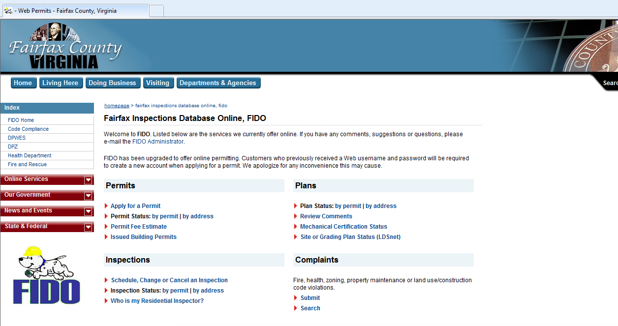

www.fairfaxcounty.gov/fido

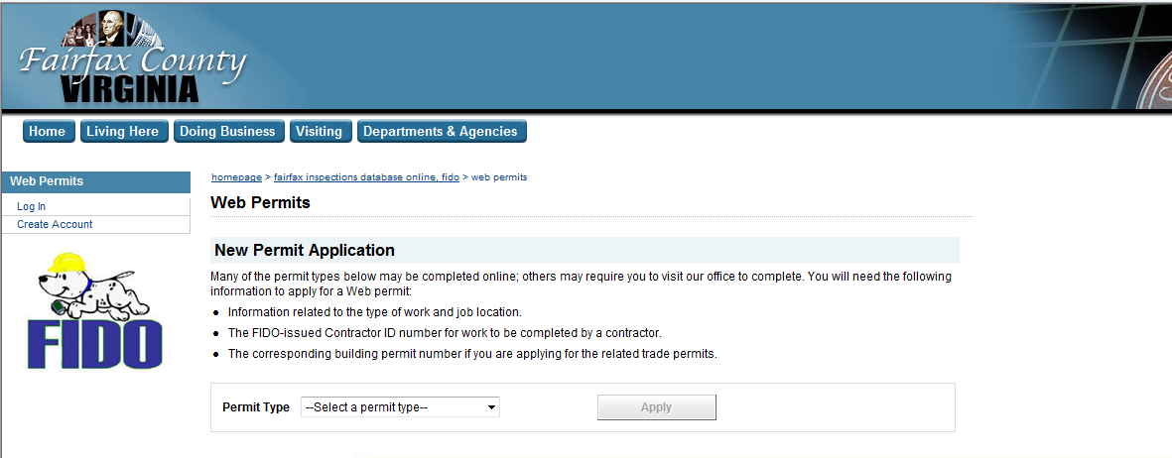

You must first create an account in order to use the online permits.
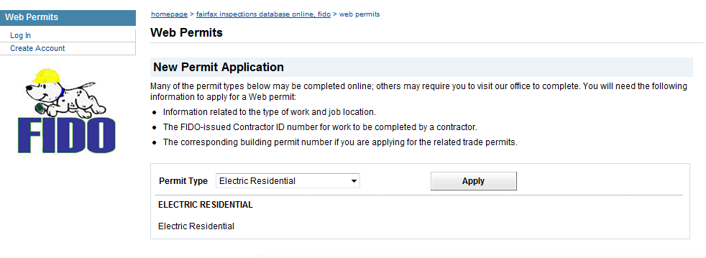
Once you have created an account, then log in and pick permit type Electric Residential, then click on the apply button.
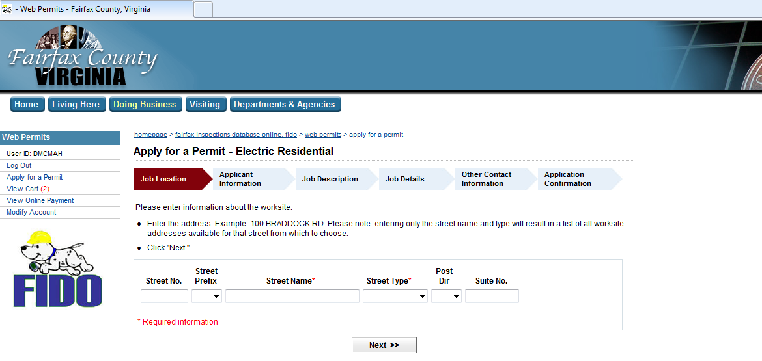
At the Job Location please type in the address where the work will be done and then click on the Next button.
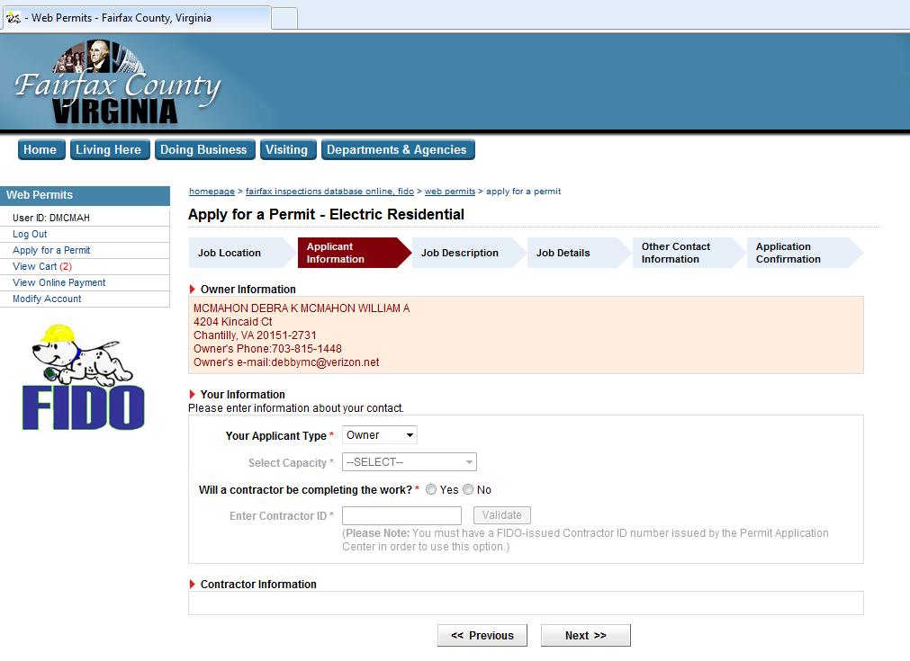
At the Applicant Information, please select your applicant type and answer yes or no to the contractor question, (if work is being done by a licensed contractor you will need to obtain there contractor id number in order to complete this process.) After both are done click on the Next button.
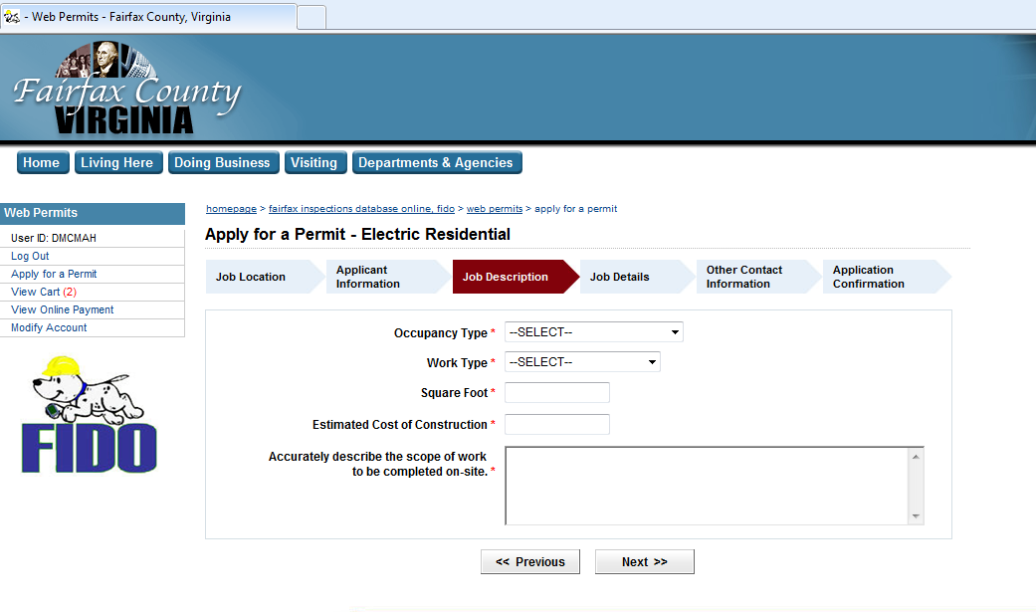
Job Description please select Occupancy Type and Work Type. Put in a number 1 for Square Foot and Estimated Cost of Construction. And please provide a scope of work description. Then click on Next button.

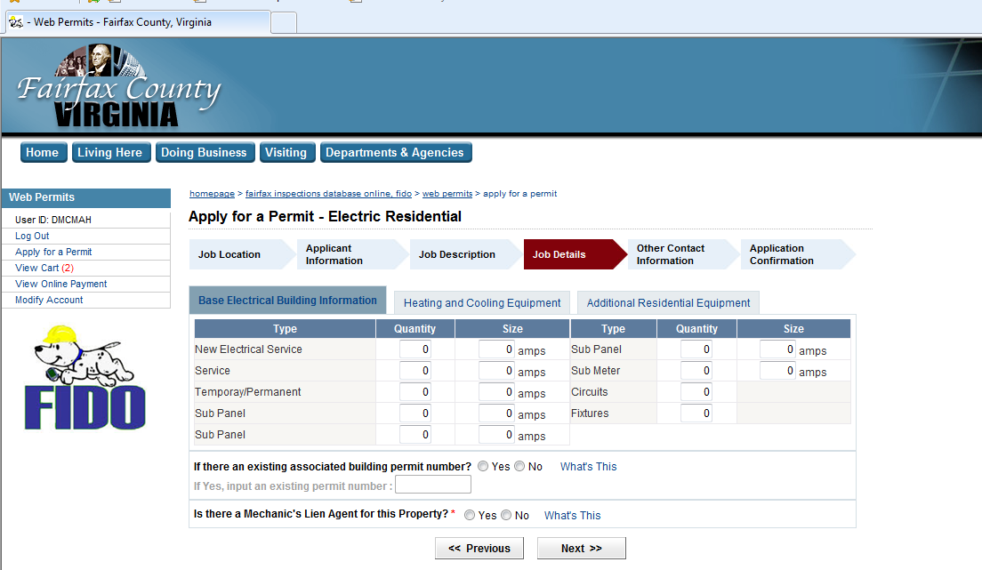

Job Details please mark quantity of fixtures, then answer below questions, and then click on Next button.
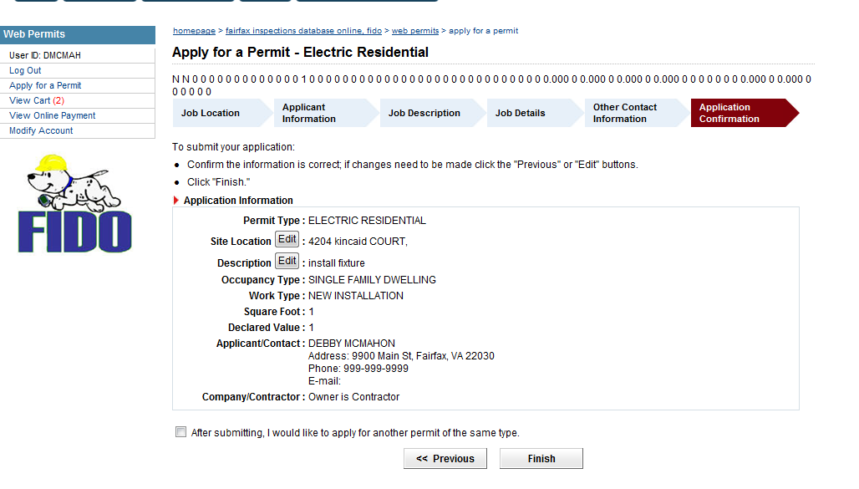
Application Confirmation, please verify and then click the Finish button.
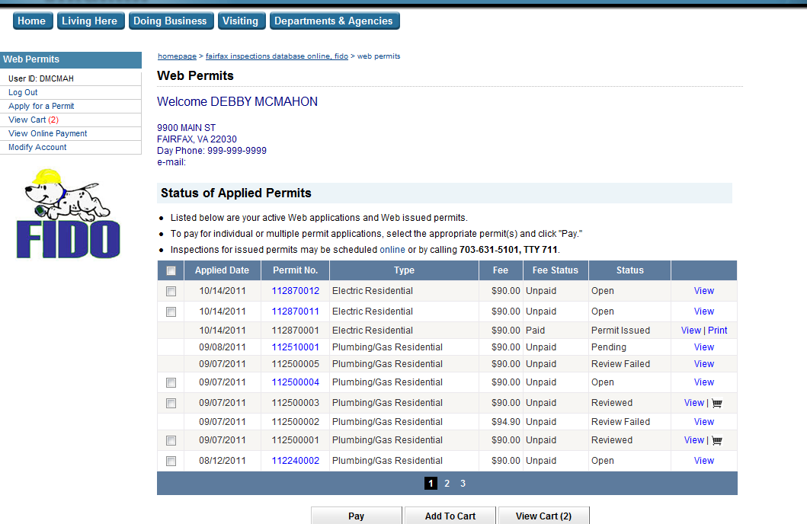

Select the permit with a check mark and then click on the Pay button.
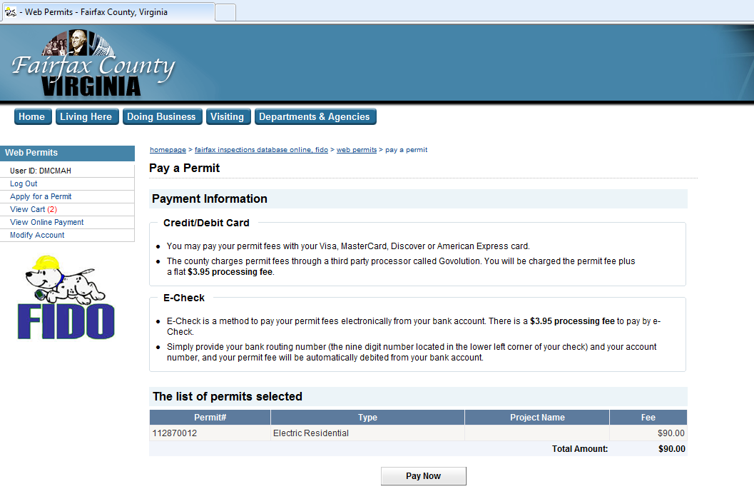
At this point click on the Pay Now button to proceed with payment, once payment has been made the system will return you to the below screen.
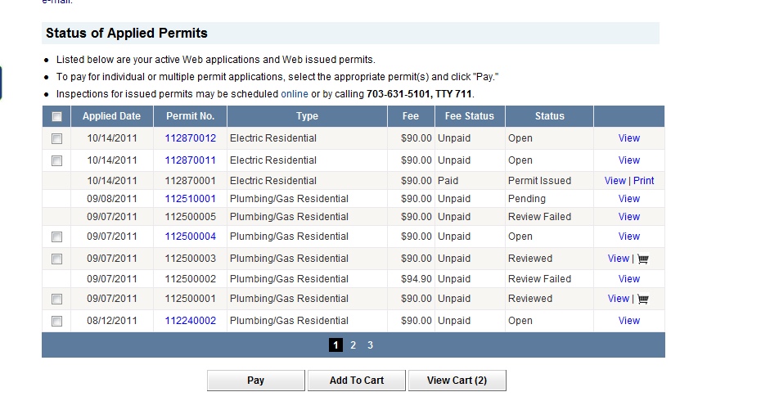
You will then see the status of your permit change to Permit Issued along with a view/print button, please click on the print button in order to print out a hardcopy of your permit.
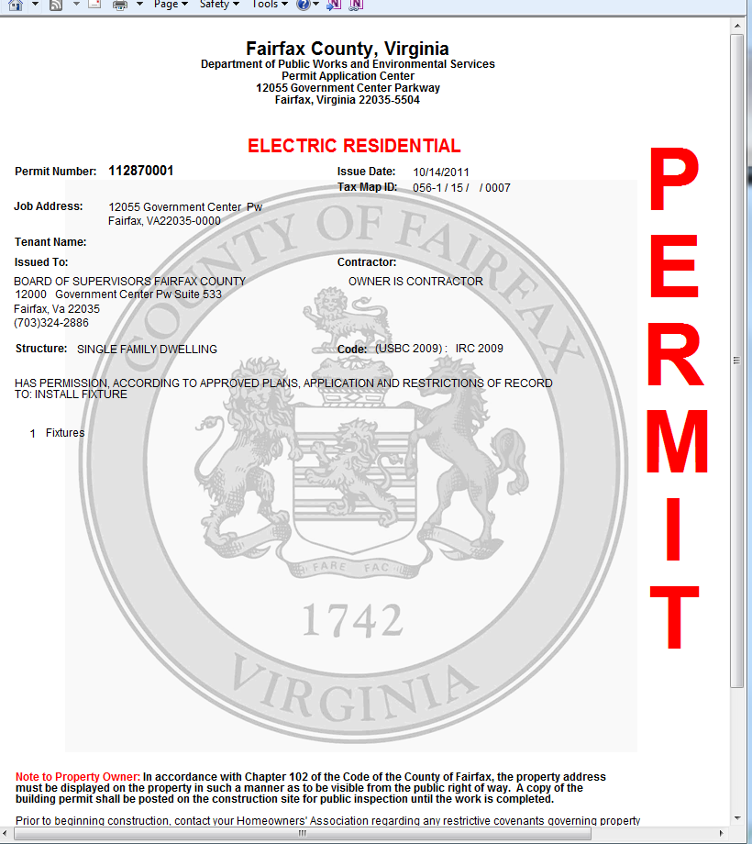
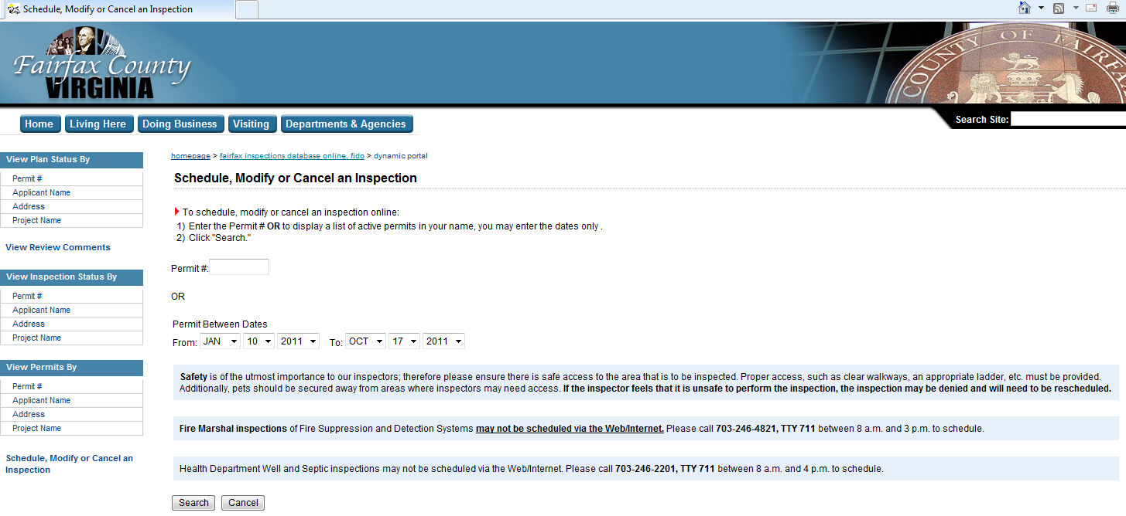

Follow the above instructions to schedule an inspection, you will need to provide the permit number, or know when the permit was issued.
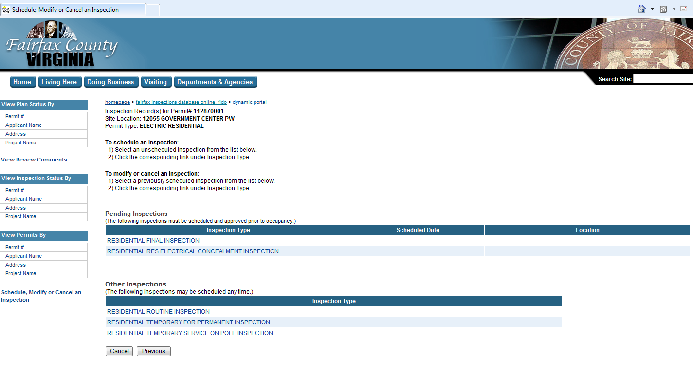
Select the type of inspection you are trying to request.

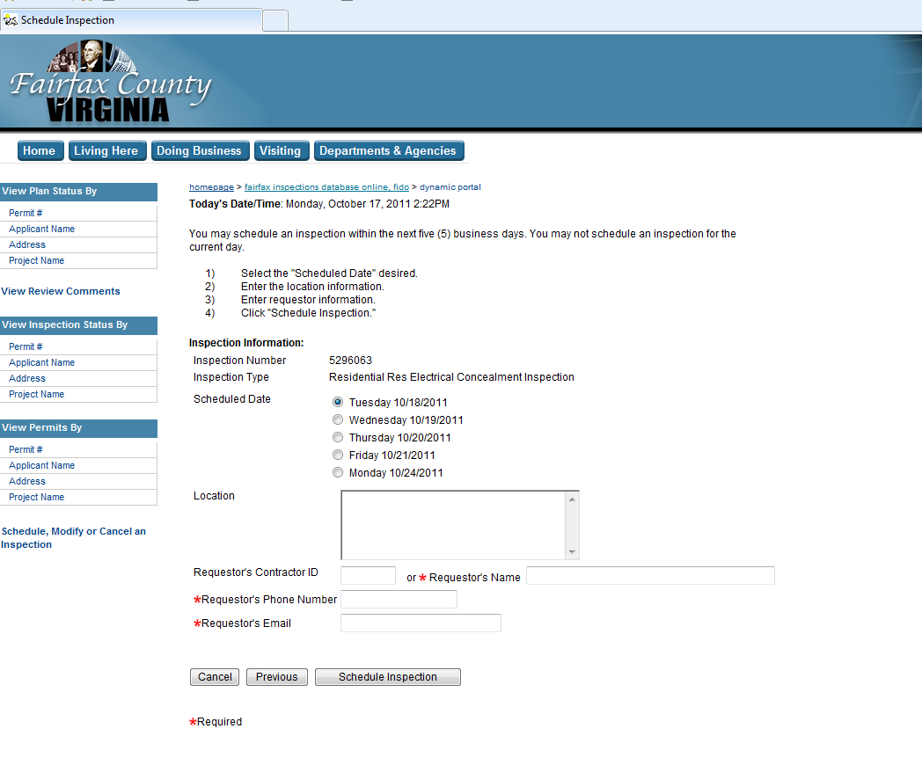
Pick the date of your requested inspection, and information you feel the inspector may need, please provide in the Location box. Please fill in all red asterisk boxes and then click on the Schedule Inspection button.

