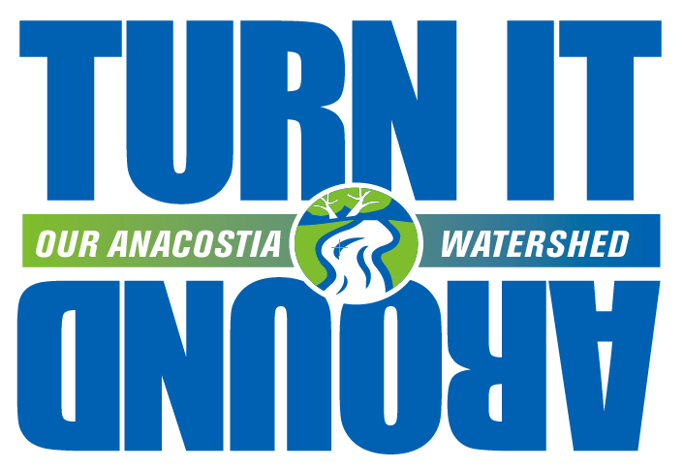

December 18, 2012

The Honorable Frank Principi, Chair
Board of Directors

The Honorable Eric Olson, Chair
Region Forward Coalition

The Honorable Todd Turner, Chair
Transportation Planning Board

Metropolitan Washington Council of Governments
777 North Capitol Street NE
Washington, DC 20002

Dear Chairs Principi, Olson and Turner:

Congratulations on the recent adoption of the Complete Streets Policy for the National Capital Region by the Transportation Planning Board (TPB). This thoughtful and forward-looking policy will help insure that the region’s highways, roads and streets are safe for all who use them for years in the future. Further, the policy was crafted with enough specificity to make it meaningful but enough flexibility to encourage all jurisdictions to join in. This policy is an accomplishment that the TPB can be proud of and that the MWCOG and the Region Forward Coalition can be very proud to have supported.

I am writing you today as Chair of the Steering Committee of the Anacostia Watershed Restoration Partnership to ask you to consider developing and adopting a similar policy for green streets. As you probably know, the Partnership is an independent public/private partnership administered by MWCOG consisting of federal, state, and local government agencies, businesses, developers, advocacy groups, foundations and others working to restore the Anacostia watershed. Our members created and are implementing the Anacostia Watershed Restoration Plan, which can be found at our website at: www.anacostia.net.

The Anacostia watershed is very degraded, but it is not much different from many urban watersheds in the Chesapeake Bay region where untreated runoff from pavement and roofs pollutes rivers and destroys streams with torrential flows. Polluted runoff prevents these rivers and streams from being valuable green recreational and aesthetic assets that are very much needed in increasingly dense urban communities. Further, increasing volumes of runoff expected as the climate changes make counties and municipalities increasingly vulnerable to destructive flooding. In the Anacostia watershed, about 30 percent of our “impervious surfaces” are roads, sidewalks and parking lots and addressing these must be part of the solution.

Green streets are not just good for rivers and streams, public safety and aesthetics—they are good for the region’s economy. Study after study shows that “green infrastructure,” such as green streets, increases property values, improves the “bottom line” in nearby retail establishments and restaurants, saves energy, decreases flooding, and reduces health care costs by reducing heat and improving air quality. (See, for example, City of Portland Bureau of Environmental Services, Portland’s Green Infrastructure: Quantifying the Health, Energy, and Community Livability Benefits, February 16, 2010.) At least one study indicates that green infrastructure, more than any other kind of infrastructure improvement, creates jobs for local businesses and workers. (See Green for All, Water Works: Rebuilding Infrastructure, Creating Jobs, Greening the Environment, 2012.)

In a word, please consider insuring that a similar policy for greening streets and highways is adopted, a Green Streets Policy for the National Capital Region, either by the TPB or another entity associated with MWCOG. With Council Member Olson’s leadership, Prince George’s County very recently adopted a “Complete and Green Street Bill” (CB 83-2012) which could provide an example of such a policy. If you contact our Executive Director, Dana Minerva at dminerva@mwcog.org, she can provide many examples of green street policies and manuals adopted by counties and municipalities across the United States that may provide examples. Further, the Anacostia local jurisdictions--the District of Columbia, Montgomery County, and Prince George’s County—have constructed many beautiful examples of green highways and streets that may inspire you.

As one of our nation’s most careful observers of the urban scene, William H. Whyte, once said: “You can measure the health of a city by the vitality and energy of its streets and public open spaces.” We hope a green street policy that encourages trees, planters, and other green features that manage polluted runoff beautifully will, like the Complete Streets Policy, increase the vitality and value of our streets and highways.
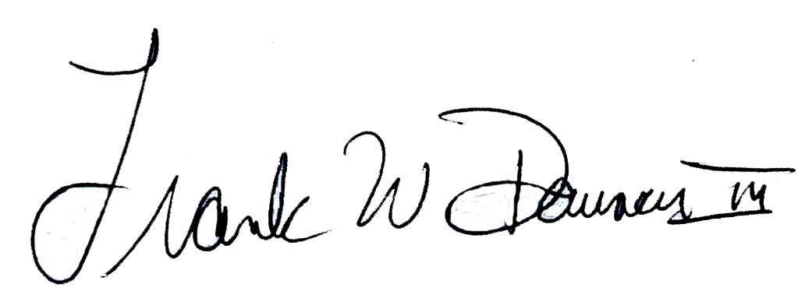
Sincerely,

Frank Dawson, Chair
Steering Committee
Anacostia Watershed Restoration Partnership

Cc: Stuart Freudberg, Steve Bieber, Dana Minerva

