COMMUNITY-WIDE GREENHOUSE GAS INVENTORY SUMMARY
Metropolitan Washington
EMISSIONS SUMMARY
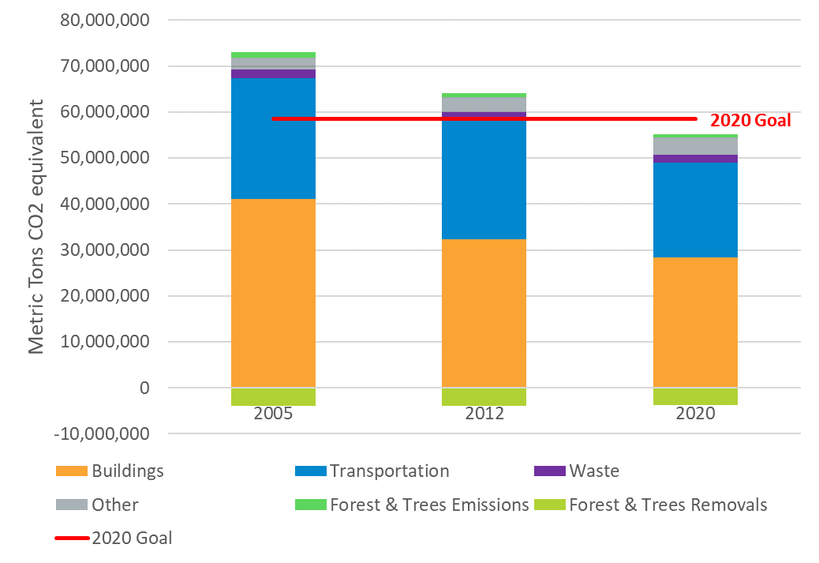
Metropolitan Washington community-wide greenhouse gas (GHG) emissions decreased by 24% between 2005 and 2020, despite a 20% growth in population.
Note: Other refers to emissions associated with the release of Hydrofluorocarbons, emissions resulting from local natural gas system losses within the community, as well as emissions from Agriculture.
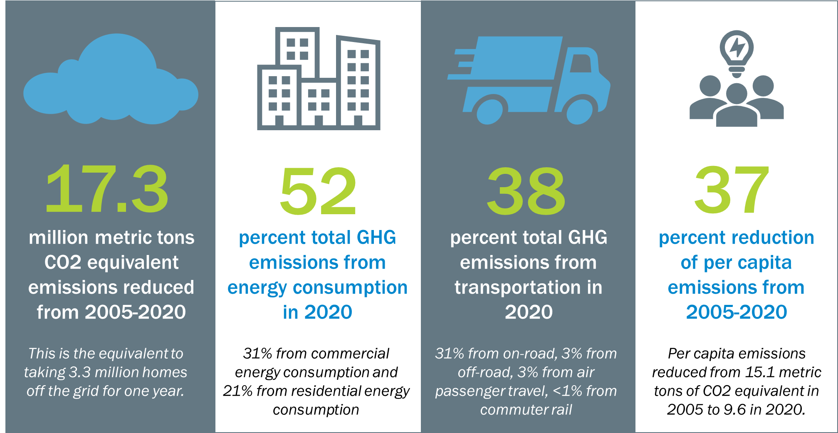
GHG CONTRIBUTION ANALYSIS

The metropolitan Washington GHG Contribution Analysis results show what has driven increases (red bars) and decreases (blue bars) in emissions between inventory years 2005 and 2020. The graph shows the main drivers increasing emissions (red bars) are growth in population, commercial space, and hydrofluorocarbons (HFCs). Driving down emissions (blue bars) is mainly a cleaner grid, reduced vehicle miles traveled (VMT) per person, and decreased commercial electricity energy intensity.
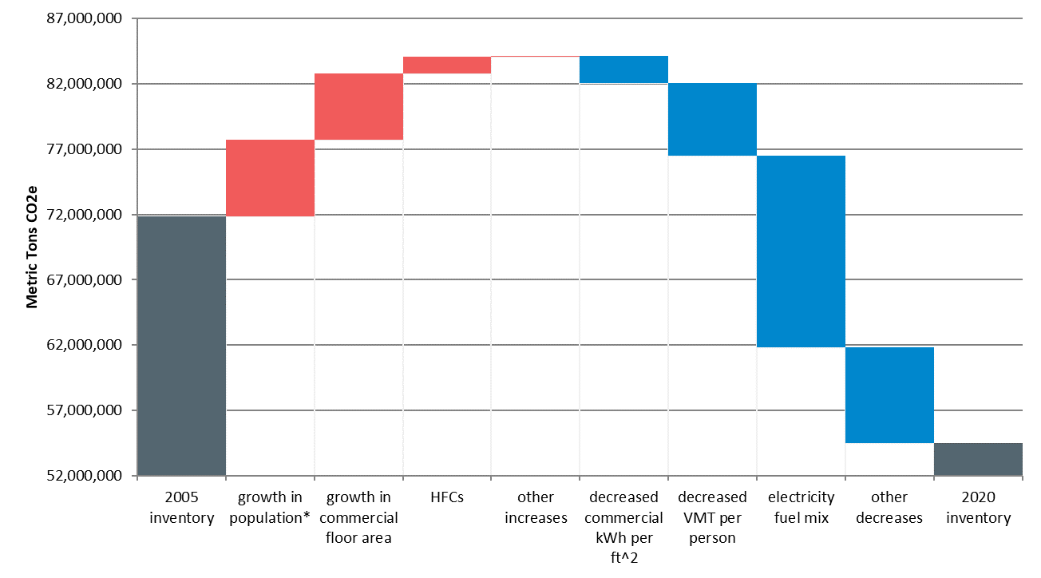
Sources: ICLEI’s Contribution Analysis Model and COG GHG Inventories
inventory background and methodology

The Metropolitan Washington Council of Governments (COG) and local governments across metropolitan Washington collaboratively established the regional GHG emission reduction goals of: 10% below business as usual projections by 2012 (back down to 2005 levels); 20% below 2005 levels by 2020; 50% by 2030; and 80% below 2005 levels by 2050. Metropolitan Washington met both the 2012 and 2020 goals. Emissions from buildings and transportation saw a greater reduction than anticipated due to the 2020 pandemic.

COG completes GHG community-scale inventories for all 24 local government members and metropolitan Washington. COG GHG inventories are compliant with both the U.S. Communities Protocol for Accounting and Reporting Greenhouse Gas Emissions (USCP) and Global Protocol for Community-Scale Greenhouse Gas Inventories (GPC). The inventories measure GHG-emitting activities undertaken by residents, businesses, industry, and government located in metropolitan Washington, as well as emissions from visitors.
ResourceS [links to be updated]
- Metropolitan Washington Greenhouse Gas Inventory Methodology Report
- COG Greenhouse Gas Inventories
- DMV Climate Partners GHGs in the DMV

