Stormwater Permitting Status
Issues Summary (10/30/17)

Municipal Separate Storm Sewer System (MS4) Permits: These permits are issued by federal (EPA Region III) and state regulatory agencies to certain local governments that own and operate drainage conveyance systems for streets and other urban infrastructure These permits require actions to lessen the volume of pollutants carried by their systems. There are two types of MS4 permits: 1)( more comprehensive Phase I permits for larger counties; and 2) Phase II permits for smaller counties and most municipalities. Among their many provisions, MS4 permits require consistency with the pollution budgets of applicable TMDLs, including the Bay TMDL. All of COG’s member jurisdictions are subject to either Phase I or Phase II MS4 permits. The permits generally cover five-year terms and tend to be updated with new or revised provisions with each re-issuance.

District of Columbia
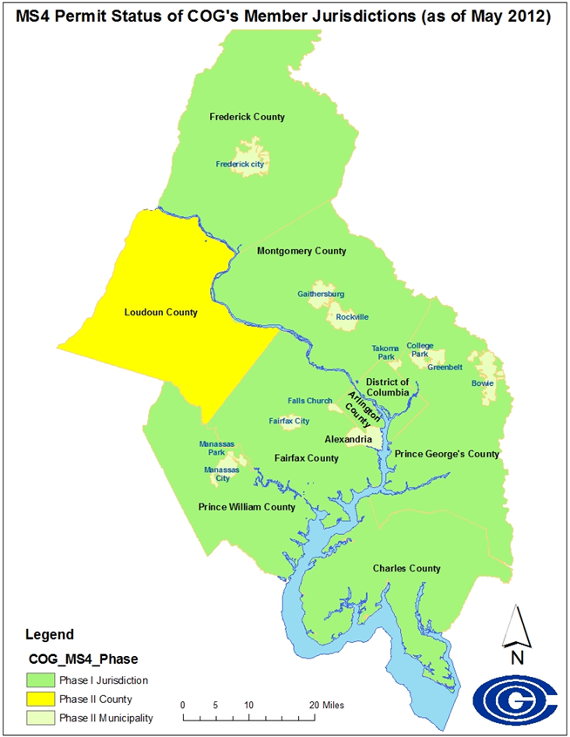
(Note: The permit covers the entire city except for the area that drains into the combined sewer system – which is managed by DC Water.)
- The District is currently operating under a Phase I permit issued by EPA Region III in October 2011, and administratively extended since then. EPA originally issued the tentative determination draft of a new permit in November 2016. After comment, the permit was revised and reissued for public comment, which has since closed.
- The permit is expected to be reissued shortly and to have more ambitious targets for BMP implementation – including impervious surface retrofits, green roof construction, tree planting, and street sweeping -- than the previous permit.
- The permit also requires new actions for addressing bacterial contamination, the runoff of road salt into waterways, and revising old TMDLs for which new data is available.

Maryland

(Note: All of Maryland’s MS4 permits apply to the total area of a county or municipality, although that interpretation is currently under litigation.)

Phase I
- All the state’s current Phase I permits – except for the one for Montgomery County -- were issued between late 2013 and late 2014. They will thus expire in sequence, from:
  - Baltimore County -- expiring on 12/23/2018, to
  - Frederick County -- expiring on 12/30/2019
- The Montgomery County permit was issued in 2010, expired in 2015, and has been administratively extended while negotiations continue over a consent decree.
- The Maryland Department of the Environment (MDE) has circulated language for a new draft permit applicable to all of the Phase I jurisdictions. MDE’s goal is to send this template draft to
- EPA III for review in December and to issue final permits in 2018 before the current permits expire.
  - The draft language would keep the current 20-percent requirement for impervious surface retrofit (ISR) the same, but would add a new requirement (based on the state’s analysis of how it will meet its Bay TMDL goals) for either additional impervious surface retrofit or an equivalent nutrient reduction.
- Meanwhile, four Phase I MS4s, including Frederick and Charles counties, are in litigation with MDE over the achievability of the 20-percent Impervious Surface Ratio (ISR) requirement and the extent of the area covered by the permit.

Phase II
- The Phase II General Permit covers several counties and most of the municipalities located within Phase I counties. Although not as comprehensive as the individual Phase I permits in its scope, the Phase II permit addresses Bay-related pollution reduction goals in the same manner.
- It was originally issued in 2005 and has been administratively extended since 2010.
- MDE issued the tentative determination draft of a new Phase II permit in December 2016. MDE expects to issue a final permit in March 2018.
  - The draft language includes a requirement to achieve by 2025 the same 20-percent ISR target that applies to the Phase I permits.

Virginia

(Note: All of Virginia’s MS4 permits apply only to the area of a county or municipality served by drainage systems owned and operated by the permittee.)

Phase I
- The Virginia Department of Environmental Quality (DEQ) began issuing the first in what is planned to be a set of three related MS4 permits for achieving Bay TMDL reduction goals in 2013:
  - Beginning with Arlington County in June 2013
  - Continuing with Prince William County in December 2014, and
  - Fairfax County in March 2015.
- Among other provisions, these permits require the counties to:
  - Achieve 5 percent of their nutrient reduction targets from the state’s Phase II Watershed Implementation Plan in the first permit cycle, and
  - Develop a plan for meeting the next nutrient reduction goal of 35-percent.

Phase II
- The General Permit for Phase II MS4s, which included the requirement for meeting five percent of the Bay-related nutrient reduction goal, expired in June 2018.
- A technical advisory committee organized by DEQ has been meeting to hammer out the details of the new general permit, which will be the first MS4 permit in Virginia to include the 35-percent nutrient reduction target.
- DEQ expects to issue the tentative determination draft of a new general permit in November and issue a final permit in early 2018.

COG Staff Contacts: Karl Berger kberger@mwcog.org / Heidi Bonnaffon hbonnaffon@mwcog.org

\\mwcog.org\dfs\DEP\WRTC\2017\110617 - November WRTC\COG Region MS4 Permits - StatusIssues Summary One-Pager -FINAL.docx

