Fall 2010 Street Smart Media Report
December 10, 2010

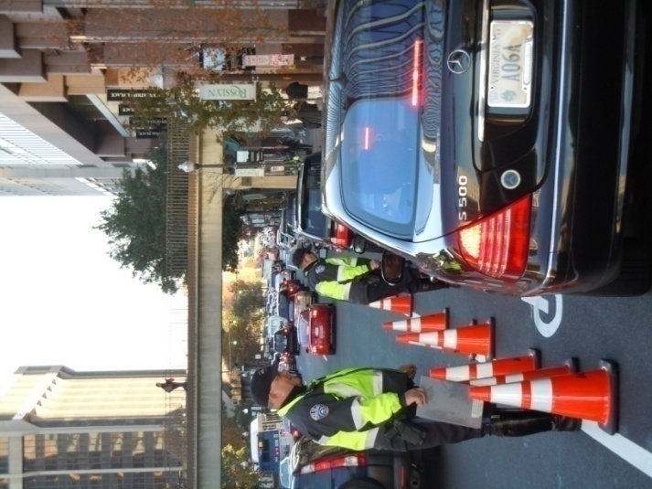
On Tuesday, November 9, 2010, the Council of Governments kicked off the fall Street Smart campaign by issuing warnings…and, in some cases, actual tickets…to offenders of the important pedestrian and cyclist safety laws in the Washington, D.C. metropolitan area.

With balanced representation of elected officials and law enforcement leaders from across the COG region, the kickoff was appropriately held at Arlington County’s single busiest intersection (Wilson and Lynn Streets in Rosslyn), where the Arlington County Police carried out two waves of enforcement. Pedestrians and cyclists were given verbal warnings and motorists received citations. Over the three hours of enforcement, a total of 47 tickets and more than 50 warnings were issued, averaging one ticket/warning every 75 seconds.

The event earned tremendous media coverage, both during the morning enforcement wave and at the afternoon press conference. Notable highlights include:
- Reaching nearly 3 million people across the region, specifically:
- 17 print and online articles reaching a total of 1,535,000 readers
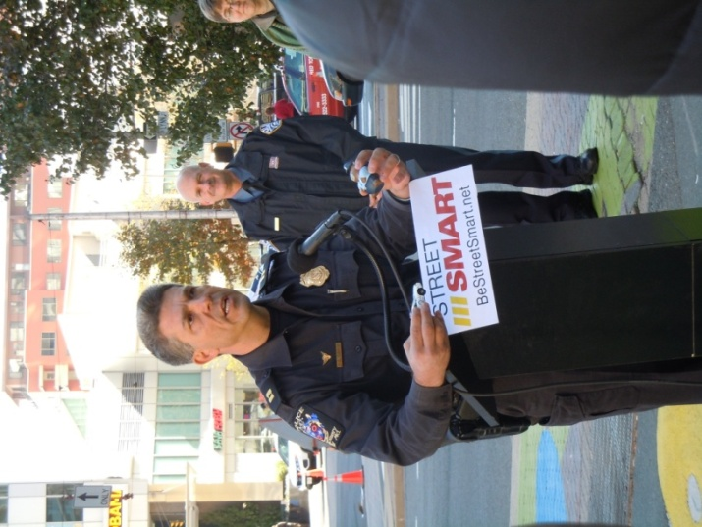
- 48 television stories reaching at least 1,289,890 area viewers
- Coverage by all local broadcast outlets: NBC-4, FOX-5,
ABC-7, CBS-9 and News Channel 8 (TBD)
- WTOP and WAMU coverage reaching an audience of 172,000 listeners
- Total estimated publicity value of $116,527
- Print and online coverage: $27,450
- Television coverage: $71,077
- Radio coverage: $18,000
- Telemundo and Univision coverage of the event on November 9
- One print in The Washington Post and three accompanying online stories
- Significant social media coverage by Arlington Now, WeLoveDC and The WashCycle blogs

We appreciate the opportunity to continue working with the Street Smart team on this valuable public safety program. Please contact Emily Howard or John Undeland with any questions at 202-289-2001.

Broadcast Coverage
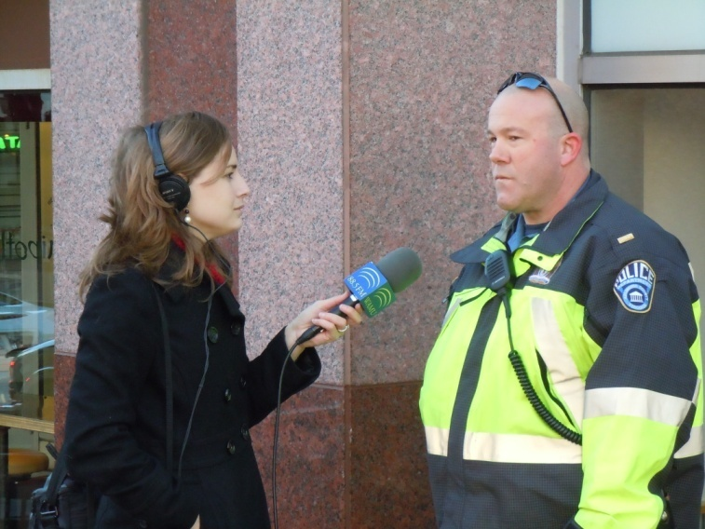
VIDEO: Arlington cops dish out 33 traffic violations — including one to a Metrobus driver — during Rosslyn a.m. rush hour
TBD Online
November 9, 2010
Dave Jamieson

VIDEO: Arlington Targets Motorists, Pedestrians

MyFoxDC Online

November 9, 2010

John Henrehan

Arlington Police Stake-Out Intersection To Protect Pedestrians
WAMU-FM Online
November 9, 2010
Jessica Jordan

Listen to this feature
- Real Audio
- Windows Media

Sometimes the Only Way to Get Through to People is to Hit Them in the Pocketbook
WTOP
November 9, 2010
Kristi King

Crackdown on Drivers and the Jaywalkers They Could Hit
WTOP
November 9, 2010
Kristi King

Bus driver cited for traffic violation in Arlington
WTOP Online
November 10, 2010
Adam Tuss

Report Summary:

Total Hits: 48

Total Audience Impressions: 1,289,890

Total Publicity Value: $71,076.82

# | Market | Date | Time | Aired On | Affiliate | Show | Audience | Publicity Value
 | Washington. DC (Hagerstown. MD) [DC] [9] | 11/10/2010 | 07:00:00pm | TBD | NEWS8 | TBD News (1/2) | 7,700 | $1,680.00
 | Washington. DC (Hagerstown. MD) [DC] [9] | 11/10/2010 | 12:00:00pm | WUSA | CBS | 9News Now at Noon | 77,446 | $3,505.98
 | Washington. DC (Hagerstown. MD) [DC] [9] | 11/10/2010 | 09:00:00am | WTTG | Fox | Fox Morning News (1/2) | 42,830 | $1,938.91
 | Washington. DC (Hagerstown. MD) [DC] [9] | 11/10/2010 | 08:00:00am | TBD | NEWS8 | TBD News (1/2) | 2,200 | $420.00
 | Washington. DC (Hagerstown. MD) [DC] [9] | 11/10/2010 | 07:00:00am | TBD | NEWS8 | TBD News (1/2) | 2,700 | $630.00
 | Washington. DC (Hagerstown. MD) [DC] [9] | 11/10/2010 | 06:00:00am | WUSA | CBS | 9News Now at 6am (1/2) | 25,350 | $1,147.59
 | Washington. DC (Hagerstown. MD) [DC] [9] | 11/10/2010 | 05:30:00am | WJLA | ABC | Good Morning Washington at 5:00 (2/2) | 29,591 | $1,339.58
 | Washington. DC (Hagerstown. MD) [DC] [9] | 11/10/2010 | 05:00:00am | WUSA | CBS | 9News Now at 5am (1/2) | 34,701 | $1,570.91
 | Washington. DC (Hagerstown. MD) [DC] [9] | 11/10/2010 | 04:30:00am | WUSA | CBS | 9News Now at 4:30am | 29,278 | $1,325.41
 | Washington. DC (Hagerstown. MD) [DC] [9] | 11/10/2010 | 04:30:00am | WTTG | Fox | Fox 5 Morning News at 4:25am (1/2) | 24,748 | $1,120.34
 | Washington. DC (Hagerstown. MD) [DC] [9] | 11/09/2010 | 07:30:00pm | TBD | NEWS8 | TBD News (2/2) | 7,700 | $1,680.00
 | Washington. DC (Hagerstown. MD) [DC] [9] | 11/09/2010 | 07:00:00pm | WUSA | CBS | 9News Now Tonight | 45,317 | $2,051.50
 | Washington. DC (Hagerstown. MD) [DC] [9] | 11/09/2010 | 05:00:00pm | WRC | NBC | News 4 at 5 (1/2) | 107,569 | $4,869.64
 | Washington. DC (Hagerstown. MD) [DC] [9] | 11/09/2010 | 05:00:00pm | WTTG | Fox | Fox 5 News at 5 (1/2) | 52,003 | $2,354.17
 | Washington. DC (Hagerstown. MD) [DC] [9] | 11/09/2010 | 05:00:00pm | WUSA | CBS | 9News Now at 5pm (1/2) | 38,604 | $1,747.60
 | Washington. DC (Hagerstown. MD) [DC] [9] | 11/09/2010 | 03:30:00pm | TBD | NEWS8 | TBD News | 3,750 | $430.00
 | Washington. DC (Hagerstown. MD) [DC] [9] | 11/09/2010 | 03:00:00pm | TBD | NEWS8 | TBD News | 3,750 | $460.00
 | Washington. DC (Hagerstown. MD) [DC] [9] | 11/09/2010 | 02:30:00pm | TBD | NEWS8 | TBD News | 3,500 | $430.00
 | Washington. DC (Hagerstown. MD) [DC] [9] | 11/09/2010 | 02:00:00pm | TBD | NEWS8 | TBD News | 3,300 | $420.00
 | Washington. DC (Hagerstown. MD) [DC] [9] | 11/09/2010 | 01:30:00pm | TBD | NEWS8 | TBD News | 3,300 | $420.00
 | Washington. DC (Hagerstown. MD) [DC] [9] | 11/09/2010 | 01:00:00pm | TBD | NEWS8 | TBD News | 3,300 | $420.00
 | Washington. DC (Hagerstown. MD) [DC] [9] | 11/09/2010 | 12:30:00pm | TBD | NEWS8 | TBD News | 3,300 | $420.00
 | Washington. DC (Hagerstown. MD) [DC] [9] | 11/09/2010 | 12:00:00pm | TBD | NEWS8 | TBD News | 3,300 | $420.00
 | Washington. DC (Hagerstown. MD) [DC] [9] | 11/09/2010 | 12:00:00pm | WJLA | ABC | ABC 7 News at Noon | 40,700 | $1,842.48
 | Washington. DC (Hagerstown. MD) [DC] [9] | 11/09/2010 | 11:00:00am | WRC | NBC | News 4 Midday (1/2) | 31,655 | $1,433.02
 | Washington. DC (Hagerstown. MD) [DC] [9] | 11/09/2010 | 09:30:00am | TBD | NEWS8 | TBD News | 4,200 | $920.00
 | Washington. DC (Hagerstown. MD) [DC] [9] | 11/09/2010 | 08:30:00am | TBD | NEWS8 | TBD News (2/2) | 4,800 | $1,150.00
 | Washington. DC (Hagerstown. MD) [DC] [9] | 11/09/2010 | 07:30:00am | TBD | NEWS8 | TBD News (2/2) | 4,800 | $1,150.00
 | Washington. DC (Hagerstown. MD) [DC] [9] | 11/09/2010 | 06:30:00am | TBD | NEWS8 | TBD News (2/2) | 4,000 | $900.00
 | Washington. DC (Hagerstown. MD) [DC] [9] | 11/09/2010 | 06:30:00am | WJLA | ABC | Good Morning Washington 6:00 (2/2) | 45,020 | $2,038.05

 | Washington. DC (Hagerstown. MD) [DC] [9] | 11/09/2010 | 06:30:00am | WRC | NBC | News 4 Today at 6 (2/2) | 97,443 | $4,411.24
 | Washington. DC (Hagerstown. MD) [DC] [9] | 11/09/2010 | 06:00:00am | WJLA | ABC | Good Morning Washington 6:00 (1/2) | 45,020 | $2,038.05
 | Washington. DC (Hagerstown. MD) [DC] [9] | 11/09/2010 | 06:00:00am | WRC | NBC | News 4 Today at 6 (1/2) | 97,443 | $4,411.24
 | Washington. DC (Hagerstown. MD) [DC] [9] | 11/09/2010 | 05:30:00am | TBD | NEWS8 | TBD News (2/2) | 2,500 | $300.00
 | Washington. DC (Hagerstown. MD) [DC] [9] | 11/09/2010 | 05:30:00am | WJLA | ABC | Good Morning Washington at 5:00 (2/2) | 28,385 | $1,284.98
 | Washington. DC (Hagerstown. MD) [DC] [9] | 11/09/2010 | 05:00:00am | WJLA | ABC | Good Morning Washington at 5:00 (1/2) | 28,385 | $1,284.98
 | Washington. DC (Hagerstown. MD) [DC] [9] | 11/09/2010 | 05:00:00am | WRC | NBC | News 4 Today at 5 (1/2) | 42,915 | $1,942.76
 | Washington. DC (Hagerstown. MD) [DC] [9] | 11/09/2010 | 04:30:00am | WRC | NBC | News 4 Today at 4:30 | 17,783 | $805.03
 | Washington. DC (Hagerstown. MD) [DC] [9] | 11/09/2010 | 01:00:00am | TBD | NEWS8 | TBD News | 800 | $100.00
 | Washington. DC (Hagerstown. MD) [DC] [9] | 11/09/2010 | 12:30:00am | TBD | NEWS8 | TBD News | 800 | $100.00
 | Washington. DC (Hagerstown. MD) [DC] [9] | 11/09/2010 | 12:00:00am | TBD | NEWS8 | TBD News | 800 | $100.00
 | Washington. DC (Hagerstown. MD) [DC] [9] | 11/08/2010 | 10:30:00pm | TBD | NEWS8 | TBD News | 800 | $100.00
 | Washington. DC (Hagerstown. MD) [DC] [9] | 11/08/2010 | 10:00:00pm | TBD | NEWS8 | TBD News | 4,200 | $920.00
 | Washington. DC (Hagerstown. MD) [DC] [9] | 11/08/2010 | 08:00:00am | TBD | NEWS8 | TBD News (1/2) | 4,800 | $1,150.00
 | Washington. DC (Hagerstown. MD) [DC] [9] | 11/08/2010 | 07:00:00am | TBD | NEWS8 | TBD News (1/2) | 4,800 | $1,150.00
 | Washington. DC (Hagerstown. MD) [DC] [9] | 11/08/2010 | 06:30:00am | WRC | NBC | News 4 Today at 6 (2/2) | 99,801 | $4,517.99
 | Washington. DC (Hagerstown. MD) [DC] [9] | 11/08/2010 | 06:00:00am | WRC | NBC | News 4 Today at 6 (1/2) | 99,801 | $4,517.99
 | Washington. DC (Hagerstown. MD) [DC] [9] | 11/08/2010 | 04:30:00am | WRC | NBC | News 4 Today at 4:30 | 19,602 | $887.38

Print & Online Coverage

Fall Street Smart Campaign for Pedestrian Safety Launched
Montgomery County Government News Online
November 12, 2010
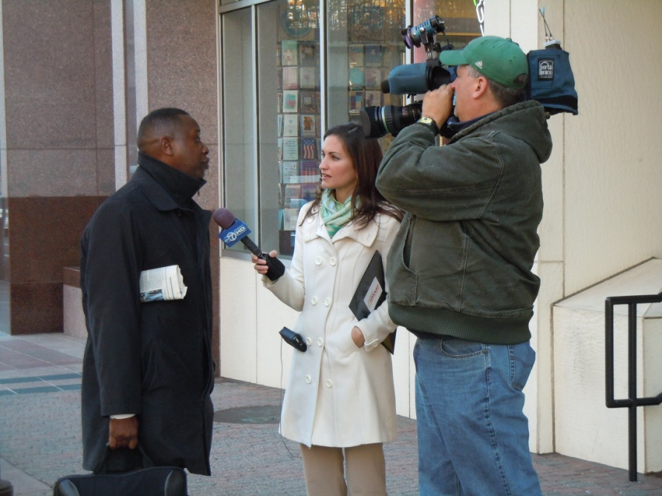
Tom Pogue

Police pushing for pedestrian safety
Washington Post - Print
November 10, 2010
Christy Goodman

Bus driver cited for traffic violation in Arlington
WTOP Online
November 10, 2010
Adam Tuss

Police pushing for pedestrian safety
Washington Post - Online
November 9, 2010
Christy Goodman

Traffic safety campaign kicks off
Washington Post - Online
November 9, 2010
Michael Bolden

Be alert or risk a ticket
Washington Post Online
November 9, 2010
Christy Goodman

Arlington: Yield right of way or get a ticket
WTOP Online
November 9, 2010

Arlington Police Stake-Out Intersection To Protect Pedestrians
WAMU-FM Online
November 9, 2010
Jessica Jordan

Arlington cops out in Rosslyn ticketing drivers for Street Smart campaign
TBD Online
November 9, 2010
Dave Jamieson

Police to Issue Tickets in Rosslyn for Pedestrian Safety

Arlington Now Online

November 9, 2010

ARL Staff

Metrobus Among the Vehicles Ticketed by Police in Rosslyn

Arlington Now Online

November 9, 2010

ARL Staff

Arlington County Police To Ticket Jaywalkers This Morning In Rosslyn
WeLoveDC Online
November 9, 2010
Patrick Pho

Watch your step in Rosslyn today
TBD Online
November 8, 2010
Rebecca Cooper

Walk-Bike-Drive Smart--Be Street Smart
Commuter Page Blog
November 9, 2010
Lauren Hassel

Street Smart fall campaign starts this week
The WashCycle

November 7, 2010

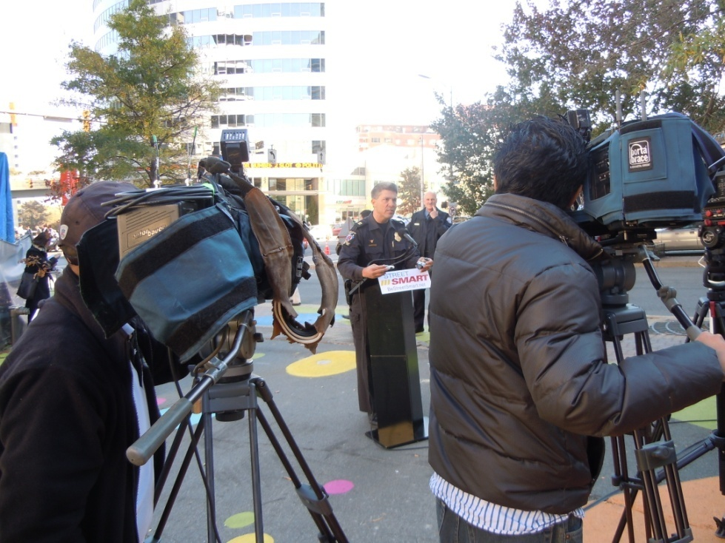
Fall Street Smart Campaign for Pedestrian Safety Launched
Montgomery County Government News Online
November 12, 2010
Tom Pogue
At a heavily-trafficked intersection in Rosslyn, Arlington County Police were deployed in force with their citation books during the morning commute and lunch hour to ensure pedestrians, cyclists and drivers obeyed the rules of road. The enforcement officially kicked off the fall 2010 Street Smart campaign to promote pedestrian and bicyclist safety and will include similar strategic enforcement engagements around the metropolitan Washington region. This year’s initiative could not be better timed, given the rash of pedestrian traffic incidents the area has witnessed in recent months.
Local elected officials and law enforcement from suburban Maryland, the District of Columbia and Northern Virginia gathered to emphasize the importance of prioritizing safety improvements throughout the region. In 2009, pedestrian and cyclist deaths accounted for more than one quarter (27 percent) of the region’s traffic-related fatalities. A total of 79 area walkers and bikers lost their lives in traffic crashes, averaging one death every five days. For information on Montgomery County's pedestrian safety program visit MCDOT's pedestrian safety website.
The Street Smart public awareness and enforcement campaign is in its eighth year. The program is sponsored by the Metropolitan Washington Council of Governments (COG) and the National Capital Region Transportation Planning Board (TPB), and receives contributions from local jurisdictions. This year, Montgomery County contributed $20,000 to the regional effort. Aimed at reducing the number of pedestrian and cyclist injuries and deaths in the Washington metropolitan area, the campaign uses creative radio and television advertising in English and Spanish to reach drivers, pedestrians and cyclists, while targeting them through outdoor and transit advertising on bus shelters and bus sides. In addition, law enforcement and local, county and state agencies will be distributing handouts and tip cards to further spread awareness and educate drivers and pedestrians. For more information about Street Smart, visit the Street Smart website or twitter.com/COGStreetSmart.

Police pushing for pedestrian safety
Washington Post - Print
November 10, 2010
Christy Goodman
Police in Arlington issued 33 tickets and 50 warnings to pedestrians, cyclists and motorists at the county's highest-volume intersection, North Lynn Street and Wilson Boulevard, on Tuesday morning - and more will be coming.
As part of the annual Street Smart campaign, police throughout the Washington region are stepping up enforcement in an attempt to reduce pedestrian and cyclist fatalities on roads.
Last year, there were 79 pedestrian and cyclist fatalities in the D.C. metropolitan area, accounting for 27 percent of all traffic-related fatalities, officials said.
"I think the bottom-line message is to pay attention. That goes for everybody," Arlington County Police Chief Douglas Scott said as law enforcement officials from around the area gathered in Rosslyn to kick off the effort.
Scott said Arlington will station additional officers at high-volume locations over the next few weeks.
This summer, the District increased fines and penalties for drivers who fail to yield to pedestrians in crosswalks to $250 and 3 points against their license. If a driver hits a pedestrian, the penalty jumps to $500 and 6 points, said D.C. police Cmdr. Hilton Burton. According to the Department of Motor Vehicles Web site, 10 points lead to a license suspension.
Officials reminded pedestrians and cyclists to wear reflective clothing at night so they are visible to drivers, to always use crosswalks and to obey signals. Drivers were warned to yield to pedestrians and cyclists and to slow down.
"Speed matters highly," said Mary Hynes, an Arlington County Board member.
A pedestrian struck by a car going 25 mph has a 5 percent chance of dying. The fatality rate increases to 40 percent if the vehicle is traveling at 30 mph, she said.
"This is your warning. We are out there and we are writing tickets," said Thomas Didone, captain of the Montgomery County Police Department.
Street Smart, now in its eighth year, is sponsored by the Metropolitan Washington Council of Governments.

Bus driver cited for traffic violation in Arlington
WTOP Online
November 10, 2010
Adam Tuss
ARLINGTON, Va. -- Arlington County Police were serious when they said anyone not following traffic rules would be targeted in an enforcement crackdown that just started.
A Metrobus driver found that out the hard way.
The driver was pulled over Tuesday afternoon while trying to make a right turn from northbound Wilson Boulevard to North Lynn Street in Roslyn. Problem is, the driver was trying to make that move from the center lane.
Arlington County Police say the driver was issued a $91 fine.
"Needless to say, the (bus) operator didn't seem too happy with the situation," the Arlnow.com tells WTOP.
The stepped-up traffic enforcement in Arlington is part of the region's Street Smart campaign. Drivers, pedestrians and even Metrobus operators who are not fully complying with traffic rules are being ticketed.

Police pushing for pedestrian safety
Washington Post - Online
November 9, 2010
Christy Goodman
Police in Arlington issued 33 tickets and 50 warnings to pedestrians, cyclists and motorists at the county's highest-volume intersection, North Lynn Street and Wilson Boulevard, on Tuesday morning - and more will be coming.
As part of the annual Street Smart campaign, police throughout the Washington region are stepping up enforcement in an attempt to reduce pedestrian and cyclist fatalities on roads.
Last year, there were 79 pedestrian and cyclist fatalities in the D.C. metropolitan area, accounting for 27 percent of all traffic-related fatalities, officials said.
"I think the bottom-line message is to pay attention. That goes for everybody," Arlington County Police Chief Douglas Scott said as law enforcement officials from around the area gathered in Rosslyn to kick off the effort.
Scott said Arlington will station additional officers at high-volume locations over the next few weeks.
This summer, the District increased fines and penalties for drivers who fail to yield to pedestrians in crosswalks to $250 and 3 points against their license. If a driver hits a pedestrian, the penalty jumps to $500 and 6 points, said D.C. police Cmdr. Hilton Burton. According to the Department of Motor Vehicles Web site, 10 points lead to a license suspension.
Officials reminded pedestrians and cyclists to wear reflective clothing at night so they are visible to drivers, to always use crosswalks and to obey signals. Drivers were warned to yield to pedestrians and cyclists and to slow down.
"Speed matters highly," said Mary Hynes, an Arlington County Board member.
A pedestrian struck by a car going 25 mph has a 5 percent chance of dying. The fatality rate increases to 40 percent if the vehicle is traveling at 30 mph, she said.
"This is your warning. We are out there and we are writing tickets," said Thomas Didone, captain of the Montgomery County Police Department.
Street Smart, now in its eighth year, is sponsored by the Metropolitan Washington Council of Governments.

Traffic safety campaign kicks off
Washington Post
November 9, 2010
Michael Bolden

Maryland, Northern Virginia and the District are kicking off an annual pedestrian and cyclist safety campaign today.
Law enforcement throughout the region plan to gather in Rosslyn to roll out the Street Smart program, part of an effort to increase awareness and reduce pedestrian- and cyclist-related deaths. According to the Metropolitan Washington Council of Governments, there were 78 pedestrian and cyclist deaths in the Washington region in 2009, accounting for 27 percent of all traffic-related fatalities.
As part of the effort, Arlington police are conducting two targeted enforcement sweeps along Wilson Boulevard today to encourage pedestrians and drivers to follow traffic laws. The first occurred this morning from 7 to 9 a.m., and the second is scheduled from 12 to 1 p.m.
Authorities from around the region are expected to gather around 12:30 p.m.

Be alert or risk a ticket
Washington Post Online
November 9, 2010
Christy Goodman
Arlington County police issued 33 tickets and 50 warnings to pedestrians, cyclists and motorists at its highest-volume intersection, North Lynn Street and Wilson Boulevard, on Tuesday morning -- and more will be coming.
Police throughout the Washington region are stepping up enforcement in order to reduce pedestrian and cyclist fatalities on roadways as part of the annual Street Smart campaign.
Last year, there were 79 pedestrian and cyclist fatalities across the D.C. metropolitan area, officials said.
"I think the bottom-line message is to pay attention. That goes for everybody," said Douglas Scott, Arlington County police chief.
There were 103 pedestrian-related accidents that resulted in four fatalities in Arlington in 2009. So far this year, there have been 73 accidents with one fatality.
Scott said he will have additional officers stationed at selected high-volume locations, in addition to regular patrols, over the next few weeks to increase awareness.
About 17 pedestrians and cyclists are killed in the District each year, said D.C. police Cmdr. Hilton Burton. This summer, the District increased fines and penalties for not yielding to pedestrians in crosswalks to $250 and 3 points. If a driver hits a pedestrian, that fine jumps to $500 and 6 points.
Officials reminded pedestrians and cyclists to wear reflective clothing at night to be visible to drivers, to always use crosswalks and obey signals. Drivers were warned to be aware and to yield to pedestrians and cyclists and to slow down.
"Speed matters highly," said Mary Hynes, an Arlington County Board member.
A pedestrian struck by a car going 25 mph has a 5 percent chance of dying. That number increases to 40 percent if the vehicle is traveling at 30 mph, she said.
"This is your warning. We are out there and we are writing tickets," said Thomas Didone, captain of the Montgomery County Police Department.
Street Smart, now in its eighth year, is sponsored by the Metropolitan Washington Council of Governments.

Arlington: Yield right of way or get a ticket
WTOP Online
November 9, 2010

ARLINGTON, Va. - Don't be surprised if you see more police in the Rosslyn Tuesday. The additional officers are part of a crackdown to emphasize pedestrian safety.
Officers will be out from noon to 1 p.m. issuing tickets to drivers and pedestrians who fail to properly yield the right of way.
The crackdown will take place at several key intersections, including Wilson Boulevard and North Lynn Street.
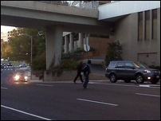
Pedestrians cross the street, but not at a crosswalk in Arlington. (WTOP Photo/Kristi King)
Arlington Police Stake-Out Intersection To Protect Pedestrians
WAMU-FM Online
November 9, 2010
Jessica Jordan
November 09, 2010 - As part of a pedestrian safety campaign, three police officers decked-out in bright yellow vests are stopping drivers for not yielding to people crossing the street at the intersection of Wilson and Lynn in Rosslyn. Later today, they'll begin a second round of enforcement near that intersection.
They're issuing citations not only for pedestrian safety, but for a number of traffic offenses, which include blocking the intersection and making a left turn into the wrong lane.
Lt. Tom Trumble says it's not uncommon to write 50 tickets in this intersection over a period of two hours.
"...this is one of the highest volume intersections in the county. Last year, in this intersection alone we wrote over 1,000 violations -- that's just for moving violations for vehicles. So it's obviously an intersection that we are concerned about, so we're trying to target the enforcement," Trumble says.
Officers will return to the intersection of Wilson and Lynn to issue citations from noon to 1 p.m.

Arlington cops out in Rosslyn ticketing drivers for Street Smart campaign
TBD Online
November 9, 2010
Dave Jamieson
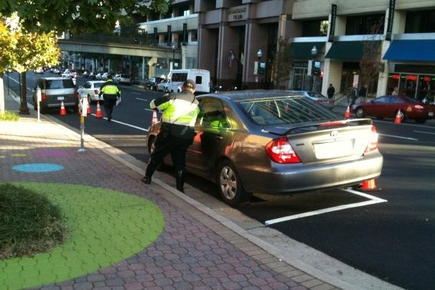
They're probably ticketing pedestrians, too, for jaywalking violations, but all we saw on our way into the office was a load of drivers getting popped for a variety of moving violations at Wilson Boulevard and North Lynn -- running a red light, making an illegal left turn, and failing to yield to pedestrians.
The officers were directing the offending drivers into little queues they'd set up with cones on either side of North Lynn (photo above), where they were writing up citations. Not a pleasant way to start your day, is it?
The police will be ticketing until 9 a.m. and again from noon until 1 p.m. The citations are part of the Metropolitan Washington Council of Governments' Street Smart campaign (yes, the campaign with the infamously grisly public-service ads), which encourages driver, pedestrian, and cyclist safety.

VIDEO: Arlington cops dish out 33 traffic violations — including one to a Metrobus driver — during Rosslyn a.m. rush hour
TBD Online
November 9, 2010
Dave Jamieson

That's what Arlington police chief Doug Scott said at the Street Smart campaign press conference in Rosslyn this afternoon. Of those 33 tickets issued at Wilson Boulevard and North Lynn, four went to drivers for failing to yield to pedestrians, while the rest were for an assortment of moving violations. Last year there were more than a thousand tickets doled out at that corner, which is one of the busiest in the county.
Local officials, including police brass from D.C. and Arlington and Montgomery counties, said similar ticketing campaigns would take place throughout the metro area through the end of the year. Montgomery police captain Thomas Didone even did a little safety demonstration with a toy car and a toy pedestrian, to demonstrate exactly how "they can't occupy the same space." Point taken, captain!
Arlington board member Mary Hynes said they chose to kick off the campaign at Rosslyn for a reason, citing how much more foot traffic the neighborhood will see once some high-profile development projects are finished.
"This environment is going to change," Hynes said. "The pedestrian environment will only get busier and richer."
Check out ABC7 reporter Brianne Carter's report above. Even a Metrobus driver gets popped, for blocking the intersection.

VIDEO: Arlington Targets Motorists, Pedestrians

MyFoxDC Online

November 9, 2010

John Henrehan
ARLINGTON - Last year, 79 pedestrians and bicyclists were killed in Metropolitan Washington. Five of them died in Arlington.
On Tuesday, a squad of traffic enforcement officers descended on the busiest intersection in the county: Wilson Blvd. and North Lynn Street. They wrote dozens of tickets (and handed out some warnings) to both motorists and pedestrians.
Many of the motorists were cited for running a red light or turning from the wrong lane. Some got tickets for failing to yield to pedestrians. A Metro bus operator got a $91 ticket for making a turn from the center lane (rather than the right lane).
Some walkers got warnings for, "crossing against the crosswalk signals [and] not crossing in the crosswalk," according to Arlington Police Chief Douglas Scott.
The high-visibility enforcement campaign is designed to remind people to move safely in areas where cars and walkers cross paths.
It may or may not work. Ten minutes after the intensive enforcement hour ended, dozens of pedestrians could be observed jaywalking across Wilson Blvd.

Police to Issue Tickets in Rosslyn for Pedestrian Safety

Arlington Now Online

November 9, 2010

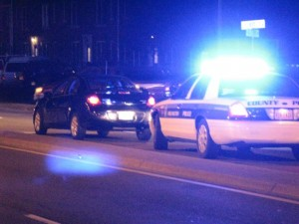
ARL Staff
Police will be out in force in Rosslyn today to promote pedestrian safety. They’ll be issuing citations to cars that don’t yield to pedestrians and warnings to jaywalkers and cyclists who ignore traffic laws.
The enforcement will be taking place in the area of North Lynn Street and Wilson Boulevard between 7:00 and 9:00 a.m. and 12:00 and 1:00 p.m.
Citations for failure to yield to pedestrians in a crosswalk carry a hefty fine of between $100 and $500 in Arlington.
Although police will only be issuing warnings to pedestrians, a citation for failure to obey signs and signals wouldn’t take too big of a chunk out of your pay check — the maximum fine is $5.
The enforcement is timed to kick off the Metropolitan Washington Council of Government’s Street Smart fall pedestrian safety campaign. The campaign encourages “proper yielding to pedestrians and drivers alike.”
In 2009, there were 78 pedestrian and cyclist-related deaths in the Washington area, which is more than one quarter of all traffic-related fatalities in the region. Local police departments are trying to decrease that number.
Arlington’s police chief, three Arlington County board members and representatives from other local jurisdictions will hold a press conference about pedestrian safety at 12:30 this afternoon in Rosslyn.

Metrobus Among the Vehicles Ticketed by Police in Rosslyn

Arlington Now Online

November 9, 2010

ARL Staff
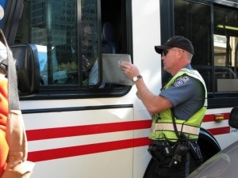
A Metrobus operator was among the unlucky drivers who did not heed warnings of stepped-up traffic enforcement in Rosslyn today.
Arlington police officers positioned themselves at the busy intersection of Wilson Boulevard and North Lynn Street during the morning traffic rush and the lunch time pedestrian rush, in an effort to catch people violating basic traffic safety laws. During the course of the morning rush hour alone, they handed out 33 citations to drivers and gave 50 verbal warnings to pedestrians and cyclists.
The enforcement was part of the Metropolitan Washington Council of Government’s eighth annual Street Smart safety campaign, which officially launched today with a lunchtime press conference in Rosslyn.
“They key message here is: we’re not pointing the finger at the motorist, we’re not pointing the finger at the pedestrian, we’re not pointing the finger at the bicyclist… when you’re talking about prevention, we all have a responsibility,” said Arlington Police Chief Douglas Scott.
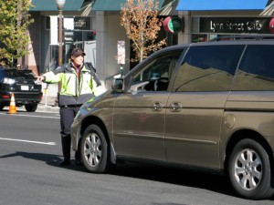
“Pedestrians, bicyclists and cars need to coexist and watch out for each other,” said Arlington County board member Mary Hynes, who told reporters that her own daughter was once struck and injured by a bus. (Clarification: Ms. Hynes’ daughter was struck by a bus in Europe. It was not a Metrobus. This article, which remains in its original form, did not mean to imply the type of bus involved in that incident.)
Scott said the police department will have stepped-up enforcement in the morning and evening rush hours throughout the course of the two-week campaign.
Among those nabbed during today’s lunch time enforcement was a Metrobus operator, who was issued a $91 ticket for making a right turn on to North Lynn Street from the center lane of northbound Wilson Boulevard. At one point, after the officer left to run his information, the bus operator slammed his window shut as television news cameras rolled.
Each year, a whopping 1,000 traffic citations are issued at just the Wilson Boulevard-Lynn Street intersection, according to police.

Arlington County Police To Ticket Jaywalkers This Morning In Rosslyn
WeLoveDC Online
November 9, 2010
Patrick Pho
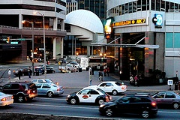
If you live in the DC Metro Area, or if you have been a pedestrian any time of your life, then you probably have crossed the street when you weren’t supposed to. Maybe you were impatient for the lights to change and there weren’t any cars in the street. Perhaps you enjoy living a real-life game of frogger on your way to Starbucks. We all know it’s technically illegal but who’s going to get a ticket for jaywalking?
Well if you work or live in Rosslyn you might end up with a ticket if you don’t follow the pedestrian rules of the road this morning.
According to TBD, Arlington County Police will be out during the rush hours of 7AM – 9AM and 12PM – 1PM to enforce jaywalking and other traffic violations around the busy intersections of North Moore, North Lynn, and Wilson Boulevard. The intersections are located outside the 1100 Wilson building (home of WJLA-TV/TBD and my office) and the Rosslyn metro station. The intersections there are often busy with foot traffic and is just ripe for police to start handing out jaywalking tickets to those that can’t wait for the “walk” sign.
The show of force is coordinated in conjunction with the Street Smart program, a campaign to inform local citizens on pedestrian and bicyclist safety through safe habits and obeying traffic laws.
So for those walking through Rosslyn make sure you use those crosswalks and wait for the light, or else you could be walking away with a pricey ticket.

Watch your step in Rosslyn today
TBD Online
November 8, 2010
Rebecca Cooper
Heads up, Rosslyn. Arlington County PD will be out in force to hand out jaywalking and other enforcement tickets near the intersections of North Moore and Lynn Streets with Wilson Boulevard today.
It's all part of the Street Smart campaign from the Metropolitan Washington Council of Governments, which is "aimed at encouraging safe, proper yielding to pedestrians and drivers alike," according to a statement from MWCOG.
A number of local officials — including members of the Arlington county board — will make presentations encouraging pedestrian, cyclist and driver safety beginning at 12:30 p.m. along Wilson Boulevard.
But more importantly for Rosslyn workers, Arlington police will be stepping up pedestrian safety enforcement during two time frames tomorrow: between 7 a.m. and 9 a.m., and between 12 p.m. and 1 p.m. This enforcement will happen at "a notoriously busy intersection" in Rosslyn, which we hear is the intersection of North Lynn and Wilson Boulevard.
So keep an eye out, drivers, cyclists and pedestrians alike. If you're not careful, today could be the day you get a ticket.
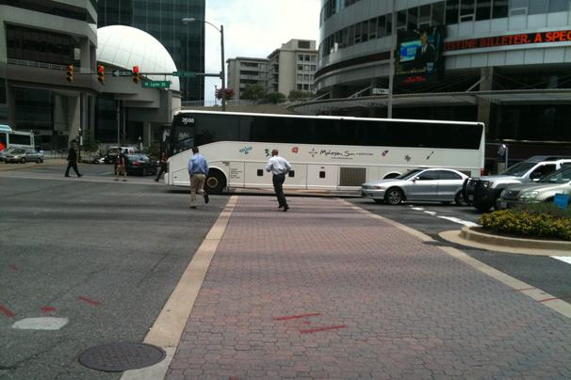

Walk-Bike-Drive Smart--Be Street Smart
Commuter Page Blog
November 9, 2010
Lauren Hassel
Daylight Savings Time ended Sunday, which means shorter days, darker commutes, and the kickoff of the Fall 2010 Street Smart Campaign.
Since 2002, Arlington County and neighboring municipalities in Virginia, Washington, DC, and suburban Maryland have joined forces on a public awareness and enforcement campaign, Street Smart. The campaign is designed to educate drivers, pedestrians, cyclists, and the general public about safely sharing the roads.
The Fall 2010 Street Smart campaign kicked off at 12:30 p.m. today with a ceremony at Rosslyn Central Space on Wilson Blvd. between N. Moore and N. Lynn Streets (site of the old Tom Sarris Orleans House). The ceremony featured remarks by elected officials, including Arlington County Board Chairman Jay Fisette and Board members Mary Hynes and J. Walter Tejada, as well as law enforcement leaders from northern Virginia, suburban Maryland, and the District of Columbia.
Aimed at reducing the number of pedestrian injuries and deaths in the Washington metropolitan area, the Street Smart campaign is sponsored by the Metropolitan Washington Council of Governments (COG) and the National Capital Region Transportation Planning Board (TPB). The campaign emphasizes education of motorists and pedestrians through mass media and is meant to complement the efforts of state local governments and agencies to build safer streets and sidewalks, enforce laws, and train better drivers, cyclists, and pedestrians.
Arlington County’s participation in this annual campaign includes Arlington County Police conducting live pedestrian safety enforcement at a notoriously busy intersection in Rosslyn. Law enforcement officers are encouraging proper yielding to pedestrians and drivers alike. In recent months, Arlington County has also implemented the following measures to help ensure pedestrian safety:
- The Arlington County Board adopted a sustainability initiative for 2010 that includes a strong bicycle and pedestrian access and safety component.
- Arlington County launched the Neighborhood 25 initiative a new public awareness campaign designed to remind motorists to slow down in neighborhoods where children play and walk to school.
- Arlington County is continuing to phase out the use of brick crosswalks and is moving towards the use of high-visibility crosswalks on arterial streets to improve safety.
- Arlington County is distributing Safe Bicycling in the Washington Area booklets, written by the Washington Area Bicyclists Association as well as Sharing the Road in Virginia – Laws and Safety Tips for Bicyclists and Pedestrians written by BikeWalk Virginia. Both are available in English and Spanish.
The Fall Street Smart campaign continues for a few weeks, with ads on-line, on air, and on billboards, trains, and buses around the region. So as you adjust to Standard Time, pay attention to the ads, be aware of pedestrians, cyclists, and drivers, and be smart--Street Smart.

Street Smart fall campaign starts this week
The WashCycle

November 7, 2010
The Fall 2010 Street Smart campaign kicks off this week with Arlington County Police conducting two waves of live pedestrian safety enforcement at a notoriously busy intersection in Rosslyn, VA, issuing citations during 7:00 – 9:00 am and 12:00 – 1:00pm on Tuesday, November 9. Law enforcement will be encouraging proper yielding to pedestrians and drivers alike
In 2009, there were 78 pedestrian and cyclist-related fatalities in the DC area, which breaks down to one every five days. Pedestrians and cyclists accounted for more than one quarter (27 percent) of all traffic-related fatalities throughout the region
The good news is that pedestrian and cyclist deaths saw an eight percent decrease from 2008 to 2009
You can attend the kickoff ceremony at 12:30 PM on Tuesday at Rosslyn Central Space on Wilson Blvd. between N Moore and N Lynn Streets
Speakers include:
· Douglas Scott, Chief, Arlington County Police Department
· Cathy Lanier, Chief, Metropolitan Police Department (invited)
· TBD, Montgomery County Police Department (invited)
· TBD, Washington Metropolitan Area Transit Authority (WMATA) (invited)
· TBD, City of Alexandria (invited)
· Jay Fisette, Chairman, Arlington County Board
· Mary Hynes, Member, Arlington County Board
· Walter Tejada, Member, Arlington County Board

