MAJOR GENERAL JEFFREY S. BUCHANAN
COMMANDER
Joint Force Headquarters National Capital Region
and the U.S. ARMY MILITARY DISTRICT OF WASHINGTON
(JFHQ-NCR/USAMDW)

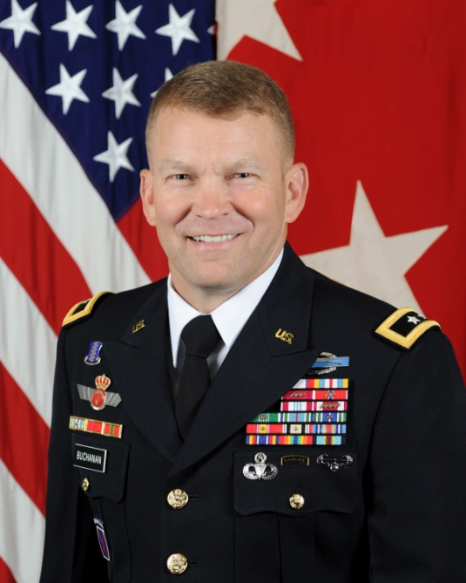
Major General Jeffrey S. Buchanan was commissioned a Lieutenant of Infantry in May 1982 after graduating from the University of Arizona with a Bachelor of Science in Wildlife Ecology. He also holds a Master of Arts in Leadership Development from the United States Military Academy. Major General Buchanan’s military education includes the Infantry Officer Basic and Advanced Courses at Fort Benning, GA; the United States Army Command and General Staff College at Fort Leavenworth, KS; and a Senior Service College Fellowship in Geneva, Switzerland.

Major General Buchanan’s duty assignments include command and staff positions within the 82nd Airborne Division, 25th Infantry Division, and 101st Airborne Division. He also served as a Company and Battalion Tactical Officer at the U.S. Military Academy. From 1995 to 1997 he served as the Director for Operations (J3) of Joint Task Force Full Accounting until returning to the 101st Airborne Division to serve as the Battalion Commander of 3-187th Infantry from 1999-2001. He also served as a Senior Light Infantry Task Force Trainer at the National Training Center from 2001-2002.

From 2003 to 2004 Major General Buchanan was assigned to the United States Army Infantry School, Fort Benning, as the Director of Combat Developments, but served most of that year deployed to Iraq as the Director of Operations (C3), Coalition Military Assistance Training Team. Between 2004 to 2006, he commanded the 2nd Brigade, 75th Division (TSB) and deployed a second time to Iraq to serve as an advisor to the Iraqi Special Police Commando Division. Upon his return, he served as the Director of Operations for U.S. Army North (Fifth Army) at Fort Sam Houston, TX until November of 2007.

From 2007 through 2009, he served as Deputy Commanding General for the 10th Mountain Division at Fort Drum, NY, including a deployment to Iraq as the Multi-National Division-South. Following an assignment as the G-3/5/7 for the United States Army Reserve Command, he returned to Iraq as the Director of Strategic Effects (J9), U.S. Forces Iraq, from July 2010 to December 2011. Major General Buchanan most recently served as the Deputy Commanding General, I Corps, Joint Base Lewis-McChord, Washington.

He and wife, Laura, have three grown children: a son who lives in Columbus, Georgia, a son who lives in Big Sky, Montana and a daughter who lives in Flagstaff, Arizona.

