Capital Trails Coalition - Trail Network Mapping Methodology
March 2019

Objective:
- Gather existing and planned trail data from within the Capital Trails Coalition footprint in order to create a trail network map of the Capital Trails Network.

Secondary Objectives:
- Begin conversation around the "culture of trail planning/development" for each jurisdiction
- Establish relationships and further engage the Coalition members and agency staff
- Begin the discussion about what types of data would be helpful to gather and track in the future

Context:
The Capital Trails Coalition is a collaborative group of public agencies, non-profit organizations, business improvement districts, citizen advisory committees and many more. The Capital Trails Coalition seeks to create a world-class network of multi-use trails that are equitably distributed throughout the Washington D.C. metropolitan region.

The Coalition's footprint includes Washington, DC and the surrounding counties- Prince George's County MD, Montgomery County MD, Arlington County VA, Fairfax County VA and the City of Alexandria, VA.

Members of the Capital Trails Coalition, led by staff from Rails-to-Trails Conservancy and Washington Area Bicyclist Association (WABA), conducted outreach to each of the local jurisdictions within the project footprint, as well as the National Park Service. Meetings were held in the jurisdictions. Meeting attendees included planning and GIS staff from various agencies.

These in-jurisdiction meetings helped direct us to the most authoritative GIS data or other planning documents for use in our mapping efforts. In some instances, the data identified as the most authoritative/current was already available via the local jurisdiction’s website. However, some jurisdictions had internal data related to ongoing planning efforts that was not publicly available.

Additionally, no jurisdiction had a comprehensive dataset or layer for trails; the data existed in various forms (e.g., as a part of bicycle facilities GIS data) and in various locations (e.g., county parks department, planning department).

There was no consistency or standard for collecting trails data across the region, and even within single jurisdictions. The CTC Network layer includes attribution (data dictionary) that represents features often captured in other trail datasets, as well as features that are part of the CTC criteria for network inclusion.

Data Collection- Steps
- Identify the relevant agency staff members at each jurisdiction. This could be DOT, Parks and Rec, GIS, Dept. of Public Works, Planning Dept., etc. Who has a stake in trail development? Whose job is it? It’s probably going to be many people, across many departments.

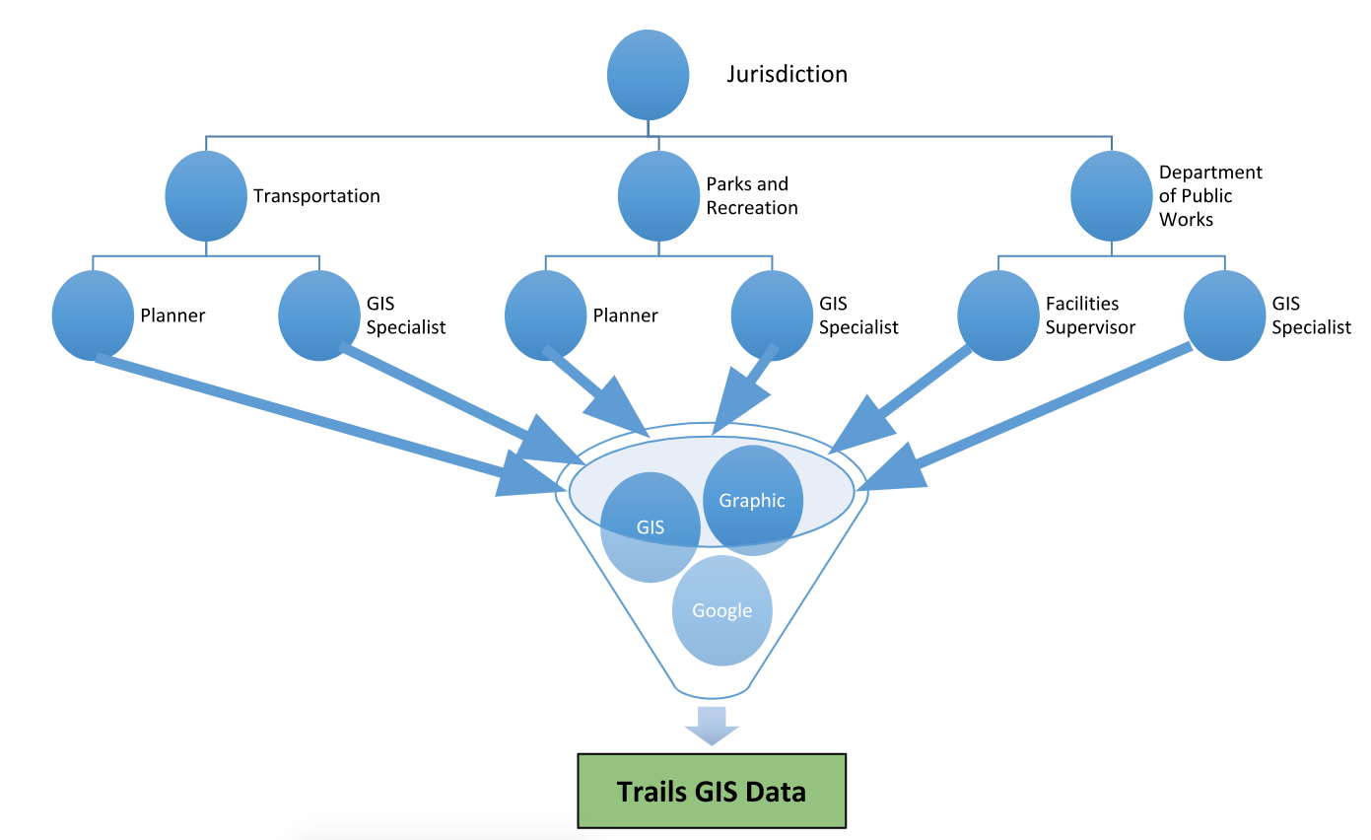

- Conduct background research to gain an understanding of how the jurisdiction has planned paved trail networks in the past. We pulled from RTC’s trail database and project files, and undertook an extensive plan review. Understand each jurisdictions’ definition of status (completed/planned/proposed).
- Establish a meeting time with relevant jurisdiction contacts. This meeting should be in-jurisdiction: go to them, don’t make them come to you. Provide food or some other incentive for attending, if you can. Make sure that people invite others to the meeting if they think they should be there.
- Send prep materials, and be clear what the jurisdiction needs to bring to the meeting. For us, that was:
  - Summary of the Coalition
  - Our objectives with these meetings
  - A description of the data that we were looking for (Data dictionary)
  - The Capital Trails Coalition criteria for network inclusion

- Host the meeting. Work together with one of the jurisdiction contacts to reserve a room with wifi and projector. Encourage others to bring their laptops and paper maps that you might need.
- GET their data (include metadata with the data). Have their GIS people send the data sets that they have (.kml, shapefiles, e.g.). Digitize trails that are just on paper maps or in planning documents. Some data was already broken down into categories, and we could easily pull the trails that fit our criteria.
- MERGE source data
  - With each dataset that is received a new field needs to be added, titled SourceLayerID. This will serve an index field that you can use to reference back to the source layer once all the data is merged.
  - Create an Index Value for each dataset (Ex. PG_COUNTY_PARK_TRAILS_2015 = PGPARKS15)
  - Populate the newly added SourceLayerID field with the Index Value that was created for that received data.
  - Keep track of your index values by organizing them in an Index Value Key document.
  - When all that received data is merged populate the “Old_Layer” field with the merged SourceLayerID field.
- SORT and FILTER the trails data to identify the trails that met our criteria.
  - For datasets with robust metadata- We examined attributes with equivalency with our criteria- pavement type, width, etc.
  - For datasets without robust metadata- We did a visual analysis using aerial imagery to determine certain characteristics of the trail (surface, width, connection to other trails, e.g.)
  - For planned trails - We conducted a plan review prior to the data collection process to identify which trail projects already existed in regional and local plans. During data gathering meetings, we talked with jurisdictions about the feasibility and timeline of trail development to determine whether the planned trail met the “feasible in 25 years” criterion. We tracked questionable trails in this spreadsheet.
- Create a list of trails that are “questionable.” Document why the are being included or not included. This could include grandfathering in some trails, or including protected bike lanes when trail connections were not feasible and an on-street option was the only alternative.
- Create a A FINAL DRAFT trail network layer from the process described above (filter all collected data using criteria)
- Verify with the agency staff that the trails included in the final draft trail network layer are appropriate.
  - We did a second round of in-jurisdiction meetings to verify the map, ensure nothing was missing, and get the sign off from the jurisdiction.
  - An editing application was created for partners to use themselves if they had proficiency with ArcGIS Online. Usually, it was most effective for the data collectors to make the edits during a face-to-face meeting with jurisdictions.
- Publish the network map and create products from trail network data (static/graphic maps, publicly accessible web maps, StoryMaps, e.g.)

Result:
- The end result is our network map, that shows both existing and planned trails that meet the Coalition's mutually agreed upon criteria. https://gis.railstotrails.org/ctc/
  - Data that informs other map deliverables (print maps, etc).
- Data that allows us to perform analysis.
- Stronger relationships with jurisdiction staff, planners, engineers.
- Encouraged jurisdictions to clean up trail data.
  - Data Dictionary possible adopted tool to capture trail data in the region as a whole

Challenges:
- Gathering the data from the jurisdictions took much more time than expected.
- Some counties have many agencies that build trails. We had to break down silos to bring all of the trail planners and managers into one room, regardless of department (e.g. Parks and Recreation, Transportation, Public Works).
- The quality of the data was incredibly variable, with some jurisdictions having very poor planned trail data. Most data was not clean and easy. Some counties had many people managing the same GIS data layer without each other’s knowledge. Some counties didn't have any GIS data for trails, just paper maps, or a list of projects with no geographic representation of the work. Some classified all of their bike infrastructure as the same, whether it was a sidewalk, sharrow (on-road bike marking), bike lane, paved trail, mountain bike trail, etc.
- Because data came from each jurisdiction, we could not share the network map publicly before getting approval from each agency. This slowed some of our efforts around public awareness and getting public-facing maps out on the timeline for which we had originally planned.

Lessons Learned:

- Be clear about what type of information you need, to ensure that you get the right people involved in the process from the start. The agency staff know better than you can guess about who manages trails data, who is involved in trail development, who will need to sign off on data sharing. Some counties have many agencies that build trails. Ask your jurisdiction contacts who else should be involved. Then ask those people who they think should be involved. We had to break down silos to bring all of the trail planners and managers into one room, regardless of department (e.g. Parks and Recreation, Transportation, Public Works).
- The specific criteria for network inclusion allowed us to winnow down to exactly the types of trails we want to focus on. The criteria were developed collaboratively with the Coalition, to ensure buy-in early on. It was incredibly helpful to have those criteria shared with agency staff in advance so that they knew the type of info we were looking for. Also helpful to have the criteria in hand during the meetings.
- Ask the jurisdictions about their trail priorities while you’re meeting with them. We waited until after we gathered their existing and planned trail info, but in hindsight, I wish we would have asked about current trail priorities while we were gathering that info, so that we could get everything in one fell swoop.
- For the data collectors, have a team of at least three- one person to lead the meeting, one person that is more adept in the GIS, one person to take notes.
- Documentation, especially in regards to decision making.
- Consider the analysis that you’ll want to do in the future. That can inform which attributes you include in your data set.

