potoMAC RIVER WATER qUALITY MONITORING
CHAIN BRIDGE Monitoring program
A Historical Dataset for the Region
In 1983, the Metropolitan Washington Council of Governments (COG) established an automated fall line monitoring station at Chain Bridge to measure water quality from upstream sources in the Potomac River into the upper Potomac estuary. The Chain Bridge Monitoring Program was established to provide the region with an independent means of verifying nutrient and sediment loads - parameters that were being evaluated as part of the newly developed Chesapeake Bay Monitoring Program. That Bay effort ultimately lead to the issuance of the Bay TMDL in 2010. Since the fall line designates the transition from the Potomac River’s free flowing waters to its tidally influenced section, monitoring at the Chain Bridge location allows for the most complete estimate of upstream nutrient and sediment loads to the upper Potomac estuary, to the middle and lower Potomac River segments, and ultimately to the Chesapeake Bay.
Funding for this program is provided by COG’s members, and is conducted by Virginia Tech’s Occoquan Watershed Monitoring Laboratory (OWML). OWML staff has operated this monitoring station and data collection effort since 1983. This long-term monitoring commitment has provided the region with the ability to monitor water quality trends, and to compare trend analysis methods with those used by the Bay Program.

Map of the Chain Bridge Monitoring Station and the Little Falls Streamflow Gauge

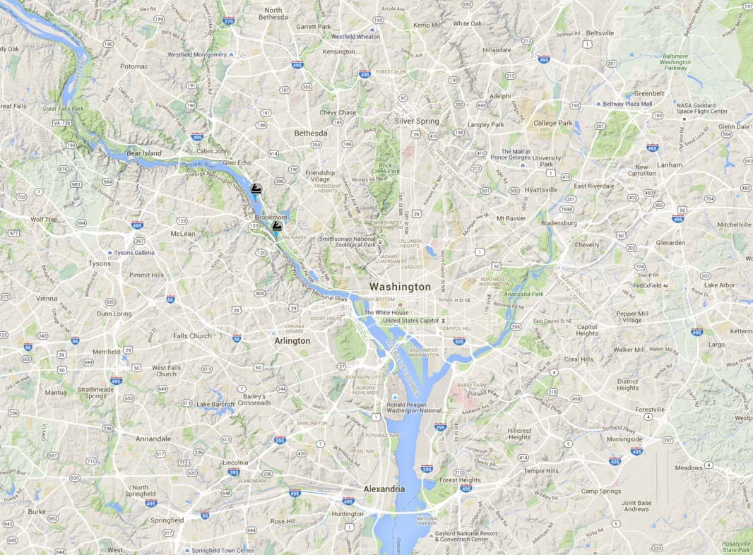
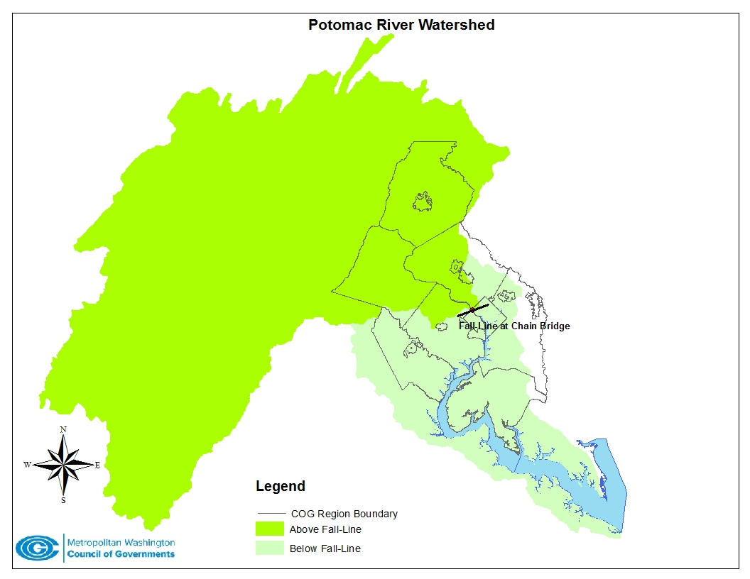
Little Falls Gauge
Chain Bridge Station
Monitoring Program Details
Sampling at the Chain Bridge monitoring station extracts representative samples of the flow at a variety of river stages, ranging from base flows to storm flows (using a flow-weighted composite approach). Sampling occurs at this station because the river channel at Chain Bridge is relatively narrow and the flow is well mixed because of turbulence. Most of the flow is constricted into a single channel near the Virginia side of the river, making it feasible to retrieve samples collected by an automated sampler. The Chain Bridge monitoring station operates either automatically or with manual-command activation. A telephone-based computer system installed at the USGS’s Little Falls gauging station automatically contacts the Chain Bridge monitoring station to activate sampling during storm events. The flow monitoring location, at the Little Falls Dam, was chosen because it already had a USGS gauge with historical data.

OWML staff has gathered weekly baseflow samples and composite stormflow samples for nearly every storm since the onset of the program. Since November 1995, OWML staff also have collected discrete grab samples for a certain number of storm flows each year (up to 25 discrete samples per year). The sampling program also includes a component to measure river flow continuously at the Little Falls gauging station, which is used to control the composite stormflow sampling. The following parameters are measured at various frequencies throughout the year:

Water Quality Parameters Measured at the Chain Bridge Monitoring Station
Nutrients
- Nitrate and Nitrite Nitrogen, Ammonia Nitrogen Total Kjeldahl Nitrogen, Soluble Kjeldahl Nitrogen, Total Nitrogen, Total Soluble Nitrogen
- Total Phosphorus, Total Soluble Phosphorus, Soluble Reactive Phosphorus

Other Constituents
- Total Organic Carbon, Dissolved Organic Carbon, Chemical Oxygen Demand
- Total Suspended Solids, Turbidity, Total Hardness
- Fecal Coliform and E. coli
- Soluble Reactive Silica, Total Alkalinity
- Dissolved Oxygen, pH, Conductivity, Temperature

Related Potomac River Monitoring
COG’s Chain Bridge monitoring program is independent of the nine non-tidal monitoring network stations maintained by the U. S. Geological Survey that provide the pollutant load estimates used to calibrate the Chesapeake Bay Program’s watershed model (see USGS RIM Stations). The USGS monitoring program collects periodic grab samples and estimates loads using statistical regression techniques, a different approach than the load estimation method used by OWML at Chain Bridge.

COG’s Chain Bridge Monitoring program has provided an independent and long-term check on the accuracy of the Bay Program’s monitoring results at the Potomac fall line and its use in calibrating the watershed model. OWML staff has produced a report that analyzes the two different data sets and the conclusions that can be drawn from them (Chain Bridge Data Analysis Report).

COG Staff Contacts: Karl Berger kberger@mwcog.org /Mukhtar Ibrahim mibrahim@mwcog.org

