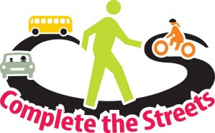

Complete Streets Implementation Workshop
January 29th, 2013

Agenda

- 1:00 p.m. Welcome and Introductions

2. 1:05 p.m. The Complete Streets Policy for the National Capital Region
Michael Farrell, COG/TPB Staff

- 1:25 p.m Implementing VDOT’s Accomodation Policy (Complete Streets)
Cindy Engelhart, VDOT-NOVA District

- 1:45 p.m. Complete Streets: DC Policy and Implementation Experience
Jim Sebastian, Office of Transportation Planning, DDOT

5. 2:10 p.m. Complete Streets Policy and Implementation: Evolving Practices at the Maryland State Highway Administration
Dustin Kuzan, Office of Planning, Maryland State Highway Administration

BREAK

6. 2:20 p.m. Arlington’s Complete Streets: Policies and Projects
Richard Viola, Arlington Department of Environmental Services

7. 2:40 p.m. Complete and Green Streets in Prince George’s County
James Wilson, Department of Public Works and Transportation, Prince George’s County

8. 3:15 p.m. Adjourn

