COG WATER RESOURCES PROGRAM
Chesapeake Bay Program (CBP) UPDATES (as of 9/12/18)
Updates on key CBP activities that COG staff are monitoring or actively involved in that have critical impacts or potential implications for COG’s members & the RWQM Work Program.
Bay TMDL – Schedule, Assessment & Strategies |  | COG Contact
Bay TMDL Implementation Schedule  - Final Phase III WIP Planning Targets – July 9, 2018  - Draft Phase III WIPs (w/ climate - narrative & # option) – April 12, 2019  - Final Draft Conowingo WIP – June 2019 [may be delayed]  - Final Phase III WIPs – August 9, 2019  - Climate Change Loads/Phase III WIP Addendum (beyond narrative)– September 2021 |  | Tanya Spano  (202)962-3776  tspano@mwcog.org  Heidi Bonnaffon  (202) 962-3216  hbonnaffon@mwcog.org
EPA’s State-by-State Midpoint Assessment Results  Through their Phase II watershed implementation plans, the Bay Partnership set a 2017 goal of putting in place practices to achieve 60% of the reductions in phosphorus, sediment and nitrogen required to meet the final Bay TMDL reductions by 2025. As part of the mid-point assessment process, EPA recently evaluated the progress the Bay states and the District made through 2017 toward the 60-percent goal.  According to EPA’s evaluation, overall the Partnership achieved the 60% goal for phosphorus and sediment reductions, but it fell short for nitrogen reductions. EPA also evaluated progress in meeting the states’ 2016-17 milestone commitments and issued a color-coded report card for each major source sector in each state. Pennsylvania is the only state with the most severe issues as noted in red. Within the COG region, the Maryland urban/suburban sector received a yellow-coded “enhanced oversight” status from EPA.  Details of the assessment are available at the web links noted below, but EPA’s concern with this Maryland source sector appears to be based strictly on programmatic issues, such as delays in the timetable the state has established for issuing its general permit for Phase II permittees and lack of formal approval of permittees’ implementation plans. The EPA evaluation “anticipates that Maryland will need to increase BMP implementation rates and build programmatic capacity in the Urban/Suburban Stormwater sector to meet its WIP and Bay TMDL targets by 2025.” EPA says the same thing in its Virginia evaluation.  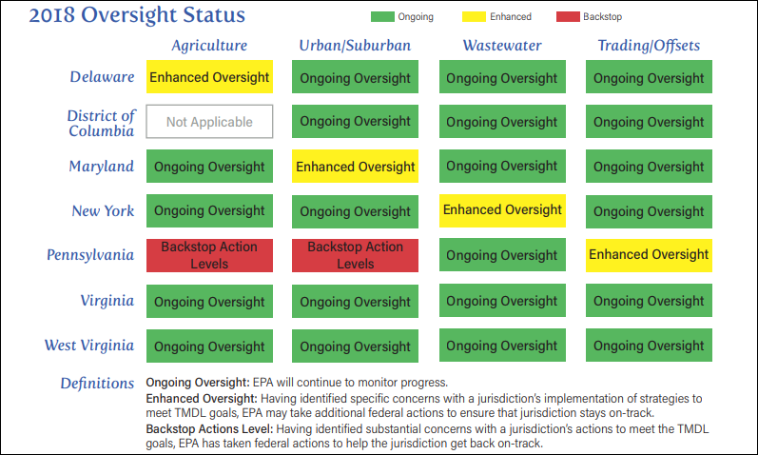  https://www.epa.gov/chesapeake-bay-tmdl/chesapeake-bay-tmdl-midpoint-assessment  https://www.epa.gov/chesapeake-bay-tmdl  https://www.epa.gov/chesapeake-bay-tmdl/epa-final-evaluation-2016-2017-milestone-and-midpoint-progress-and-2018-2019 |  | Karl Berger  (202) 962-3350  kberger@mwcog.org  Heidi Bonnaffon  (202) 962-3216  hbonnaffon@mwcog.org
Draft Management Strategy: 2017 WIP, 2025 WIP and Water Quality Standards Attainment & Monitoring Outcomes  (Note: text below is mostly verbatim from CBP write-ups)  Phase III WIPs  - Phase III WIPs are expected to describe the actions jurisdictions will take to have all practices on the ground by 2025 to achieve their respective Phase III planning targets.  - To assist the jurisdictions in implementing these parts of the Phase III WIPs, the CBP Partnership says it will work to:  - Develop enhanced understanding of BMP performance, siting and design under climate change conditions  - Provide technical assistance & funding to the Bay jurisdictions in Phase III WIP implementation  - Develop and implement a BMP verification program  - Continue to maintain and update Phase 6 modeling tools to reflect advances in understanding and support jurisdictions’ implementation planning and tracking  - Phase III WIPs are expected to contain local planning goals  - The CBP Partnership will update the high-resolution land cover dataset every four years between 2018 and 2025, using state and local data from the CBP Partnership jurisdictions  - CBP Partnership is stressing co-benefits in Phase III WIP development: For example, not only addressing water quality, but also other impairments (e.g. bacteria or toxic contaminants), environmental problems (e.g. threatened or endangered species), safety concerns (e.g. flooding, infrastructure) and 2014 Agreement Outcomes (e.g. wetlands, forest buffers).  - The CBP Partnership will assure there is use of adaptive management in response to changing conditions based on monitoring, science, and changing land use and climate.  To access the full draft Management Strategy document, for more detail, here is the link: https://www.chesapeakebay.net/channel_files/26226/2018_3c_water_quality__2018-clean_08-31-18.pdf |  | Tanya Spano  (202)962-3776  tspano@mwcog.org  Heidi Bonnaffon  (202) 962-3216  hbonnaffon@mwcog.org
Bay Restoration – Toxics & Other Contaminants |  | COG Contact
CBP Toxics Initiatives  The Toxics Workgroup is in the process of revising Management Strategies.  - For the PCBs Policy and Prevention Management Strategy:  - The new version proposes the formation of a PCB Consortium to address the broad scale of the PCB TMDL issue, focused on policy and prevention, and on specific sources of concern.  - It is out for public comment until September 23; slated to go to Management Board on October 4; and is expected to be final on October 18.  - The Contaminant Research Outcome Management Strategy/Work Plan for other toxics of emerging concern is also under revision. Revisions include:  - Less focus on relative risk; more focus on management options for ag, wastewater and stormwater-- effectiveness of BMPs  - Focus on co-occurrence, and co-benefits for addressing nutrients, sediments, and toxics  - More emphasis on mitigation studies  - Use of CBP tools (CAST) and connections with source teams  - “New” issues of emerging concern include microplastics, road salts, and coal ash, to name some. |  | Christine Howard  (202) 962-3366  cdhoward@mwcog.org
Conowingo Dam / Susquehanna Watershed |  | COG Contact
High Flows from the Conowingo Dam & Possible Bay Impacts  The Bay Program and its partners are currently assessing the impact of this summer’s higher-than average rainfall and accompanying flows to the Bay, with a particular focus on flows from the Susquehanna River at the Conowingo dam fall line. The Exelon Corporation, which operates the dam, has had to open floodgates twice this summer, once in late July and once in mid-August in response to high flows, according to a recent article in the Baltimore Sun and Washington Post. The high flows have led to well publicized problems with debris that has been piling up at various spots along the Bay shoreline. Larger-than-usual amounts of sediment have been entering the Bay as well, with a plume of muddy water visible from satellite imagery.  However, Bay scientists are still investigating the impact of these flows on water quality, including levels of dissolved oxygen in the Bay’s mainstem and the impact of sediment on the large beds of underwater grasses in the upper Bay. Aside from the obvious nuisance and aesthetic impacts of the debris, scientists will have to sort through impacts that pull in opposite directions, such as increased nutrient loadings driving increased algal concentrations versus high flows driving more mixing and less stratification.  An intensive effort undertaken by the Maryland Department of Natural Resources and other parties to study the water quality consequences of dynamic equilibrium conditions at the Conowingo dam (to inform the new generation of Bay Program models as well as the state’s dam relicensing process with Exelon) was concluded in 2017. However, the state’s regular monitoring of Bay water quality under the Bay Program’s tidal monitoring program continues and there are several initiatives to gather extra data this year as well. Preliminary information suggests that the high flows have scoured some sediment that had settled behind the dams upstream of the one at Conowingo; data from this year will inform threshold values in the Bay models for when scouring occurs.  Results from this work will be integrated into the Bay Program’s ongoing science and reporting functions. These include periodic reports on dissolved oxygen conditions in the Bay’s mainstem. Through late July, these conditions were still better than the average conditions of recent years. However, the next report from Maryland DNR will reflect more of the impact from the high flows of late July and early August; a fuller assessment of the water quality impact of this year’s conditions will take well into the fall to compile.  The news article is available at: https://www.washingtonpost.com/local/surge-of-storm-water-and-pollution-through-the-conowingo-dam-has-scientists-worried/2018/08/21/e231fb7c-a278-11e8-8e87-c869fe70a721_story.html?utm_term=.41e965a03348 |  | Karl Berger  (202) 962-3350  kberger@mwcog.org  Heidi Bonnaffon  (202) 962-3216  hbonnaffon@mwcog.org
Watershed and Water Quality Models– Activities and Issues |  | COG Contact
 | With the bulk of the work developing the new Phase 6 version of the watershed model and an upgraded version of the water quality and sediment transfer model now complete, the Bay Program’s modeling staff is transitioning toward work on model enhancements that may be incorporated into future versions of the model. One priority is to upgrade the models’ ability to simulate the impact of climate change on nutrient and sediment loads and on water quality in the Bay. The Bay Program’s Scientific and Technical Advisory Committee (STAC) is sponsoring a workshop on modeling climate change in late September (in which members of COG and NVRC staff will participate). In addition, COG plans to hold a work session on climate change modeling at its next WRTC meeting on Nov. 9. | Karl Berger  (202) 962-3350  kberger@mwcog.org  Mukhtar Ibrahim  (202) 962-3364  mibrahim@mwcog.org
 | Outreach | COG Contact
 | Bay Awareness Week Goes Local; Article  CBPC members Jon Stehle, City of Fairfax, and Dan Sze, City of Falls Church, co-authored a wonderful article in the Virginia Municipal League’s Virginia Town & City Magazine about COG’s regional coordination and outreach to increase Bay Awareness. See page 27 of the magazine link below for the article: https://www.vml.org/wp-content/uploads/pdf/VTCJulAug2018_web.pdf | Heidi Bonnaffon  (202) 962-3216  hbonnaffon@mwcog.org
\\mwcog.org\dfs\DEP\Water Resources General\ADMIN\WR Gen Updates Documents\FY18\Sept 2018 Docs\General Updates - ChesBay_Sept_FINAL.docx

