BETHESDA SECTOR PLAN
Maryland National Capital Park and Planning Commission
Tina Schneider: Tina.Schneider@montgomeryplanning.org
http://montgomeryplanning.org/wp-content/uploads/2016/12/BDP-Planning-Board-Draft_lowres2.pdf

Six Sustainability Performance Areas
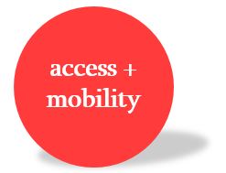
- Access and Mobility
- Goals:
  - Enhance roadway accommodation of all users
  - Reduce vehicle miles travelled
  - Increase the use of non-auto driver travel
  - Expand bicycle network
- Recommendations
  - Implement new transit alternatives
  - Improve circulation system
  - Improve pedestrian safety, walkability, and connectivity
  - Expand bicycle network & connectivity
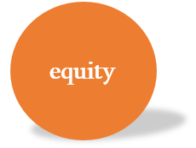
- Equity
- Goals:
  - Prioritize affordable housing opportunities
  - Retain mix of economies and age diversity/ avert displacement
  - Provide public facilities to meet the human service, recreation, security, educational needs of the community
  - Encourage flexibility in space and programming to adapt to future needs
- Recommendations
  - Incentivize expanded affordability for housing
  - Preserve existing, market-rate housing where possible
  - Promote a diversified mix of housing options through mixed-use and multifamily residential zoned development
  - Assure that schools provide adequate capacity
  - Preserve existing single-family neighborhoods in and around the Sector Plan area
  - Maintain and enhance the quality of housing through County Design Excellence
  - Support live/work opportunities
- Community Identity
- Goals:
  - Retain and improve neighborhood identity and character
- Recommendations
  - Retain recognizable and unique urban design through design excellence, public art, gateways
  - Promote quality buildings & compatibility
  - Promote a pleasing pedestrian experience
  - Provide walkable access to transit options, public green space, shopping and entertainment
  - Accommodate opportunities for creative placemaking to activate the streets and open spaces
  - Enhance the primary links between Bethesda’s established centers of activity and major transit nodes

- Health and Habitat
- Goals:
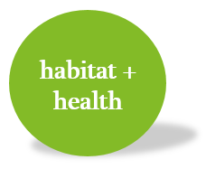
  - Increase parks, open space, civic green, and recreation areas
  - Improve community health and well-being
  - Reduce Heat Island Effect
  - Link green spaces creating green connected corridors
  - Increase biodiversity
  - Increase nesting, breeding, foraging, and brooding options for wildlife

- Recommendations
  - Expand park and open space networks
  - Plant native and locally adaptive species to reduce water demand and improve nesting, foraging, and brooding availability
  - Provide additional street tree planting, site and open space canopy cover
  - Provide 35% greenspace on private property
- Water
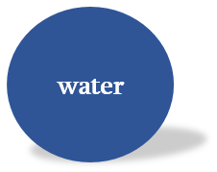
- Goals
  - Reduce untreated stormwater runoff to improve water quality
  - Reduce water use through conservation measures
- Recommendations
- Integrate low impact development strategies for stormwater management on all redevelopment sights
- Integrate stormwater management within the right-of-way where feasible without displacing bicycle network
- Promote the use of intensive green roofs on redevelopment properties
- Provide environmental site design on sidewalks and right-of-way where practical
- When feasible, exceed the County’s minimum stormwater treatment requirement
- Energy
- Goals:
  - Improve building energy efficiency and reduce energy demand
  - Reduce demand of non-renewable resources
  - Reduce vehicle miles travelled
- Recommendations
  - Exceed the County’s minimum ASHRAE 90.1 energy standard or other codes that replace ASHRAE in the future
  - Optimize whole building design
  - Maximize use of alternative energy systems to supply a portion or all of a building’s energy demand
  - Use renewable energy
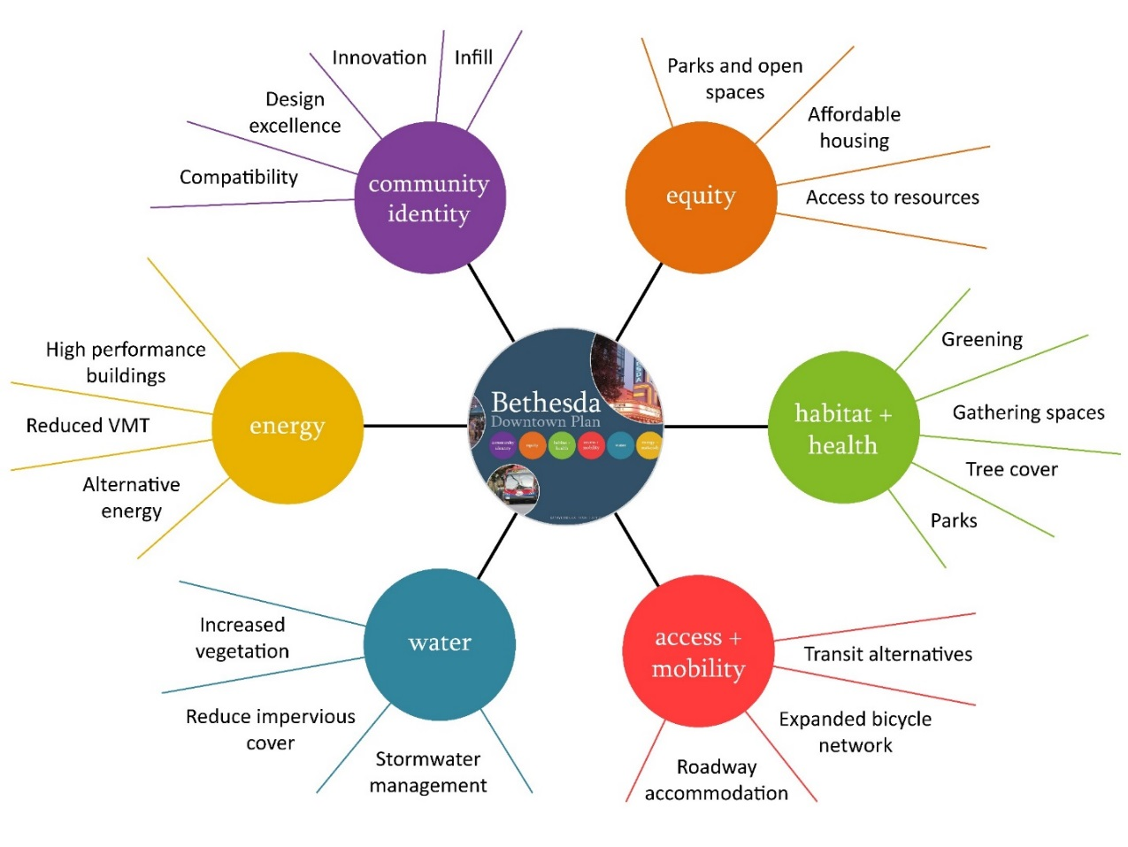

Some of the Most Challenging Recommendations
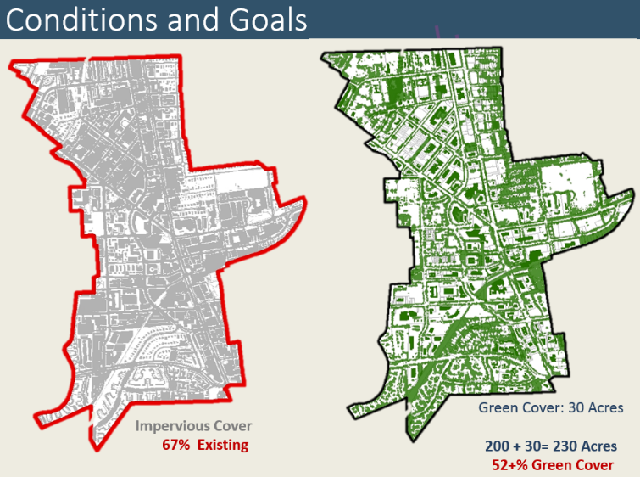
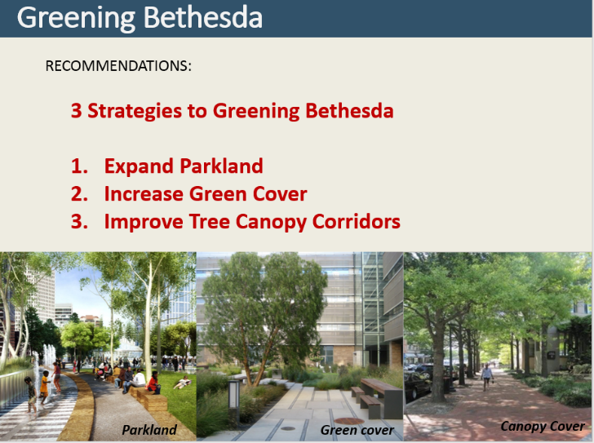

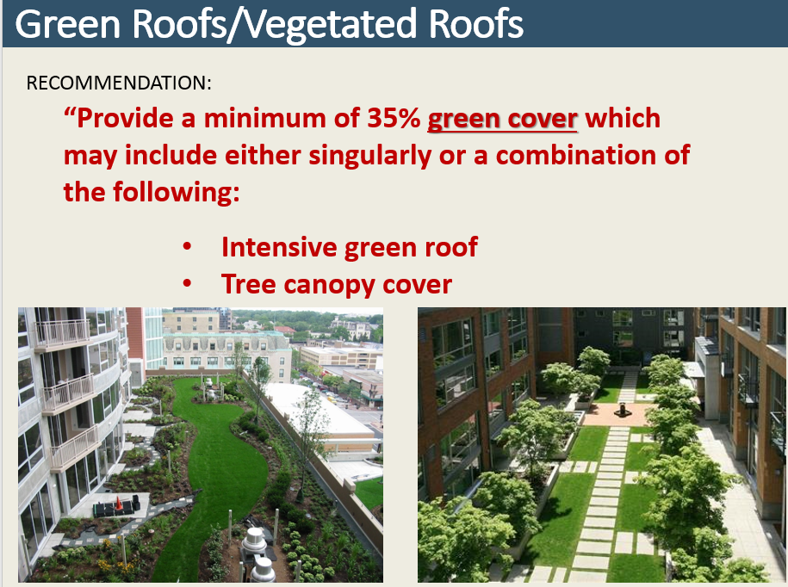
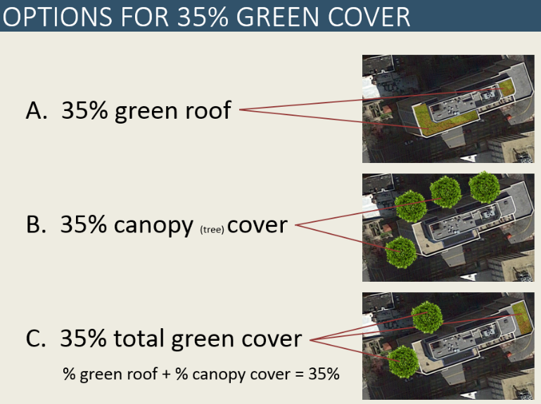

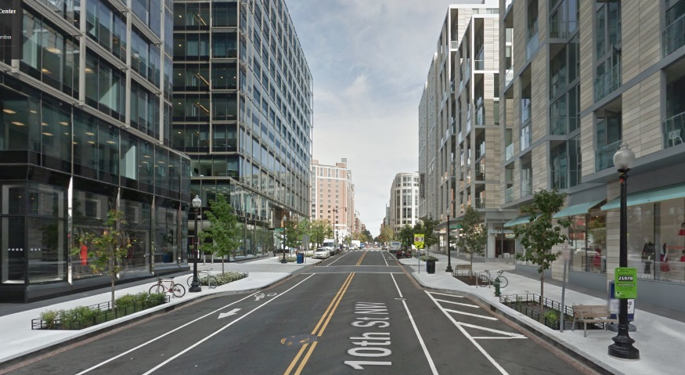
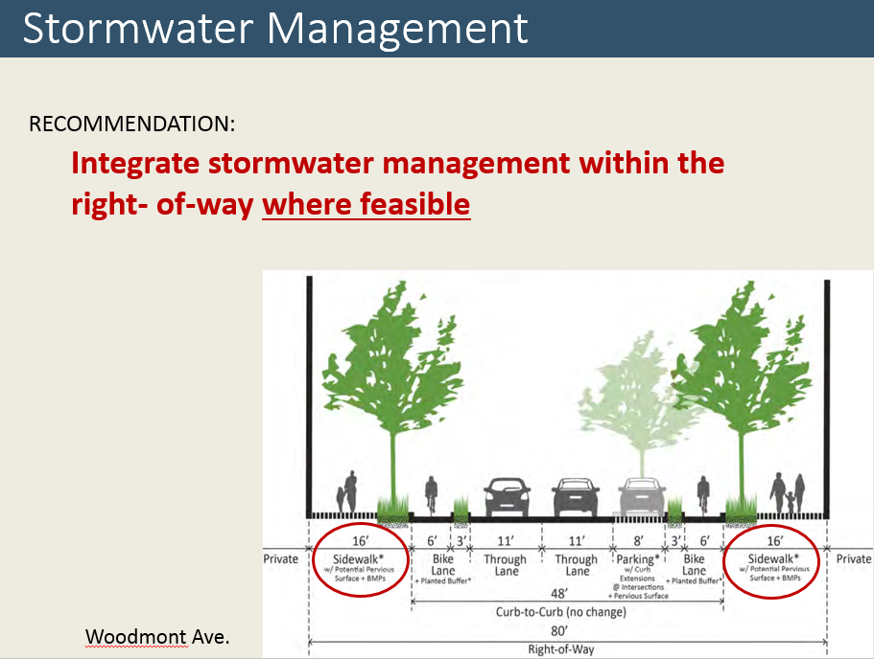

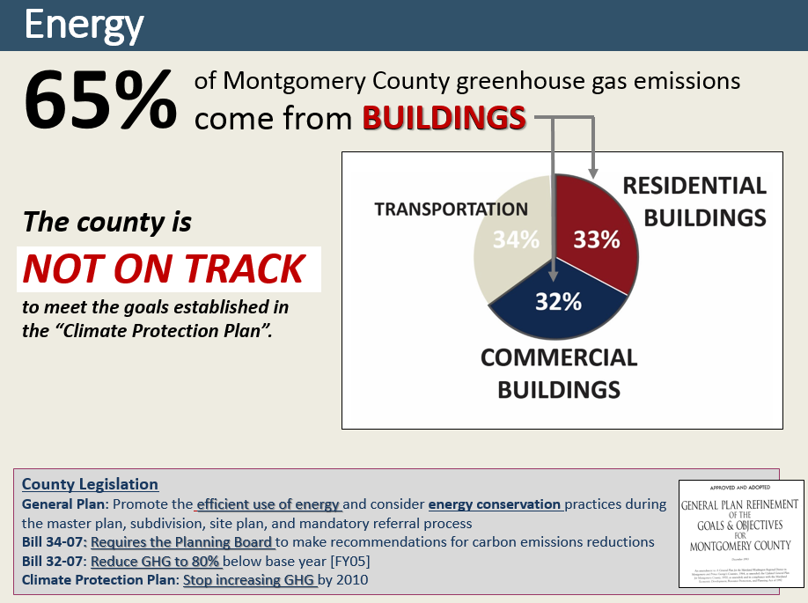

High Performance Building Recommendation

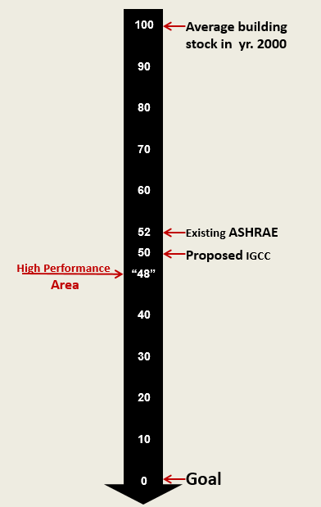
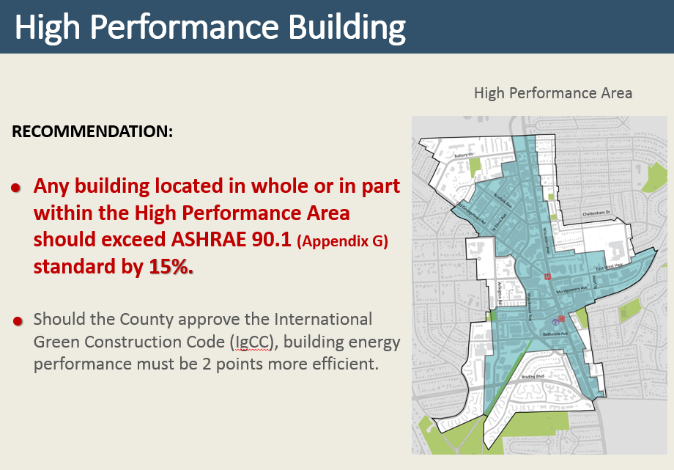

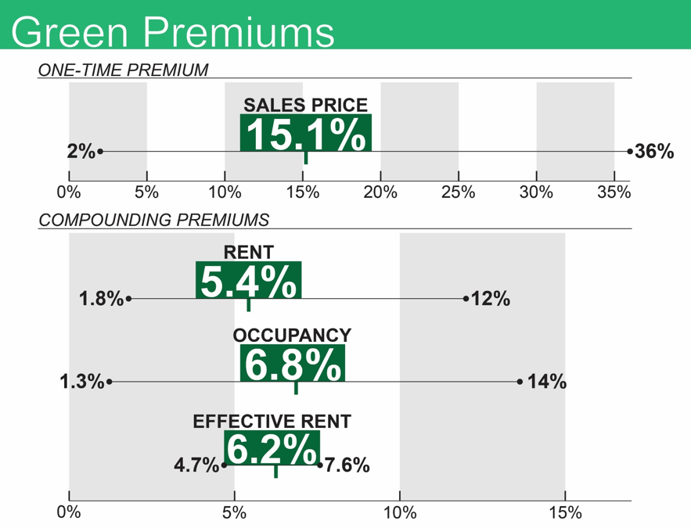

Financial benefits of
green buildings

