Major Projects Needed to Complete the National Capital Trail, by Jurisdiction
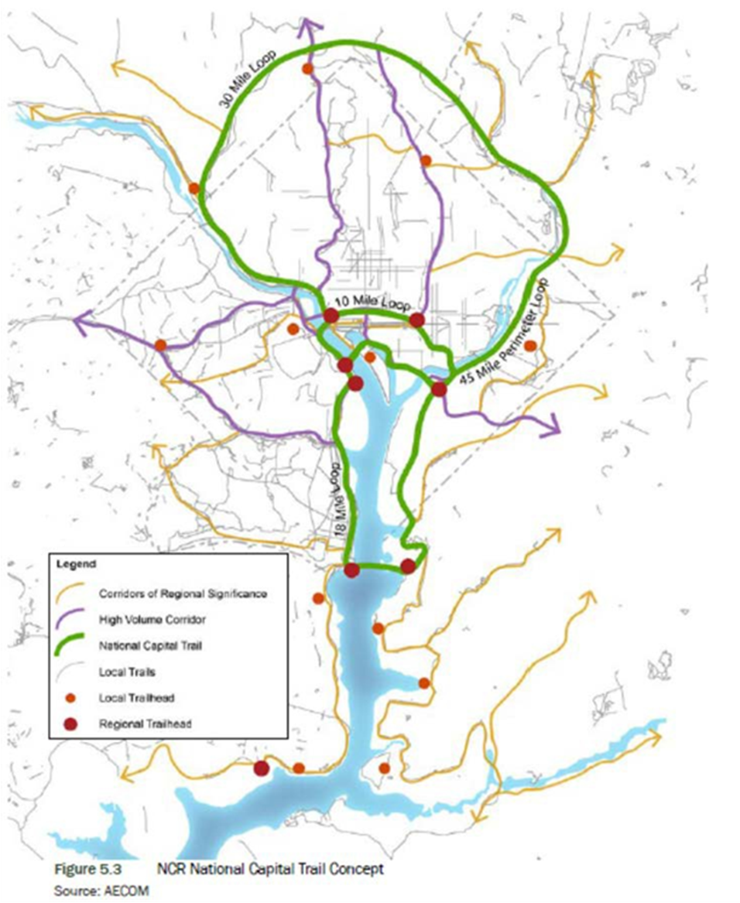

The National Capital Trail is the route (green on the map) defined by the National Park Service.

The projects on this list will:
- Fill gaps in the National Capital Trail where no separated facility currently exists, or
- Upgrade an existing facility on the National Capital Trail route, or
- Provide short connections to improve access from adjacent neighborhoods and trails.

Name | Jurisdiction | Gap | Plan | Project ID | L’Notes | MF Notes
Capital Crescent Trail | Montgomery County | Connect Capital Crescent Trail to Silver Spring Transit Center | Montgomery County Trails Plan, Purple Line | CIP Project 501316
Silver Spring Green Trail | Montgomery County | Connect Silver Spring Transit Center to Sligo Creek Trail | Montgomery County Trails Plan, Purple Line | CIP Project 509975
Anacostia River Trail | DC | Connect to Prince George’s County Anacostia River Trail | MoveDC, NPS Paved Trails |  | Long-term off-street route pending NPS site remediation.
Georgetown Waterfront Connector | DC | Connect Capitol Crescent Trail to Rock Creek Trail | NPS Paved Trails, MoveDC | C1.1 | Plan says project is underway
Capitol to Virginia Ave SE Trail | DC | Connect US Capitol to Virginia Ave SE | MoveDC
South Capitol Street Trail | DC | Connect Anacostia Riverwalk Trail south to PG County | NPS Paved Trails, MoveDC | TIP ID 6114
Key Bridge Connection to Capital Crescent Trail | DC | Provide direct connection from Key Bridge to the Capitol Crescent Trail | NPS Paved Trails, MoveDC | C5.4
Oxon Cove Hiker Biker Trail Connector | DC, Prince George’s | Provides an off-street connection between the NPS Oxon Hill Farm property and the proposed South Capitol Street Trail currently under development by the DDOT. | NPS Paved Trails | E1.1
Oxon Hill Farm Trail Connector | Prince George’s County | Develop on-street facility from Oxon Hill Farm Trail across I-495 to Oxon Hill Road and Harborview Avenue (in Prince George's Co.); improve signage and crossings. | NPS Paved Trails, Prince George’s County Trails Plan | E1.8
Extend 15th Street NW Protected Bike Lane | DC | Connect existing protected bike lane to 14th Street Bridge | MoveDC, NPS Paved Trail | N1.2
Pedestrian and Bicycle Access at Lincoln Memorial Circle | DC | Develop a set of recommendations to improve visitor safety and reduce conflicts for motorists, pedestrians, and cyclists at Lincoln Memorial Circle. | NPS Paved Trail | N2.2, N2.3
TR Bridge Connector | DC | Improve safety of trail connectivity between National Mall, TR Bridge and Rock Creek Park Multi-use Trail | NPS Paved Trail | N2.4 | NEW
Whitney Memorial Bridge Ped and Bicycle Access | DC | Connect Anacostia Rivewalk Trail to East Capitol Street | MoveDC, NPS Paved Trails | E5.3
Virginia Ave SE Protected Bike Lane | DC | Connect to 11th St Bridge and Anacostia Rivewalk Trail | MoveDC
Arboretum Bridge | DC | Connect National Arboretum to Anacostia River Trail System | MoveDC, NPS Paved Trails Plan |  | Proposed Bridge under design
Fort Lincoln Connector Trail | DC | Connect Fort Lincoln to Anacostia River Trail System | MoveDC |  | Proposed connection between Fort Lincoln and ART, north of Route 50 Bridge
East Abingdon at Mount Vernon Trail | Alexandria | Improve safety at East Abingdon and Slaters Lane intersection | Alexandria Pedestrian and Bicycle Master Plan, Alexandria CIP
Royal Street Neighborhood Bikeway | Alexandria | Provide direct, alternative connection for Mount Vernon Trail users traveling through Old Town | Alexandria Pedestrian and Bicycle Master Plan, Alexandria CIP
Union Street at Pendleton Street Improvements | Alexandria | Extend the Mount Vernon Trail by two blocks | Alexandria Pedestrian and Bicycle Master Plan
Potomac Yard Trail to Four Mile Run Park Connection | Alexandria | Connect Potomac Yard Trail to Four Mile Run Park Trail on Alexandria side of river | Alexandria Pedestrian and Bicycle Master Plan, North Potomac Yard Small Area Plan |  |  | Direct connection to the Mt. Vernon Trail?
Four Mile Run Park to Mount Vernon Trail Connection | Alexandria | Connect Four Mile Run Park Trail to Mount Vernon Trail on Alexandria side of river | Alexandria Pedestrian and Bicycle Master Plan, North Potomac Yard Small Area Plan |  |  | Includes the above project?
Mount Vernon Trail - Widening | Alexandria | Create a wider, user-separated trail between East Abingdon and Pendleton Street | Old Town North Small Area Plan
Arlington Ridge Park Connection to TR Bridge | Arlington, VA | Connect Arlington Ridge Park (USMC Memorial and Netherlands Carillon) to the TR Bridge | NPS Paved Trails Plan, Realize Rosslyn Sector Plan | G1.6 | NEW  Priority project- connectivity to the network
Mount Vernon Trail Connection to the TR Bridge | Arlington, VA | Connect trail on the south side of the TR Bridge to the Mount Vernon Trail | NPS Paved Trails Plan, Realize Rosslyn Sector Plan | G2.4 | NEW
Long Bridge Park Connection to Mt. Vernon Trail | Arlington, VA | Extend Long Bridge Park Esplanade with a bridge over the George Washington Memorial Parkway (GWMP) to connect with the Mt. Vernon Trail. (With possible new connections across the Potomac River to D.C. | Long Bridge Park Master Plan |  | NEW

