Subject Line: You’re invited to EPA’s 2014 National Building Competition: Team Challenge!
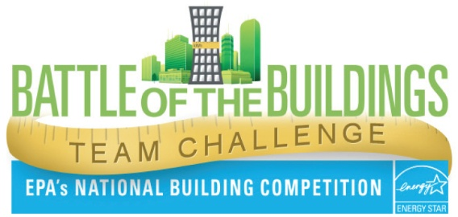
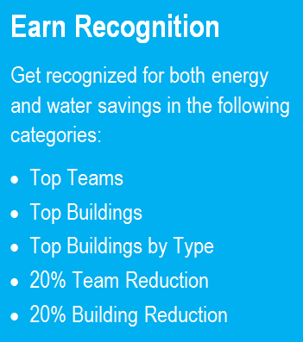
EPA’s annual Battle of the Buildings is back for 2014. This year, there’s a new twist: groups of five or more buildings can compete in teams!

Why teams this year? Because teaming up is a great way to motivate, collaborate, and learn new strategies that can lead to bigger savings for everyone!

Can’t field a team? That’s okay – your building can still compete individually. The teams and buildings with the greatest energy or water savings will be recognized by EPA.

Registration runs April 16 – May 16, 2014, so mark your calendars!

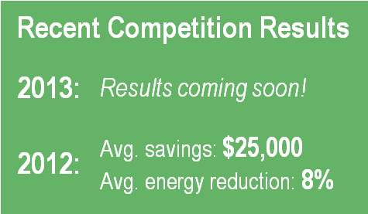
For more information about the competition rules and details, visit: www.energystar.gov/battleofthebuildings.

Good luck – and may the best building or team win!

