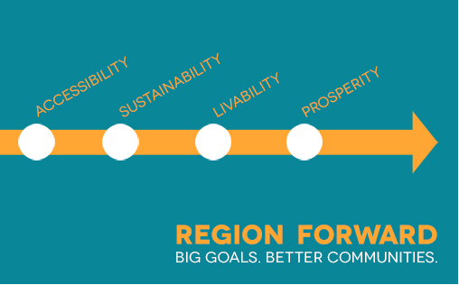

Region Forward Coalition Meeting
Friday, January 24, 2014 • 11:00 a.m. - 1:30 p.m. • Lunch provided
COG Board Room
777 North Capitol Street

AGENDA

- Welcome & Announcements 11:00am

- Place + Opportunity and the Regional Transportation Priorities Plan: 11:15am
How Do We Move from Approval to Implementation?
Mary Hynes, Arlington County Board, Facilitator
- Joint Presentation on Final Reports
    - Sophie Mintier, COG
    - John Swanson, COG TPB
- Next Steps/ Implementation
- ULI-Washington Technical Assistance Panels – Lisa Rother, ULI-Washington and Bob Eisenberg, Heritage Property Company
- What are other ideas for how to implement these plans?

- Strategic Consultation: 12:00pm
How Can COG & Partners Support Regional Infrastructure to Advance the Region Forward Vision & Goals?
- Chuck Bean, COG, Background
- Emmett Jordan, City of Greenbelt, Facilitator
- Harriet Tregoning, DC Office of Planning, Facilitator

- Priorities & Direction-Setting for 2014 & Beyond: 12:45pm
Given Our Core Competencies/Goals/Interests, What’s the Most Strategic Focus for the RFC?
- Core Competencies – Stuart Freudberg, COG, Facilitator
  - How do we build depth in these areas in the near term?
- Other Region Forward Areas – Patricia Mathews, Northern Virginia Health Foundation, and Amy Fishman Kurz, Nonprofit Roundtable
  - How do we build breadth across the rest of Region Forward over the longer term?
    - Health
    - Workforce Development
    - Education

- Wrap-up & Adjourn 1:25pm
- Workplan Next Steps
- Region Forward Coalition 2014 Meeting Dates
- Friday, April 25th
- Friday, July 18th
- Friday, October 24th

