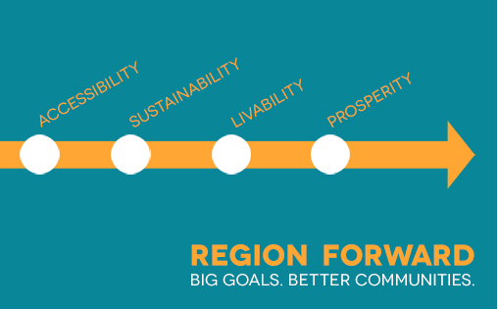

Region Forward Coalition Meeting
October 28, 2014 • 10:00 a.m. – 1:30 p.m. • Pick up box lunch upon arrival
COG Board Room
LIVABILITY

- Welcome & Announcements 10:00am
Mary Hynes, Arlington County Board Member, and Chair, Region Forward Coalition
Emmett Jordan, Mayor, City of Greenbelt, and Vice Chair, Region Forward Coalition

- Region Forward “Livability” 10:15am
Chair Hynes, Vice Chair Jordan, Mark Fenton

Presentation on Healthy and Well-Designed Activity Centers 10:15am
Mark Fenton, MS, Public Health Expert & Adjunct Associate Professor, Tufts University

Mark Fenton is a national public health, planning, and transportation consultant and an adjunct associate professor at Tufts University's Friedman School of Nutrition Science and Policy. Mr. Fenton works to build communities that support a healthier, more physically active population, and more sustainable and enjoyable lifestyles. Mr. Fenton will present the results of a “tour” of several of COG’s Activity Centers and discuss how they could better support the “Livability” goals of Region Forward.

Mini-panel: Health in All Policies – Moderator Mark Fenton 11:00am
Sharon Arndt, Division Director, Fairfax County Health Department
Pamela Creekmur, Health Officer, Prince George’s Health Department
Evelyn Hoban, Environmental Health Manager, Prince George’s Health Department

Following on Mr. Fenton’s presentation, we will hear about how two of the region’s largest jurisdictions are incorporating “health in all policies” to create more healthy and livable communities. Sharon Arndt will discuss the current health impact assessment (HIA) for Fairfax County’s Richmond Highway Transit Center. Pamela Creekmur and Evelyn Hoban will share how Prince George’s County’s recent policy (CB-41-2011) mandating HIAs for new development projects is changing planning, design, and development in the County.

New Targets and Goals: Health & Child Welfare 11:45am
Chair Hynes, Vice Chair Jordan
Stephen Haering, MD, Director, Alexandria Health Department
Wanda Tolliver, Interim Deputy Director, DC Child & Family Services Agency

COG’s Health Officers Committee (HOC) has been working to refine the goals and targets for health in Region Forward. Dr. Haering, the HOC representative to the Region Forward Coalition, will share the rationale for revisiting the health goals and targets and present the results of the HOC’s efforts. Suzanne Chis, chair of the COG Child Welfare Committee, will also share a proposed goal and target for child welfare—while this is a robust program at COG, it has not yet been incorporated into Region Forward.

- Region Forward 2.0: Where do we go from here? 12:15pm
Chair Hynes, Vice Chair Jordan, and COG Staff

Since its establishment in 2011 to oversee the implementation of Region Forward’s goals and targets, the Region Forward Coalition has led the production of several key projects (including the Baseline Progress Report, the Activity Center update, and Place + Opportunity). Chair Hynes and Vice Chair Jordan will lead a direction-setting discussion on “Region Forward 2.0” that will focus on the next phase of the Coalition. The chairs will share ideas for building on past achievements by aligning COG work programs and Coalition activities to support and improve Activity Centers. We want to hear your thoughts and ideas about how the Coalition can best move forward with a shared agenda for our region. The discussion will focus on the following questions:
- What are best practices and other replicable actions that the Region Forward Coalition can identify to support COG members with their jurisdictional initiatives to enhance Activity Centers?
- How should we best organize “learning sessions” to share information among COG members and other key stakeholders?

- Other Business – Preview of Winter 2015 Coalition meeting 1:15pm

- Adjourn 1:30pm

Next meeting of Region Forward Coalition: Friday, January 23, 2015

