Revisiting Region Forward Housing Targets

- Region Forward, COG’s long-range vision plan adopted by COG and its member governments in 2010, includes 28 targets, including several targets related to housing affordability.

- These housing targets were measured in COG’s 2012 Baseline Progress Report, but the structure of some of the targets made data collection or measurement difficult.

- In State of the Region: Economic Competitiveness Report, released January 2016, COG included modified targets and indicators to assess housing affordability.

- These modified targets and indicators and their measurements are presented for review and revision to the Housing Directors Advisory Committee; once HDAC has weighed in, COG will forward these for use in future Region Forward assessments.

Summary Targets and Indicators selected for study:

- Affordable housing inventory;
- Housing + Transportation costs in Activity Centers vs. region-wide;
- New or preserved affordable units; and
- Cost-burdened households (renters and owners).

Targets and Indicators related to Housing Affordability:

- Affordable Housing Inventory

Existing target: The region will maintain a minimum of 10% of housing stock affordable to households earning less than 80% of the regional median income.

Recommendation/rationale: Given widespread consensus that there is NOT enough affordable housing in the region, increase target percentage to reflect that 32% of region’s households are below 80% of AMI (based on 2014 Housing Security Study). Include both market-rate and subsidized affordable units. Add subtargets for very low and extremely low income households.

Proposed target: The region will maintain a minimum of 30% of the region’s housing stock affordable to households earning less than 80% of regional median income, including 10% of units affordable to very-low income households (31-50% AMI) and 10% of units affordable to extremely low-income households (0-30% AMI).

Total renter and owner units |  | 1,852,700
Total units affordable to Low Income HHs (<80% AMI) |  | 806,500
 | % of regional total | 43.5%
Total units affordable to Very Low Income (30-50% AMI) |  | 353,800
 | % of regional total | 19%
Total units affordable to Extremely Low Income (<30% AMI) |  | 150,500
 | % of regional total | 8%

NOTE: As noted in the 2014 report Housing Security in the Washington Region, while a large share of the region’s housing stock is affordable to households at or below 80% AMI, many of these units are “unavailable” because they are occupied by higher-income households.

- Housing + Transportation Costs in Activity Centers
Existing target: Beginning in 2012, the housing and transportation costs in the Regional Activity Centers will not exceed 45% of area median income.

Proposed revisions: Keep target, but add calculation for entire region for comparison (H + T for Activity Centers and H + T for entire region), and calculate at both 100% of AMI and 80% of AMI (working families breakout)
2013 Data* | Activity Centers | Entire COG Region
At 100% of Area Median Income
Average H + T Cost as a Percent of Income | 37% | 42%
At 80% of Area Median Income
Average H + T Cost as a Percent of Income | 46% | 52%
Source: Center for Neighborhood Technology, Housing + Transportation Index.
*A variety of data inputs are used but the most recent year used is 2013.

- New or Preserved Affordable Units

Existing target: Beginning in 2012, at least 80% of new or preserved affordable units will be located in Activity Centers.

Recommendation/rationale: Existing target is difficult to measure because it requires data on total new units and their location. Due to geographic specificity and data availability, focus on income-restricted affordable rental units. Switch from measuring new units to measuring portion of region’s total income-restricted affordable rental units located in Activity Centers.

Proposed indicator: Percentage of the region’s income-restricted affordable rental housing located in Activity Centers.

Measured performance: Currently, 48.6% of restricted affordable rental units are located within Activity Centers, and 65.7% are within a half-mile. 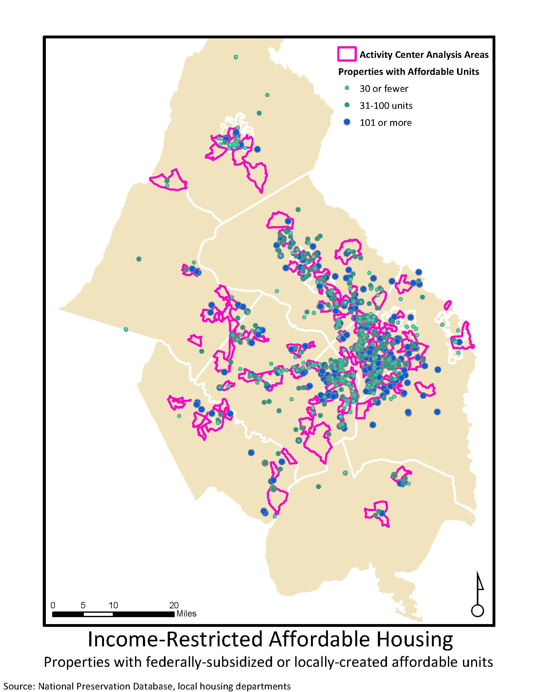
- Cost-Burdened Households

Proposed new indicator: Proportion of cost-burdened renter household and owner households.

Renter Households

Owner Households

