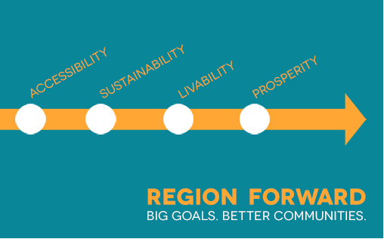

Region Forward Coalition Meeting
Friday, April 25, 2014 • 11:00 a.m. - 2:00 p.m. • Lunch provided
COG Training Center
777 North Capitol Street

- Welcome & Announcements 11:00am
- Mary Hynes, Chair, Region Forward Coalition
- Emmett Jordan, Vice Chair, Region Forward Coalition

- Region Forward and Sustainability: 11:10am
What is sustainability in the Region Forward context and what regional actions
are working toward Region Forward sustainability goals?
- Stuart Freudberg, COG Senior Director, Environment, Public Safety and Health
- Steve Walz, COG Environmental Programs Director

- Panel Discussion: 11:20pm
What can sustainability look like in the next generation of Activity Centers in
the National Capital Region?
- Roger Berliner, Moderator
- Twinbrook (LEED-ND) – Tony Greenberg, JBG
- Crystal City (District Energy) – Chris Somers, Arlington County
- Southwest Eco-District – Diane Sullivan, National Capital Planning Commission
- North Point Zero Energy Community in Frederick, MD - John Spears, Sustainable Design Group

- Lunch, Poster Session and Roundtable Discussions: 12:15pm
How can the next generation of sustainable Activity Centers be more broadly
implemented across the National Capital Region?
Maia Davis, COG Department of Environmental Programs
- What types of support can COG provide to help make it happen?
- What partnerships are needed to help make it happen?

Poster Session will feature Boston Innovation District, Seattle 2030 District, and Kansas City Green Impact Zone

- Presentation: 1:15pm
What does it take to have a resilient city?
- ICLEI, Resilient Communities for America

- Roundtable Consolidated Report Out and Adjourn 1:30pm
Mary Hynes and Maia Davis
- Region Forward Coalition 2014 Meeting Dates
- Friday, July 18th
- Friday, October 24th

