COG Map Highlights Centers Essential to Region’s Growth and Future Success
http://www.mwcog.org/news/press/detail.asp?NEWS_ID=611

A Suburban Wasteland in Virginia Gets a Modern Urban Feel
http://www.nytimes.com/2012/12/19/realestate/commercial/a-suburban-wasteland-in-virginia-gets-a-modern-urban-feel.html?pagewanted=all&_r=0

Washington’s Economic Boom, Financed by You
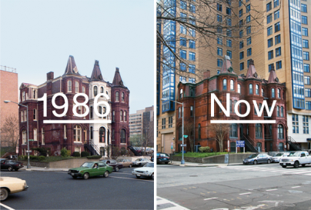
http://www.nytimes.com/2013/01/13/magazine/washingtons-economic-boom-financed-by-you.html?_r=0&pagewanted=all

America Is a Walking Disaster
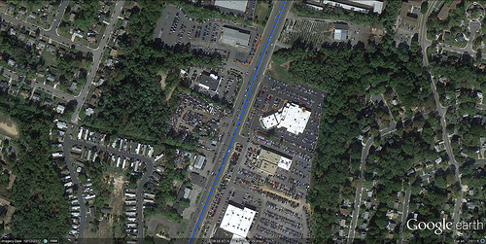
http://www.theatlanticcities.com/neighborhoods/2013/01/america-walking-disaster/4409/

Recent Presentations
- Washington Economy After the Fiscal Cliff, Dr. Fuller CRA Conference, Jan 2013
- Population & Demographic Change in Washington, Dr. Sturtevant CRA Conference, Jan 2013
- Transition to “Normal”?, Dr. Duncan (Fannie Mae) CRA Conference, Jan 2013

http://cra.gmu.edu/
http://cra.gmu.edu/pdfs/Washington_After_Fiscal_Cliff.pdf

http://bestcities.milkeninstitute.org/
http://bestcities.milkeninstitute.org/best-performing-cities-2012-large-compare.html

