more features
quick search
Type in your starting and ending locations or type of destination and any special needs you might have. This will return a list of service providers you can contact.

reach your
community!

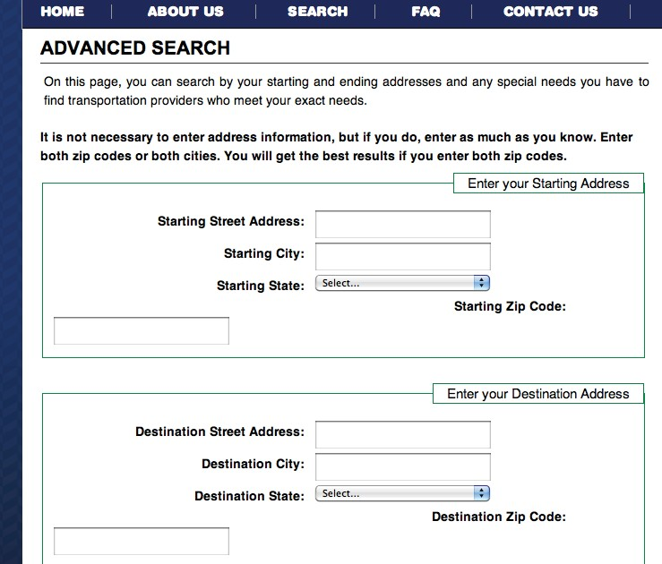for service providers:

reacharide invites you to join in our effort.
You are key in the dissemination of information to those who will benefit from your services.

Please update and maintain your information by visiting reacharide.org and clicking on the righthand “Provider Login”.

help!
contact us
If you didn’t find the information you requested, please call 855.reacharide or 855.732.2427. We’re available Monday-Friday 9:00am-5:00pm.
Listings are free and provide untold benefits to both parties!

visit: reacharide.org call: 855.reacharide
855.732.2427

TTY/TDD: 202.962.3213
need transportation info?
Alternative formats of this brochure are available on request. Phone 202.962.3300 or 202.962.3213 (TDD)
or email accommodations@mwcog.org. Please allow seven working days for preparation of the material.
in the national capital region

reacharide is a gateway website and information hotline furnished by the Metropolitan Washington Council of Governments’ National Capital Region Transportation Planning Board that provides information on transportation options for people with special transportation needs throughout D.C., suburban Maryland and northern Virginia.
we can help.

If you’ve ever felt unable to find information on how to get to the grocery store, medical facilities, or just plain out of the house, this information service is for you!

reacharide.org
toll-free: 855.reacharide
855.732.2427
We realize that finding information about reaching your desired destination might require more than one service. Here are a few easy steps to help you navigate the website.

step 1.
accessing the website
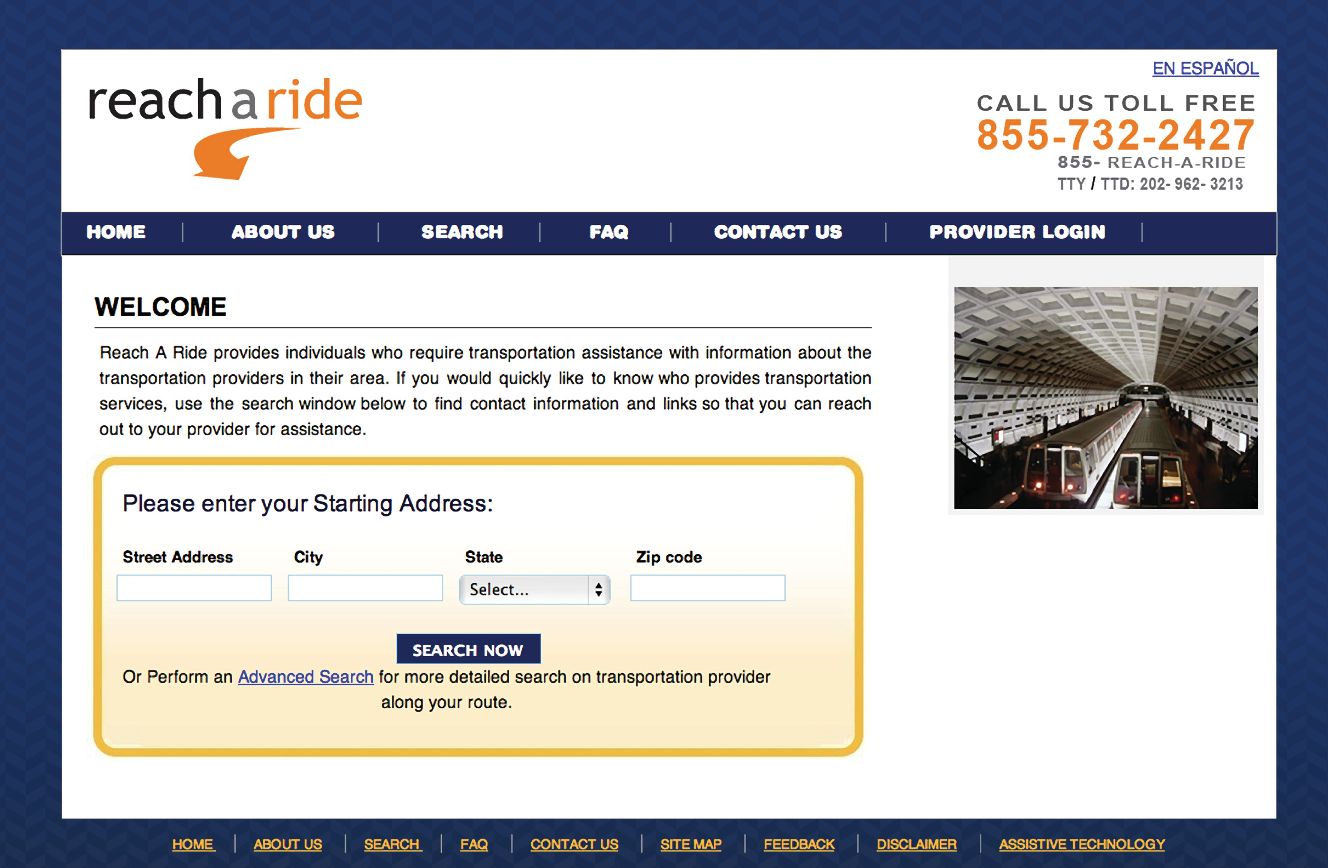
In an internet browser window, type: reacharide.org

You should see this screen.

step 2.
search
Type in your starting street address and click on the “Search Now” button.

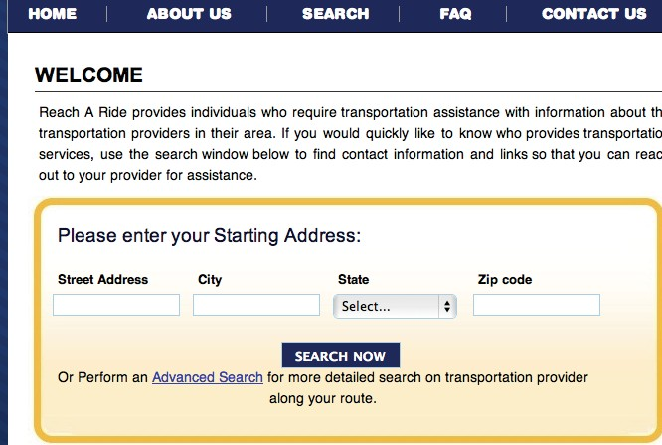

step 3 .
finding your service
You should receive a list of service providers that you can contact either by web or phone by selecting “View Details” next to the provider’s name.
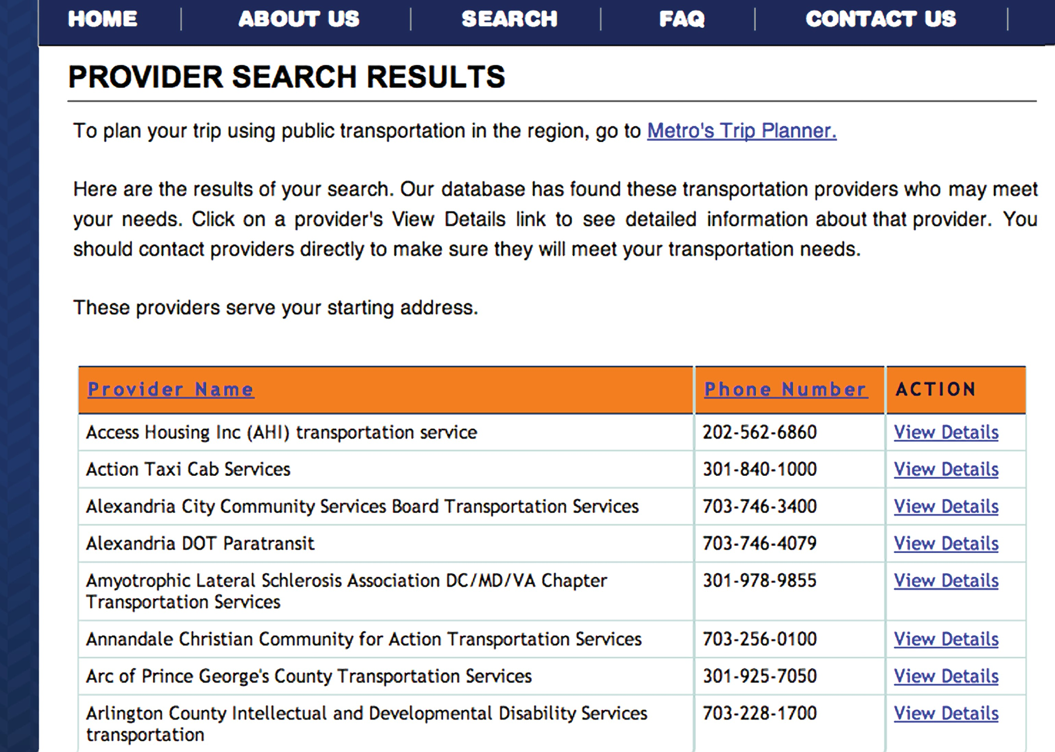

that didn’t work!
start over
If you didn’t find the information you requested, return to the search screen by clicking on the reacharide logo at the top of your screen.

Select “Advanced Search“ (below the “Search Now“ button). The more detailed information you provide, the better chance you will have of getting relevant information.
