TPB Regional Public Transportation Subcommittee
June 27, 2023
Agenda Item #6
memorandum

TO: TPB Regional Public Transportation Subcommittee (RPTS)
FROM: Mohammad Azeem Khan, TPB Enhanced Mobility Programs Manager
SUBJECT: Solicitation for Applications for Enhanced Mobility Grants
DATE: June 27, 2023

Purpose

The purpose of this memo is to announce and request assistance from the Technical Committee in publicizing the TPB solicitation for grant applications under the Federal Transit Administration (FTA) Section 5310 Enhanced Mobility of Seniors and Individuals with Disabilities Program (referred to as “Enhanced Mobility”).

The Enhanced Mobility program aims to fill gaps in transportation for older adults and persons with disabilities by providing matching grants for services that go above and beyond traditional public transit and the Americans with Disabilities Act (ADA) complementary paratransit service. Eligible projects include travel training, vehicle acquisition, and volunteer driver programs specifically serving people who have mobility impairments.

SUMMARY

On August 1, 2023, the TPB will begin soliciting applications for Enhanced Mobility grant funding with a deadline of September 30, 2021 at 3 PM. Three pre-application conferences are scheduled in the month of August 2023, one pre-application conference per each state in the region with the District of Columbia one also held virtually (see the schedule on page 3). Eligible applicants include non-profit agencies, private providers, transit agencies, and local governments. Eligible projects must benefit populations in the Washington DC-VA-MD Urbanized Area, which is shown in Figure 1. You can help by distributing the attached flyer within your agency and external contacts with details for potential applicants. The flyer includes information on eligibility, the competitive selection process, and the dates and locations of the mandatory pre-application conferences. Additional details can be found at mwcog.org/enhancedmobility.

background

COG, as administrative agent for the TPB, is the designated recipient for the Enhanced Mobility program for the Washington DC-VA-MD Urbanized Area. The program provides approximately $6 million every two years in matching federal grants for non-profit organizations, local governments, transit agencies, and private for-profit providers through matching grant funds for capital and operating expenses. The FTA grant funding is meant to incentivize coordination of services; the intent is for agencies to work together to provide specialized transportation to clients and to eliminate any duplication and to potentially save on costs. Federal and state regulatory barriers make coordination of actual services across state lines in a multi-state region difficult to achieve. However, the TPB has had success with funding grants that promote the coordination of services within a single jurisdiction or a single state.

The TPB has conducted four solicitations for Enhanced Mobility grants since 2010 and funded $31 million. Prior to the Enhanced Mobility program, the TPB facilitated seven solicitations for FTA’s JARC and New Freedom programs, funding 59 projects totaling over $22 million. A small handful of projects are still active and in the process of spending down.

The Coordinated Plan
The federally required Coordinated Human Service Transportation Plan (“Coordinated Plan”) guides the implementation of the Enhanced Mobility program and is updated every four years. The Coordinated Plan identifies the unmet transportation needs of people with disabilities and older adults, strategies and priority projects for addressing the unmet needs, and outlines the competitive selection process for grant funding. The TPB adopted the 2018 Update to the Coordinated Human Service Transportation Plan for the National Capital Region, which was developed under the guidance of the Access for All Advisory Committee. Every two years the TPB issues a solicitation for Enhanced Mobility grant applications.

2023 enhanced mobility GRANT solicitation

The TPB will conduct a solicitation for grant applications from August 1 to September 30, 2023. Approximately $10.8 million in federal funds is available for capital and operating grants that improve transportation for people with disabilities and older adults. Important elements include:

- Funds must be matched by the applicant by the of application:
  - 20% for capital or mobility management grants
  - 50% for operating grants.
- Projects must benefit populations within the Washington DC-VA-MD Urbanized Area as shown in Figure 1.
- Grants are for two-years of funding and Federal rules require that at least 55% of the funds be spent on capital projects for non-profit agencies and qualifying local governments.

Competitive Selection Process and Priority Projects
The Coordinated Plan outlines the selection process for Enhanced Mobility grants. An independent selection committee, chaired by a TPB member, will be comprised of local and national experts in transit, human services, disabilities and aging who will review the applications and make recommendations for funding to the TPB. Selection Committee members evaluate applications on the selection criteria listed here and further described at mwcog.org/enhancedmobility:

- Coordination among agencies;
- Responsiveness to the TPB’s Coordinated Human Service Transportation Plan
(Strategies and/or Priority Projects);
- Institutional capacity to manage and administer an FTA grant
(includes past grant performance);
- Project feasibility;
- Regional need;
- Equity Emphasis Areas; and
- Customer focus.

The TPB’s Coordinated Plan identifies the following priority projects to make the best use of limited grant funding. Applications that respond to any of the priority projects will receive up to 12 points in the selection process scoring which is comprised of seven criteria that total to a maximum of 100 points. Applicants can still propose eligible projects other than the priority projects. For specific eligibility guidance, see the FTA circular 9070.1G or contact TPB staff. More details on priority projects can be found here: mwcog.org/assets/1/6/Priority_Projects_from_ADOPTED_COORDINATED_PLAN_12.19.18.pdf.

Priority Projects

- Mobility Management
- Coordinated Planning Efforts
- Travel Training
- Door-through-Door or Escorted Transportation Service
- Increase Access to Transit Stations
- Increase Wheelchair-Accessible Options in Taxi and Ride-Hailing Services
- Volunteer Driver Programs
- Tailored Transportation Service for Clients of Human Service Agencies

Pre-Application Conferences
TPB staff will be holding five virtual pre-application conferences to provide potential applicants with information on eligible projects, the online application process, how to use the grant budget templates, the federal requirements, and the TPB’s selection process. Every applicant must register and attend a session; details are at mwcog.org/enhancedmobility.

VIRGINIA: Tysons-Pimmit Regional Library Meeting Room #2
7584 Leesburg Pike, Falls Church, VA 22043
Tuesday, August 8, 2023
10:00 AM – 12:00 PM

DISTRICT OF COLUMBIA: Metropolitan Washington Council of Governments
777 North Capitol Street NE, Suite 300 Washington, DC 20002
Wednesday, August 16, 2023
10:00 AM – 12:00 PM
VIRTUAL OPTION AVAILABLE

MARYLAND: Silver Spring Civic Building at Veterans Plaza, Colesville Room
1 Veterans Pl, Silver Spring, MD 20910

Friday, August 4, 2023
10:00 AM – 12:00 PM

solicitation OUTREACH and ADVERTISING

Staff will announce this grant opportunity in several ways: distribution to the TPB, the Access for All Advisory committee, email announcements, and other TPB communication channels including mentions in TPB News, social media posts, and limited media placement.

To ensure as many potential applications are aware of this opportunity throughout the region, staff requests that Technical Committee members share the attached Solicitation-at-a-Glance flyer within their agencies, external contacts, and engage TPB members to assist in promoting in your communities.

TIMELINE

After the TPB approves the Selection Committee’s recommendations for grant funding (anticipated for December 2023), TPB staff will notify applicants in writing and those selected for funding will have approximately 30 days to complete the required FTA documents. Following FTA approval, COG will provide sub-grant agreements to the recipients. Depending on the timing of FTA approval and the final signature of the sub-grant agreements, grantees can expect to begin project implementation in late 2024/early 2025.

FOR MORE INFORMATION

Please contact Mohammad Azeem Khan (mkhan@mwcog.org, (202) 962-3253) with any questions.

Figure 1: The Washington DC-VA-MD Urbanized Area

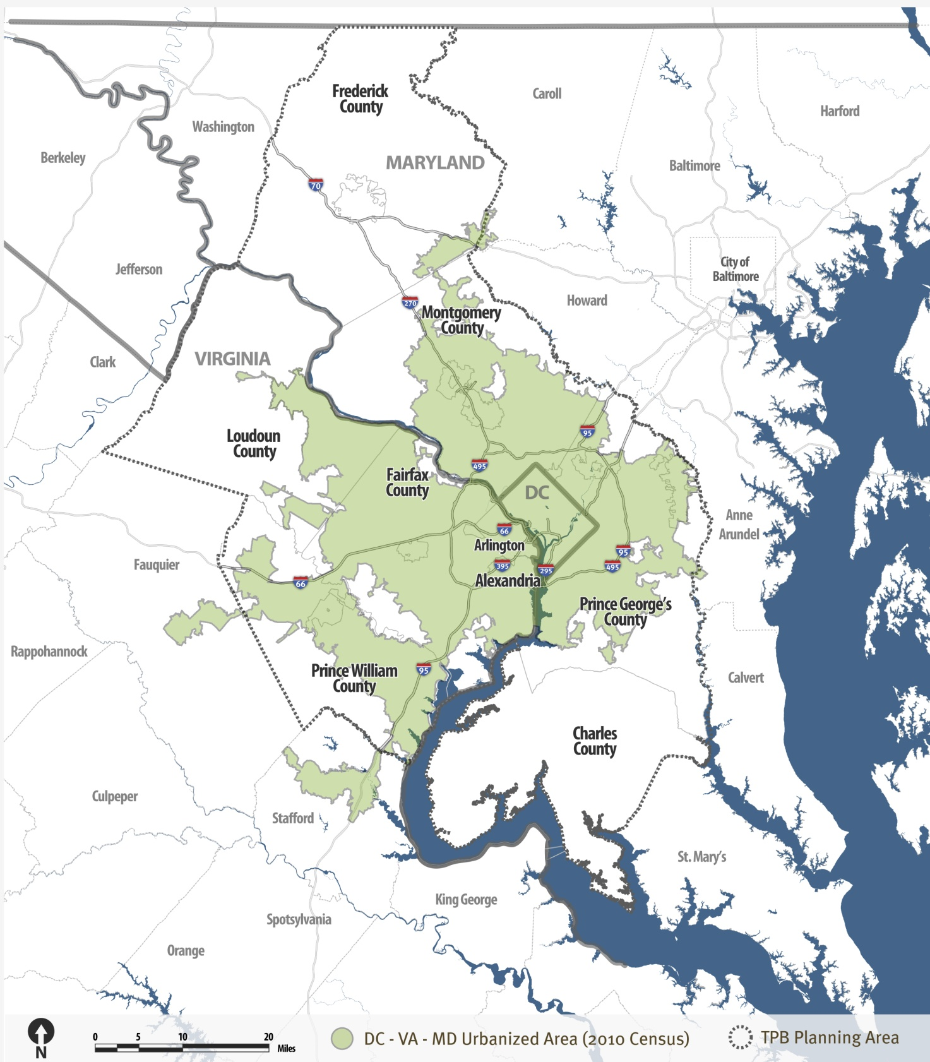
Projects must benefit populations within the Washington DC-VA-MD Urbanized Area to be eligible for funding.

For detailed jurisdictional maps with zip codes, visit: mwcog.org/transportation/programs/enhanced-mobility/solicitation-process/eligible-urbanized-area/

FTA defines mobility management as short-range planning and management activities and grants for improving coordination among public transportation and other transportation service providers.
FTA Circular 9070.1G is at https://www.federalregister.gov/documents/2014/06/06/2014-13178/enhanced-mobility-of-seniors-and-individuals-with-disabilities-final-circular

