Metropolitan Washington Council of Governments (MWCOG)
Geographic Information System Committee
Proposal for
GIS Support For
The National Capital Region Data Exchange Hub
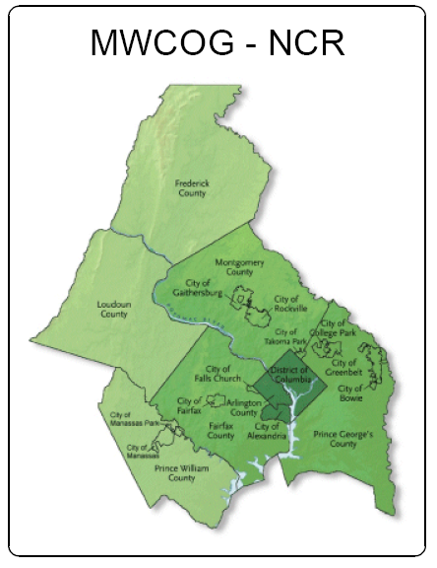
Applicant Organization: Metropolitan Washington Council of Governments Geographic Information Systems Committee http://www.mwcog.org/committee/committee/default.asp?COMMITTEE_ID=184

Project Leader: Lynn Hadden
Project Manager
National Capital Region Data Exchange Hub
Phone: 703-599-5157
Email: Lynn.Hadden@fairfax.gov

Summary: Collect, document, assemble, and distribute geospatial data for the National Capital Region (NCR) plus Frederick County Maryland through the NCR Data Exchange Hub. The NCR includes the District of Columbia; Montgomery and Prince George’s Counties in Maryland; Arlington, Fairfax, Prince William, and Loudoun Counties as well as the cities of Alexandria, Falls Church, Fairfax, Manassas, and Manassas Park in Virginia.

Project Scope
Federal policy and homeland security applications now demand that metropolitan regions cooperate to a degree not envisioned even a few years ago. Geospatial data and applications support a broad range of Emergency Support Functions (ESFs). Combining spatial data from multiple ESFs, serving multiple jurisdictions on a common map, is essential to understanding and responding to large scale events.
The National Capital Region (NCR) consists of the District of Columbia and parts of Maryland, and Virginia. MWCOG is the Metropolitan Planning Organization (MPO) for the entire NCR plus Frederick County, Maryland. The NCR/MWCOG area is a complex environment for sharing geospatial data. The area includes 19 MWCOG member jurisdictions, a large Federal presence, 4.6 million people, and 3020 square miles of land. Local governments, as well as federal and state agencies, operating in the NCR have mature GIS. However, the region does not yet have the ability to display and use a common, standard, regional GIS map. Many of the pieces are available, but the regional base map puzzle has yet to be assembled or maintained.
As the local GIS managers, we intend work with the National Capital Region Data Exchange Hub to demonstrate that detailed local geospatial data has much to contribute to regional and national initiatives. We have responsibility for providing, maintaining and serving the most accurate and detailed data available for our localities and we seek the ability to share this valuable information regionally and with the nation.

Task 1: Concept of Operations for and Implementation of a National Capital Regional Base Map

It is clear that detailed local GIS data is not needed to map and understand events at a regional scale. National map services such as Google Maps and ESRI ArcMap Services contain sufficient detail for decision makers operating at a regional or even county level. The national services are fast, reliable, and available at little or no cost. However, these services are often out-of-date or incomplete when viewed at the scale of an individual incident.
Local government GIS data, on the other hand, is far more detailed and usually more current. The biggest problem with the local data is that it can be difficult and expensive to assemble and work with at a regional scale.
An opportunity exists to provide a cost effective regional base map that employs national data services homogonously across the NCR until the user zooms in to a scale at which more detailed local data is appropriate for a specific operation. Although such operations are likely to occur at jurisdictional borders, even in such cases it is rational to assume that the availably of detailed data is a first priority and uniformity of the data across boundary lines is of secondary importance.
Deliverable 1-1: A cost effective plan for mixing national map services with more detailed local map service using scale dependency. This plan must detail what data is required at given map scales and what local systems are needed to provide detailed map services that complete what the national map services provide. The existing HIRA system will be included in this evaluation.
Deliverable 1-2: An inventory of the data collected from member jurisdictions and federal sources including metadata provided by the suppliers.
Deliverable 1-3: A listing of those geospatial data themes deemed relevant for Emergency Management and required of NCR member jurisdictions. This requires interaction with the regional Emergency Managers and Federal agencies.

Task 1: Concept of Operations for and Data Exchange Hub, WebEOC, and Regional GIS

The GIS Managers will work the Emergency Managers and Data Exchange Hub staff to develop a concept of operations for the flow of spatial data among jurisdictions. This concept of operations must take into consideration systems already in production and nearing production. The concept of operations will describe how spatial information should flow through the following systems during several different emergency scenarios.

- WebEOC (regional and local boards)
- EMMA / MEGAN (both Maryland and Virginia versions)
- Local GIS systems (including DC GIS)
- Department of Homeland Security ICAV

Task 2: Integration Planning and Data Modeling for Transportation Theme

Transportation is the sector for which homogonous regional data is most required. This project will attempt to deliver transportation and structures themes with a uniform set of minimum attributes for the NCR/MWCOG area. This will require adoption of a data model.

It is our intention that the data themes from this project become the base map for UASI funded Homeland Security projects in the NCR. The NCR Data Exchange Hub requires that data be NIEM compliant. However, the regional GIS departments have not worked with NIEM and are uncertain of its ability to accommodate geospatial data. Furthermore, the NIEM (for geospatial data) is in development and may not encompass all of the elements and attributes of the Framework themes.

We will use the grant to develop a schema for the NCR Transportation Themes, both attributes and geometry that is compliant with NIEM.

There should be standard symbology for display of the transportation theme. This will enable correct and consistent interpretation of the data across the NCR. We will research and recommend standard symbols for the framework themes based on The National Map.

Deliverable 2-1: The data model
Deliverable 2-2: Test results of the transformations
Deliverable 2-3: Report listing NCR transportation symbols, and symbol options

Task 3: Data Assembly

The project will assemble the regional framework themes from the highest resolution and most current data collected.

Deliverable 3-1: Assembled transportation and structures themes on a DVD in an ESRI-compatible format
Deliverable 3-2: FGDC compliant metadata for the above on the same DVD

Task 4: Data Distribution

We plan to house the assembled themes on an existing regional server and software hosted by MWCOG and set-up by the Towson University Center for GIS for a UASI funded project known as Hazard Identification and Risk Assessment (HIRA). We will distribute the NCR transportation and structures themes to The National Map and Geospatial One Stop from the MWCOG server.

Deliverable 4-1: Web Map Service (WMS) compatible with The National Map and other applications. Only three jurisdictions established such service for the HIRA project. Clearly more technical support and encouragement is needed to make Web Services a part of normal business for the GIS community.

Deliverable 4-2: Metadata Service compatible with the Geospatial One Stop and other applications such as MEGAN. Each Web Service and data theme must be documented.

Task 5: Sustainability / Maintenance Recommendations
The grant guidance seeks “sustained operation over next three years”. As proposed this is a one time compilation of NCR/MWCOG regional data, but clearly a sustainable process for maintaining these data themes is desirable. Both Maryland and Virginia have statewide centerline projects underway and the District Department of Transportation maintains DC’s centerline. A memo recommending how to maintain transportation themes across state lines will be the final deliverable of this project.

Deliverable 5-1: Memo recommending data maintenance strategy for NCR transportation and structures
Deliverable 5-2: Memo recommending a system maintenance strategy for the interdependent local Web mapping and metadata services.

Project Management

Organizational and Managerial Capacity

The executive members of the MWCOG GIS Committee are also the directors of this project. Tom Conry, Barney Krucoff and Apollo Teng have more that 15 years experience in GIS and each are geospatial program managers for major jurisdictions in the NCR. Chris Willey, MWCOG Chief Information Officer is also a project director. The directors [or managers? Or this team?] will be responsible for overall performance including coordination with MWCOG jurisdictions.

Lynn Hadden will serve as the project manager. Ms Hadden is project manager for the National Capital Region Data Exchange Hub. Geospatial information exchange will be part of the hub’s functions.

