Summary

This project will enhance the VGIN RCL data set to create a regional street centerline data layer capable of supporting routing, geocoding, and persistent updates to local 911 map systems. The project will directly benefit wireless 911 response as well as traditional land line calls. It will allow for the design, development, update, and population of an enhanced RCL data model which will fully support each individual CAD system for data outside their own jurisdiction while not forcing them to change the data model they use for CAD. The proposal also outlines storage and distribution of the enhanced data as well as unique provisions for elements critical to supporting CAD systems. This project should also result in the creation of a model capable of being used by other regional areas for supporting data updates to their CAD mapping systems.

Detailed project description:

Supporting the mapping and routing component of Computer Aided Dispatch (CAD) systems at the local government level is a very challenging task. Every CAD system has its own unique and usually very detailed requirements for how data must be entered to support geo-verification of addresses, routing, and map display. Usually a jurisdiction will spend hundreds if not thousands of hours each year maintaining the core GIS data required to support these applications. While local governments are committed to maintaining core GIS data for their jurisdictions, it is completely impossible for them to maintain data for surrounding jurisdictions. Data for surrounding jurisdictions is necessary for supporting mutual aid responsibilities and sometimes to determine proper ownership of incoming calls. It will become absolutely critical to supporting phase II wireless as calls will no longer always be tied to an address or intersection. With tightening budgets local governments are required to do more with less. The only logical source for this information is the existing VGIN RCL statewide centerline data set. The Northern Virginia GIS Managers have been working with the VGIN RCL since its inception and there is an existing data sharing process between VGIN and the local governments to incorporate new local government data into the RCL data set each year. Figure 1.
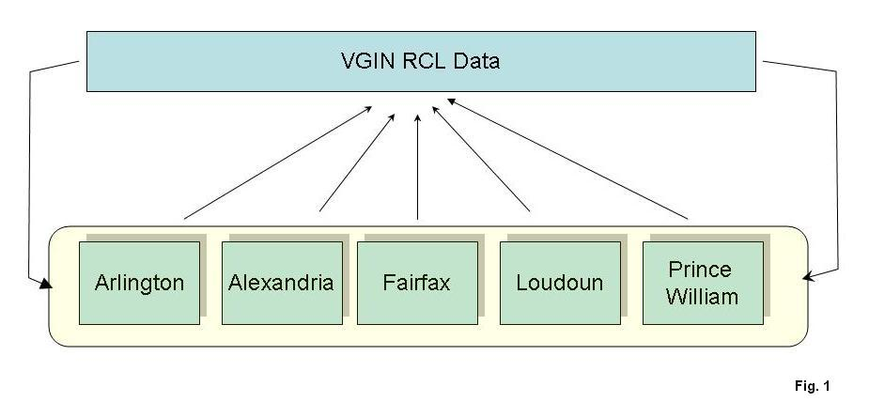
However, while the original intent of the VGIN RCL data set was to support routing, mapping, and geocoding for 911 purposes, it is not capable of being used for all of those purposes today. These issues have come to the forefront as Fairfax County prepares data for its new CAD system. This project will address all of the issues associated with the RCL data in the jurisdictions listed, provide a framework data model for use statewide, and provide an increased level of routable centerline data back to the local jurisdictions which they will then be able to maintain and continue to improve. Conceptually the project will add a regionally routable data layer to the VGIN data library. Figure 2.

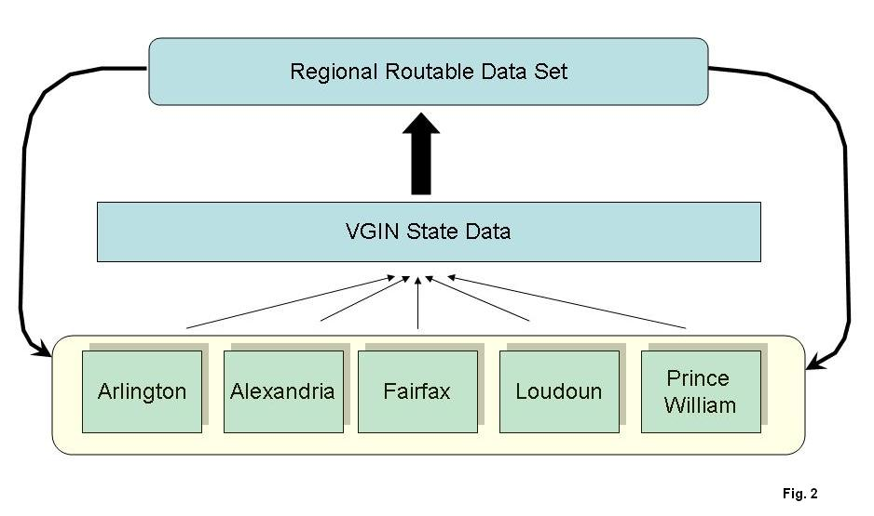

The project will address the following issues with the VGIN and local centerline data sets:

Persistent Unique Id’s and parent child id tracking for relationship management: The current VGIN data has a unique ID field but it is not completely populated with unique ID’s nor is there a process in place to track parent ID’s. VGIN has recently implemented a GeoID field which is a combination of x and y values for the centerline midpoint. While this ensures uniqueness it does not yet provide for parent child relationships of arcs. A further problem with the geoid values are that some CAD systems don’t allow for ID values of that size. This parent child relationship is critical for local governments supporting CAD because CAD incident records are tied to a street ID. Once the data is updated a change in ID’s means that CAD records essentially become orphaned and can no longer be related to the map data. The new VGIN regional routable model will provide for the storing of parent child ID’s in centerline data and for a way for local governments to process those values throughout an ongoing maintenance cycle.

Establish standards and a methodology for dealing with border streets: As part of the maintenance process VGIN collects and distributes data from local jurisdictions based on a FIPS code (jurisdiction designation) for each arc.
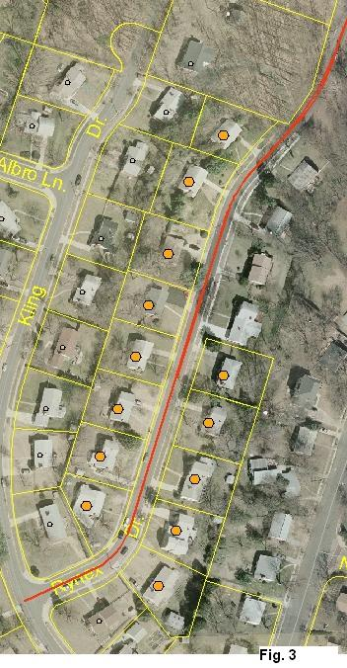
For the current use of the VGIN data, it makes no difference which jurisdiction an arc straddling two jurisdictions comes from. However once those local governments try and use that data in a CAD system it makes a huge difference. Consider the example of Rynex Rd. (figure 3) on the border of Fairfax County and Alexandria City. A portion of this street has Fairfax addresses on both sides, a portion has Fairfax addresses on one side and Alexandria addresses on the other (the Fairfax addresses are marked with an orange hexagon). Both jurisdictions need a representation as part of their database to support CAD. Using the current process, only one would get imported into the VGIN data causing problems with future updates. This project will develop a technical solution to this problem as well as a methodology and best practices guide which other jurisdictions can use to resolve the same issue.

Establish a speed limit attribute: The current VGIN data set does not include a speed limit attribute. All five jurisdictions in this proposal have speed limit data for their road centerline network. VGIN also now has access to additional speed limit data based on an agreement with NAVTEQ. Using those sources as a guide, a new populated speed limit attribute will to be added to the VGIN data set for the 5 PSAP jurisdictions as well as those covered geographically (Fairfax City, Falls Church City, Ft. Belvoir). QC of this new data will also be conducted. Since this data does exist and is essential to supporting CAD currently, this data will be maintained by each jurisdiction in the future. It is import to note that there can be a difference between the posted speed limit and a CAD speed limit, which is a value many jurisdictions maintain to ensure certain roads are used only when an incident occurs on them. A provision for this data will also be made in the regional data set.

Establish a common state-wide road classification scheme: Every jurisdiction listed in this grant maintains some sort of road classification scheme. There is also a simple regional classification scheme that was developed 7 years ago that is maintained. Road classification values are used in CAD systems for a variety of purposes from cartographic display to defining other attribute values. There are several nationally recognized road classification schemes with the most likely being the CFCC scheme developed by the US Census Bureau. Using the jurisdictional source data and other data available to VGIN, all roads will be classified into a chosen road classification scheme. Assignment of road classification values for future roads will be done at the local level and updated by VGIN as part of the existing maintenance process.

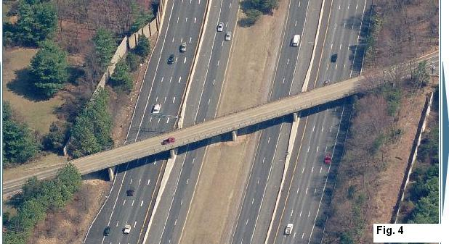
Establish a state-wide methodology for dealing with elevated crossings: How jurisdictions deal with elevated crossings is a critical issue not just for supporting CAD but for supporting any routing application. Consider the graphic in figure 4. This is an image of the intersection of Beulah Rd. and The Dulles Toll Rd. There are really three basic ways to deal with this in a GIS. One is to represent this simply as it occurs in the real world, where the arc representing the road on the bridge does not intersect in the system with the arcs representing the roadways beneath it. (Fig 5): In a routing application there would never be an occurrence where a route was defined turning from one arc to the next because there are no possible nodes for the system to interpret as turning points.

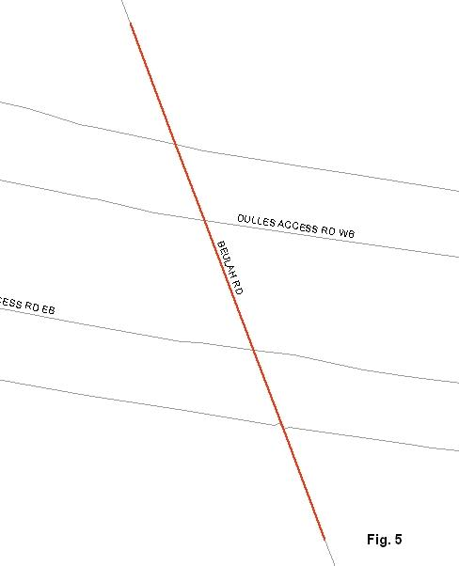
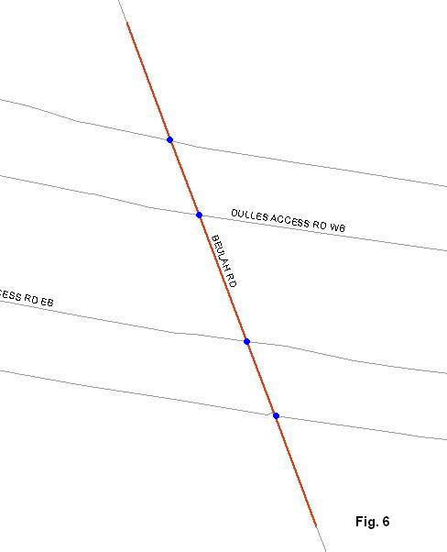
The second approach is to use an elevation attribute. In the GIS data, an intersection point would occur at every point the lines cross. These points are represented in Fig. 6 as blue dots. Each intersection (or node) would then be coded with an elevation value. In this figure the Dulles Toll road endpoints would be given an elevation value of 1 and the Beulah Rd. endpoints would be given a value of 2. The elevation values would prevent any application from routing vehicles from the Beulah Rd. onto the Dulles Toll Rd The third option is similar to the second. A node in the GIS data would occur where the lines cross as they would in the elevation example however routing would be prevented from one arc to the next based on turn restriction values. These are usually coded at the node level. All three methods are employed by the PSAPs listed in this grant. As a result of the work in this grant, a methodology for modeling virtual intersections will be chosen and populated for the regional data. Work will then be conducted to bring jurisdiction data up to the chosen standard or to allow jurisdictions to import data that uses the new standard. It is important to note that jurisdictions will be using the regional data for areas outside their own jurisdictions so this new data will not affect what they are doing currently within their own borders.

Establish a one-way attribute: Another critical component to supporting routing of emergency vehicles is the definition of one-way roads in a GIS. Most commonly this is done using a one-way attribute. Four of the five PSAP’s maintain this information currently. This information is tied to the directionality of how an arc was digitized. This information is also available to VGIN via an agreement with NAVTEQ to acquire their data. In this project all existing one-way information will be collected and QC’d and added to the regional data set. It will be collected for those areas where it does not exist. Once collected, jurisdictions will be expected to maintain updates to this information as new development and changes to the existing road network occur.

Task List: See budget narrative for detailed description.

Task 1: Document Summary of Existing Jurisdiction and Source Data Quality and Completeness
Task 2: Define Data Model
Task 3: Develop Statement of Work
Task 4: Develop RFP
Task 5: Data Conversion to New Model
Task 6: Data QC
Task 7: Develop Maintenance Tools
Task 8: Specific Changes to Support Local Installation
Task 9: Develop Best Practices Guide
Task 10 (optional): Publication and Dissemination of Results

