Mercury Pollution in the Washington, D.C. Region
and the Chesapeake Bay Watershed
Alessandro Sacerdoti*
January 2005
D R A F T
1. Introduction

Man-made airborne emissions of mercury in the United States totalled 158 tons in a recent year. This injection of mercury into the environment poses risks to public health and has effects on our natural and recreational resources.

The U.S. Environmental Protection Agency (“EPA”) defines mercury as a hazard to health and to the natural environment, stating that pregnant and new mothers and their unborn or breastfed children are the most vulnerable groups in the population. EPA has discussed mercury in terms of neurological damage, observing that prenatal exposure, even at levels not threatening to the mother, and consumption of mercury in breast milk, can delay neurological development in children, and that mercury slows neurological and organ growth in children under six, causing reduced verbal, motor or learning abilities. A state environmental department has pointed out that children are not the only group at risk; adults may suffer a variety of symptoms depending on the extent of exposure, with low levels of mercury causing high blood pressure, heart attack or immune system problems, and high levels of exposure causing tremors, mental instability, cerebral palsy, coma or even death.

Historically, many industrial processes, including paint and battery production, made use of mercury, creating health hazards for production, use and disposal. The toxicity of mercury has been known since the beginning of the industrial age: the notion of being "as mad as a hatter" came from the use of mercury in Victorian times to shine top hats made from beaver pelts. Workplace contact with elemental or inorganic mercury has, however, declined in modern times. In the 1990s, U.S. manufacturers reduced the amount of mercury in thermometers, paint and batteries; consumers can now purchase thermometers containing red alcohol instead of liquid mercury.

Coal-fired power plants currently emit more mercury than any other source in the United States. EPA reporting of hazardous air pollutants in the United States shows that these plants emit approximately 52 tons of mercury into the atmosphere annually. The area of the United States from Washington, D.C. to Boston is one of the country’s most concentrated mercury-emitting regions.

2. Mercury Pollution Mechanics

Man-made emissions have doubled the amount of toxic mercury in the human environment in the last 150 years. Emissions from coal combustion processes contain three different forms of mercury (chemical abbreviation Hg). Coal smokestack emissions contain, on average, approximately 80-85% elemental mercury (Hg⁰), 15% mercuric mercury ion (Hg²⁺), and 1-2% particulate mercury; these numbers vary based on the facility and type of fuel.

The portion emitted as elemental mercury, Hg⁰, stays in the atmosphere and travels around the globe on air currents for up to a year, until sunlight and other factors transform it into Hg²⁺, which eventually falls to the ground (see below). Thus the effect of U.S. emissions is felt overseas. By the same token, other major mercury-emitting regions of the world such as Asia and Europe deposit a large amount of mercury on the United States.

The portion emitted from smokestacks as Hg²⁺ falls to the ground quickly in rain or snow. This has the potential to create an increased mercury precipitation area extending 6–60 miles downwind from the combustion plant source. This effect is seasonal and irregular, depending on rainfall, snowfall and varying wind conditions.

The portion emitted as particulate mercury may stay in the atmosphere longer than Hg²⁺or fall to the ground, depending on the weight of the particle attached to the mercury molecule.

Whether Hg²⁺ is emitted from a smokestack or compounded in the atmosphere from Hg⁰, eventually Hg²⁺ binds to water molecules in clouds, falls with rain and snow, and migrates into plant tissue, soil and waterways. Water- and ground-dwelling bacteria found naturally in all regions turn Hg²⁺ into the neurotoxin methylmercury.

Methylmercury accumulates in organisms up the food chain, a process known as bioaccumulation. Plankton absorb methylmercury into their tissues, and small fish eat the plankton. Fish higher in the food chain such as king mackerel, shark, swordfish and tuna accumulate mercury systematically. Finally, humans, and wildlife such as bald eagles, loons, osprey and otters, eat the large fish. EPA warns pregnant women and children under six not to eat locally caught fish or canned albacore tuna more than once a week and fresh tuna no more than once a month.

3. Current U.S. Emissions and Available Cleanup Measures

The 1990 Clean Air Act Amendments require EPA to maintain a database of emissions from sources that release mercury into the atmosphere. These sources must acquire a permit from EPA and submit quarterly emissions reports. Coal-fired utilities generate 33% of U.S. mercury emissions; municipal waste incinerators create 19% of U.S. emissions, industrial boilers 18% and medical waste incinerators 10%. The remaining 20% comes from fossil fuel processing, manufacturing and other mining or industrial activities. Federal efforts for mercury reduction focus primarily on the coal-fired power sector.

Different types of coal and combinations of technology all play a role in generating and reducing mercury emissions. Mercury can be extracted from fuels prior to combustion, or filtered from smokestack exhaust. Coal suppliers may wash coal to extract mercury, allowing it to burn cleaner. Cleaning processes used on coal mined east of the Mississippi reduce mercury content on average 21% and up to 64%, according to EPA.

Power plants currently using technology to reduce the acid rain pollutants SO₂ and NOx have learned that this technology reduces mercury emissions also. Several plants target mercury emissions using new combustion mechanisms to burn the fuel more completely, installing cloth filters or “wet filters” to screen exhaust, or building chambers to create chemical reactions that extract pollutants from the exhausts. Combined filter technologies have removed up to 98% of mercury from smokestack emissions in some tests. However, industry and EPA disagree about the quantity of mercury reductions achievable using currently available technology.

4. The Proposed Federal Regulations

The 1990 Clean Air Act Amendments also require EPA to proceed with rulemaking to control hazardous air pollutant emissions from utilities if EPA finds regulation to be appropriate and necessary. Also in 1990, Congress requested that EPA conduct a comprehensive study of mercury and other hazardous air pollutants.

EPA completed, in 1997, a lengthy report that included results of research sponsored by EPA, the Department of Energy and the National Energy Technology Laboratory. The report established that mercury in the environment threatens public health and the environment. It found coal-fired utility units to be the largest man-made U.S. source of mercury, and linked mercury emissions from coal-fired utility units to high methylmercury concentrations in fish. The EPA found that mercury in fish may be largely responsible for the elevated levels of mercury in American women of childbearing age. The report declined to give a numerical link between specific emission levels and specific mercury levels in fish, creating uncertainty in the subsequent rulemaking process. The report recommended implementation of the “maximum achievable control technologies” (“MACT”) standard (a term defined in the Clean Air Act) as the most effective means of reducing mercury, in conjunction with a cap-and-trade system.

In 2003, EPA proposed its federal mercury control regulations. The proposed rules would reduce mercury emissions using a cap-and-trade method, limiting mercury emissions to current levels within each state and requiring a 30% reduction by 2018.

The proposed rules sparked an outcry from environmental groups, which claimed the rules favored industry and would not fulfill the Clean Air Act Amendments’ requirement that the government implement the best achievable emissions standards. The debate concerns which approach EPA should endorse to achieve emission reductions. The 1997 MACT alternative, in accordance with the 1990 legislation, would create separate mercury emission limits for new and existing coal-fired power plants and require that the best technology for mercury reduction be in place by 2008. The 2003 cap-and-trade approach, generally favored by the power industry, would set a nationwide 2010 limit in line with the mercury reductions to be achieved by the SO₂ and NOx abatement technology currently being installed and a 2018 emission limit at 70% of current emissions. In response to the proposed rules, the public submitted a record number of comments to EPA, with many of these comments citing discrepancies between EPA’s 1997 recommendation of the MACT standard and EPA’s 2003 proposed rule with its cap-and-trade approach. EPA subsequently extended the comment period until March 2005.

Both of the possible regulatory approaches appear to have some merit. The large amount of elemental mercury released by coal power plants into global air currents, affecting far-off communities, makes cap-and-trade regulation an efficient approach to reduce overall mercury emissions. But coal-fired plants deposit mercury locally too, causing concern for people who live near a plant that decides to purchase pollution credits under the cap-and-trade system instead of reducing emissions.

5. Mercury Emissions and Effects in the Washington Region

A 1999 EPA report on emissions shows that Pennsylvania, which includes thousands of square miles of Bay watershed, is the largest mercury-emitting state east of the Mississippi and the second largest mercury-emitting state in the United States, at 4.9 tons per year. Maryland (0.91 tons/year) ranks 20th among mercury-emitting states, and Virginia 23rd (0.63 tons/year). The coal power plants in the Bay watershed collectively emit 3.95 tons of mercury into the air each year. (See Figure 3.)

Six combustion facilities monitored by EPA fall within the Metropolitan Washington Air Quality Committee (“MWAQC”) region (see Figure 2):
- Chalk Point Power Plant, Prince George’s County, operated by Mirant Corporation, producing approximately 22% of Maryland’s mercury emissions.
- Dickerson Power Plant, Montgomery County, also operated by Mirant, producing nearly 17% of Maryland’s mercury emissions.
- Montgomery County Resource Recovery Facility, which includes a municipal waste incinerator that is monitored by EPA but apparently no longer emits a significant amount of mercury.
- Morgantown Power Plant, Charles County, operated by Mirant, emitting 21% of Maryland’s mercury.
- Possum Point Power Station, Prince William County, operated by Dominion Resources, emitting 10% of Virginia’s mercury.
- Potomac River Power Plant, Alexandria, Virginia, operated by Mirant, producing 6.6% of Virginia’s emissions.

The majority of the states in the Bay watershed, and EPA, as mentioned above, have issued mercury advisories, urging residents (or certain vulnerable groups of residents) to reduce or avoid eating fish from the region’s waters:
- Delaware has 5 fish consumption advisories based on mercury.
- Maryland has issued advisories for restricted consumption by the general population of largemouth and smallmouth bass, bluegill, pickerel, northern pike, and walleye from all lakes and all rivers in the state, due to mercury contamination. The Maryland Department of Natural Resources considers rockfish (striped bass) of greatest concern for mercury contamination in the Chesapeake Bay and has noted the negative effect of current mercury emissions on recreational fishing in the region. Local shellfish contain elevated methylmercury as well. The Maryland Department of Environment has warned the public not to eat the “mustard” of blue crabs from the Bay due to high methylmercury content and other pollutants.
- Pennsylvania issued a 2001 mercury advisory recommending restricted consumption of fish from all freshwater rivers and all lakes in the state.

- Virginia has issued mercury advisories, recommending the complete cessation of consumption, for all fish from the North Fork of the Holston River, the South Fork of the Shenandoah River and the South River.

- The above states, plus the District of Columbia, New York and West Virginia are subject to the EPA national advisory, which affects all fish and shellfish from all waters in all of these jurisdictions.

The streams and rivers of the region absorb the large quantities of airborne mercury that fall in rain and snow, and concentrate this mercury in the Chesapeake Bay. EPA has described the area from Washington, D.C. to Boston (see Figure 1) as one of the areas of highest concern for mercury in the United States.

155038
Figure 1. Man-Made Mercury Emission Sources, Eastern United States 1994-1995.

Figure 2. Facilities Monitored for Mercury Airborne Emissions in the Washington Region.
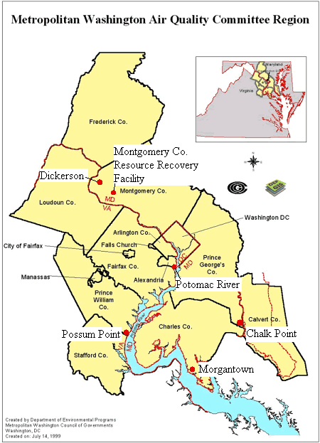

Figure 3. Approximate 60-Mile Radius around Coal Power Plants in Chesapeake Bay Watershed (gray).
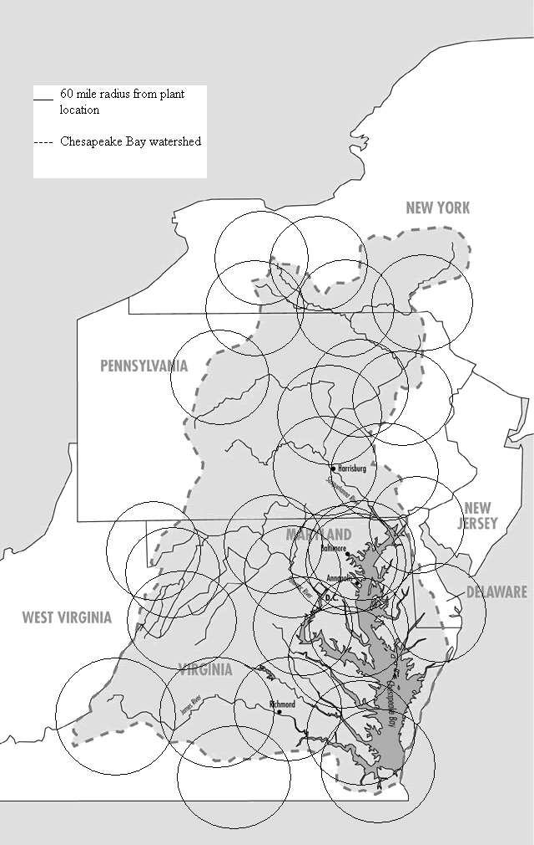

* Boston University School of Law, Class of 2007; Middlebury College, B.A., 2000. ? U.S. Environmental Protection Agency (“EPA”), Mercury Study Report to Congress, Rep. No. EPA452/R-97-004, vol. 2, at ES-4 (1997).
69 Federal Register (FR) 4656, January 30, 2004.
EPA, Mercury Study Report to Congress, Rep. No. EPA452/R-97-007, vol. 5, at 4-1 (1997).
69 FR 4658, January 30, 2004.
See EPA supra note 3, vol. 5, at 4-1.
Vermont Department of Environmental Conservation, Mercury Toxicity, Mercury Education and Reduction Campaign (2003).
See EPA supra note 1, vol. 2, at ES-4.
See id., vol. 2, at 6-1; see also below, Figure 1.
See FR supra note 4.
L. Lowen, et al., Direct Measurement of Mercury Reactions in Coal Power Plant Plumes: Technical Progress Report, U.S. Department of Energy National Energy Technology Laboratory, Award DE-FC26-03NT41724Y, at viii (2004).
See id. at vii.
See id. at iii.
NESCAUM, Mercury Emissions from Coal-Fired Power Plants: The Case for Regulatory Action, at 1-7 (2003).
U.S. Department of Health and Human Services and EPA, What You Need to Know about Mercury in Fish and Shellfish, Report No. EPA-823-R-04-005 (2004). For a list of fish mercury levels see http://www.cfsan.fda.gov/~frf/sea-mehg.html.
See EPA supra note 1, vol. 2, at ES-4. (The recycling of municipal waste, including mercury-containing products such as batteries, cosmetics, lamps and thermometers, has reduced mercury emissions from incinerators dramatically in recent years, see id. at 4-20). Maryland incinerates 11% of municipal waste, landfills 32% and recycles 33%. Maryland Department of Environment (MDE), Solid Waste Report 2000, at 9.
See EPA supra note 1, vol. 2, at 4-10.
EPA, Control of Mercury Emissions from Coal-fired Electric Utility Boilers 2 (2002).
Clean Air Act Amendments of 1990, § 112(n)(1)(A).
Id. § 112(n)(1)(B), which requires that EPA conduct and transmit to the Congress a study of mercury emissions from electric utility steam generating units, municipal waste combustion units, and other sources.
See FR supra note 5. (A Center for Disease Control study found that 8% of women of childbearing age had mercury levels above or at the EPA RfD.)
M. Rossler, Mercury’s Two Alternatives, Electric Perspectives, Edison Electric Institute, March/April 2004.
J. Eilperin, Utilities, Environmentalists at Odds over EPA Path, Washingtonpost.com, June 29, 2004.
EPA, Emissions of Mercury by State (1999).
EPA, Compilation of Reported Emissions 13 (1999).
See id.
MDE, Solid Waste Report 2000, at 9.
See id.
See EPA supra note 24.
Id. For an interesting recent development see A. Gowen, Alexandria Moves to Evict Power Plant, The Washington Post, June 24, 2004, at B8. (City Council effort to revoke agreement allowing plant to operate at the site in attempt to evict the plant).
Jakus, McGuinness and Krupnik, The Benefit and Costs of Fish Consumption Advisories for Mercury, Resources for the Future, Discussion Paper 02-55, at 9 (2002). Some local advisories for the listed states are for waters outside of the Bay watershed.
See id. at 11-12. Maryland has also placed yellow perch from several lakes and rivers under an advisory. Id.
See id.
MDE, Fish and Shellfish Contaminant Monitoring (2004), at http://www.mde.state.md.us/CitizensInfoCenter/FishandShellfish/home/index.asp.
See Jakus supra note 30, at 10.
See id. at 11.
See EPA supra note 1, vol. 2, at 6-1.
This memorandum is to be submitted to the Air Quality Public Advisory Committee of the Metropolitan Washington Air Quality Committee. It has not been adopted by, and does not constitute a position of, either Committee.
EPA, Mercury Study Report to Congress, vol. 2 at ES-8 (1997).
Map from www.mwcog.org/ environment/air/mwaqc1a.asp.
The coal-fired power plants in the Bay watershed emit 3.95 tons of mercury annually. EPA, Emissions of Mercury by Plant (1999) (sum of reported mercury emission tonnage from plants located within Chesapeake Bay watershed or within 60-mile radius). Watershed map from U.S. Forest Service (2004), at http://www.na.fs.fed.us/briefs/chesapeakebay/chesapeakebay04/chesapeakebay04.htm. Plant locations from Clean Air Task Force (2004), at www.catf.us/publications/fact_sheets/children_at_risk_list.php. (See page 3, text at n. 12, for significance of the 60-mile radius.)

