A legacy of regional cooperation, a commitment to a vibrant future
March 16, 2007

Jeffrey L. Lape, Director
Chesapeake Bay Program
Environmental Protection Agency
410 Severn Avenue
Suite 109
Annapolis, MD 21403

Dear Mr. Lape:

On behalf of the Chesapeake Bay Policy Committee of the Metropolitan Washington Council of Governments, I want to take this opportunity to congratulate you on your appointment as the new Director of the Chesapeake Bay Program. We in local government in the Washington region have a strong interest in the health of the Bay and its tributaries and recognize the critical stewardship role that we have. From technological innovation to direct participation on Bay Program committees, including the Local Government Advisory Committee, this region has demonstrated its commitment to the restoration efforts.

The local governments in the COG region have developed an excellent working relationship with the Bay Program and look forward to continuing that relationship under your tenure as Director. Once you have had a chance to settle in, we would like for you to join us at one of our meetings so that we can get acquainted and explore how we can work together most effectively.

Again, congratulations on your new appointment. Rest assured that we will do what we can to assist you, particularly in relation to local government programs.

Sincerely,
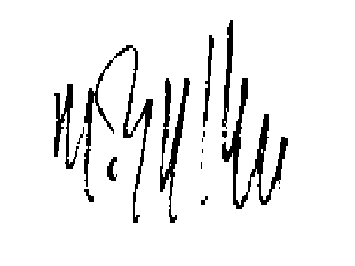

Martin E. Nohe, Chair
Chesapeake Bay Policy Committee

District of Columbia
Bladensburg*
Bowie

College Park
Frederick
Frederick County
Gaithersburg
Greenbelt
Montgomery County

Prince George’s County
Rockville
Takoma Park
Alexandria
Arlington County
Fairfax
Fairfax County
Falls Church
Loudoun County
Manassas
Manassas Park
Prince William County

*Adjunct member

