METROPOLITAN WASHINGTON |   COUNCIL OF GOVERNMENTS

Local governments working together for a better metropolitan region

February 21, 2007

The Honorable John H. Chichester, Chairman
Committee on Finance
Senate of Virginia
P.O. Box 396
Richmond, VA 23218

The Honorable Harry R. Purkey, Chairman
Committee on Finance
Virginia House of Delegates
General Assembly Building
P.O. Box 406
Richmond, Virginia 23218

Dear Senator Chichester and Delegate Purkey:

I am writing on behalf of the Metropolitan Washington Council of Governments (COG) to indicate our strong support for the Governor’s current proposal to provide an additional $250 million to the Water Quality Improvement Fund to help pay for nutrient removal upgrades at municipal wastewater plants within the state’s portion of the Chesapeake Bay watershed.

As required by the state, our municipal wastewater plants are developing plans and even beginning construction on improvements that will further reduce their already low levels of nutrient discharge into local streams and ultimately the Chesapeake Bay. Previous implementation of nutrient removal technology at these plants resulted from a successful funding partnership between the state and local authorities; the current round likewise depends on the provision of state grants to match local expenditures.

We also are writing to let you know of our support for efforts to provide a fair and reliable funding source for the state’s Water Quality Improvement Fund (WQIF). As you know, revenue in the fund has fluctuated in response to the overall budget situation, and in some years no new funds have been provided. Despite the approximately $500 million that may available in this fund if the Governor’s request is approved, the fund will not be sufficient to meet the state’s estimated share of nutrient upgrades for wastewater plants, let alone its needs for helping to fund agricultural and other non-point source controls.

A number of proposals have been introduced in recent years for a dedicated funding mechanism for the WQIF. While we have not taken a specific position endorsing any of these bills, we are urging the General Assembly to put the fund on a firm fiscal footing.

District of Columbia
Bladensburg*
Bowie

College Park
Frederick
Frederick County
Gaithersburg
Greenbelt
Montgomery County

Prince George’s County
Rockville
Takoma Park
Alexandria
Arlington County
Fairfax
Fairfax County
Falls Church
Loudoun County
Manassas
Manassas Park
Prince William County

*Adjunct member

Thank you for your consideration of this request. We look forward to working with you and other members of the Virginia General Assembly to insure that the clean water needs of the metropolitan Washington region and the Chesapeake Bay are met.

Sincerely,

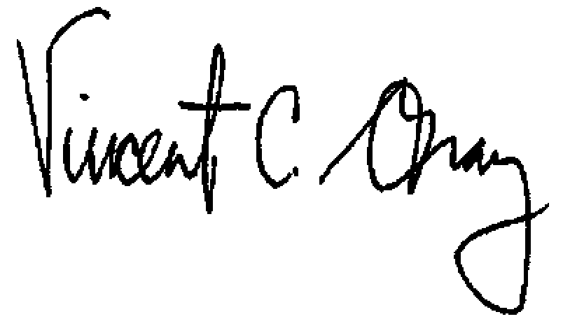
Vincent C. Gray
Chair, Metropolitan Washington Council of Governments Board of Directors

cc Virginia General Assembly members from the Washington metropolitan region

