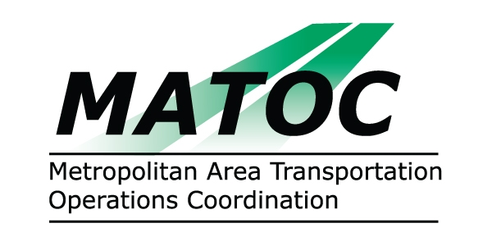

METROPOLITAN AREA TRANSPORTATION
OPERATIONS COORDINATION (MATOC) PROGRAM
OPERATIONS SUB-COMMITTEE

DATE: Thursday, July 09, 2009

TIME: 10:00 AM to 12:00 PM

PLACE: MD SHA Statewide Operations Center (SOC)
7491 Connelley Dr
Hanover, MD 21076

CHAIR: Alvin Marquess, MD SHA

AGENDA

- Approval of Minutes from June 11, 2009 Sub-Committee Meeting
- MATOC Report
  - Status Report
  - FITM / Traffic Management Plans
  - Statistical Analysis
  - MATOC Web Page
- DDOT Report
- MD SHA Report
- VDOT Report
- WMATA Report

- Other

