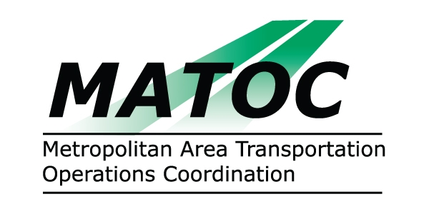

METROPOLITAN AREA TRANSPORTATION
OPERATIONS COORDINATION (MATOC) PROGRAM
OPERATIONS SUB-COMMITTEE

DATE: Thursday, March 12, 2009

TIME: 9:30 AM to 11:30 AM

PLACE: University of MD Center for Advanced Transportation Technology
5000 College Ave.
College Park, MD 20740

CHAIR: Alvin Marquess, MD SHA

AGENDA

- Operational Guidelines
- MATOC notification process
  - discuss 50% / 30 min
  - stakeholder questionnaire
- RITIS IT Enhancements
  - prepare list for Info Systems subcommittee
  - schedule joint meeting
- Discuss March 9 MATOC Steering Committee meeting

- Next Steps

