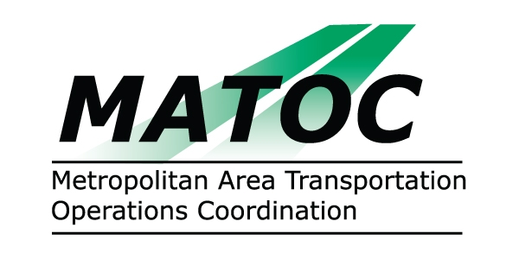

METROPOLITAN AREA TRANSPORTATION
OPERATIONS COORDINATION (MATOC) PROGRAM
OPERATIONS SUB-COMMITTEE

DATE: Thursday, April 9, 2009

TIME: 10:00 AM to 12:00 PM (meet and greet HSEMA at 9:30)

PLACE: DC TMC / Homeland Security Emergency Management Agency
2720 Martin Luther King Jr. Avenue, SE
Washington, DC 20032

CHAIR: Alvin Marquess, MD SHA

AGENDA

- Approval of March 6 and March 12 meeting minutes.
- Report on joint meeting with Info Systems subcommittee
- Discuss MATOC Concept of Operations, proposed hours, staffing and location for operations beginning July 1, 2009.
- RICCS notification process (if HSEMA staff available)
- Incident Notification Flowchart (power point presentation)

- Other

