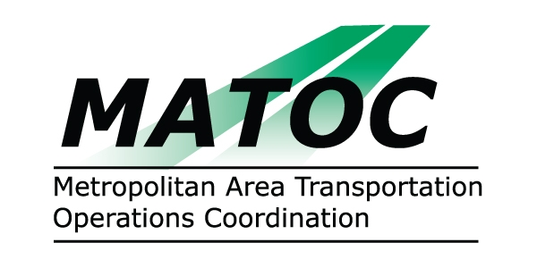

METROPOLITAN AREA TRANSPORTATION
OPERATIONS COORDINATION (MATOC) PROGRAM
OPERATIONS SUB-COMMITTEE

DATE: Friday, March 6, 2009

TIME: 9:30 AM to 11:30 AM

PLACE: University of MD Center for Advanced Transportation Technology
5000 College Ave.
College Park, MD 20740

CHAIR: Alvin Marquess, MD SHA

AGENDA

- Approval of Minutes from February 12, 2008 Sub-Committee Meeting
- Continue discussion of operational guidelines and revisions
- MATOC notification process and updated contact list
- RITIS IT Enhancements (recommendations for info Systems Sub)
- CapWIN update (status of system in each TOC/TMC)
- MATOC hours and staffing discussion

- Next Steps

