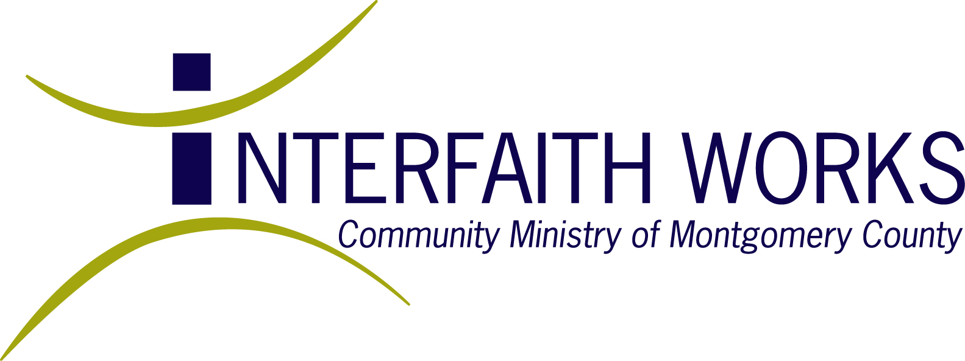
114 West Montgomery Avenue, Rockville, Maryland 20850
www.iworksmc.org Tel: (301) 762-8682 Fax: (301) 762-8773

Interfaith Works (formerly named Community Ministry of Montgomery County) is a non-sectarian interfaith coalition of 140 congregations of diverse faiths working together to assist low-income and homeless residents of Montgomery County. Our stated mission is “to pursue social justice with an emphasis on identifying and meeting the needs of the poor, and leading and engaging Montgomery County’s faith communities in service, education and advocacy.” Interfaith Works’ programs serve over 30,000 low-income and homeless residents of the county each year, including working poor families, disabled and chronically homeless adults, and other disadvantaged populations. Current programs include:
Homeless Services:
- Wilkins Avenue Women’s Shelters: 65 beds, serving 300 women (13,500 bednights) annually
- Community Vision day program for homeless adults: 300 adults served annually in therapeutic programs, education programs, vocational training and supportive employment programs.
- Community Vision emergency winter night shelters: 400 served annually Nov – April
Housing:
- Interfaith Housing Coalition: 25 homes, serving 30 families/yr (35 adults, 65 children)
- Permanent Supportive Housing for adults: 50 adults housed in 7 group homes (33 beds)
Mentoring:
- Friends in Action family mentoring: 35 families mentored by 130 volunteer mentors/yr
Interfaith Clothing Centers:
- At two ICC sites: 4,750 qualified low-income families/yr (15,000 individuals) provided with over $4,000,000 in gently used clothing and household goods free of charge, enabling these families to use cash resources for rent, food, medicine, etc. Also: 2,500 backpacks distributed to students and 150 layettes distributed to new mothers.
Emergency Support
- Congregation Support: Educates and supports 140 diverse faith communities about poverty
- Safety Net Support: Field over 1,500 calls/yr (5,000 people) providing referrals and counseling for those in financial crisis.
- Hand to Hand: Eviction prevention loan program serving 250 ($20,000 in loans made)
- Unmet needs fund: Emergency cash support for utilities, medicine, rent, training subsidies, funerals, transportation, etc.: 50-60 households (250 individuals) served annually with funds of $20,000
- Emergency Assistance Coalition: lead county consortium of 40+ helping (safety net) agencies. Distribute $70,000 in funds through network assisting 2,000 households annually (approx 7,500 individuals).
- Holiday giving Project: coordinate holiday food and gifts for 9,000 families in county, linking donors and those in need through network of 30+ coordinating partner agencies.
- Caregivers’ Conference: Annual meeting/training of 250+ public, private providers of safety net services.
Other Programs:
- Vocational Services: Provide job counseling, readiness, and training classes for those re-entering the workforce or working poor in low wage jobs. Serve 200/year
- Resource referrals: Case manage and provide counseling for low-income families who are eligible for human services support (food, housing, medical care/insurance, education & training, etc.) 500 families/yr served.
Community Education and Advocacy: Provide outreach and education on poverty issues in the County to the public and work with congregations so they can give voice to the poor with public officials and in their communities.

Barbara Garlock, Director of Community Outreach bgarlock@iworksmc.org; 301.315.1096
April 2009

