Metropolitan Washington Air Quality Committee

Suite 300, 777 North Capitol Street, N.E. Washington , D.C. 20002-4239  202-962-3358  Fax: 202-962-3203

February 11, 2004

Delegate Albert C. Eisenberg
General Assembly Building, Room 817
Capitol Square
Richmond, Virginia 23219

Dear Delegate Eisenberg:

I am writing on behalf of the Metropolitan Washington Air Quality Committee (MWAQC). MWAQC is certified by the governors of Maryland and Virginia and the mayor of the District of Columbia to develop a regional ground-level ozone strategy for the Washington, D.C. non-attainment area.

MWAQC urges your support for SB 454 as approved unanimously by the Virginia Senate on January 30 and now before the House Committee on Agriculture, Chesapeake and Natural Resources. This bill authorizes the Virginia Department of Environmental Quality to collect penalty fees from stationary sources of air emissions if the severe nonattainment areas in which those facilities are located do not attain federal air quality standards by the deadlines established by the Clean Air Act. Passage of this legislation is critical to both the Washington region’s air quality planning efforts and to the continuity of Northern Virginia’s transportation plans and funding.

If the legislature does not approve the fee penalty, EPA will find the Washington region’s air quality plan incomplete. This will start a 24-month sanctions clock. Upon expiration of this clock, highway sanctions would be imposed. Construction of most new transportation projects, including roads, bridges and transit projects, would be halted until EPA approves a complete air quality plan including the fee penalty requirement. In addition, after 18 months EPA would be required to develop a federal plan for improving the region’s air quality, removing state and local authority to develop cost-effective, regionally appropriate pollution control measures and replacing it with an unfunded federal mandate.

Virginia must submit a complete air quality plan, including an approved fee penalty provision, to the US EPA no later than March 1, 2004. Failure to submit a complete plan could have a major impact on regional transportation planning. Should the Virginia legislature fail to approve the fee penalty provision by March 1, 2004, EPA will prepare to issue a finding that the air quality plan is incomplete. If the legislature acts to approve the fee penalty before the end of the current session, the deficiency will be rectified.

We urge you to support SB 454 to enable the Washington region to submit a complete and approvable air quality plan and to protect the region’s transportation plans and funding. Should you have any questions regarding the importance of this bill, please contact me.

Sincerely,
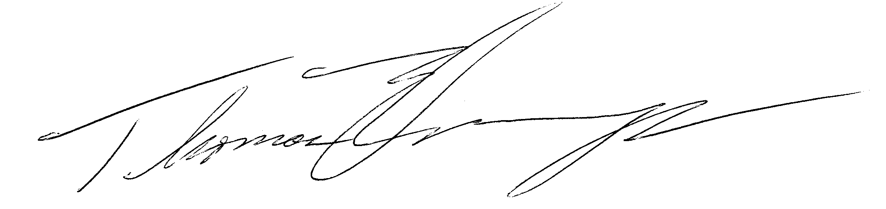
Hon. Thomas Dernoga, Chair

