Final Rule for Mandatory Reporting of Greenhouse Gases
(TAC Meeting, October 13, 2009, 10 AM-12PM)

Signed - September 22, 2009. Effective - 60 days from publication in FR.

Key Elements of the Rule
• Annual reporting of GHG by:
– 25 source categories
- 5 types of fuel suppliers and industrial GHG
- Motor vehicle and engine suppliers (except light duty sector)
• 25,000 metric tons CO2e per year reporting threshold for most sources; capacity-based thresholds where feasible
• Direct reporting to EPA electronically
• EPA verification of emissions data
• An estimated 85 percent of the total U.S. GHG emissions, from approximately 10,000 facilities, are covered by this final rule.
• Monitoring will begin on January 1, 2010 and the first report will need to be submitted by March 31, 2011.
• Ultimately, this reporting will be merged with the EPA’s National Emissions Inventory (NEI) reporting system.

Reporting Entities
States, municipalities, and tribes could be required to submit an annual GHG report if they own or operate facilities that emit 25,000 metric tons or more of CO2e per year.
Any businesses above that level also need to report.

GHGs to be Reported
CO2, CH4, N2O, Fluorinated gases (HFCs, PFCs, SF6), other fluorinated gases

Rule Applicability - 3 Categories of facilities covered
- “All-in” source categories
- Threshold categories
- Stationary fuel combustion

Table 1: All-in Source Categories (17 facilities)
Electricity Generation if report CO2 year-round through Part 75
Adipic Acid Production
Aluminum Production
Ammonia Manufacturing
Cement Production
HCFC-22 Production
HFC-23 Destruction Processes that are not collocated with a HCFC-22 production facility and that destroy more than 2.14 metric tons of HFC-23 per year
Lime Manufacturing
Nitric Acid Production
Petrochemical Production
Petroleum Refineries
Phosphoric Acid Production
Silicon Carbide Production
Soda Ash Production
Titanium Dioxide Production
Municipal Solid Waste Landfills that generate CH4 equivalent to 25,000 metric tons CO2e or more per year
Manure Management Systems with combined CH4 and N2 O emissions in amounts equivalent to 25,000 metric tons CO2 e or more per year.

Note: For these facilities, the annual GHG report must cover all source categories and GHGs for which calculation methodologies are provided in subparts C - JJ of the part 98.

Table 2: Threshold Source Categories (7 facilities)
Ferroalloy Production
Glass Production
Hydrogen Production
Iron and Steel Production
Lead Production
Pulp and Paper Manufacturing
Zinc Production

Note: GHG emissions must be reported if the total facility level emissions ≥ 25,000 metric tons CO2e per year from all source categories, combustion units, and miscellaneous use of carbonates combined.

Table 3: Stationary Combustion Units
Boilers
Stationary Internal Combustion Engines
Process Heaters
Combustion Turbines
Incinerators
Other Stationary Fuel Combustion Equipment

Note: If any facility does not belong to Table 1 & 2 and if:
a. Aggregate maximum rated heat input capacity ≥ 30 mmBtu/hr and,
b. Emits ≥ 25,000 metric tons CO2e per year
then, for these facilities, the annual GHG report must cover emissions from stationary fuel combustion sources only.

Does my facility need to report?
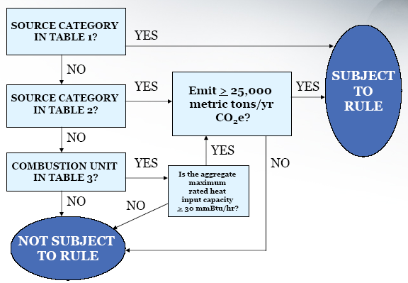
Source Categories Not Included in Final Rule
EPA plans to further review public comments and other information before deciding on these subparts:
• Electronics manufacturing
• Ethanol production
• Fluorinated GHG production
• Food processing
• Magnesium production
• Oil and natural gas systems
• Sulfur hexafluoride (SF6) from electrical equipment
• Underground coal mines
• Industrial landfills
• Wastewater treatment
• Suppliers of coal
Facilities with these source categories could be covered by the rule based on GHG emissions from stationary fuel combustion sources.

What Suppliers Are Covered?
• All producers of:
Petroleum products, Coal-based liquids, Industrial GHGs (F-GHG and N2O), CO2
• Importers and Exporters of 25,000 metric tons CO2e per year
• Natural gas and natural gas liquids
- All fractionators
- All local gas distribution companies

What do Suppliers Report?
• Quantity of each product introduced into the economy (e.g., barrels, tons)
• GHG emissions associated with:
- 100% oxidation of fuels (CO2e)
- 100% release of gases (CO2e)

General Monitoring Approaches
• Continuous emission monitoring systems (CEMS)
- Required if already used (e.g., NSPS, Acid Rain Program) and meet specified criteria
- Optional for other sources
• Source category-specific GHG calculation methods
- Monitor process parameters, fuel use
- Calculate GHG using equations in applicable subparts
- Example approaches (varies by source category)
• Mass balance calculation
• Site-specific emission factors
• Default emission factors

When Can an Annual Reporting be Stopped?
• If annual reports demonstrate CO2 e <25,000 metric tons/yr for 5 consecutive years.
• If annual reports demonstrate CO2 e <15,000 metric tons/yr for 3 consecutive years.
• If you shut down all processes/units/supply operations covered by the rule.

Emissions Verification?
• Self certification
- Designated representative certifies and submits report
- Rule allows one designated representative for each facility and supplier
• EPA verification
- Reports submitted through an electronic system
- Built-in calculation and completeness checks for reporters
- Additional EPA electronic QA and consistency checks
- On-site audits

Additional Information
www.epa.gov/climatechange/emissions/ghgrulemaking.html

Which facilities will be covered in Washington, DC region?
MD – EGUs, Large Industrial Facilities, Landfills, Large Government Facilities, Large Military Facilities
DC - Pepco Benning Road, Capitol Power, GSA Central, Blue Plains
VA – Provided criteria for facility applicability for reporting based on heat input capacity rate (mmBTU/Hour) and annual fuel uses.

EPA Information on what Combustion Units will emit 25,000 MT CO2e per year?

Fuel Design Capacity¹ (mmBtu/hr) Annual fuel Use
Coal 30 10,800 tons
Fuel Oil 35 2.3 million gallons
Natural Gas 50 460 million ft³

¹Assuming full utilization and 8,760 hours/yr.

EPA Training
http://epa.gov/climatechange/emissions/training.html#app

Overview Session (Webinar)
- Webinar: October 13/20/27, 2009, 3:30 – 5:30 pm EDT
Detailed Training Session (Webinar)
This Webinar training session provides detailed information on such topics as applicability, estimating emissions, reporting, and recordkeeping requirements under the rule, as well as guidance for stationary fuel combustion facilities.
- Webinar: October 15/19/29, 2009, 3:30 – 5:30 pm EDT
Applicability Tool Training Session (Webinar)
This Webinar training session provides a tutorial on using EPA’s Applicability Tool, which is designed to help you assess whether your facility would be required to report greenhouse gas emissions as required by EPA’s Mandatory Reporting of Greenhouse Gases Rule.
- Webinar: October 8, 2009, 10:00 – 11:00am EDT
- Webinar: October 22, 2009, 3:30 – 4:30pm EDT

