GOVERNMENT OF THE DISTRICT OF COLUMBIA
DEPARTMENT OF TRANSPORTATION


Urban Forestry Administration

District of Columbia Citizen Tree Forum
June 3, 2009 – 10am to 3pm
Metropolitan Washington Council of Governments

Agenda

10:00 - 10:30 Tree Biology
Anne Cumming
USFS Morgantown Field Office

10:30 – 12:00 Caring for the Present Urban Forest:
Care of Established Trees and Planting and Caring for Young Trees
John Ball, Ph.D.
Extension Forester
South Dakota State University

12:00 – 12:30 Lunch

12:30 – 1:00 New Tools and Resources from the US Forest Service
Donna Murphy
Mid-Atlantic Center for Urban and Community Forestry
USFS Morgantown Field Office

1:00 – 2:00 Common Abiotic and Biotic Problems in Urban Trees
Christopher J. Luley, Ph.D.
Urban Forestry LLC

2:00 – 2:30 District Department of the Environment (DDOE)
RiverSmart Homes Program
Steve Saari – DDOE, Jim Woodworth – Casey Trees

2:30 – 3:00 Question and Answer Period

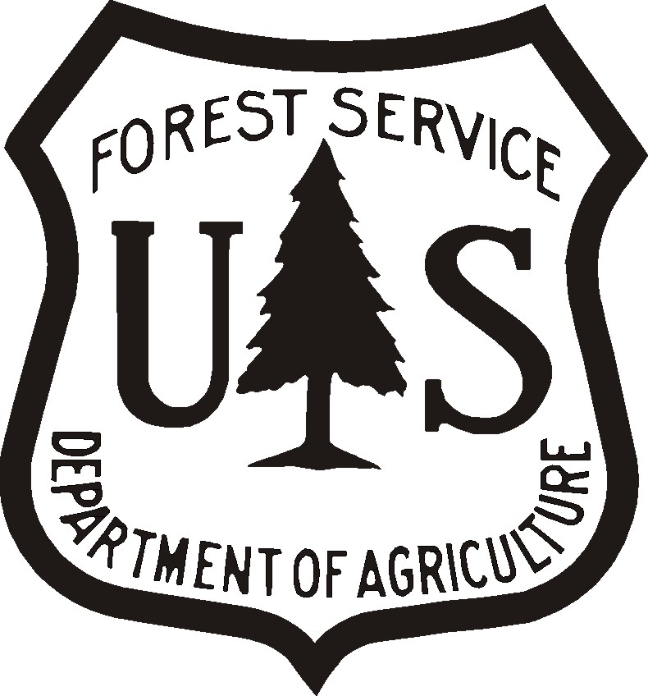

This event is sponsored by a grant from the U.S. Forest Service and hosted by the Metropolitan Washington Council of Governments

