DRAFT, April 15, 2005

CHAPTER 2: LEVEL OF BICYCLING AND WALKING IN THE WASHINGTON AREA

We do not have the all data we need to make definitive conclusions about the level of biking and walking in the region. However, using a variety of data sources, we can begin to paint a picture of bicycle and pedestrian activity. Below are three of the most relevant sources of data.

1. The US Census. The most fine-grained data on travel behavior comes from the Census. Every 10 years the Census Bureau asks roughly one in seven individuals (those who fill out the >long form=) how they get to work. People are polled at their home, not at their place of work. The most recent data available is from the 2000 Census. In 1990, 6633 people (0.3 %) biked to work on an average day in the Washington area and 85,292 (3.9 %) walked. In 2000, 7,532 people (0.3%) biked to work and 77,900 (3.3%) walked. The decline in walking in the Washington area corresponds with national trends. Tables I and II below show the changes in walking and biking to work by jurisdiction.

Generally, the urban core of the Washington region, consisting of the District of Columbia, Arlington, and Alexandria, has experienced modest losses in pedestrian mode share and considerable gains in bicycling. The District of Columbia has maintained its pedestrian mode share for the journey to work, while increasing its bicycle mode share considerably. The suburban jurisdictions had very few people bicycling or walking to work in 1990, and that number fell further during the decade that followed. For example, in Calvert County 41 people biked to work in 1990, and only 18 people biked to work in 2000.

The biggest limitation of the Census data is that it only contains work related trips. Less than one-quarter of all trips are work related. However, work trips occur at the most congested time of day.

Maps #? on pages ? show the percentage of home-based work trips by bicycle and on foot for each census tract within the Metropolitan Washington Council of Governments member jurisdictions.

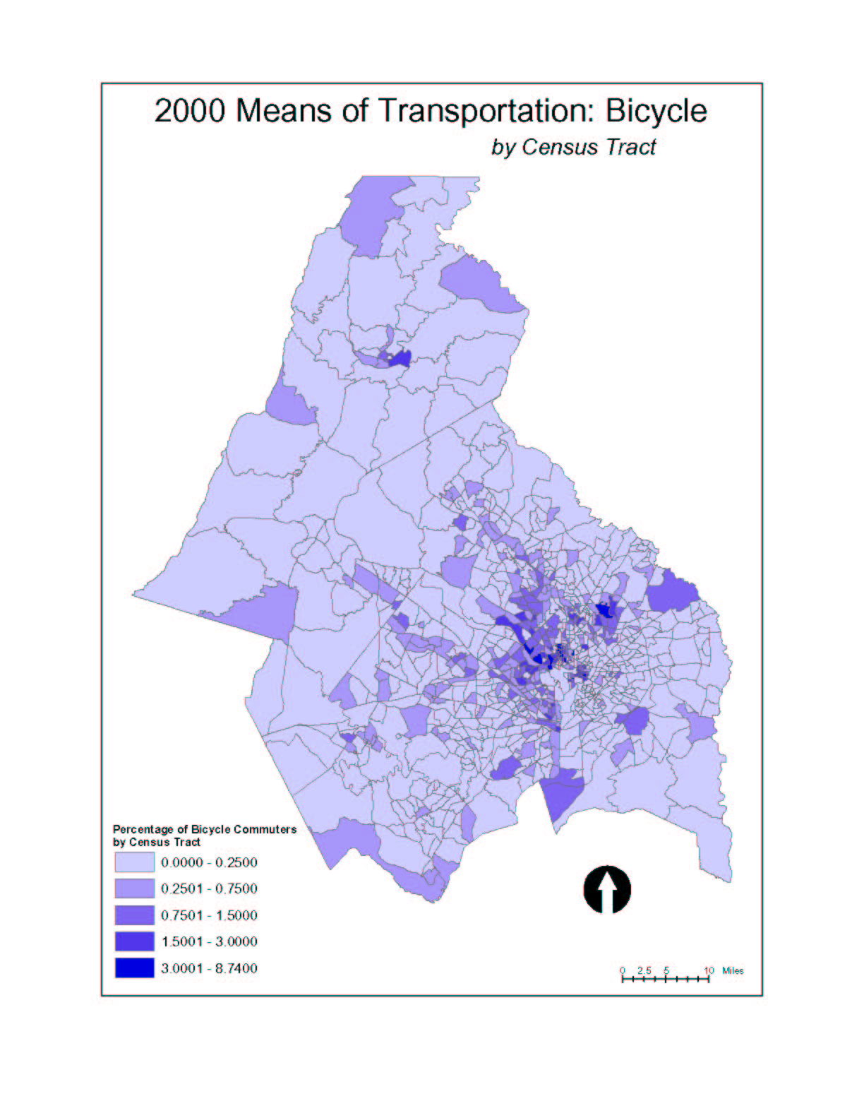

2. COG Household Travel Survey

In order to calibrate the regional travel demand model, the Council of Governments conducts periodic surveys of travel behavior. The most recent surveys that include bicycle and pedestrian data were conducted in 1988, 1994 and in 1999.

These surveys use a much smaller sample of the region=s residents than the Census. In 1994, roughly 4000 households were surveyed about their travel behavior (out of a metropolitan population of roughly 4 million). In 1999, only 2000 were sampled. The advantage of the Household Travel Survey is that we learn about trips of all purposes, not just work trips.

According to Figure ? bicycle trips nearly doubled from 1988 to 1999. However, this increase coincides with an increase in population and employment in the region. In those 11 years the population increased an estimated 17% and the number of jobs increased 14%. Another important factor in the apparent increase is the difference in survey methodology between 1988 to 1994. A greater effort was made to gather bicycle and pedestrian trips in 1994 and 1999.

From 1994 to 1999 bicycle trips as a portion of total trips for all modes remained about the same: 0.5 % for all trip purposes and 0.7% for work trips.

The number of pedestrian trips is higher. In the 1994 Household Travel Survey, we found that 7.8% of all trips were on foot, and that walking accounted for 3.1% of work trips. The 1988 Household Travel Survey only asked about work trips, and this data does not include walking to transit. [1988 and 1999 data forthcoming]

3. On-site counts. Another valuable source of bicycle and pedestrian data is actual counts, conducted by machine or in person, on specific roads or trails. The Council of Governments counts bicycles when conducting periodic >cordon counts= of traffic in the region. In cordon counts, we count the volume of traffic crossing a series of points along an imaginary circle. For example, one cordon line is the Capital Beltway. At approximately 60 points along the Beltway, COG counts all vehicles crossing over or under the Beltway. Another cordon line is known as the Metro Core, circling downtown DC and part of Arlington.

Below are some of the bicycle count results. In most cases these numbers represent only one day of counting and can not be viewed as a daily average. The amount of bicycle traffic is dependent on the weather and other factors which vary day to day. The values below are the number of inbound trips in the morning (6:30 to 9:30) added to the number of outbound trips in the evening (3:30 to 6:30)

