

ATRI Seeks Teams to Demonstrate Mobile Idle Reduction Technologies

Request for Proposals
The American Transportation Research Institute (ATRI) recently released a request for proposals (RFP) seeking project teams to demonstrate and evaluate mobile idle reduction technologies on heavy-duty trucks, either installed as part of the truck manufacturing process or prior to the truck being placed in service. Project teams must consist of a trucking fleet, a truck manufacturer and an idle reduction technology vendor.

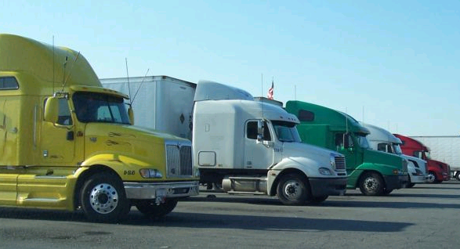

Project Goals
The anticipated outcomes for the project include:

- recommendations for integrating commercially-available idle reduction technologies into the original equipment manufacturer (OEM) truck manufacturing process;

- a comparison between the cost and, possibly, load requirements of integrated systems versus non-integrated systems; and

- collection and quantification of actual operational data leading to an assessment of fleet operator costs, benefits and payback period for selected idle reduction technologies.

To Submit a Proposal
Interested parties must submit proposals no later than 5:00 PM EST on March 1, 2006. A total of $350,000 is expected to be awarded. To obtain a copy of the RFP, visit www.ATRI-online.org.

This RFP is being funded as part of a $5 million grant program administered by the U.S. Environmental Protection Agency’s SmartWay Transport Partnership to help promote technologies that save fuel while also reducing pollution. This funding comes at a critical time as the trucking industry spent an unprecedented $87.7 billion on fuel last year, marking a $21.8 billion increase over 2004. The idle reduction technologies demonstrated under this RFP are expected to save fuel and reduce pollution by providing mobile cab heating and cooling while the truck’s main engine is turned off.



For more information on this project and other ATRI studies, please visit: WWW.ATRI-ONLINE.ORG


ATRI’s primary mission is to conduct and support research in the transportation field, with an emphasis on the trucking industry’s essential role in the U.S. and international marketplace.

