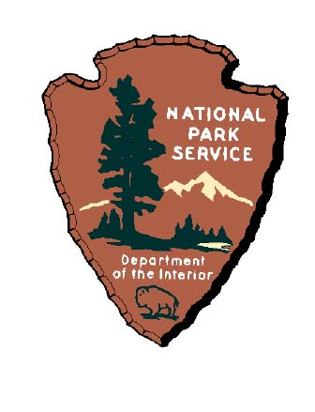
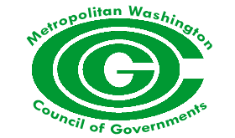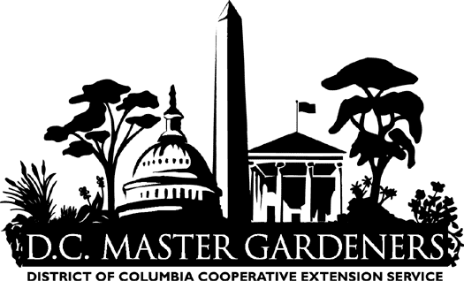
Hosted by COG’s Community Forestry Network (CFN)
Sponsored by the Metropolitan Washington Council of Governments
DC Cooperative Extension Service / University of the District of Columbia
and the
National Park Service

Wednesday June 28th, 2006
10:00 to 4:00 p.m. Training Center - 1st Floor Meeting Rooms at COG
Lunch will be provided for all attendees

Agenda

10:00 - Call to order - Brian LeCouteur - COG Todd Bolton, VDOT / CFN Chair

10:10. - Professor Tony Mucciardi – Tree Radar Inc.

10:55 - John Thomas – Acting Urban Forester - DC Urban Forestry Administration

11:30 - CitiLog – Stubby & Maria Warmbold – Citi Log is a nonprofit organization that turns urban waste wood into useable products and trains and employs urban youth enabling them with woodworking skills.

12:15 - Lunch

12:45 - Chris Holmgren – Seneca Creek Joinery takes logs from the stump to finished furniture, Cabinetry, and millwork. A vertically integrated business, Seneca Creek also offers custom sawmilling and drying of lumber.

1:15 - Kevin John Richardson – Pogo Organics – Olney, Maryland

2:00 - Dan Rider – MDNR Associate Director – Forest Service Marketing & Utilization

3:00 - Al Steele – U.S. Forest Service - Mr. Steele works with the Wood Energy Education Research Center for the U.S. Forest Service. He will discuss his examples of successful demonstration projects and current efforts to improve the utilization of wood from Forest Service lands.

3:45 p.m. – Workshop Summary and Survey - Brian LeCouteur - COG

4:00 p.m. - Future Activities / Closing Remarks/ Adjourn

