METROPOLITAN WASHINGTON |   COUNCIL OF GOVERNMENTS

Local governments working together for a better metropolitan region

February 16, 2007

Washington Post…..

Dear XXXXXX:

As Chairman of the Chesapeake Bay and Water Resources Policy Committee for the Metropolitan Washington Council of Governments, I must address Mr. Farenthold’s February 13th article “The Deadlines That Failed.” Contrary to the impression left by the article, real progress has been and continues to be made in reducing sources of pollution in the Washington region.
The Blue Plains wastewater treatment plant readily met the “Bay-driven” 2000 deadline to reduce nitrogen by 40% and has been on target since. DC-WASA is working with EPA to meet the new requirement for achieving an additional 50% reduction in nitrogen – at an estimated cost of $1 billion. The other wastewater treatment plants in the Washington region have achieved comparable reductions and are also developing plans for “limit of technology” upgrades. This is in addition to the very low phosphorus limits that the region’s wastewater plants all implemented in the late 1970s and early 1980s that still represent limits of technology.
Regarding the District of Columbia’s Combined Sewer Overflows (CSOs), a 20-year long-range plan has been worked out between DC-WASA and EPA. Phase I of this plan is on schedule for completion by 2008. This phase will achieve an initial 40% reduction in CSOs at a cost of $140 Million. The details and schedule for Phase II are being worked out by EPA and DC-WASA. It will achieve the remaining 60% reductions at an estimated cost of $2.2 Billion.
Many technical and funding challenges remain as we work toward our common water quality goals, challenges that often interfere with schedules made in good faith. While much more remains to be done, the Washington region has a record of solid achievement in reducing pollution.

Sincerely,
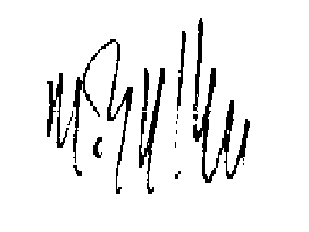

Martin Nohe
Chair, Metropolitan Washington Council of Governments Chesapeake Bay and Water Resources Policy Committee

District of Columbia
Bladensburg*
Bowie

College Park
Frederick
Frederick County
Gaithersburg
Greenbelt
Montgomery County

Prince George’s County
Rockville
Takoma Park
Alexandria
Arlington County
Fairfax
Fairfax County
Falls Church
Loudoun County
Manassas
Manassas Park
Prince William County

*Adjunct member

