 TIPS For 
USING THE RESISTOGRAPH and HAND DRILLING WITH A PORTABLE DRILL
Christopher J. Luley, Urban Forestry LLC
Applications

- To confirm the presence of decay in a particular location. For example, behind co-dominant stems or in buttress roots.

- To determine the amount of decay in a particular location. For example, for use in strength loss formulas.

- To evaluate the presence of other defects (cracks and ring shake, mainly), although it may be difficult to interpret the results for other defects.

- To determine growth rate in softwood species (Resistograph only).

Drilling Location Selection

- On any tree part being evaluated, select the location suspected to have the most decay or is most likely to fail. Use of decay indicators and a sounding mallet is highly recommended to aid in drilling location selection.

- For strength loss calculations, quadrant out the stem and drill in each quadrant. Three drill locations is usually the minimum, four is better.

- Avoid valleys (especially in the butt region) and other unusual stem deformations (unless these are being tested for some reason). There is minimal holding strength in the valleys, especially in the root crown area.

- Drill as many times as you need to satisfy yourself that you have the information needed to make a sound judgment. However, drilling can spread decay if certain fungi are present.

- Be sure to record all observations and measurements to document field drilling and observations. The “ISA Tree Hazard Evaluation Form” is a good place to do this.

Drilling Technique (Resistograph)

- Drill if at all possible at 90 degrees to the stem holding the Resistograph level as possible.

- Try not to move when drilling as it may cause unusual peaks on the charts.

- Drill softwoods on setting 1 and hardwoods on setting 2.

- Pull the bit entirely out of the tree when the drill has reached the end of the chart. Reverse the bit with it out of the tree. It saves batteries.

- Do not run the drill at either end of the chart in the wrong direction. It wears out the clutch. Make sure that the drill bit is moving forward into the tree and the direction is reversed when pulling it out.

- It is often not necessary to drill the entire length of the chart if doing strength loss formulas. Drill far enough to get data that you need. Once you enter decayed wood you can often stop drilling.

- Mark drill locations on the wax chart with the compass bearing and height off the ground. I usually put species, location (address) and date information also.

- You usually get 8-12 full drills from a battery depending on the wood density and charge on the battery. A 12v 18A sealed battery will give you 60-80 drills depending on the density of the trees being drilled.

- Because the drill bit is not spiraled, there is little chance of transmission of diseases on the bit. Clean the tip of the bit with an appropriate disinfectant if needed (some research has shown that passing decay to other trees is unlikely (Kersten, W, and F Schwarze, 2005). This would be wise if Dutch elm disease, Verticillium wilt, sapstreak or other destructive disease are present.

Interpretation of Resistograph Charts (Figure 1)

- Bark has no resistance and its thickness can be estimated from the chart. Be sure to include its thickness in strength loss measurements as a subtraction from the amount of sound wood.

- If possible drill a known sound area on the same tree species for a test comparison.

- Resistance generally increases as the drill bit progresses into the stem. This is due to resistance on the bit shaft and not denser wood. On softwood species the increase in resistance may be minimal.

- Incipient decay may be missed using the Resistograph. Resistance seldom drops to the bottom line even for completely hollow cavities.

- Watch for subtle changes in resolution in peaks, this often indicates incipient decay.

- Increased resistance often shows up just before decay pockets.

- Softwood species often show little resistance to the drill, making interpretation of decay difficult.

- Hardwood species that show little increase in resistance may have extremely brittle and decayed wood.

- Wood quality (strength) can be evaluated with the Resistograph based on the height of the needle on the chart.

Resistograph Deficiencies

- We assume that the needle goes straight into the tree, although this may not always be the case.

- Trees with saprot may show a typical or level pattern on the drill chart, suggesting no decay is present. Be sure to test a known sound part of the same species for comparison.

- Trees with extremely dense wood may prohibit the tool from recording decay because of the resistance on the shaft of the needle. This is most likely to occur near the middle or end of drill paths.

- Failure to use the correct wood density setting may result in decay no being recorded (using softwood setting for dense species).

- A hand held drill and drill bit may be needed to further investigate drill charts that are inconclusive.

Repairs and Adjustments

- The clutch is the weak link in the tool. It is worthwhile to learn how to replace and adjust it.

- If the drill bit won’t move (either in or out), punch the trigger in a series of short bursts. Do in both forward and reverse. This usually will get the bit moving. If not, adjust the clutch.

- If the drill bit breaks, DO NOT reverse the bit back into the machine as it can get stuck and cannot be changed without sending the unit back to IML.

- Dull bits make a difference. Replace when they get rounded off or worn.

- Bits can be replaced if they are broken in the tree by using the forward hole. If the drill bit breaks, DO NOT retract it into the machine. Use the forward hole to replace it.

- If the bit won’t move at all, the drive pin is probably sheared.

To replace the drill bit, I usually rotate the shaft of the Resistograph using the trigger. The screw to turn the shaft is very soft and it ends up getting buggered up.

Drilling Technique (Portable Drill)

- Having a hand held drill around is a good idea when using the Resistograph. You can it test trees with dubious results from the Resistograph.

- Use as small a drill bit as possible, 5/64 is usually the smallest that you can find’ 1/8 inch is common in big box stores like Lowe’s or Home Depot.

- Drill slowly into the tree, extracting and examining shavings as you go. Usually drilling 1-2 inches of new wood before extracting the drill bit.

- Be careful to note resistance to the bit with each drill. Examine shavings for any changes in color or texture. Shavings may become darker colored or crumbly when moving into a decayed area.

- When drill resistance noticeably changes, stop drilling and mark location on drill bit or use a sliding ring (an ear plug works well) on the drill bit to mark the drill bit depth. Extract the bit and measure the amount of sound wood. Remember to subtract the thickness of the bark for strength loss measurements.

- Disinfection of the drill bit is probably needed for the hand held drill as wood retained in the spirals on the bit have more potential to transmit diseases.

Drill Direction

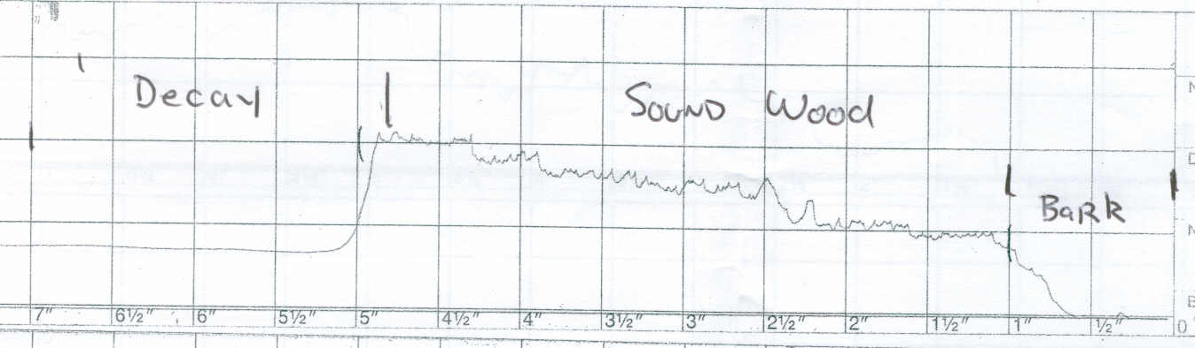
Figure 1. Typical Resistograph drill into decayed wood. There is approximately 4 inches of sound wood in the outer shell of this tree (5-1 inch of bark = 4).

