Metropolitan Washington Air Quality Committee

Suite 300, 777 North Capitol Street, N.E. Washington , D.C. 20002-4239  202-962-3358  Fax: 202-962-3203

March 11, 2004

Delegate Maggie L. McIntosh
Lowe House Office Building, Room 141
84 College Ave.
Annapolis, MD 21401-1991
Dear Delegate McIntosh:

I am writing on behalf of the Metropolitan Washington Air Quality Committee (MWAQC). MWAQC is certified by the governors of Maryland and Virginia and the mayor of the District of Columbia to develop a regional ground-level ozone strategy for the Washington, D.C. non-attainment area.

MWAQC urges your support for HB 1441, introduced at the request of the Maryland Department of the Environment (MDE) and now before the House Environmental Matters Committee. This bill requires major stationary sources of air pollution to pay an annual fee to MDE if the severe non-attainment areas in which those facilities are located do not attain federal air quality standards by the deadlines established by the Clean Air Act. Passage of this legislation is critical to both the Washington region’s air quality planning efforts and to the continuity of Maryland’s transportation plans and funding.

If the legislature does not approve the fee penalty, EPA will find the Washington region’s air quality plan incomplete. This will start a 24-month sanctions clock. Upon expiration of this clock, highway sanctions would be imposed. Construction of most new transportation projects, including roads, bridges and transit projects, would be halted until EPA approves a complete air quality plan including the fee penalty requirement. In addition, after 18 months EPA would be required to develop a federal plan for improving the region’s air quality, removing state and local authority to develop cost-effective, regionally appropriate pollution control measures and replacing it with an unfunded federal mandate.

Maryland must submit a complete air quality plan, including an approved fee penalty provision, to the US EPA no later than March 1, 2004. Failure to submit a complete plan could have a major impact on regional transportation planning. Should the Maryland legislature fail to approve the fee penalty provision by March 1, 2004, EPA will prepare to issue a finding that the air quality plan is incomplete. If the legislature acts to approve the fee penalty before the end of the current session, the deficiency will be rectified.

We urge you to support the fee penalty legislation to enable the Washington region to submit a complete and approvable air quality plan and to protect the region’s transportation plans and funding. Should you have any questions regarding the importance of this bill, please contact me.

Sincerely,
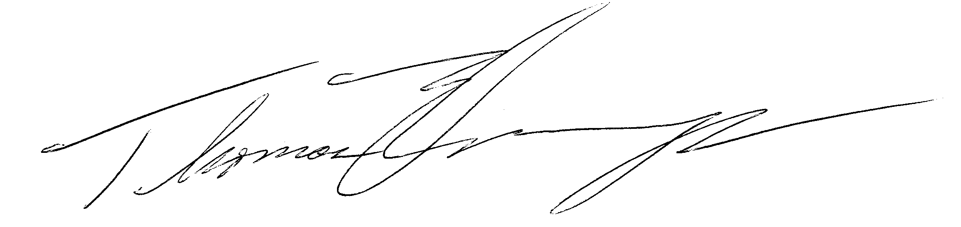
Hon. Thomas Dernoga, Chair

