VORTEX
Developed in cooperation with the Chesapeake Bay Program
An on-line decision support tool for developing nitrogen and phosphorus management strategies.

Vortex was developed to compare changes in nitrogen, phosphorus, and sediment loading to the land under different management scenarios. These data may be used alone, or as inputs to the Chesapeake Bay Program’s Watershed Model-HSPF Phase 5. Vortex is developed by the University of Maryland, College Park in partnership with the Chesapeake Bay Program.

Vortex is designed as decision support for regional, state, and county-level planners to assess and forecast causal mechanisms of nitrogen and phosphorus loads and to develop management strategies that reduce these pollutant loadings. Our goal in developing this tool is to facilitate an analytical approach to management practice implementation that increases effectiveness, minimizes costs, and allows for information transfer between regions.

Vortex is linked as a component of the Chesapeake On-line Assessment Support Tool (COAST). COAST provides an adaptive management framework for assessing pollution in the Chesapeake Bay Watershed. Other components of COAST allow identification of high priority areas of concern.

Overview of the Vortex Model
The Vortex Model computes a mass balance between nitrogen and phosphorus in the Chesapeake Bay Watershed. Sources of nitrogen and phosphorus include farm animals, chemical fertilizer, biosolids, atmospheric deposition, septic and sewer systems. Manure nitrogen and phosphorus concentrations are derived from animal populations, animal location, amount and concentration excreted. This manure and chemical fertilizer are spread on agricultural land according to the need of each crop type under various crop management practices in a specified growth region.

Calculations take into account chemical volatilization and loss from storage. Urban application is calculated as the remainder from agricultural application. Additional data output from Vortex are related to plant growth, harvest, and the decomposition of the residual material left on a field after harvest. These are all calculated curves over a 12-month period. The percentage remaining under specified best management practices (BMPs) is also calculated.

Scale
The Vortex Model is primarily designed for the Chesapeake Bay Watershed scale. Much of the source data is from USDA National Agricultural Statistics Service, which is statistically representative at the county scale. Results are specified down the Watershed Model-HSPF Phase 5 modeling segments using area-weighted averages. The Watershed Model-HSPF Phase 5 modeling segments are an intersection of land and river segments. The land segments scale up to political boundaries and the river segments scale up to watershed boundaries. While a single land-river segment may be modeled, error is introduced as source data is specified to a finer scale than that at which it was collected. The same is true of river segments that extend beyond county boundaries. The larger the area, the less error introduced. Vortex Model results are not valid at a site-specific or field scale.

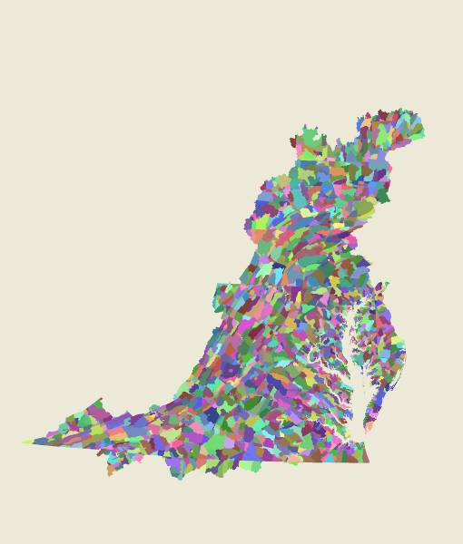
Scale of Phase 5 Output

Each segment has
up to 24 land uses

Vortex calculations are on an annual basis beginning with 1982 and projecting through 2030. Each year is calculated independently without considering interactions from year to year. Data is produced on a monthly basis where applicable.

Rapid scenario development
Vortex is designed to provide rapid scenario development for users to understand the impact of land use change, choice and location of management actions, impacts of forecasted land use and management practice change, and define the factors that reduce loading to the land and reduce contamination. Users have the option to explore different scenarios by controlling inputs and variables including:

- Best management practices (BMPs) location, type, and efficiencies
- Animal population locations and numbers
- Land use using the Chesapeake Bay Program-specified 24 land use categories
- Crop management parameters such as fertilizer application rates and tillage practices

An example of an analysis might include creating a scenario where there are no BMPs and comparing this to a scenario where there is full BMP implementation while holding other inputs static. Another analysis might involve creating a scenario where current levels of BMPs are on the land, and projecting land use change in the future. An initial assessment could use the Chesapeake Bay Program source data as inputs. The user may load their source data, which is especially advisable if it is at a finer scale.

Output includes graphed and tabular reports of manure and fertilizer loading to the land by segment in lbs per acre, BMPs implemented and the associated reduction, and bare soil area. The user may also view the results (outputs) from a Watershed Model-HSPF Phase 5 model run.

Development process and timeframe
The Vortex Model is under development and a limited version will be available in December 2008 with a full version release anticipated in December 2009. Current work includes verifying base data and programming calculation procedures. The web interface design will follow.

Contact Olivia Devereux devereux@umd.edu June 2008

