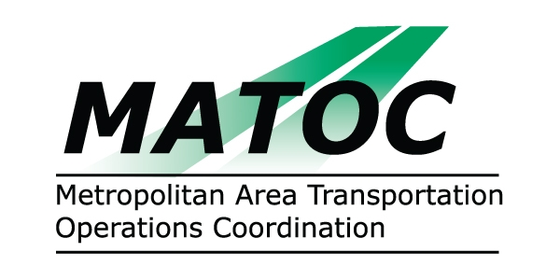

METROPOLITAN AREA TRANSPORTATION
OPERATIONS COORDINATION (MATOC) PROGRAM
OPERATIONS SUB-COMMITTEE

DATE: Thursday, May 14, 2009

TIME: 10:00 AM to 12:00 PM

PLACE: University of MD Center for Advanced Transportation Technology
5000 College Ave.
College Park, MD 20740

CHAIR: Alvin Marquess, MD SHA

AGENDA

- Approval of Minutes from April 9, 2009 Sub-Committee Meeting
- MATOC Report
  - Status Report
  - Notification Architecture
  - Strategic Plan and July 1st Planned activities
- DDOT Report
- MD SHA Report
- VDOT Report
- WMATA Report

- Other

