Bicycling, Walking and the Vision
of the Transportation Planning Board

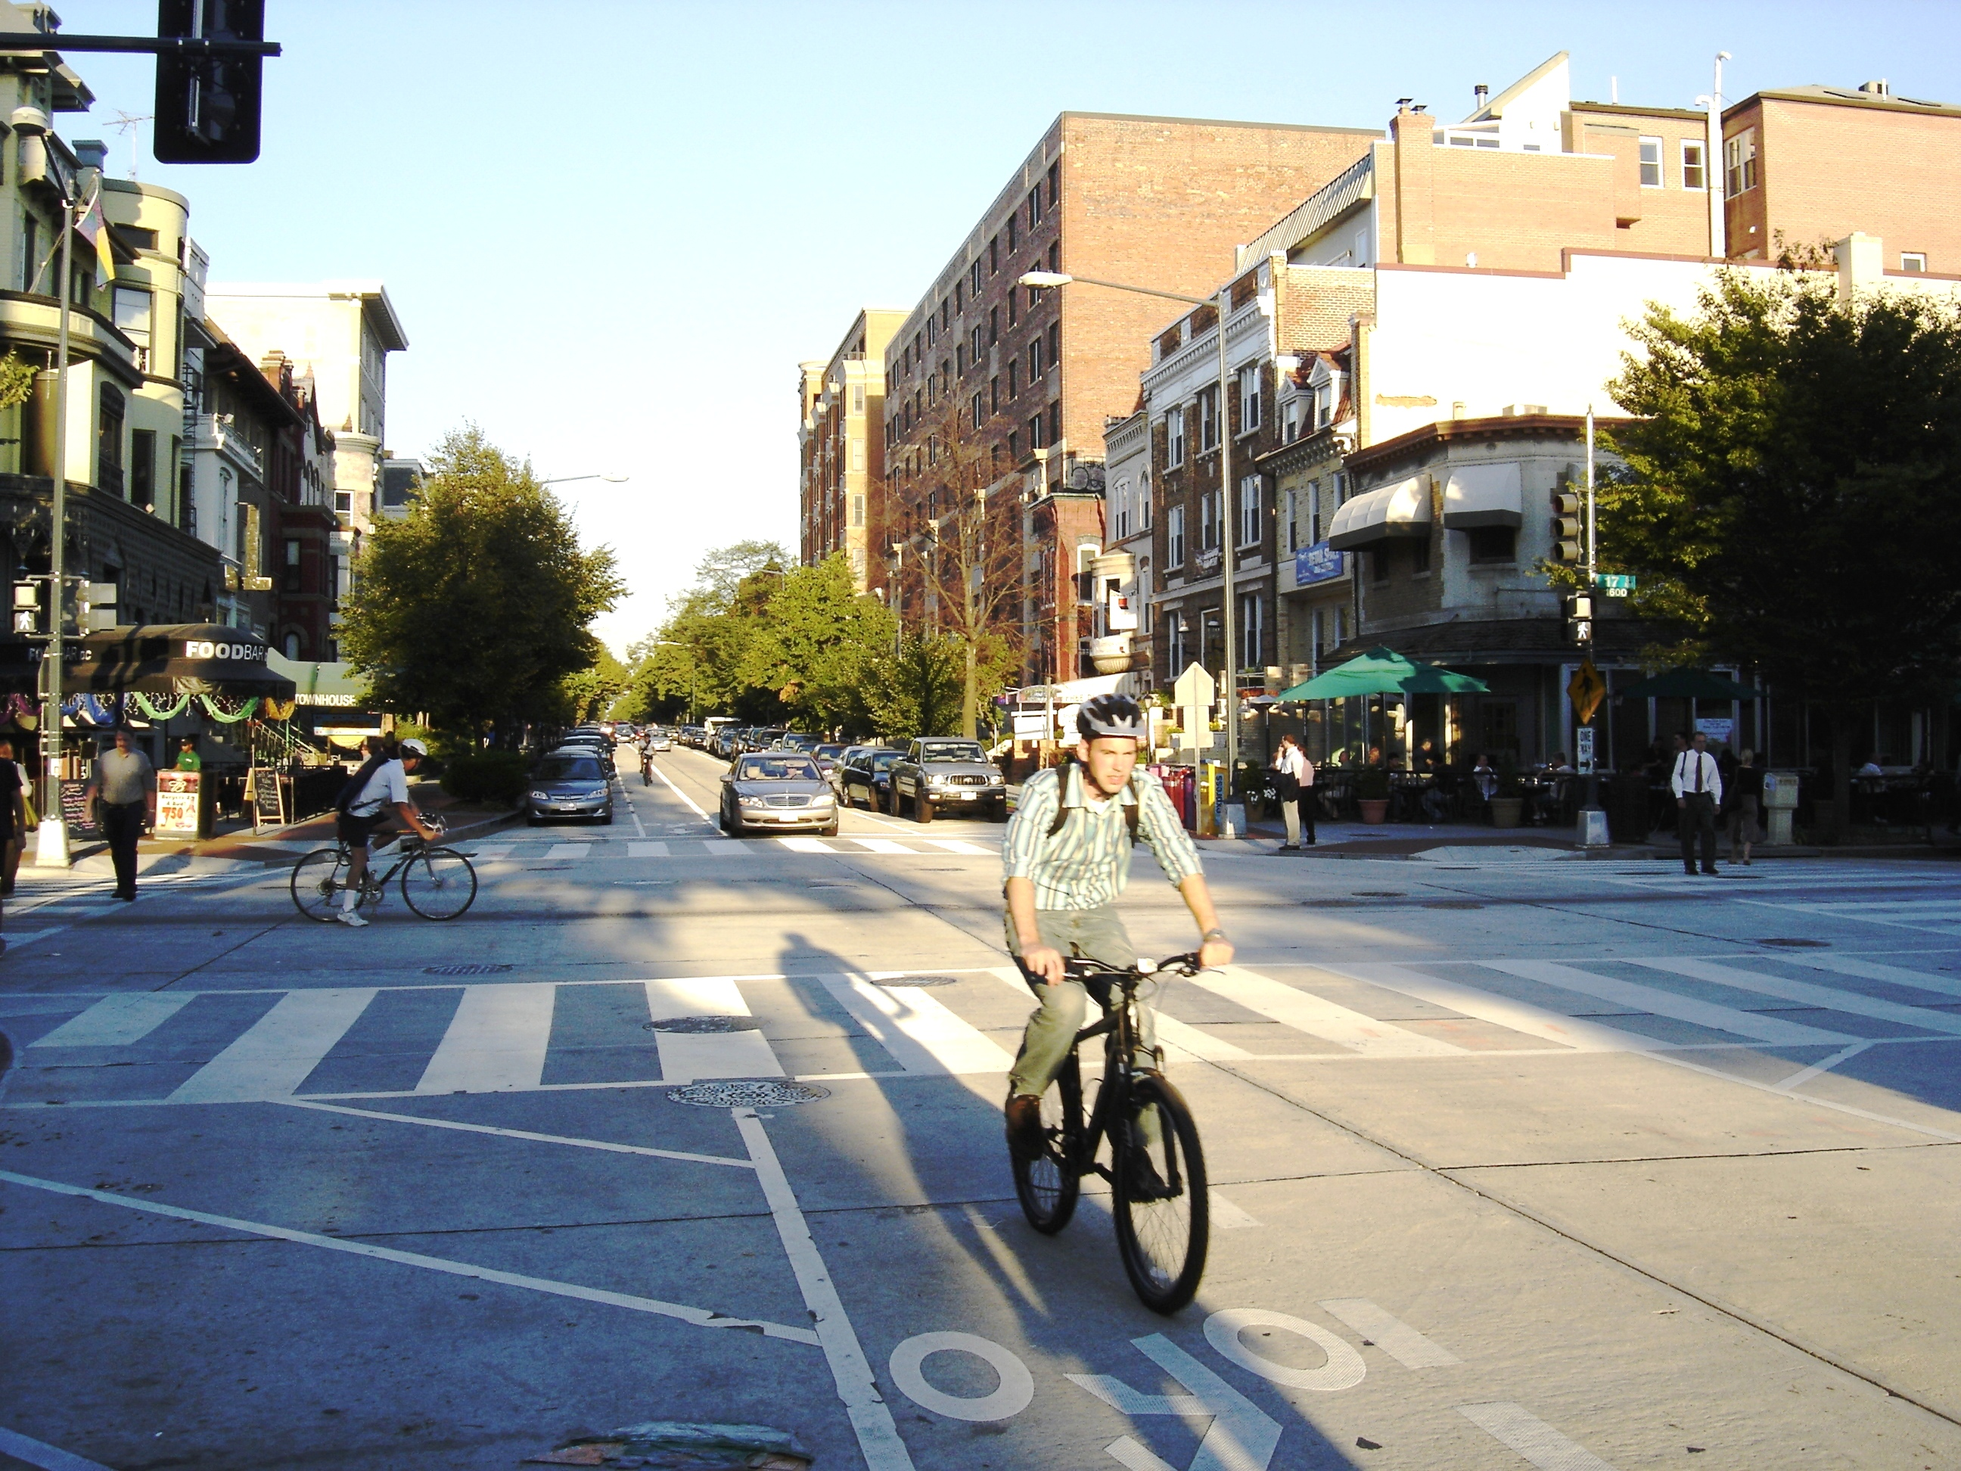
The National Capital Region Transportation Planning Board has long recognized the benefits of bicycling and walking in the region’s multi-modal transportation system. The Transportation Planning Board’s Transportation Vision for the 21st Century, adopted in 1998, emphasizes bicycles and pedestrians in its goals, objectives and strategies. A key part of the vision is a strong urban core and a set of regional activity centers, which will provide for mixed uses in a walkable environment and reduced reliance on the automobile. The Vision also calls for the implementation of a regional bicycle and pedestrian plan. The policy recommendations and projects in this plan, if implemented, will help realize the Vision.

Bicycling and Walking in the National Capital Region
The Urban Core has a Growing Network of Bicycle Lanes

The Washington region is nationally known for the quality, beauty, and extent of its bicycle paths. Its walkable core neighborhoods attract residents and visitors alike. The region has a strong foundation of walking and bicycling facilities to build upon.

Bicycling and walking together are a significant mode of transportation in the Washington region. According to the Metropolitan Washington Council of
Walking and Bicycling account for 8.3% of all trips in the region
Governments’ 1999 Household Travel Survey there are roughly 1.1 million pedestrian trips per day in the region, which is 7.8% of all trips. There are roughly 76,000 bicycle trips per day in the region, which is one-half of one percent of the almost 14 million daily trips for all modes of transportation.

The last ten years have seen tremendous progress for bicyclists and pedestrians. Several major new trails have opened, and most local governments have adopted bicycle, pedestrian, and/or trail plans. The Washington Metropolitan Area Transit Authority has eliminated the requirement for bike-on-rail permits, expanded bicycle boarding hours, and added bike racks to its buses. Bicycle or pedestrian coordinators and trail planners are now found at most levels of government. In accordance with federal guidance and new state policies, pedestrian and bicycle facilities are increasingly being provided as part of larger transportation projects. Employers are investing in bike facilities at work sites, and developers are including paths in new
construction.

Bicycling and walking have yet to reach their full potential in the Washington region, however. Many trips currently taken by automobile could potentially be taken by bicycle. The average work trip length for all modes in the Washington Metropolitan
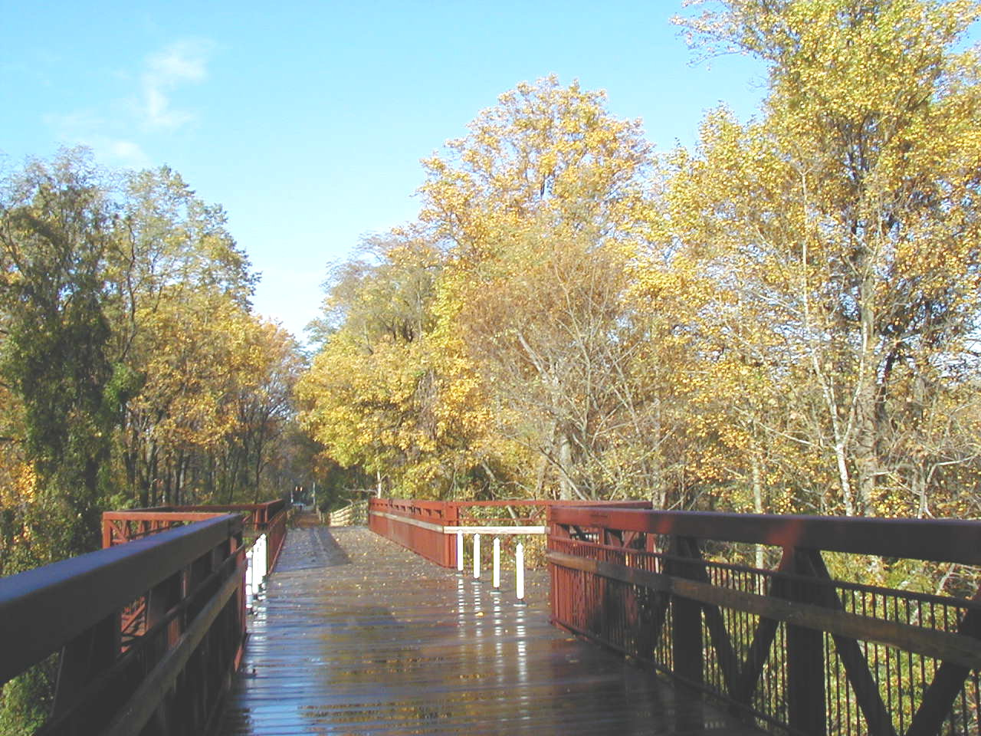
Statistical Area is 16.2 miles. But 17% of commute trips are less than five miles, a distance easily covered by bicycle for most people.

Many people who live far from their jobs, but closer to transit or a carpool location could walk or bike to transit or the carpool instead of driving. The average trip distance to transit or carpool is only 3.1 miles. Only 15% of transit riders and carpoolers travel more than five miles to the transit or carpool location, yet 29% of them drive and leave their cars there.

The potential for shifting non-work trips to
The Capital Crescent Trail Bridge over Rock Creek, Chevy Chase, MD opened in 2003
bicycle or walking is probably even greater than for work trips. The average non-work trip is a little more than five miles, and nearly 3/4 of all trips are non-work trips. Destinations such as schools, shopping, and recreational facilities are often close enough to walk or bicycle. Bicycling and walking have considerable potential to displace automobile trips if suitable transportation, design, safety, parking, school siting, and land development policies are followed.

Plan Development and Organization

This plan has been prepared by the National Capital Region Transportation Planning Board (TPB), the federally designated Metropolitan Planning Organization (MPO) for the Washington region. The TPB is made up of representatives of 20 local governments, the departments of transportation of Maryland, Virginia, and the District of Columbia, the state legislatures, and the Washington Metropolitan Area Transit Authority (WMATA). Member jurisdictions are shown in Figure i-1 on page i-4. This area, when expanded to include Charles and Calvert counties in Maryland and Stafford County in Virginia, comprises the Washington, DC-MD-VA Metropolitan Statistical Area (MSA).

This document presents the unconstrained long-range Bicycle and Pedestrian Plan for the Washington Region through the year 2030. The plan is a list of projects identified by the TPB member jurisdictions, accompanied by broad policy recommendations and a description of existing facilities and regional trends for bicycling and walking. As a multi-state region, we do not specify design guidelines, but refer instead to state and national guidelines for bicycle and pedestrian facilities.
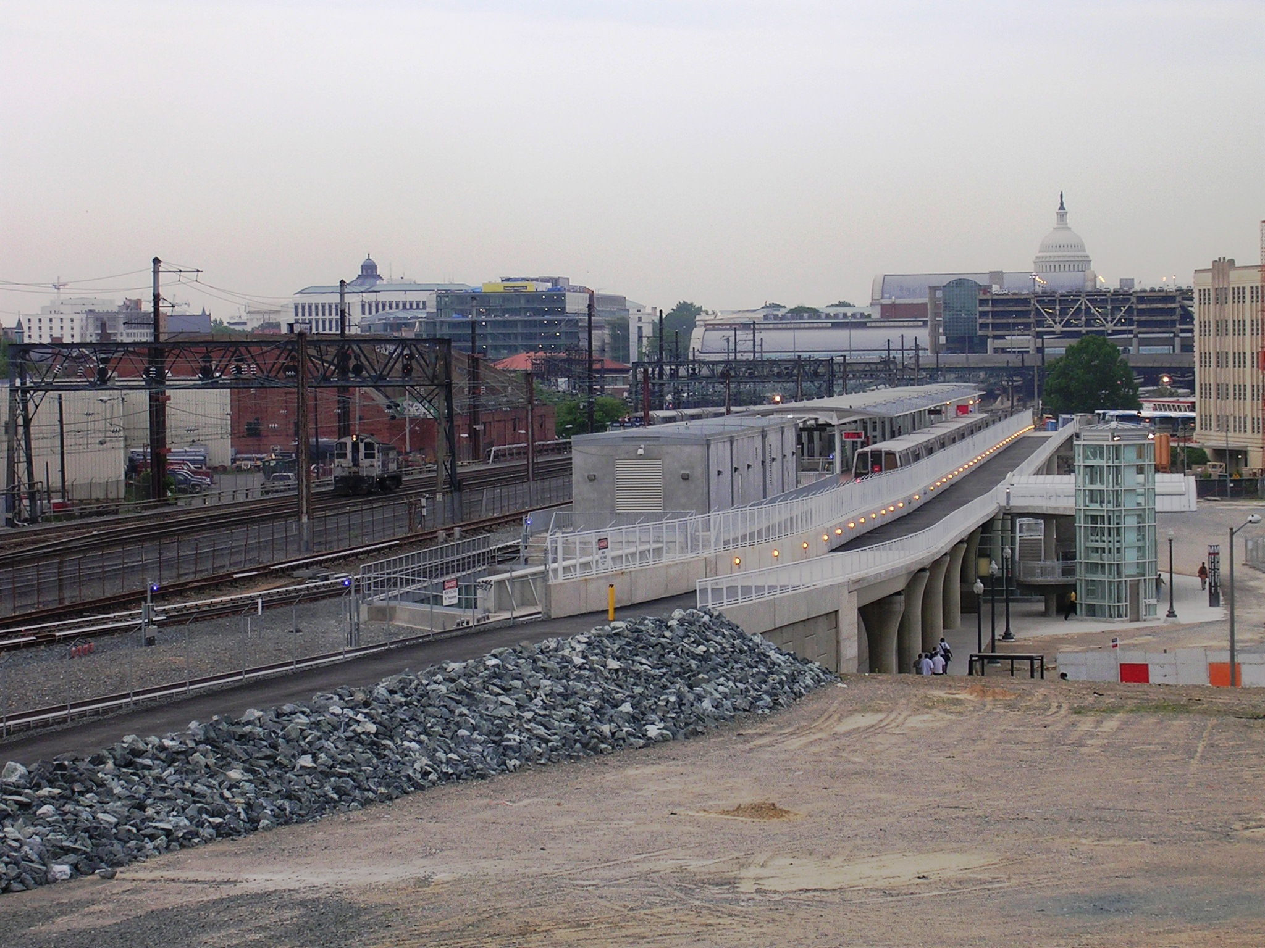
The original policy recommendations and project categories were developed by a task force of regional staff and volunteers in 1991, then updated in 1994 and again in 2005. The project lists have changed as projects have been completed, deleted and proposed by local jurisdictions. This update of the Bicycle and Pedestrian Plan for the National Capital Region seeks to reflect the goals, objectives and strategies of the TPB’s 1998 Transportation Vision while building on the policies of the 1995 version of the Plan.

This update also incorporates pedestrian issues for the first time. Pedestrian planning is most needed at the county, city and neighborhood level. There is, however, a role for regional pedestrian planning. By recommending policies and keeping track of regional trends, we can help make the Washington area a better place to walk.
The New York Avenue Metro Station Incorporates a Shared-Use Path and Bicycle Parking

Figure i-1
TPB Planning Area, Washington DC-MD-VA Metropolitan Statistical Area (MSA)

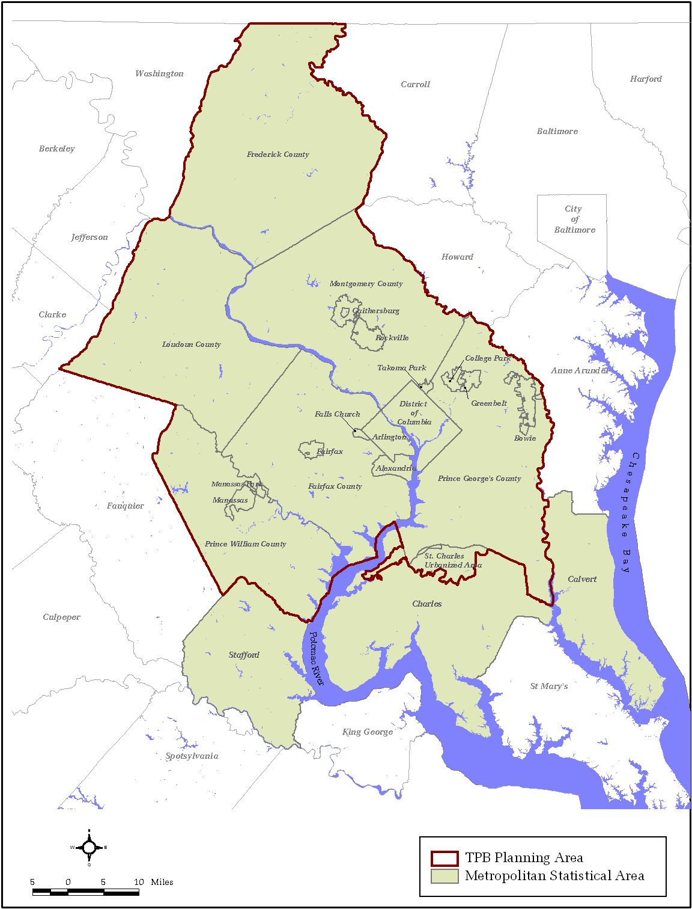

National Capital Region Transportation Planning Board, 2004 State of the Commute Survey Report, November, 2004, p. 22.
Ibid, p. 27.
Ibid, p. 27.
National Capital Regional Transportation Planning Board, 1994COG/TPB Household Travel Survey: Summary of Major Findings, January, 1998. Page 5.

