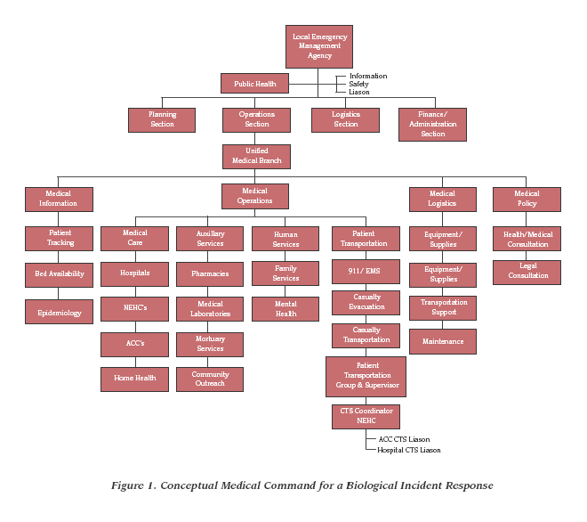

From DHHS expanding local healthcare structure for mass casualty DOD January 2002 Mr. James Church, U.S. Army Soldier and
Biological Chemical Command, Homeland Defense Office, 5183 Blackhawk Road,
Aberdeen Proving Ground, MD 21010-5424. Mr. Church: telephone: 410-436-5686,

E-mail: james.church@sbccom.apgea.army.mil

